**Practical Machine learning with python Summary - Neel Shah**

1. The iterative nature of these projects involves several Select → Apply → Validate → Tune cycles before coming up with a suitable Machine Learning-based model. A final and important step is to integrate the solution (Machine Learning model) into existing (or new) organization systems or business processes to sustain actionable and relevant results.
2. Hence, the broad requirements of the ingredients for a robust Machine Learning solution require a development platform that is suited not just for interactive modeling of Machine Learning, but also excels in data ingestion, processing, visualization, systems integration, and strong ecosystem support for runtime deployment and maintenance.
3. The key idea of using techniques from Machine Learning or artificial intelligence is to automate processes or tasks by learning specific patterns from the data.
4. Traditional Programming Paradigm

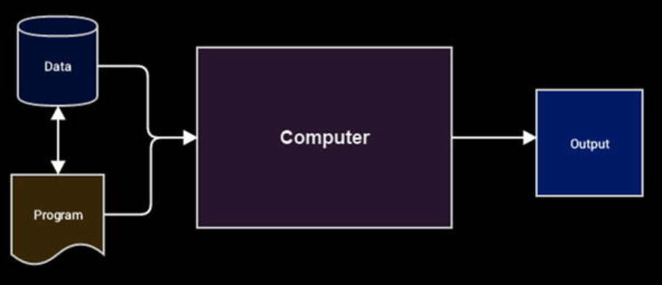

1. **Why Machine Learning?**
   1. Considering what you have learned so far, while the traditional programming paradigm is quite good and human intelligence and domain expertise is definitely an important factor in making data-driven decisions, we need Machine Learning to make faster and better decisions.
   2. The Machine Learning paradigm tries to take into account data and expected outputs or results if any and uses the computer to build the program, which is also known as a model. This program or model can then be used in the future to make necessary decisions and give expected outputs from new inputs. Figure below shows how the Machine Learning paradigm is similar yet different from traditional programming paradigms.

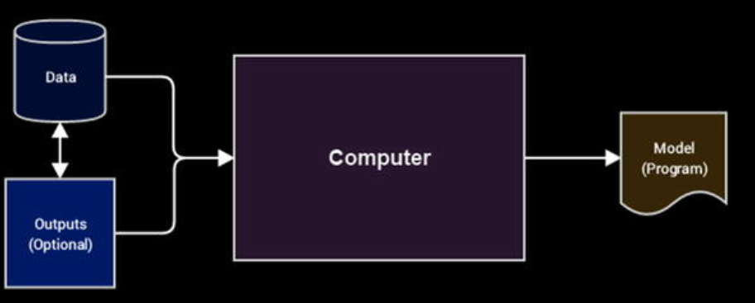

* 1. the machine, in this context the computer, tries to use input data and expected outputs to try to learn inherent patterns in the data that would ultimately help in building a model analogous to a computer program, which would help in making data-driven decisions in the future (predict or tell us the output) for new input data points by using the learned knowledge from previous data points (its knowledge or experience). You might start to see the benefit in this. We would not need hand-coded rules, complex flowcharts, case and if-then conditions, and other criteria that are typically used to build any decision making system or a decision support system. The basic idea is to use Machine Learning to make insightful decisions.

1. **Formal Definition**
   1. **“A computer program is said to learn from experience E with respect to some class of tasks T and performance measure P, if its performance at tasks in T, as measured by P, improves with experience E.”**

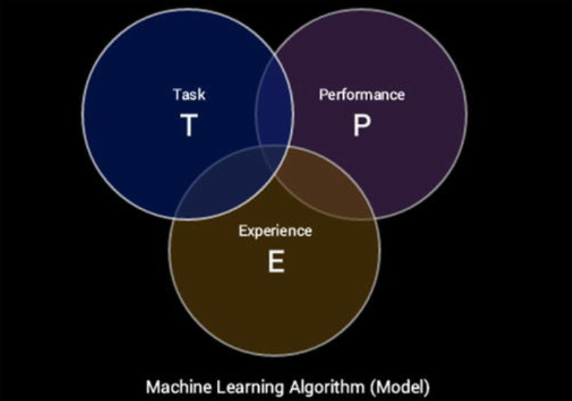

* 1. We can simplify the definition as follows. Machine Learning is a field that consists of learning algorithms that:
     1. Improve their performance P
     2. At executing some task T
     3. Over time with experience E

1. **Types of machine learning**
   1. Supervised Learning
   2. Un-supervised Learning
   3. Semi-supervied Learning
   4. Reinforcement Learning
2. Machine learning as multi disciplinary field

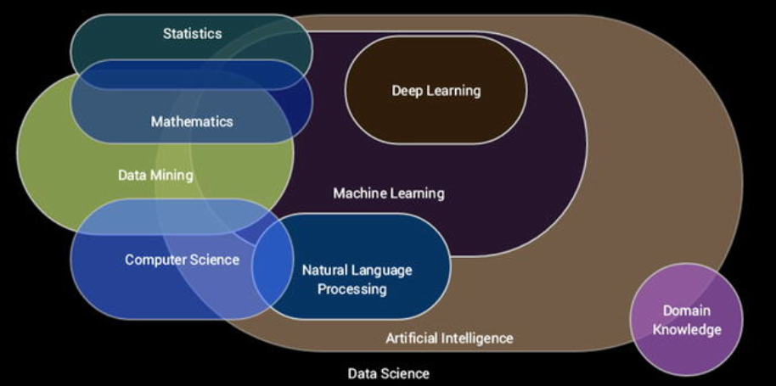

1. Important Concepts
   1. Scalar: A scalar usually denotes a single number as opposed to a collection of numbers. A simple example might be x = 5 or x ∈ R, where x is the scalar element pointing to a single number or a real-valued single number.
   2. Vector: A vector is defined as a structure that holds an array of numbers which are arranged in order. This basically means the order or sequence of numbers in the collection is important. Vectors can be mathematically denoted as x = [x1, x 2, …, x n ], which basically tells us that x is a one-dimensional vector having n elements in the array. Each element can be referred to using an array index determining its position in the vector. The following snippet shows us how we can represent simple vectors in Python.

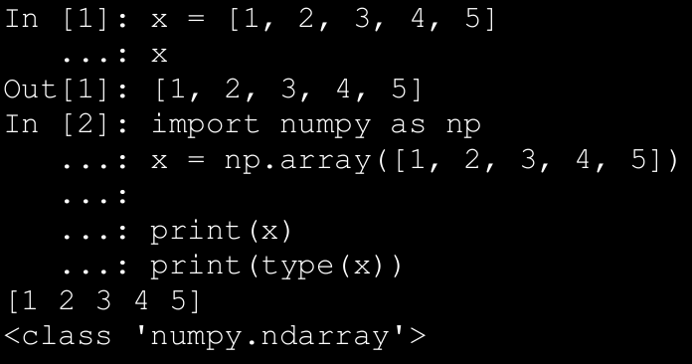

* 1. Tensor: You can think of a tensor as a generic array. Tensors are basically arrays with a variable number of axes. An element in a three-dimensional tensor T can be denoted by T x,y,z where x, y, z denote the three axes for specifying element T.
  2. Bayes Theorem: This is another rule or theorem which is useful when we know the probability of an event of interest P(A), the conditional probability for another event based on our event of interest P(B | A) and we want to determine the conditional probability of our event of interest given the other event has taken place P(A | B). This can be defined mathematically using the following expression.

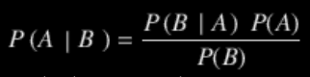

1. **Natural Language Processing**

The field of Natural Language Processing (NLP) is a multi-disciplinary field combining concepts from computational linguistics, computer science and artificial intelligence. NLP involves the ability to make machines process, understand, and interact with natural human languages. The major objective of applications or systems built using NLP is to enable interactions between machines and natural languages that have evolved over time. Major challenges in this aspect include knowledge and semantics representation, natural language understanding, generation, and processing. Some of the major applications of NLP are mentioned as follows.

A. Machine translation

B. Speech recognition

C. Question answering systems

D. Context recognition and resolution

E. Text summarization

F. Text categorization

G. Information extraction

H. Sentiment and emotion analysis

I. Topic segmentation

1. **Deep Learning**

The field of Deep Learning, as depicted earlier, is a sub-field of Machine Learning that has recently come into much prominence. Its main objective is to get Machine Learning research closer to its true goal of “making machines intelligent”

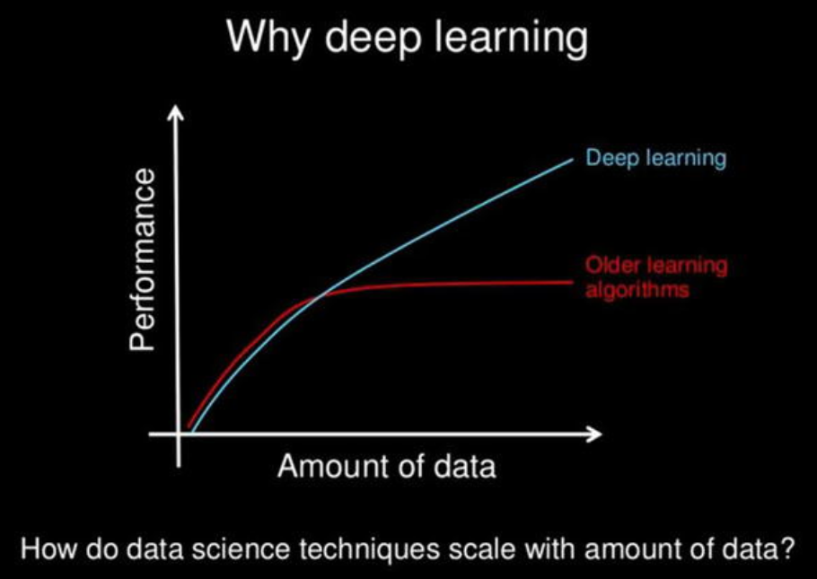

1. Artificial Neural Networks

→ An Artificial Neural Network (ANN) is a computational model and architecture that simulates biological neurons and the way they function in our brain. Typically, an ANN has layers of interconnected nodes. The nodes and their inter-connections are analogous to the network of neurons in our brain. A typical ANN has an input layer, an output layer, and at least onehidden layer between the input and output with inter-connections, as depicted in figure below:

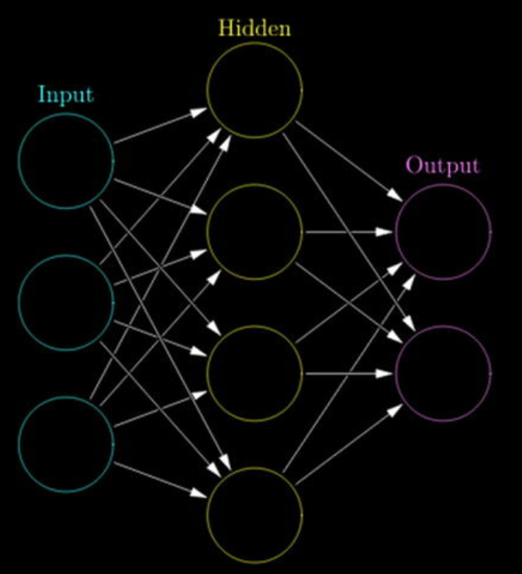

→Any basic ANN will always have multiple layers of nodes, specific connection patterns and links between the layers, connection weights and activation functions for the nodes/neurons that convert weighted inputs to outputs. The process of learning for the network typically involves a cost function and the objective is to optimize the cost function (typically minimize the cost). The weights keep getting updated in the process of learning.

1. Backpropagation

→The backpropagation algorithm is a popular technique to train ANNs and it led to a resurgence in the popularity of neural networks in the 1980s. The algorithm typically has two main stages—propagation and weight updates. They are described briefly as follows:

* 1. Propagation
     1. The input data sample vectors are propagated forward through the neural network to generate the output values from the output layer.
     2. Compare the generated output vector with the actual/desired output vector for that input data vector.
     3. Compute difference in error at the output units.
     4. Backpropagate error values to generate deltas at each node/neuron.
  2. Weight Update
     1. Compute weight gradients by multiplying the output delta (error) and input activation.
     2. Use learning rate to determine percentage of the gradient to be subtracted from original weight and update the weight of the nodes.

→These two stages are repeated multiple times with multiple

iterations/epochs until we get satisfactory results. Typically backpropagation is used along with optimization algorithms or functions like stochastic gradient descent.

1. Multilayer Perceptrons

→A multilayer perceptron , also known as MLP, is a fully connected, feed-forward artificial neural network with at least three layers (input, output, and at least one hidden layer) where each layer is fully connected to the adjacent layer. Each neuron usually is a non-linear functional processing unit. Backpropagation is typically used to train MLPs and even deep neural nets are MLPs when they have multiple hidden layers. Typically used for supervised Machine Learning tasks like classification.

1. Convolutional Neural Networks

→A convolutional neural network, also known as convnet or CNN, is a variant of the artificial neural network, which specializes in emulating functionality and behavior of our visual cortex. CNNs typically consist of the following three components.

* 1. **Multiple convolutional layers**, which consist of multiple filters that are convolved across the height and width of the input data (e.g., image raw pixels) by basically computing a dot product to give a two-dimensional activation map. On stacking all the maps across all the filters, we end up getting the final output from a convolutional layer.
  2. **Pooling layers** , which are basically layers that perform non-linear down sampling to reduce the input size and number of parameters from the convolutional layer output to generalize the model more, prevent overfitting and reduce computation time. Filters go through the heights and width of the input and reduce it by taking an aggregate like sum, average, or max. Typical pooling components are average or max pooling.
  3. Fully connected MLPs to perform tasks such as image classification and object recognition.

→A typical CNN architecture is as shown in the figure below:

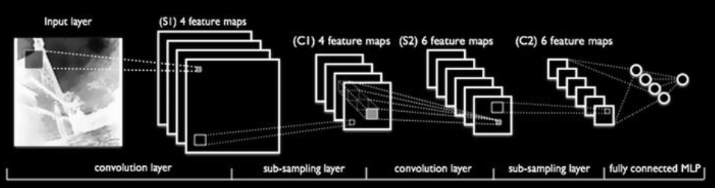

1. Recurrent Neural Networks

→A recurrent neural network, also known as RNN, is a special type of an artificial neural network that allows persisting information based on past knowledge by using a special type of looped architecture. They are used a lot in areas related to data with sequences like predicting the next word of a sentence. These looped networks are called recurrent because they perform the same operations and computation for each and every element in a sequence of input data.

→RNNs have memory that helps in capturing information from past sequences as shown in the figure below:

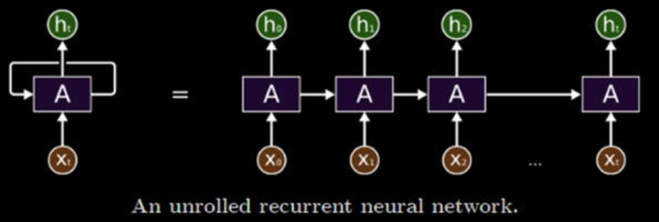

1. **Long Short-Term Memory Networks**

→RNNs are good in working on sequence based data but as the sequences start increasing, they start losing historical context over time in the sequence and hence outputs are not always what is desired. This is where Long Short-Term Memory Networks, popularly known as LSTMs, come into the picture! Introduced by Hochreiter & Schmidhuber in 1997, LSTMs can remember information from really long sequence based data and prevent issues like the vanishing gradient problem, which typically occurs in ANNs trained with backpropagation. LSTMs usually consist of three or four gates, including input, output, and a special forget gate. Figure below shows a high-level pictorial representation of a single LSTM cell.

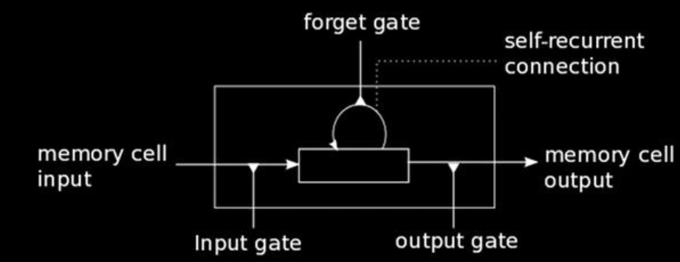

→The input gate usually can allow or deny incoming signals or inputs to alter the memory cell state. The output gate usually propagates the value to other neurons as needed. The forget gate controls the memory cell’s self-recurrent connection to remember or forget previous states as necessary. Multiple LSTM cells are usually stacked in any Deep Learning network to solve real-world problems like sequence prediction.

1. Methods based on the ability to learn from incremental data samples:
   1. Batch Learning
   2. Online Learning
2. Methods based on their approach to generalization from data samples:
   1. Instance based learning
   2. Model based learning
3. **Supervised Learning**

→ Supervised learning methods or algorithms include learning algorithms that take in data samples (known as training data) and associated outputs (known as labels or responses) with each data sample during the model training process. The main objective is to learn a mapping or association between input data samples x and their corresponding outputs y based on multiple training data instances. This learned knowledge can then be used in the future to predict an output y ′ for any new input data sample x′ which was previously unknown or unseen during the model training process. These methods are termed as supervised because the model learns on data samples where the desired output responses/labels are already known beforehand in the training phase.

→ Supervised learning methods are of two major classes based on the type of ML tasks they aim to solve.

* 1. Classification
  2. Regression

1. **Unsupervised Learning**

→ These methods are called unsupervised because the model or algorithm tries to learn inherent latent structures, patterns and relationships from given data without any help or supervision like providing annotations in the form of labeled outputs or outcomes.

→ Unsupervised learning is more concerned with trying to extract meaningful insights or information from data rather than trying to predict some outcome based on previously available supervised training data.

→ Unsupervised learning methods can be categorized under the following broad areas of ML tasks relevant to unsupervised learning.

* 1. Clustering
  2. Dimensionality Reduction
  3. Anomaly Detection
  4. Association rule-mining

1. There are various types of the clustering methods that can be classified under the following major approaches:
   1. Centroid based method such as K-means and K-medoids
   2. Hierarchical clustering methods such as agglomerative and divisive (Ward’s, affinity propagation)
   3. Distribution based clustering methods such as Gaussian mixture Models
   4. Density based methods such as dbscan and optics.
   5. Besides this, we have several methods that recently came into the clustering landscape, like birch and clarans.
2. Dimensionality Reduction

→Dimensionality reduction is used to reduce the number of feature variables by extracting or selecting a set of principal or representative features. There are multiple popular algorithms available for dimensionality reduction like Principal Component Analysis (PCA) , nearest neighbors, and discriminant analysis.

→An example of the dimensionality reduction is as shown below:

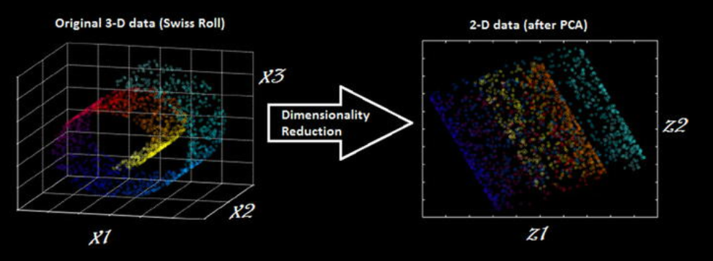

→Dimensionality reduction techniques can be classified in to the two major approaches as follow:

* 1. **Feature selection method**: Specific features are selected for each data sample from the original list of features and other features are discarded. No new features are generated in this process.
  2. **Feature extraction method**: We engineer or extract new features from the original list of features in the data. Thus the reduced subset of features will contain newly generated features that were not part of the original feature set. PCA falls under this category.

1. The process of detecting the anomaly is called as the **anomaly detection.**

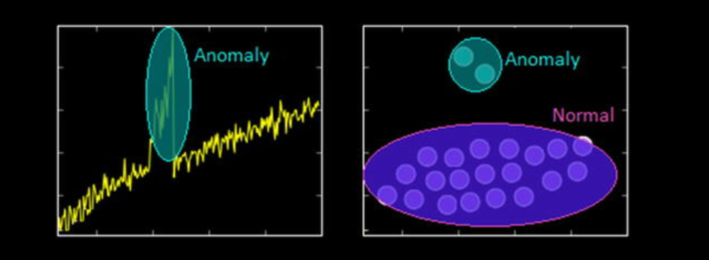

1. **Association Rule-Mining**

→Typically association rule-mining is a data mining method use to examine and analyze large transactional datasets to find patterns and rules of interest. These patterns represent interesting relationships and associations, among various items across transactions. Association rule-mining is also often termed as market basket analysis , which is used to analyze customer shopping patterns. Association rules help in detecting and predicting transactional patterns based on the knowledge it gains from training transactions. Using this technique, we can answer questions like what items do people tend to buy together, thereby indicating frequent item sets. We can also associate or correlate products and items, i.e., insights like people who buy beer also tend to buy chicken wings at a pub. Figure below shows how a typical association rule-mining method should work ideally on a

transactional dataset.

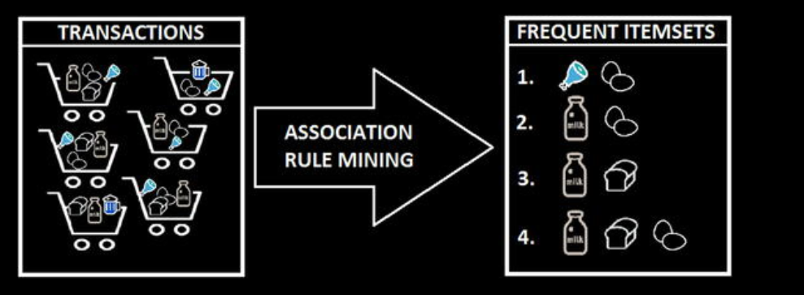

→From Figure above, you can clearly see that based on different customer transactions over a period of time, we have obtained the items that are closely associated and customers tend to buy them together. Some of these frequent item sets are depicted like {meat, eggs}, {milk, eggs} and so on. The criterion of determining good quality association rules or frequent item sets is usually done using metrics like support, confidence, and lift.

→ This is an unsupervised method, because we have no idea what the frequent item sets are or which items are more strongly associated with which items beforehand. Only after applying algorithms like the apriori algorithm or FP-growth, can we detect and predict products or items associated closely with each other and find conditional probabilistic dependencies.

1. **Semi-Supervised Learning**

→ The semi-supervised learning methods typically fall between supervised and unsupervised learning methods. These methods usually use a lot of training data that’s unlabeled (forming the unsupervised learning component) and a small amount of pre-labeled and annotated data (forming the supervised learning component). Multiple techniques are available in the form of generative methods, graph based methods, and heuristic based

methods.

→A simple approach would be building a supervised model based on labeled data, which is limited, and then applying the same to large amounts of unlabeled data to get more labeled samples, train the model on them and repeat the process. Another approach would be to use unsupervised algorithms to cluster similar data samples, use human-in-the-loop efforts to manually annotate or label these groups, and then use a combination of this information in the future. This approach is used in many image tagging systems.

1. **Reinforcement Learning**

→ Typically the agent starts with a set of strategies or policies for interacting with the environment. On observing the environment, it takes a particular action based on a rule or policy and by observing the current state of the environment. Based on the action, the agent gets a reward, which could be beneficial or detrimental in the form of a penalty. It updates its current policies and strategies if needed and this iterative process continues till it learns enough about its environment to get the desired rewards. The main steps of a reinforcement learning method are mentioned as follows.

1. Prepare agent with set of initial policies and strategy
2. Observe environment and current state
3. Select optimal policy and perform action
4. Get corresponding reward (or penalty)
5. Update policies if needed
6. Repeat Steps 2 - 5 iteratively until agent learns the most optimal policies

→ An example of the reinforcement learning is as shown in the figure below:

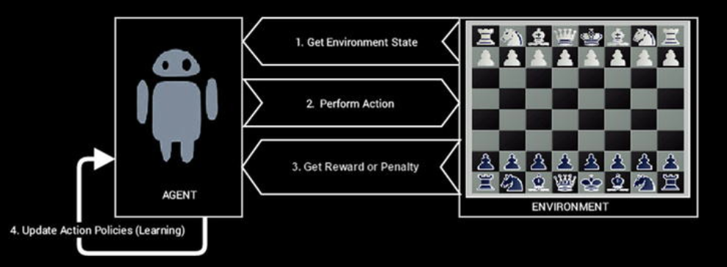

1. **Batch Learning**

→ Batch learning methods are also popularly known as offline learning methods. These are Machine Learning methods that are used in end-to-end Machine Learning systems where the model is trained using all the available training data in one go. Once training is done and the model completes the process of learning, on getting a satisfactory performance, it is deployed into production where it predicts outputs for new data samples.

→ However, the model doesn’t keep learning over a period of time continuously with the new data. Once the training is complete the model stops learning. Thus, since the model trains with data in one single batch and it is usually a one-time procedure, this is known as batch or offline learning.

→ We can always train the model on new data but then we would have to add new data samples along with the older historical training data and again re-build the model using this new batch of data. If most of the model building workflow has already been implemented, retraining a model would not involve a lot of effort; however, with the data size getting bigger with each new data sample, the retraining process will start consuming more processor, memory, and disk resources over a period of time. These are some points to be considered when you are building models that would be running from systems having limited capacity.

1. Online Learning

→ Online learning methods work in a different way as compared to batch learning methods. The training data is usually fed in multiple incremental batches to the algorithm. These data batches are also known as mini-batches in ML terminology. However, the training process does not end there unlike batch learning methods. It keeps on learning over a period of time based on new data samples which are sent to it for prediction. Basically it predicts and learns in the process with new data on the fly without have to re-run the whole model on previous data samples.

→ There are several advantages to online learning—it is suitable in real-world scenarios where the model might need to keep learning and re-training on new data samples as they arrive. Problems like device failure or anomaly prediction and stock market forecasting are two relevant scenarios. Besides this, since the data is fed to the model in incremental mini-batches, you can build these models on commodity hardware without worrying about memory or disk constraints since unlike batch learning methods, you do not need to load the full dataset in memory before training the model. Besides this, once the model trains on datasets, you can remove them since we do not need the same data again as the model learns incrementally and remembers what it has learned in the past.

→ One of the major caveats in online learning methods is the fact that bad data samples can affect the model performance adversely. All ML methods work on the principle of “Garbage In Garbage Out”. Hence if you supply bad data samples to a well-trained model, it can start learning relationships and patterns that have no real significance and this ends up affecting the overall model performance.

→ Since online learning methods keep learning

based on new data samples, you should ensure proper checks are in place to notify you in case suddenly the model performance drops. Also suitable model parameters like learning rate should be selected with care to ensure the model doesn’t overfit or get biased based on specific data samples.

1. **Instance based learning**

→There are various ways to build Machine Learning models using methods that try to generalize based on input data. Instance based learning involves ML systems and methods that use the raw data points themselves to figure out outcomes for newer, previously unseen data samples instead of building an explicit model on training data and then testing it out.

→ A simple example would be a K-nearest neighbor algorithm. Assuming k = 3, we have our initial training data. The ML method knows the representation of the data from the features, including its dimensions, position of each data point, and so on. For any new data point, it will use a similarity measure (like cosine or Euclidean distance) and find the three nearest input data points to this new data point. Once that is decided, we simply take a majority of the outcomes for those three training points and predict or assign it as the outcome label/response for this new data point. Thus, instance based learning works by looking at the input data points and using a similarity metric to generalize and predict for new data points.

1. Model Based Learning

→ The model based learning methods are a more traditional ML approach toward generalizing based on training data. Typically an iterative process takes place where the input data is used to extract features and models are built based on various model parameters (known as hyperparameters). These hyperparameters are optimized based on various model validation techniques to select the model that generalizes best on the training data andsome amount of validation and test data (split from the initial dataset). Finally, the best model is used to make predictions or decisions as and when needed.

1. **The CRISP-DM Process Model**

→ The CRISP-DM model stands for **CRoss Industry Standard Process for Data Mining**.

→ More popularly known by the acronym itself, CRISP-DM is

a tried, tested, and robust industry standard process model followed for data mining and analytics projects. CRISP-DM clearly depicts necessary steps, processes, and workflows for executing any project right from formalizing business requirements to testing and deploying a solution to transform data into insights. Data Science, Data Mining, and Machine Learning are all about trying to run multiple iterative processes to extract insights and information from data. Hence we can say that analyzing data is truly both an art as well as a science, because it is not always about running algorithms without reason; a lot of the major effort involves in

understanding the business, the actual value of the efforts being invested, and proper methods to articulate end results and insights.

→ he CRISP-DM model tells us that for building an end-to-end solution for any analytics project or system, there are a total of six major steps or phases, some of them being iterative. Just like we have a software development lifecycle with several major phases or steps for a software development project, we have a data mining or analysis lifecycle in this scenario. Figure below depicts the data mining lifecycle with the CRISP-DM model.

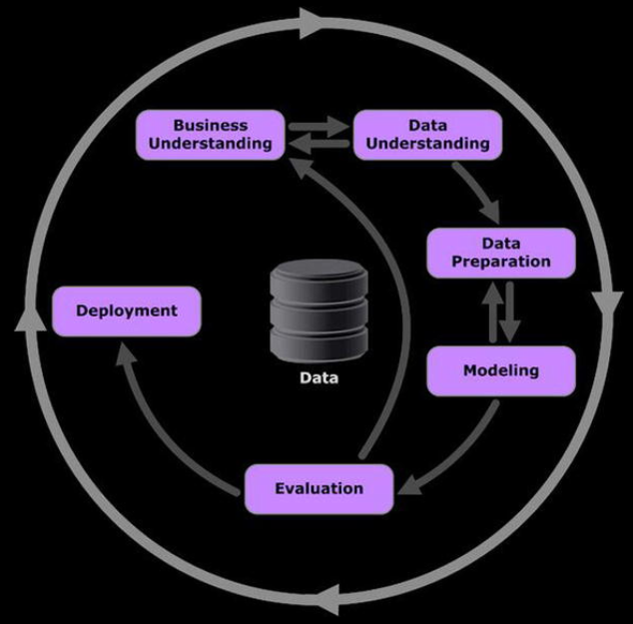

1. **Define Data Mining Problem**

→ This could be defined as the pre-analysis phase, which starts once the success criteria and the business problem is defined and all the risks, assumptions and constraints have been documented. This phase involves having detailed technical discussions with your analysts, data scientists, and developers and keeping the business stakeholders in sync. The following are the key tasks that are to be undertaken in this phase.

* 1. Discuss and document possible Machine Learning and data mining methods suitable for the solution by assessing possible tools, algorithms, and techniques.
  2. Develop high-level designs for end-to-end solution architecture.
  3. Record notes on what the end output from the solution will be and how will it integrate with existing business components.
  4. Record success evaluation criteria from a Data Science standpoint. A simple example could be making sure that predictions are at least 80% accurate.

1. **Project Plan**

→ This is the final stage under the business understanding phase. A project plan is generally created consisting of the entire major six phases in the CRISP-DM model , estimated timelines, allocated resources and personnel, and possible risks and contingency plans. Care is taken to ensure concrete high-level deliverables and success criteria are defined for each phase and iterative phases like modeling are highlighted with annotations like feedback based on SMEs might need models to be rebuilt and retuned before deployment.

→ You should be ready for the next step once you have the following points covered.

* 1. Definition of business objectives for the problem
  2. Success criteria for business and data mining efforts
  3. Budget allocation and resource planning
  4. Clear, well-defined Machine Learning and data mining methodologies to be followed, including high-level workflows from exploration to deployment
  5. Detailed project plan with all six phases of the CRISP-DM model defined with estimated timelines and risks

1. **Exploratory Data Analysis**

→ Exploratory data analysis , also known as EDA, is one of the first major analysis stages in the lifecycle. Here, the main objective is to explore and understand the data in detail. You can make use of descriptive statistics, plots, charts, and visualizations to look at the various data attributes, find associations and correlations and make a note of data quality problems if any. Following are some of the major tasks in this stage.

* 1. Data volume (size, number of records, total databases, tables)
  2. Data volume (size, number of records, total databases, tables)
  3. Data attributes and their description (variables, data types)
  4. Relationship and mapping schemes (understand attribute
  5. representations)
  6. Basic descriptive statistics (mean, median, variance)
  7. Focus on which attributes are important for the business
  8. Explore, describe, and visualize data attributes
  9. Select data and attributes subsets that seem most important for the problem
  10. Extensive analysis to find correlations and associations and test hypotheses
  11. Note missing data points if any

1. **Data Quality Analysis**

→ Data quality analysis is the final stage in the data understanding phase where we analyze the quality of data in our datasets and document potential errors, shortcomings, and issues that need to be resolved before analyzing the data further or starting modeling efforts. The main focus on data quality analysis involves the following.

* 1. Missing Values
  2. Inconsistent Values
  3. Wrong information due to data errors (manual/automated)
  4. Wrong metadata information

1. Data Wrangling

→ The process of data wrangling or data munging involves data processing, cleaning, normalization, and formatting. Data in its raw form is rarely consumable by Machine Learning methods to build models. Hence we need to process the data based on its form, clean underlying errors and inconsistencies, and format it into more consumable formats for ML algorithms. Following are the main tasks relevant to data wrangling.

* 1. Handling missing values (remove rows, impute missing values)
  2. Handling data inconsistencies (delete rows, attributes, fix inconsistencies)
  3. Fixing incorrect metadata and annotations
  4. Handling ambiguous attribute values
  5. Curating and formatting data into necessary formats (CSV, Json, relational)

1. Attribute Generation and Selection

→ Data is comprised of observations or samples (rows) and attributes or features (columns). The process of attribute generation is also known as feature extraction and engineering in Machine Learning terminology. Attribute generation is basically creating new attributes or variables from existing attributes based on some rules, logic, or hypothesis. A simple example would be creating a new numeric variable called age based on two date-time fields—current_date and birth_date—for a dataset of employees in an organization. There are several techniques with regard to attribute generation.

→ Attribute selection is basically selecting a subset of features or attributes from the dataset based on parameters like attribute importance, quality, relevancy, assumptions, and constraints. Sometimes even Machine Learning methods are used to select relevant attributes based on the data. This is popularly known as feature selection in Machine Learning terminology.

1. Model Assessment

→ Once we have models that are providing desirable and relevant results, a detailed assessment of the model is performed based on the following parameters.

* 1. Model performance is in line with defined success criteria
  2. Reproducible and consistent results from models
  3. Scalability, robustness, and ease of deployment
  4. Future extensibility of the model
  5. Model evaluation gives satisfactory results

1. Machine Learning Pipelines

→ The best way to solve a real-world Machine Learning or analytics problem is to use a Machine Learning pipeline starting from getting your data to transforming it into information and insights using Machine Learning algorithms and techniques. This is more of a technical or solution based pipeline and it assumes that several aspects of the CRISP-DM model are already covered, including the following points.

→Business and data understanding

→ ML/DM technique selection

→ Risk, assumptions and constraints assessment

→ A Machine Learning pipeline will mainly consist of elements related to data retrieval and extraction, preparation, modeling, evaluation, an deployment. Figure 1-23 shows a high-level overview of a standard Machine Learning pipeline with the major phases highlighted in their blocks.

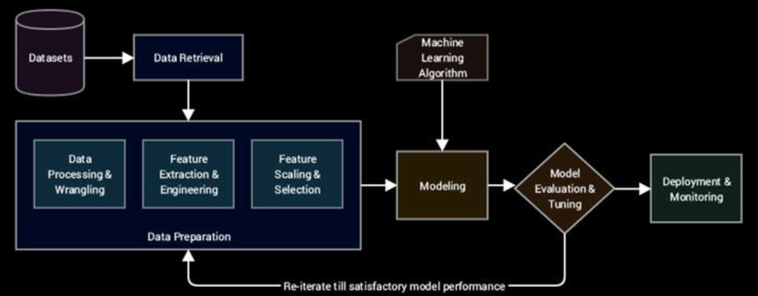

1. Supervised Machine Learning Pipeline

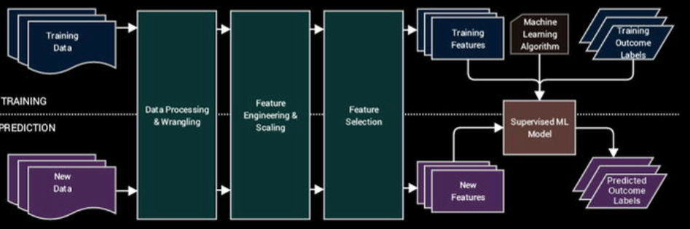

1. Unsupervised Machine Learning Pipeline

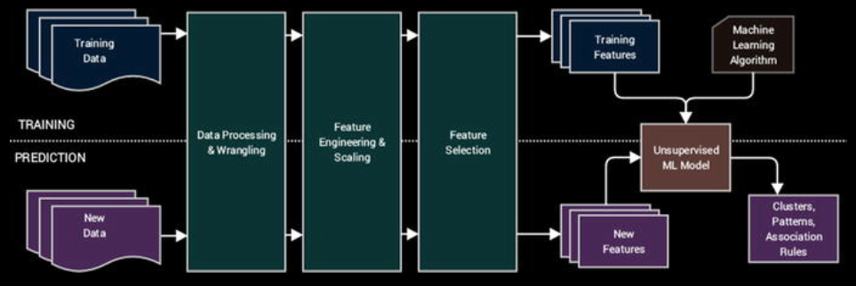

1. Model Deployment

→ Suppose we built our supervised learning model, and to deploy this model typically in a system or server, we need to persist the model. We also need to save the scalar object we used to scale the numerical features since we use it to transform the numeric features of new data samples. The following snippet depicts a way to store the model and scalar objects.

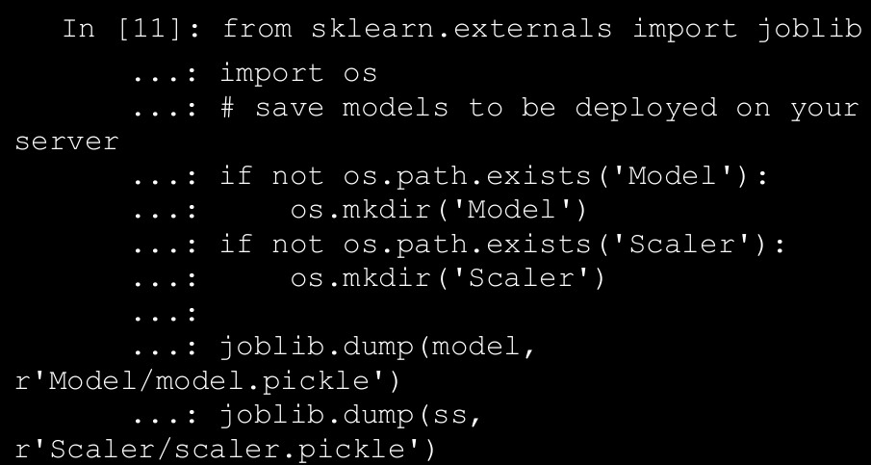

1. Real-World Applications of Machine Learning

→ Machine Learning is widely being applied and used in the real world today to solve complex problems that would otherwise have been impossible to solve based on traditional approaches and rule-based systems. The following list depicts some of the real-world applications of Machine Learning.

* 1. Product recommendations in online shopping platforms
  2. Sentiment and emotion analysis
  3. Anomaly detection
  4. Fraud detection and prevention
  5. Content recommendation (news, music, movies, and so on)
  6. Weather forecasting
  7. Stock market forecasting
  8. Market basket analysis
  9. Customer segmentation
  10. Object and scene recognition in images and video
  11. Speech recognition
  12. Churn analytics
  13. Click through predictions
  14. Failure/defect detection and prevention
  15. E-mail spam filtering

1. The Python Machine Learning Ecosystem

→This Python ML ecosystem is a collection of libraries that

enable the developers to extract and transform data, perform data wrangling operations, apply existing robust Machine Learning algorithms and also develop custom algorithms easily. These libraries include numpy, scipy, pandas, scikit-learn, statsmodels, tensorflow, keras, open cv and so oN.

→Setting up the python environment

* + 1. Anaconda
    2. Jupyter Lab
    3. Jupyter Notebook
    4. NumPy
    5. Pandas
    6. Scikit-Learn
    7. Theano
    8. Tensorflow
    9. Keras
    10. nltk

1. We will now take a look at the major modules of nltk library and introduce the functionality that each of them provides.
   1. Corpora

→ The starting point of any text analytics process is the process of collecting the documents of interest in a single dataset. This dataset is central to the next steps of processing and analysis. This collection of documents is generally called a corpus. Multiple corpus datasets are called corpora. The nltk module nltk.corpus provides necessary functions that can be used to read corpus files in a variety of formats. It supports the reading of corpora from the datasets bundled in nltk package as well as external

corpora.

* 1. Toenization

→ Tokenization is one of the core steps in text pre-processing and normalization. Each text document has several components like paragraphs, sentences, and words that together make up the document. The process of tokenization is used to break down the document into these smaller components. This tokenization can be into sentences, words, clauses, and so on. The most popular way to tokenize any document is by using sentence tokenization and\or word tokenization. The nltk.tokenize module of the nltk library provides functionality that enables efficient tokenization of any textual data.

* 1. Tagging

→ A text document is constructed based on various grammatical rules and constructs. The grammar depends on the language of the text document. Each language’s grammar will contain different entities and parts of speech like nouns, pronouns, adjectives, adverbs, and so on. The process of tagging will involve getting a text corpus, tokenizing the text and assigning metadata information like tags to each word in the corpora. The nltk.tag module contains implementation of different algorithms that can be used for such tagging and other related activities.

* 1. Stemming and Lemmatization

→ A word can have several different forms based on what part of speech it is representing. Consider the word fly; it can be present in various forms in the same text, like flying, flies, flyer, and so on. The process of stemming is used to convert all the different forms of a word in to the base form, which is known as the root step. Lemmatization is similar to stemming but the base form is known as the root word and it’s always a semantically and lexicographically correct word. This conversion is crucial, as a lot of timesthe core word contains more information about the document, which can be diluted by these different forms. The nltk module nltk.stem contains different techniques that can be used for stemming and lemmatizing a corpus.

* 1. Chunking

→ Chunking is a process which is similar to parsing or tokenization but the major difference is that instead of trying to parse each word, we will target phrases present in the document. Consider the sentence “The brown fox saw the yellow dog”. In this sentence, we have two phrases which are of interest. The first is the phrase “the brown fox,” which is a noun phrase and the second one is the phrase “the yellow dog,” which again is a noun phrase. By using the process of chunking, we are able to tag phrases with additional parts of speech information, which is important for understanding the structure of the document. The nltk module nltk.chunk consists of necessary techniques that can be used for applying the chunking process to our corpora.

* 1. Sentiment

→ Sentiment or emotion analysis is one of the most recognizable applications on text data. Sentiment analysis is the process of taking a text document and trying to determine the opinion and polarity being represented by that document. Polarity in the reference of a text document can mean the emotion, e.g., positive, negative, or neutral being represented by the data. The sentiment analysis on textual data can be done using different algorithms and at different levels of text segmentation. The

nltk.sentiment package is the module that can be used to perform different sentiment analyses on text documents.

* 1. Classification / Clustering

→ Classification of text documents is a supervised learning problem, as we explained in the first chapter. Classification of text documents may involve learning the sentiment, topic, theme, category, and so on of several text documents (corpus) and then using the trained model to label unknown documents in the future. The major difference from normal structured data comes in the form of feature representations of unstructured text we will be using. Clustering involves grouping together similar documents based on some similarity measure, like cosine similarity, bm25 distance, or even semantic similarity. The nltk.classify and nltk.cluster modules are typically used to perform these operations once we do the necessary feature engineering and extraction.

1. Other text analytics frameworks are pattern, gensim, textblob, spacy
2. CSV

→ A CSV data file is one of the most widely available formats of data. It is also one of the oldest formats still used and preferred by different systems across domains. Comma Separated Values (CSV) are data files that contain data with each of its attributes delimited by a “,” (a comma). Figure 3-1 depicts a quick snapshot of how a typical CSV file looks.

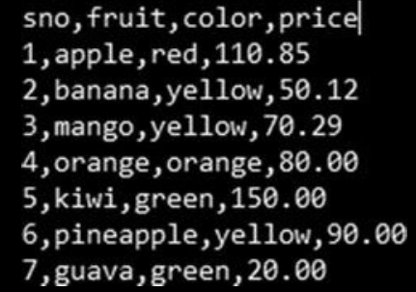

1. JSON

→ Java Script Object Notation (JSON) is one of the most widely used data interchange formats across the digital realm. JSON is a lightweight alternative to legacy formats like XML (we shall discuss this format next). JSON is a text format that is language independent with certain defined conventions. JSON is a human-readable format that is easy/simple to parse in most programming/scripting languages.

1. Web Scraping

→ Web scraping is a technique to scrape or extract data from the web, particularly from web pages. Web scraping may involve manually copying the data or using automation to crawl, parse, and extract information from web pages. In most contexts, web scraping refers to automatically crawling a particular web site or a portion of the web to extract and parse information that can be later on used for analytics or other use cases. A typical web scraping flow can be summarized as follows:

* 1. **Crawl**: A bot or a web crawler is designed to query a web server using the required set of URLs to fetch the web pages. A crawler may employ sophisticated techniques to fetch information from pages linked from the URLs in question and even parse information to a certain extent. Web sites maintain a file called **robots.txt** to employ what is called as the “Robots Exclusion Protocol” to restrict / provide access to their content.
  2. **Scrape**: Once the raw web page has been fetched, the next task is to extract information from it. The task of scraping involves utilizing techniques like regular expressions, extraction based on XPath, or specific tags and so on to narrow down to the required information on the page.

→ Web scraping involves creativity from the point of view of narrowing down to the exact piece of information required. With web sites changing constantly and web pages becoming dynamic (see asp, jsp, etc.), presence of access controls (username/password, CAPTCHA, and so on complicate the task even more. Python is a very powerful programming language, which should be evident by now, and scraping the web is another task for which it provides multiple utilities.

1. For this we would use the requests.get() function to extract the content and then utilize BeautifulSoup’s utilities to get the content from the URLs.
2. We use isnull() to identify columns containing missing values. The utilities any() and nonzero() provide nice abstractions to identify any row/column conforming to a condition (in this case pointing to rows/columns having missing values).

→ We also get some basic summary statistics like min, max, and so on; these will be useful in coming tasks. For the first task, we use the info() utility while the summary statistics are provided by the describe() function.

1. Type Casting

→ Typecasting or converting data into appropriate data types, is an important part of cleanup and wrangling in general. Often data gets converted into wrong data types while being extracted or converted from one form to the other. Also different platforms and systems handle each data type differently and thus getting the right data type is important.

→ To fix our dataframe, we use to_datetime() function from pandas. This is a very flexible utility that allows us to set different attributes like date time formats, timezone, and so on. Since in our case, the values are just dates, we use the function as follows with defaults.

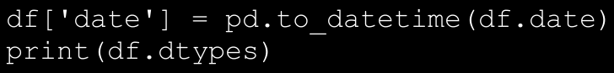

→ Similarly, we can convert numeric columns marked as strings using to_numeric() along with direct Python style typecasting as well. Upon checking the data types now, we clearly see the date column in the correct data type of datetime64.

1. Transformation

→ Another common task with data wrangling is to transform existing columns or derive new attributes based on requirements of the use case or data itself. To derive or transform column, pandas provide three different utilities—apply(), applymap(), and map(). The apply() function is used to perform actions on the whole object, depending upon the axis (default is on all rows). The applymap() and map() functions work element-wise with map() coming from the pandas.Series hierarchy.

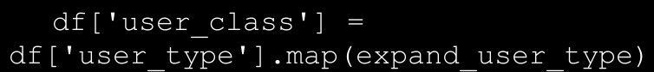

→ Along the same lines, we use the applymap() function to perform another element-wise operation to get the week of the transaction from the date attribute. For this case, we use the lambda function to get the job done quickly.

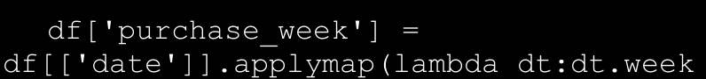

1. Imputing Missing Values

→ Missing values can lead to all sorts of problems when dealing with Machine Learning and Data Science related use cases. Not only can they cause problems for algorithms, they can mess up calculations and even final outcomes. Missing values also pose risk of being interpreted in non-standard ways as well leading to confusion and more errors. Hence, imputing missing values carries a lot of weight in the overall data wrangling process.

→ One of the easiest ways of handling missing values is to ignore or remove them altogether from the dataset. When the dataset is fairly large and we have enough samples of various types required, this option can be safely exercised. We use the dropna() function from pandas in the following snippet to remove rows of data where the date of transaction is missing.

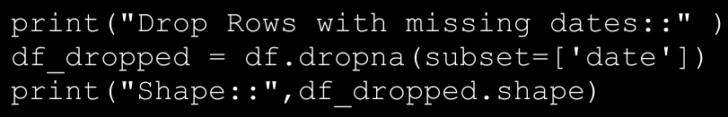

→ The result is a dataframe with rows without any missing dates. The output data frame is depicted in figure below.

→ Often dropping rows is a very expensive and unfeasible option. In many scenarios, missing values are imputed using the help of other values in the dataframe. One commonly used trick is to replace missing values with a central tendency measure like mean or median. One may also choose other sophisticated measures/statistics as well. In our dataset, the price column seems to have some missing data. We utilize the **fillna()**

method from pandas to fill these values with mean price value from our dataframe.

→ On the same lines, we use the **ffill()** and **bfill()** functions to

impute missing values for the user_type attribute. Since, user_type is a string type attribute, we use a proximity based solution to handle missing values in this case. The **ffill()** and **bfill()** functions copy forward the data from the previous row (forward fill) or copy the value from the next row (backward fill). The following snippet showcases the three functions.

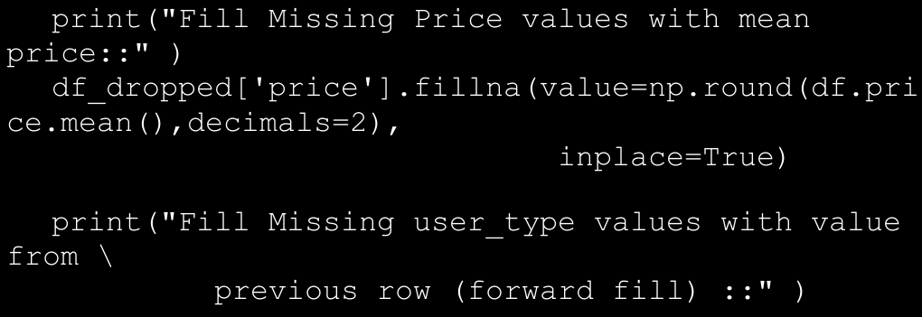

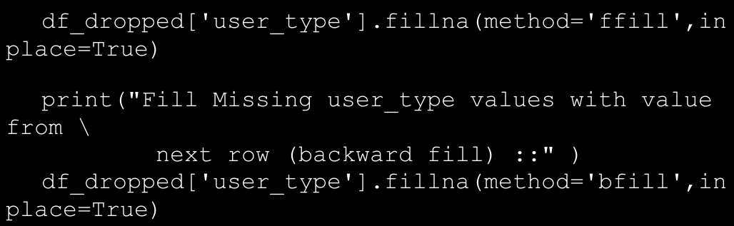

→ Apart from these ways, there are certain conditions where a record is not much of use if it has more than a certain threshold of attribute values missing. For instance, if in our dataset a transaction has less than three attributes as **non-null**, the transaction might almost be unusable. In such a scenario, it might be advisable to drop that data point itself. We can filter out such data points using the function **dropna()** with the parameter **thresh** set to the threshold of non-null attributes. More details are available on the official documentation page.

1. **Handling Duplicates**

→ Another issue with many datasets is the presence of duplicates. While data is important and more the merrier, duplicates do not add much value per se. Even more, duplicates help us identify potential areas of errors in recording/collecting the data itself. To identify duplicates, we have a utility called **duplicated()** that can applied on the whole dataframe as well as on a subset of it. We may handle duplicates by fixing the errors and use the **duplicated()** function, although we may also choose to drop the duplicate data points altogether. To drop duplicates, we use the method **drop_duplicates()**. The following snippet showcases both functions discussed here.

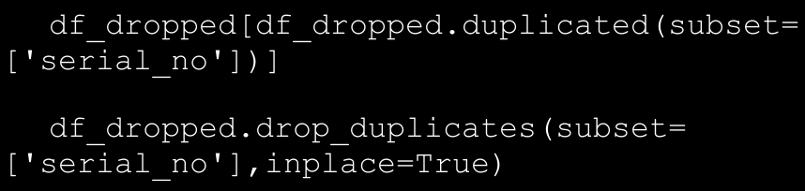

→ The output of identifying a subset of a dataframe having duplicate values for the field **serial_no** is depicted in Figure below. The second line in the previous snippet simply drops those duplicates.

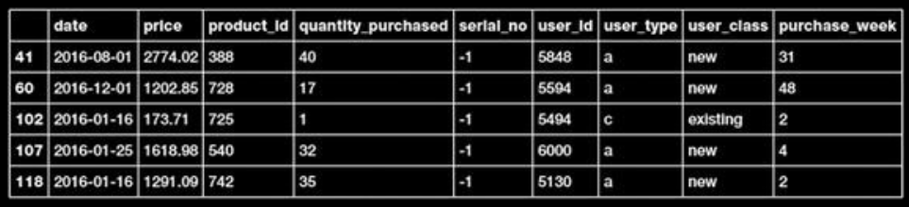

1. Handling Categorical Data

→ As discussed in the section “Data Description,” categorical attributes consist of data that can take a limited number of values (not always though). Here in our dataset, the attribute user_type is a categorical variable that can take only a limited number of values from the allowed set {a,b,c,d}. The algorithms that we would be learning and utilizing in the coming chapters mostly work with numerical data and categorical variables may pose some issues.

→ For instance, statistical operations like addition, mean, and so on, though syntactically valid, should be avoided for obvious reasons. The second method is to convert the categorical variable into indicator variables using the get_dummies() function. The function is simply a wrapper to generate one hot encoding for the variable in consideration. One hot encoding and other encodings can be handled using libraries like sklearn as well.

→ The following snippet showcases both the methods discussed previously using map() and get_dummies().

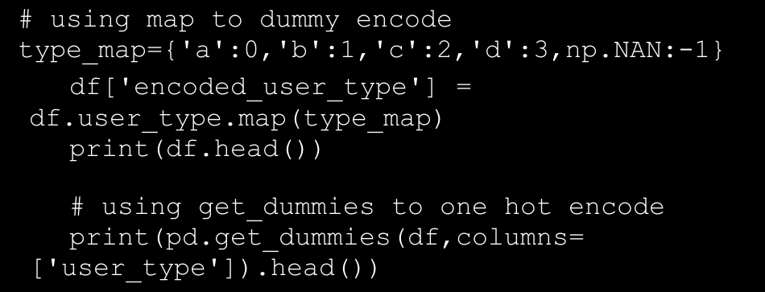

→ The output is generated as depicted in figure below shows the output of dummy encoding. With the map() approach we keep the number of features in check, yet have to be careful about the caveats mentioned in this section.

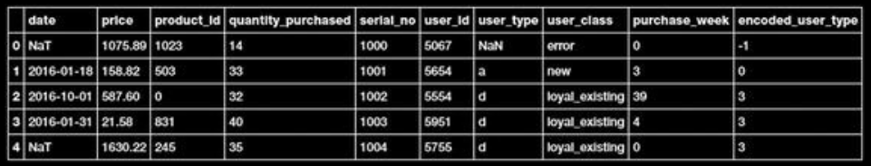

→ The second image, figure below, showcases the output of one hot encoding the user_type attribute.

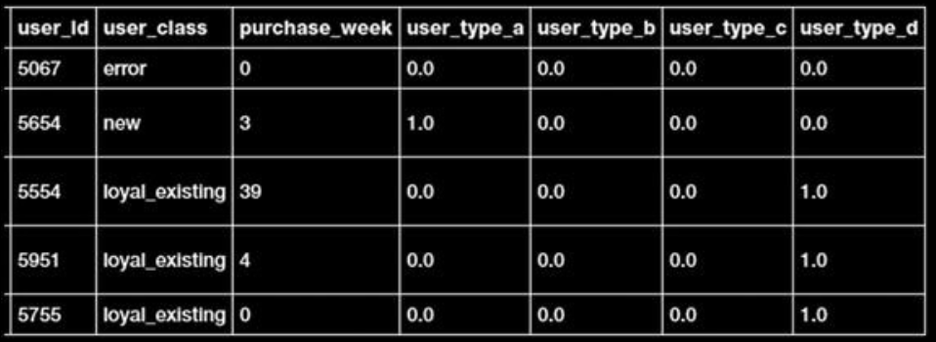

1. **Normalizing Values**

→ Attribute normalization is the process of standardizing the range of values of attributes. Machine learning algorithms in many cases utilize distance metrics, attributes or features of different scales/ranges which might adversely affect the calculations or bias the outcomes.

→ **Normalization is also called feature scaling**. There are various ways of scaling/normalizing features, some of them are rescaling, standardization (or zero-mean unit variance), unit scaling and many more. We may choose a normalization technique based upon the feature, algorithm and use case at hand. This will be clearer when we work on use cases.

→ The following snippet showcases a quick example of using a min-max scaler, available from the preprocessing module of sklearn, which rescales attributes to the desired given range.

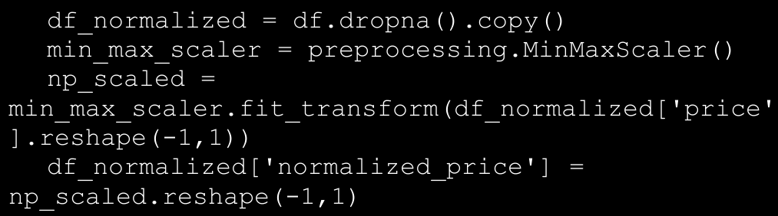

→ Figure below showcases the unscaled price values and the normalized price values that have been scaled to a range of [0, 1].

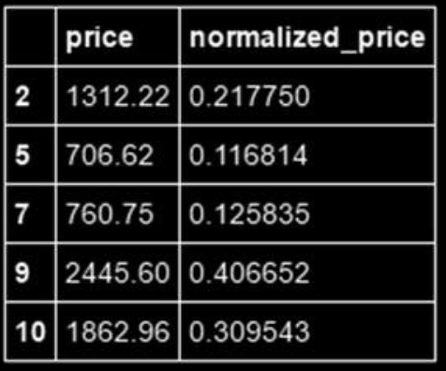

1. Data Summarization

→ Data summarization refers to the process of preparing a compact representation of raw data at hand. This process involves aggregation of data using different statistical, mathematical, and other methods.Summarization is helpful for visualization, compressing raw data, and better understanding of its attributes.

→ The pandas library provides various powerful summarization

techniques to suit different requirements. We will cover a couple of them here as well. The most widely used form of summarization is to group values based on certain conditions or attributes. The following snippet illustrates one such summarization.



→ The first statement calculates the mean price for all transactions by user_type, while the second one counts the number of transactions per week. Though these calculations are helpful, grouping data based on attributes helps us get a better understanding of it. The groupby() function helps us perform the same, as shown in the following snippet.

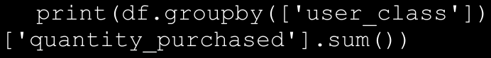

→ This statement generates a tabular output representing sum of quantities purchased by each user_class. The output is generated is as follows.

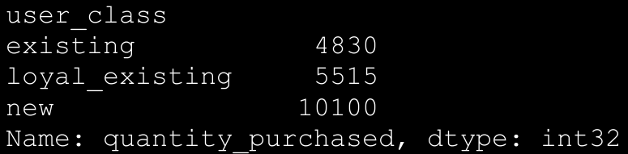

→ The groupby() function is a powerful interface that allows us to

perform complex groupings and aggregations. In the previous example we grouped only on a single attribute and performed a single aggregation (i.e., sum). With **groupby()** we can perform multi-attribute groupings and apply multiple aggregations across attributes. The following snippet showcases three variants of groupby() usage and their corresponding outputs.

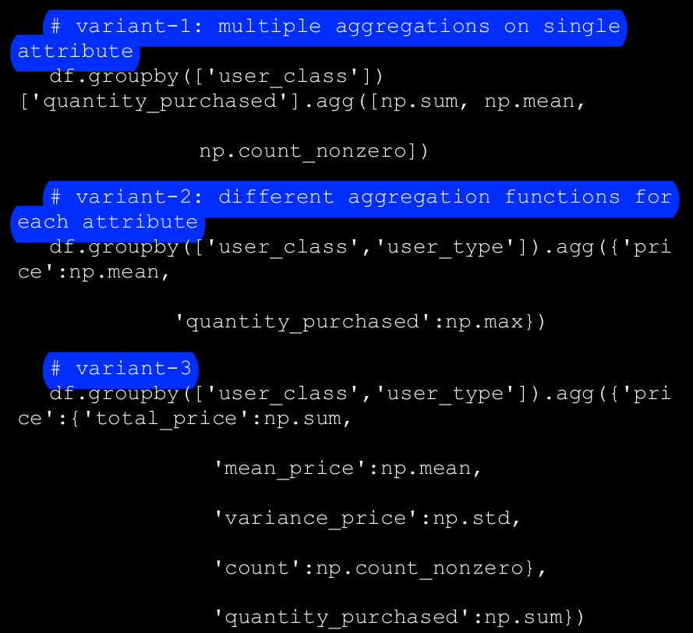

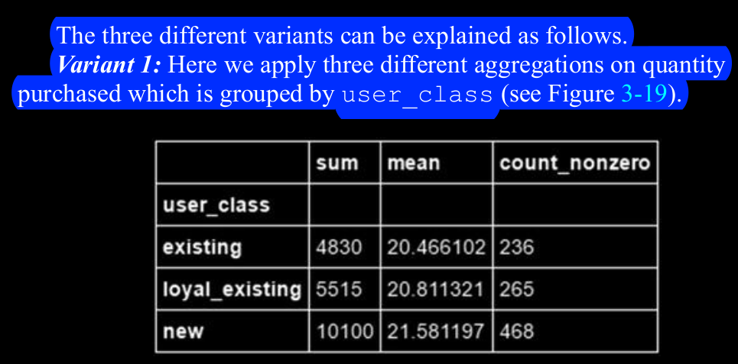

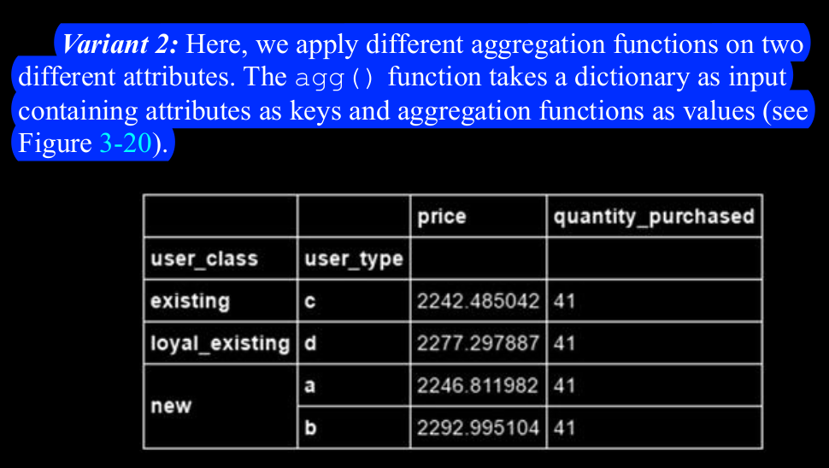

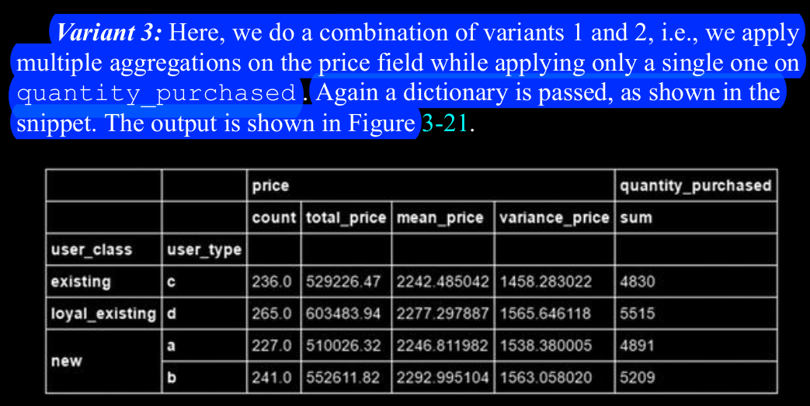

→Apart from groupby() based summarization, other functions such as pivot(), pivot_table(), stack(), unstack(), crosstab(), and melt() provide capabilities to reshape the pandas dataframe as per requirements.

1. Feature Scaling

→ Feature selection is another important task that comes hand in hand with feature engineering, where the data scientist is tasked with selecting the best possible subset of features and attributes that would help in building the right model.

→ An important point to remember here is that feature engineering and selection is not a one-time process which should be carried out in an ad hoc manner.

→ You may need to extract new features and try out multiple selections each time you build a model to get the best and optimal model for your problem. Data processing and feature engineering is often described to be the toughest task or step in building any Machine Learning system by data scientists.

1. Features

→ Raw data is hardly used to build any Machine Learning model, mostly because algorithms can’t work with data which is not properly processed and wrangled in a desired format. Features are attributes or properties obtained from raw data. Each feature is a specific representation on top of the raw data.

→ Typically, each feature is an individual measurable attribute

which usually is depicted by a column in a two dimensional dataset. Each observation is depicted by a row and each feature will have a specific value for an observation. Thus each row typically indicates a feature vector and the entire set of features across all the observations forms a two-dimensional feature matrix also known as a feature set.

→ Features are extremely important toward building Machine Learning models and each feature represents a specific chunk of representation and information from the data which is used by the model. Both quality as well as quantity of features influences the performance of the model.

→ Features can be of two major types based on the dataset. Inherent raw features are obtained directly from the dataset with no extra data manipulation or engineering. Derived features are usually what we obtain from feature engineering where we extract features from existing data attributes.

1. Models

→ Typically the process of modeling involves multiple major steps. Model building focuses on training the model on data features. Model tuning and optimization involves tuning specific model parameters, known as hyperparameters and optimizing the model to get the best model.

→ Model evaluation involves using standard performance evaluation metrics like accuracy to evaluate model performance. Model deployment is usually the final step where, once we have selected the most suitable model, we deploy it live in production which usually involves building an entire system around this model based on the CRISP-DM methodology.

1. What Is Feature Engineering?

→ Features are the final end result from the process of feature engineering, which depicts various representations of the underlying data.

→ In fact, more than often it’s not the algorithms but the features that determine the effectiveness of the model. In simple words, good features give good models. A data scientist approximately spends around 70% to 80% of his time in data processing, wrangling, and feature engineering for building any Machine Learning model.

→“Feature engineering is the process of transforming **raw data** into features that better represent the underlying problem to the predictive models, resulting in improved model accuracy on **unseen data**.”

→ Features are also very much dependent on the underlying problem. Thus, even though the Machine Learning task might be same in different scenarios, like classification of e-mails into spam and non-spam or classifying handwritten digits, the features extracted in each scenario will be very different from the other.

→ “At the end of the day, some Machine Learning projects succeed and some fail. What makes the difference? Easily the most important factor is the features used.”

→ The following list depicts some examples of engineering features.

* 1. Deriving a person’s age from birth date and the current date
  2. Getting the average and median view count of specific songs and music videos
  3. Extracting word and phrase occurrence counts from text documents
  4. Extracting pixel information from raw images
  5. Tabulating occurrences of various grades obtained by students

1. Why feature engineering?
   1. Better representation of data
   2. Better performing models
   3. Essential for model building and evaluation
   4. More flexibility on data types
   5. Emphasis on the business and domain
2. Text Preprocessing

→ Before feature engineering, we need to pre-process, clean, and normalize the text like we mentioned before. There are multiple pre-processing techniques, some of which are quite elaborate. We will not be going into a lot of details in this section but we will be covering a lot of them in further detail in a future chapter when we work on text classification and sentiment analysis. Following are some of the popular pre-processing techniques.

* 1. Text tokenization and lower casing
  2. Removing special characters
  3. Contraction expansion
  4. Removing stopwords
  5. Correcting spellings
  6. Stemming
  7. Lemmatization

→ We will be normalizing our tex here by lowercasing, removing special characters, tokenizing, and removing stopwords. The following code helps us achieve this.

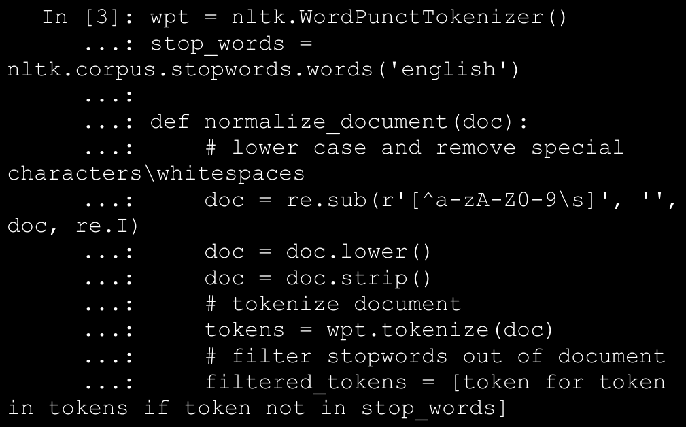

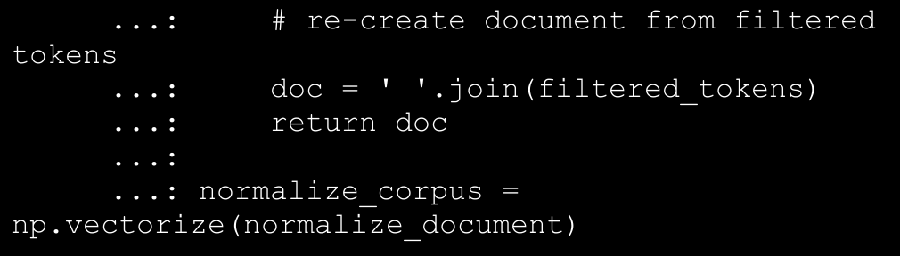

→ The np.vectorize(...) function helps us run the same function

over all elements of a numpy array instead of writing a loop. We will now use this function to pre-process our text corpus.

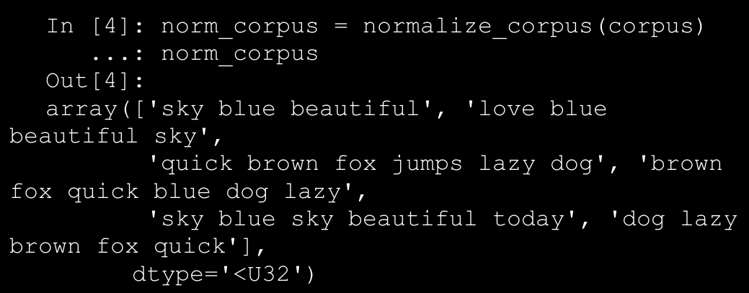

→ You can compare each text document with its original form in our initial dataframe. You will see that each document is in the lower case, special symbols have been removed and stopwords (words which carry little meaning like articles, pronouns, etc.) have been removed. We can now engineer features from this pre-processed corpus.

1. Bag of Words Model

→ This is perhaps one of the simplest yet effective schemes of vectorizing features from unstructured text. The core principle of this model is to convert text documents into numeric vectors. The dimension or size of each vector is N where N indicates all possible distinct words across the corpus of documents. Each document once transformed is a numeric vector of size N where the values or weights in the vector indicate the frequency of each word in that specific document. The following code helps us vectorize the text corpus into numeric feature vectors.

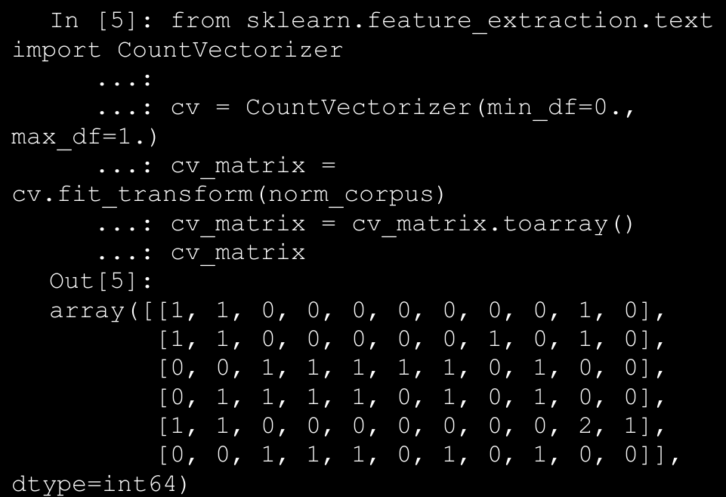

→ The output represents a numeric term frequency based feature vector for each document like we mentioned before. To understand it better, we can represent it using the feature names and view it as a dataframe.

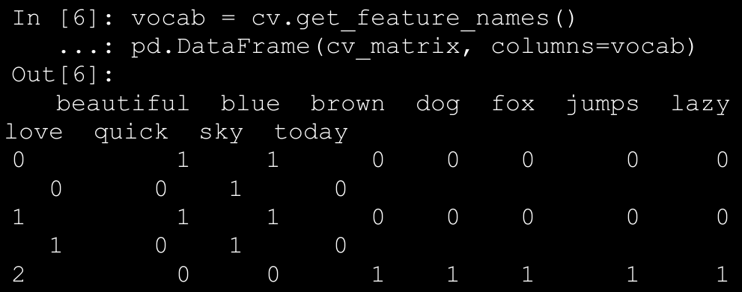

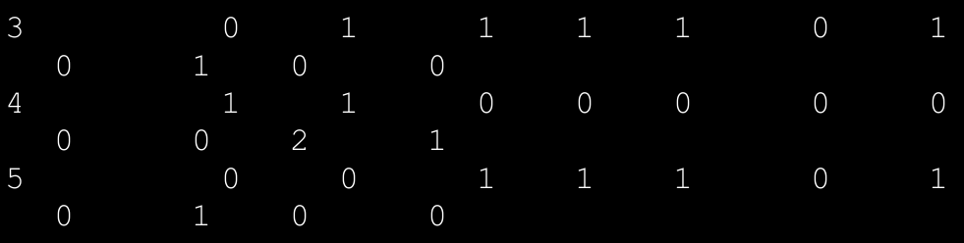

→ We can clearly see now that each row of the data frame depicts the term frequency vector for each text document. Hence the name bag of words because this model represents unstructured text into a bag of words without taking into account word positions, syntax, or semantics.

1. Bag of N-Grams Model

→ We have used single word terms as features in the above mentioned bag of words model. But what if we also wanted to take into account phrases or collection of words which occur in a sequence? N-grams help us achieve that. An n-gram is basically a collection of word tokens from a text document such that these tokens are contiguous and occur in a sequence.

→ Bi-grams indicate n-grams of order 2 (two words), Tri-grams indicate n-grams of order 3 (three words), and so on. We can easily extend the bag of words model to use a bag of n-grams model to give us n-gram based feature vectors. The following code computes bi-gram based features on our corpus.

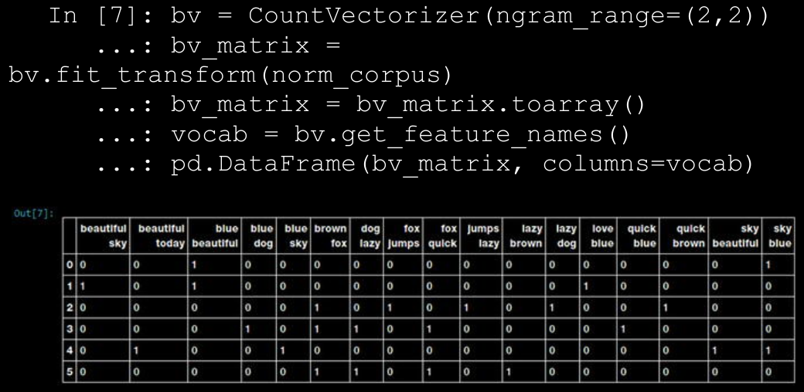

→ Figure above clearly shows our bi-gram feature vectors where each feature is a bi-gram of two contiguous words and the values depict the frequency of that bi-gram in each document. You can use the

ngram_range parameter to extend the n-gram range to get n-grams of higher orders. Typically n-grams until order three are sufficient for most tasks in Machine Learning and natural language processing.

1. TF-IDF Model

→ There are some potential problems which might arise with the Bag of Words model when it is used on large corpora. Since the feature vectors are based on absolute term frequencies, there might be some terms which occur frequently across all documents and these will tend to overshadow other terms in the feature set. The TF-IDF model tries to combat this issue by using a scaling or normalizing factor in its computation.

→ TF-IDF stands for Term Frequency-Inverse Document Frequency, which uses a combination of two metrics in its computation, namely: term frequency (tf) and inverse document frequency (idf). This technique was developed for ranking results

for queries in search engines and now it is an indispensable model in the world of information retrieval and text analytics.

→ Mathematically, we can define TF-IDF as tfidf = tf x idf, which can be expanded further to be represented as follows.

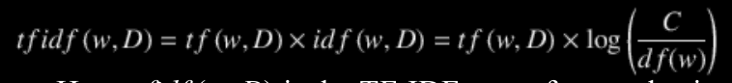

→ Here, tfidf (w, D) is the TF-IDF score for word w in document D. The term tf (w, D) represents the term frequency of the word w in document D, which can be obtained from the Bag of Words model. The term idf (w, D) is the inverse document frequency for the term w, which can be computed as the log transform of the total number of documents in the corpus C divided by the document frequency of the word w, which is basically the frequency of documents in the corpus where the word w occurs. The following code depicts TF-IDF based feature engineering on our corpus.

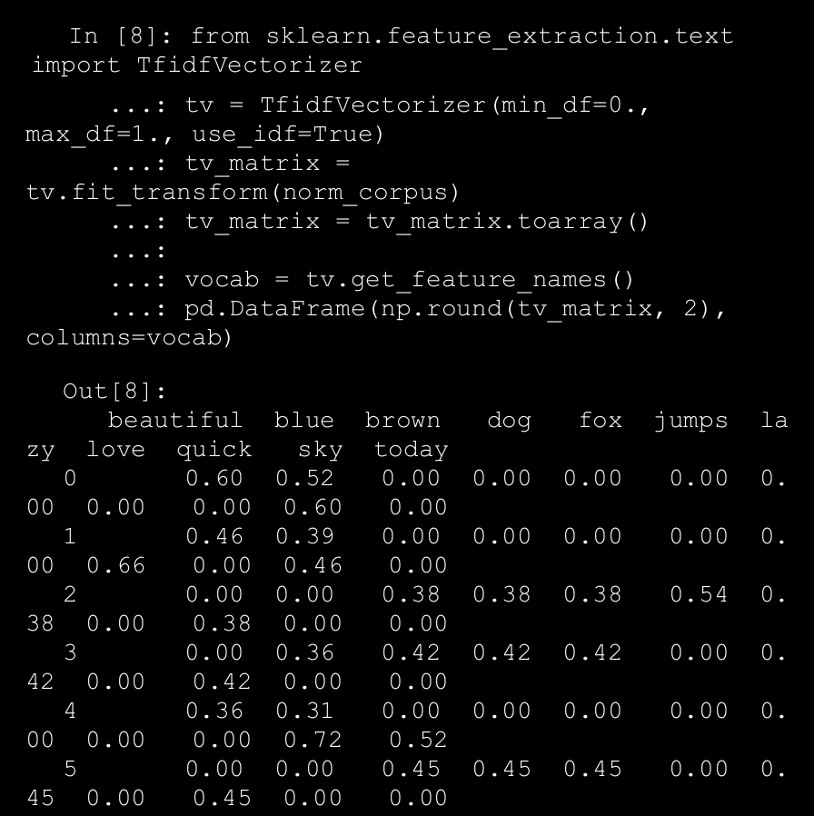

→ Thus, the preceding output depicts the TF-IDF based feature vectors for each of our text documents. Notice how this is a scaled and normalized version as compared to the raw Bag of Words model.

1. **Document Similarity**

→ You can even build on top of the tf-idf based features we engineered in the previous section and use them to generate new features which can be useful in multiple applications. An example of this is computing document similarity. This is very useful in domains like search engines, document clustering, and information retrieval. Document similarity is the process of using a distance or similarity based metric that can be used to identify how similar a text document is with another document based on features extracted from the documents like bag of words or tf-idf. → Pairwise document similarity in a corpus involves computing document similarity for each pair of documents in a corpus. Thus if you have C documents in a corpus, you would end up with a C x C matrix such that each row and column represents the similarity score for a pair of documents, which represent the indices at the row and column, respectively. There are several similarity and distance metrics that are used to compute document similarity. **These include cosine distance/similarity,**

**BM25 distance, Hellinger-Bhattacharya distance, jaccard distance, and so on**.

→ In our analysis, we will be using perhaps the most popular and widely used similarity **metric, cosine similarity**. **Cosine similarity basically gives us a metric representing the cosine of the angle between the feature vector representations of two text documents**. Figure below shows some typical feature vector alignments for text documents.

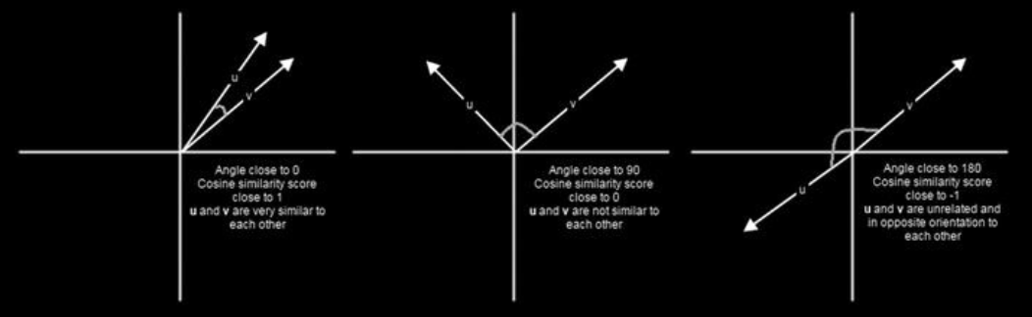

→ From Figure above, we can clearly see that feature vectors having a similar orientation will be very close to one another and the angle between them will be closer to 0° and thus cosine similarity would be cos 0° = 1 When cosine similarity is close to cos 90° = 0, the angle between the documents is closer to 90° indicating they are far apart and hence not very similar. Similarity scores close to -1 indicate the documents have completely opposite orientation as the angle between them would be closer to 180°. The following code helps us compute pairwise cosine similarity for all the documents in our sample corpus.

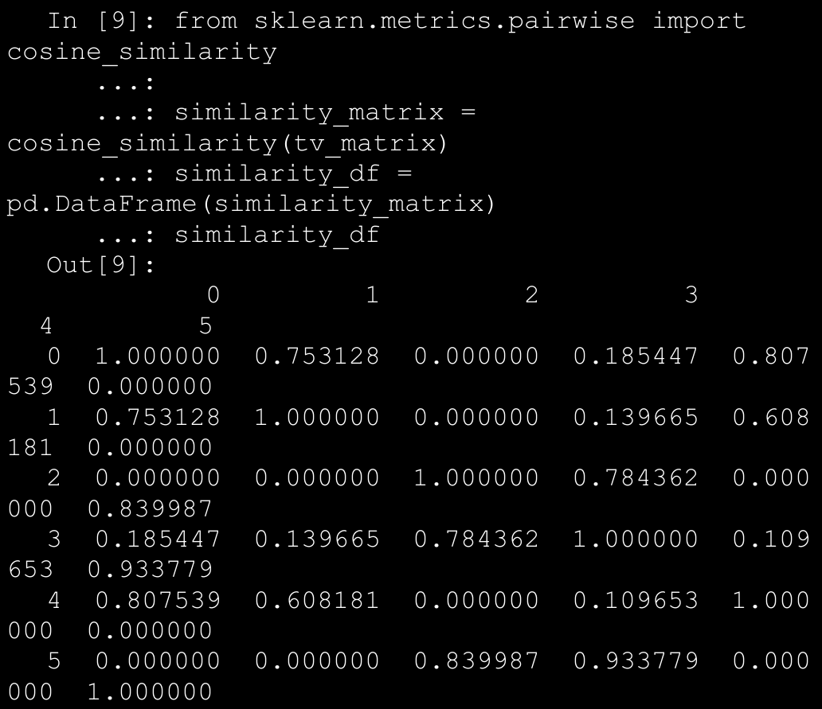

→ From the pairwise similarity matrix obtained in the preceding output, we can clearly see that documents 0, 1, and 4 have very strong similarity among one another. Also documents 2, 3, and 5 have strong similarity among themselves. This must indicate they all have some similar features. This is a perfect example of grouping or clustering that can be solved by unsupervised learning.

→ Let’s use K-means clustering to try to use the features to see if we can actually cluster or group these documents based on their feature representations. In K-means clustering, we have an input parameter k, which specifies the number of clusters it will output using the document features.

→ This clustering method is a centroid based clustering method, where it tries to cluster these documents into clusters of equal variance. It tries to create these clusters by minimizing the within-cluster sum of squares measure, also known as inertia. The following snippet builds a clustering model using our similarity features to cluster our text documents.

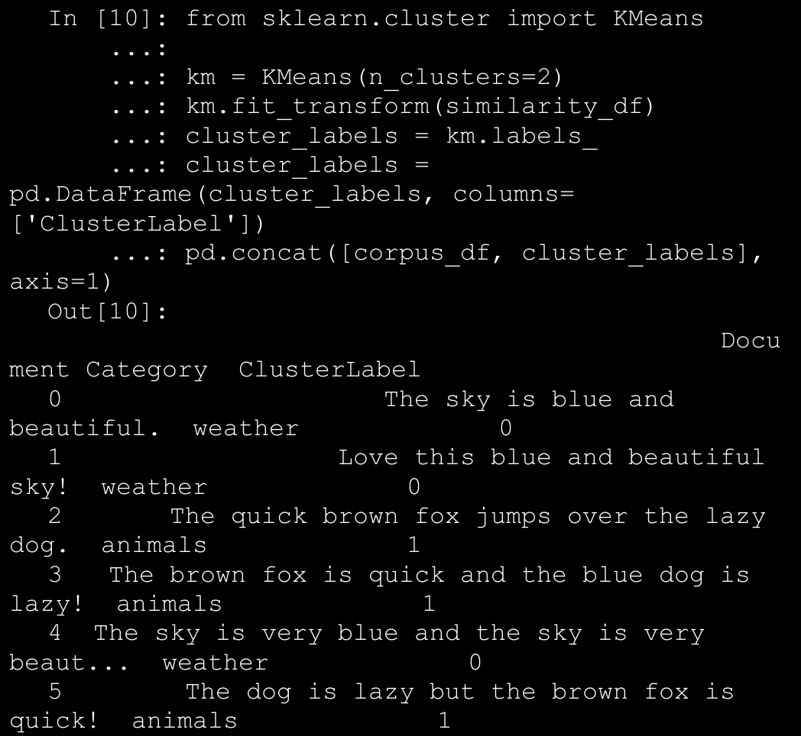

→ The output obtained clearly shows us that our K-means clustering model has labeled our documents into two clusters with labels 0 and 1. We can also see that these labels are correct where labels with value 0 indicate documents relevant to weather and labels with value 1 indicate documents relevant to animals. Thus you can see how useful these features are in document clustering and categorization!

1. Topic Models

→ Besides document terms, phrases and similarities, we can also use some summarization techniques to extract topic or concept based features from text documents. The idea of topic models revolves around the process of extracting key themes or concepts from a corpus of documents which are represented as topics. Each topic can be represented as a bag or collection of words/terms from the document corpus. Together, these terms signify a specific topic, theme or a concept and each topic can be easily distinguished from other topics by virtue of the semantic meaning conveyed by these terms.

→ These concepts can range from simple facts and statements to opinions and outlook. Topic models are extremely useful in summarizing large corpus of text documents to extract and depict key concepts. They are also useful in extracting features from text data that capture latent patterns in the data.

→ There are various techniques for topic modeling and most of them involve some form of matrix decomposition. Some techniques like Laten Semantic Indexing (LSI) use matrix decomposition operations, more specifically Singular Valued Decomposition, to split a term-document matrix (transpose of our TF-IDF document-term feature matrix) into three matrices, U, S & V T . You can use the left singular vectors in matrix U an multiply it by the singular vectors S to get terms and their weights (signifying importance) per topic. You can use scikit-learn or gensim to use LSI based topic modeling.

→ Another technique is Latent Dirichlet Allocation (LDA) , which uses a generative probabilistic model where each document consists of a combination of several topics and each term or word can be assigned to a specific topic. This is similar to pLSI based model (probabilistic LSI). Each latent topic contains a Dirichlet prior over them in the case of LDA. The math behind this is pretty involving and it would not be possible to go into details in the current scope.

→ For the purpose of feature engineering, you need to remember that when LDA is applied on a document-term matrix (TF-IDF feature matrix), it gets decomposed into two main components. A document-topic matrix, which would be the feature matrix we are looking for and a topic-term matrix, which helps us in looking at potential topics in the corpus. The following code builds an LDA model to extract features and topics from our sample corpus.

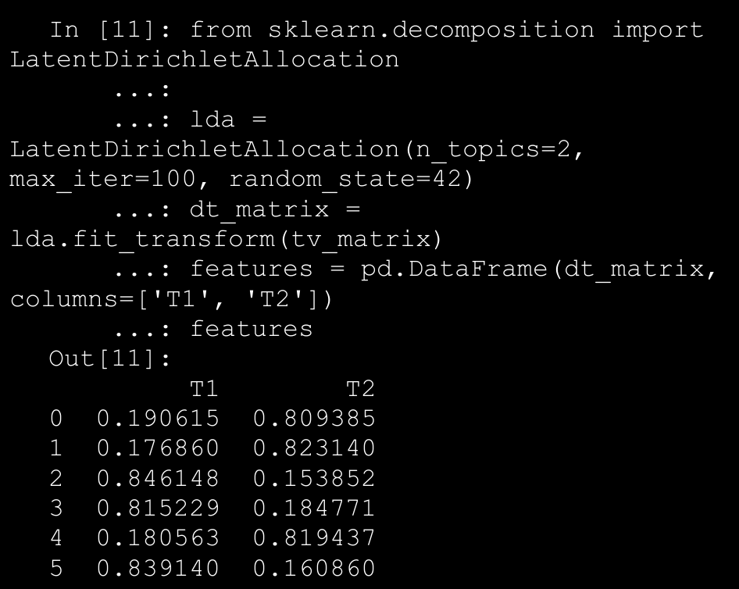

→ Thus, the dt_matrix refers to the document-topic matrix giving us two features since we chose number of topics to be 2. You can also use the other matrix obtained from the decomposition, the topic-term matrix to see the topics extracted from our corpus using the LDA model using the following code.

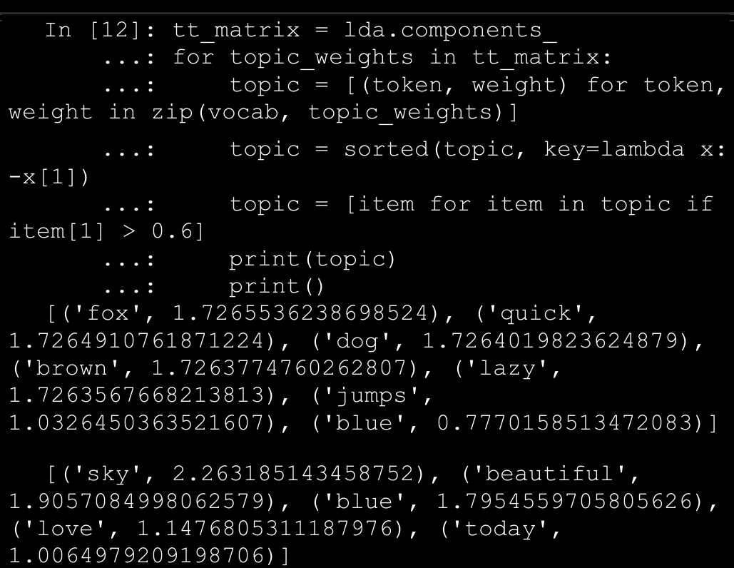

→ The preceding output represents each of the two topics as a collection of terms and their importance is depicted by the corresponding weight . It is definitely interesting to see that the two topics are quite distinguishable from each other by looking at the terms. The first topic shows terms relevant to animals and the second topic shows terms relevant to weather. This is reinforced by applying our unsupervised K-means clustering algorithm on our document-topic feature matrix (dt_matrix) using the following code snippet.

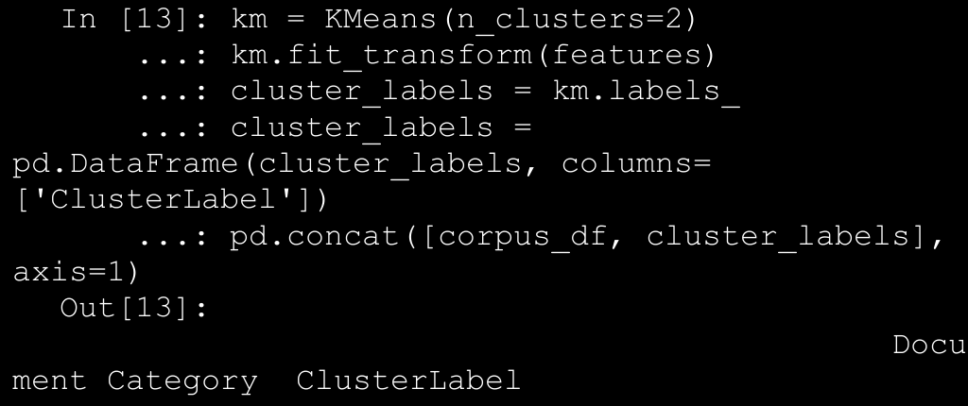

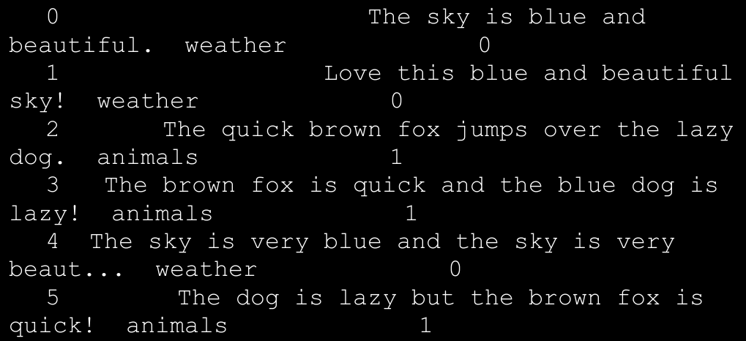

1. Word Embeddings

→ There are several advanced word vectorization models that have recently gained a lot of prominence. Almost all of them deal with the concept of word embeddings.

→ Basically, word embeddings can be used for feature extraction and language modeling. This representation tries to map each word or phrase into a complete numeric vector such that semantically similar words or terms tend to occur closer to each other and these can be quantified using these embeddings.

→ The word2vec model is perhaps one of the most popular neural network based probabilistic language models and can be used to learn distributed representational vectors for words. Word embeddings produced by **word2vec** involve taking in a corpus of text documents, representing words in a large high dimensional vector space such that each word has a corresponding vector in that space and similar words (even semantically) are located close to one another, analogous to what we observed in document similarity earlier.

→ The word2vec model was released by Google in 2013 and uses a neural network based implementation with architectures like continuous Bag of Words and Skip-Grams to learn the distributed vector representations of words in a corpus. We will be using the gensim framework to implement the same model on our corpus to extract features.Some of the important parameters in the model are explained briefly as follows.

* 1. **size**: Represents the feature vector size for each word in the corpus when transformed.
  2. **window**: Sets the context window size specifying the length of the window of words to be taken into account as belonging to a single, similar context when training.
  3. **min_count**: Specifies the minimum word frequency value needed across the corpus to consider the word as a part of the final vocabulary during training the model.
  4. **sample**: Used to downsample the effects of words which occur very frequently.

→ The following snippet builds a word2vec embedding model on the documents of our sample corpus. Remember to tokenize each document before passing it to the model.

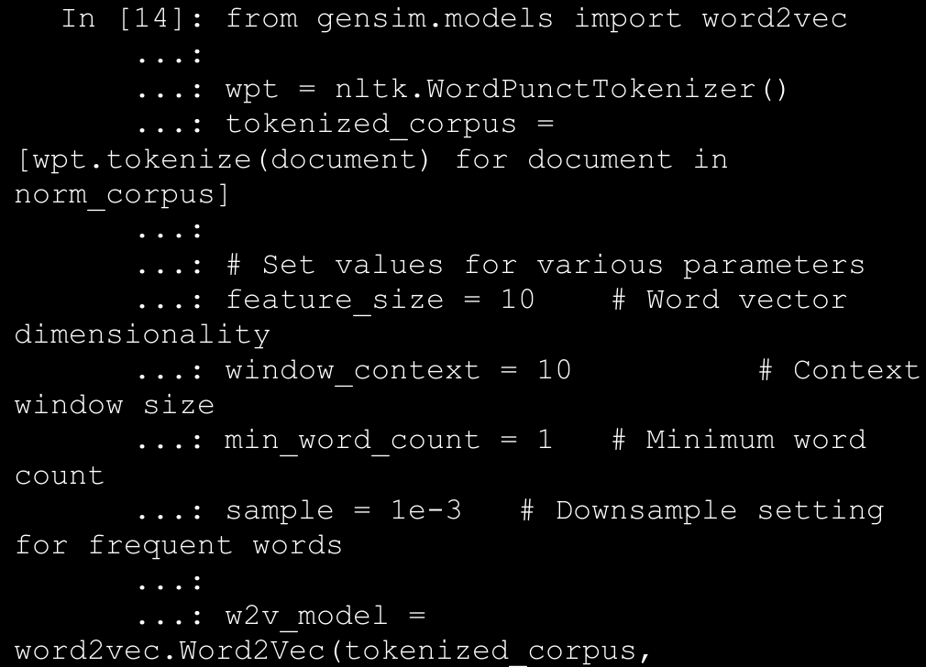

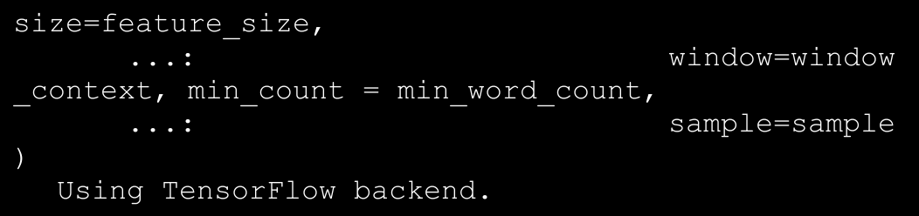

→ Each word in the corpus will essentially now be a vector itself of size 10. We can verify the same using the following code.

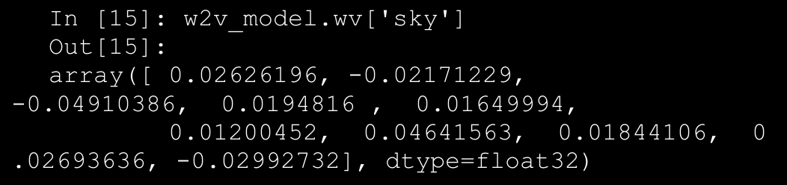

→ A question might arise in your mind now that so far, we had feature vectors for each complete document, but now we have vectors for each word. How on earth do we represent entire documents now? We can do that using various aggregation and combinations. A simple scheme would be to use an averaged word vector representation, where we simply sum all the word vectors occurring in a document and then divide by the count of word vectors to represent an averaged word vector for the document. The following code enables us to do the same.

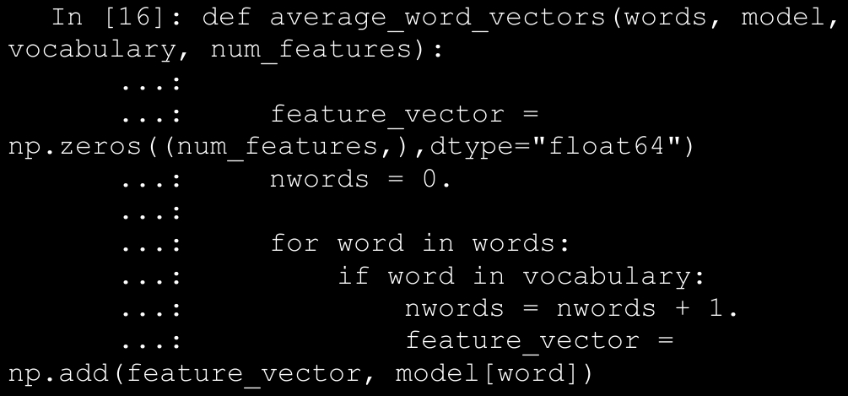

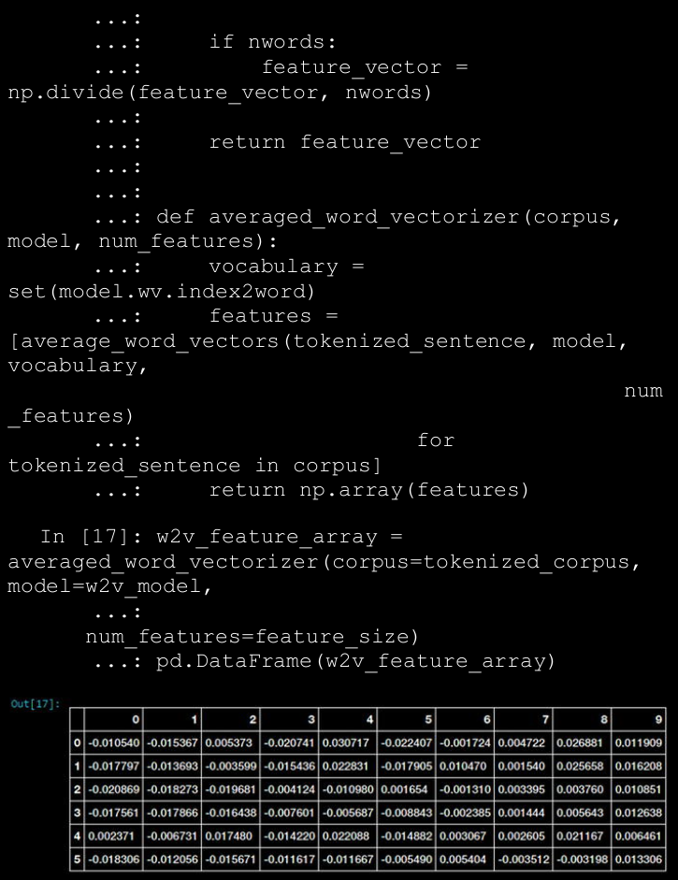

→ Thus, we have our averaged word vector based feature set for all our corpus documents, as depicted by the dataframe in Figure above. Let’s use a different clustering algorithm this time known as Affinity Propagation to try to cluster our documents based on these new features. Affinity Propagation is based on the concept of message passing and you do not need to specify the number of clusters beforehand like you did in K-means clustering.

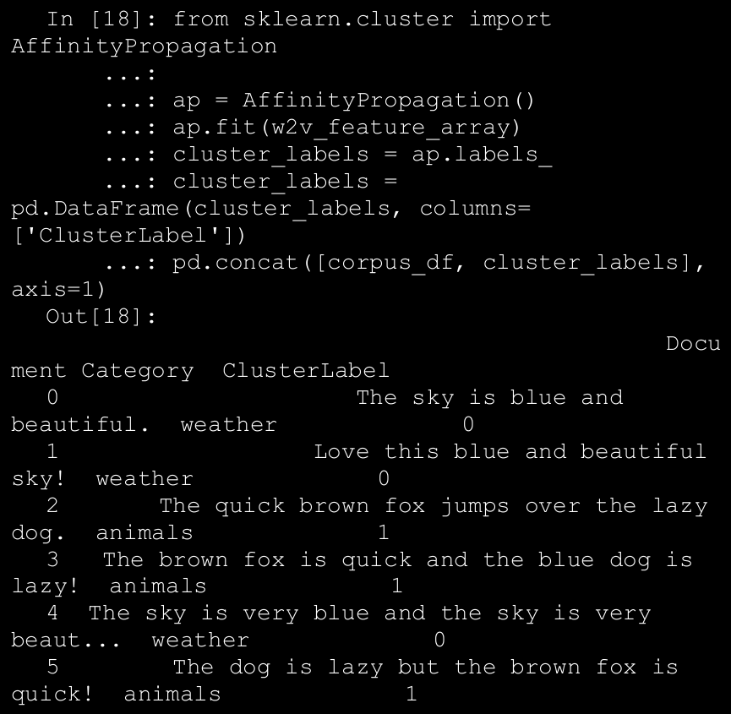

→ We can see that we have a total of six documents, where three of them are relevant to weather and the other three talk about animals as depicted by the Category class label.

1. Date-Based Features

→ Each temporal value has a date component that can be used to extract useful information and features pertaining to the date. These include features and components like year, month, day, quarter, day of the week, day name, day and week of the year, and many more. The following code depicts how we can obtain some of these features from our temporal data.

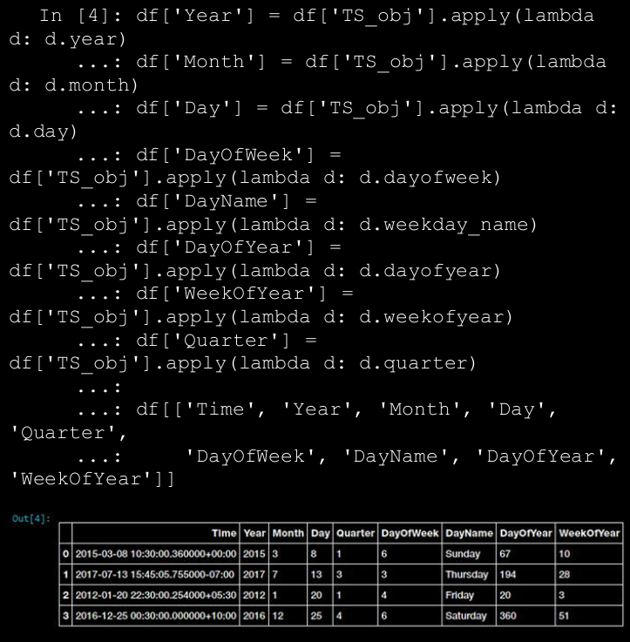

→ The features depicted in figure above show some of the attributes we talked about earlier and have been derived purely from the date segment of each temporal value. Each of these features can be used as categorical features and further feature engineering can be done like one hot encoding, aggregations, binning, and more.

1. Time-Based Features

→ Each temporal value also has a time component that can be used to extract useful information and features pertaining to the time. These include attributes like hour, minute, second, microsecond, UTC offset, and more. The following code snippet extracts some of the previously mentioned time-based features from our temporal data.

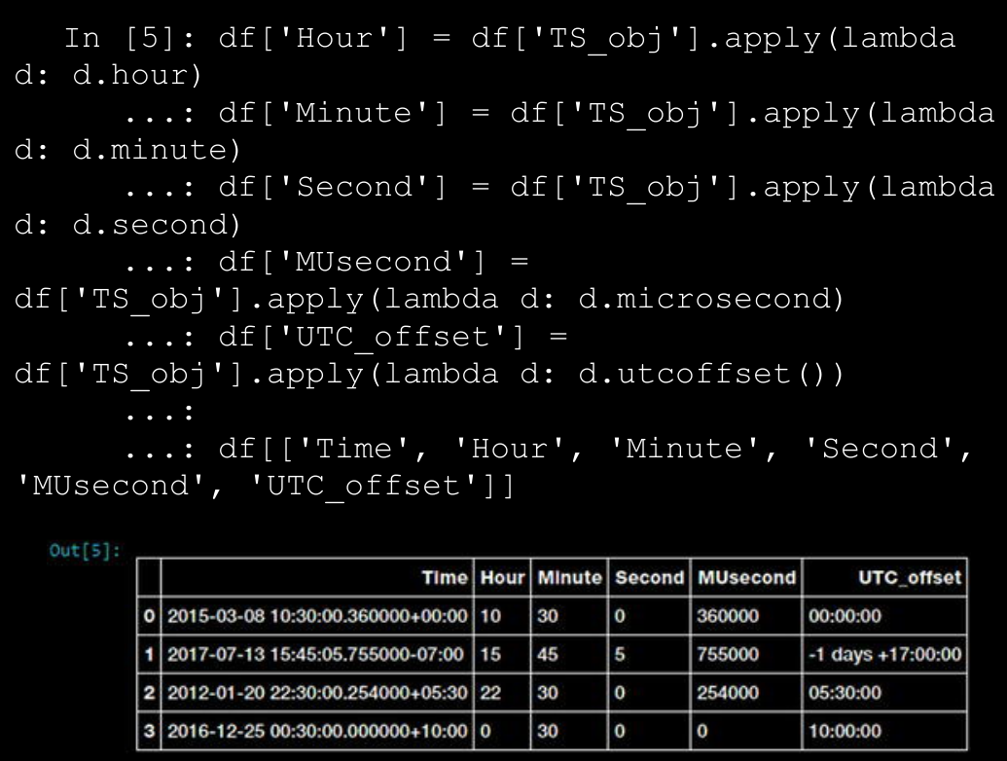

→ The features depicted in figure above show some of the attributes we talked about earlier which have been derived purely from the time segment of each temporal value. We can further engineer these features based on categorical feature engineering techniques and even derive other features like extracting time zones. Let’s try to use binning to bin each temporal value into a specific time of the day by leveraging the Hour feature we just obtained.

1. Feature Engineering on Image Data

→ Another very popular format of unstructured data is images. Sound and visual data in the form of images, video, and audio are very popular sources of data which pose a lot of challenge to data scientists in terms of processing, storage, feature extraction and modeling. However their benefits as sources of data are quite rewarding especially in the field of artificial intelligence and computer vision.

→ Due to the unstructured nature of data, it is not possible to directly use images for training models. If you are given a raw image , you might have a hard time trying to think of ways to represent it so that any Machine Learning algorithm can utilize it for model training. There are various strategies and techniques that can be used in this case to engineer the right features from images. One of the core principles to remember when dealing with images is that any image can be represented as a matrix of numeric pixel values.

→ With that thought in mind, let’s get started! You can load feature_engineering_image.py directly and start running the examples or use the jupyter notebook, Feature Engineering on Image Data.ipynb, for a more interactive experience. Let’s start by loading the necessary dependencies and configuration settings.

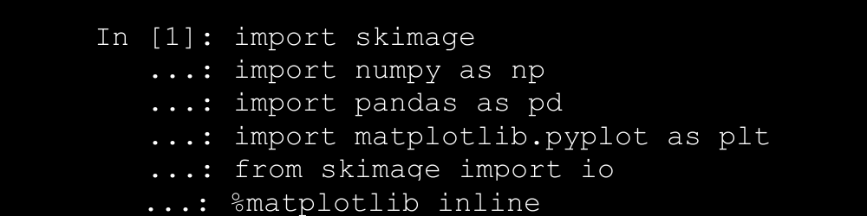

→ The scikit-image (skimage) library is an excellent framework

consisting of several useful interfaces and algorithms for image processing and feature extraction. Besides this, we will also leverage the mahotas framework, which is useful in computer vision and image processing. OpenCV is another useful framework that you can check out if interested in aspects pertaining to computer vision. Let’s now look at ways to represent images as useful feature vector representations.

1. Raw Image and Channel Pixels

→ An image can be represented by the value of each of its pixels as a two dimensional array. We can leverage numpy arrays for this. However, colorimages usually have three components also known as channels. The R, G, and B channels stand for the red, green, and blue channels, respectively. This can be represented as a three dimensional array (m, n, c) where m indicates the number of rows in the image, n indicates the number of columns. These are determined by the image dimensions. The c indicates which channel it represents (R, G or B). Let’s load some sample color images now and try to understand their representation.

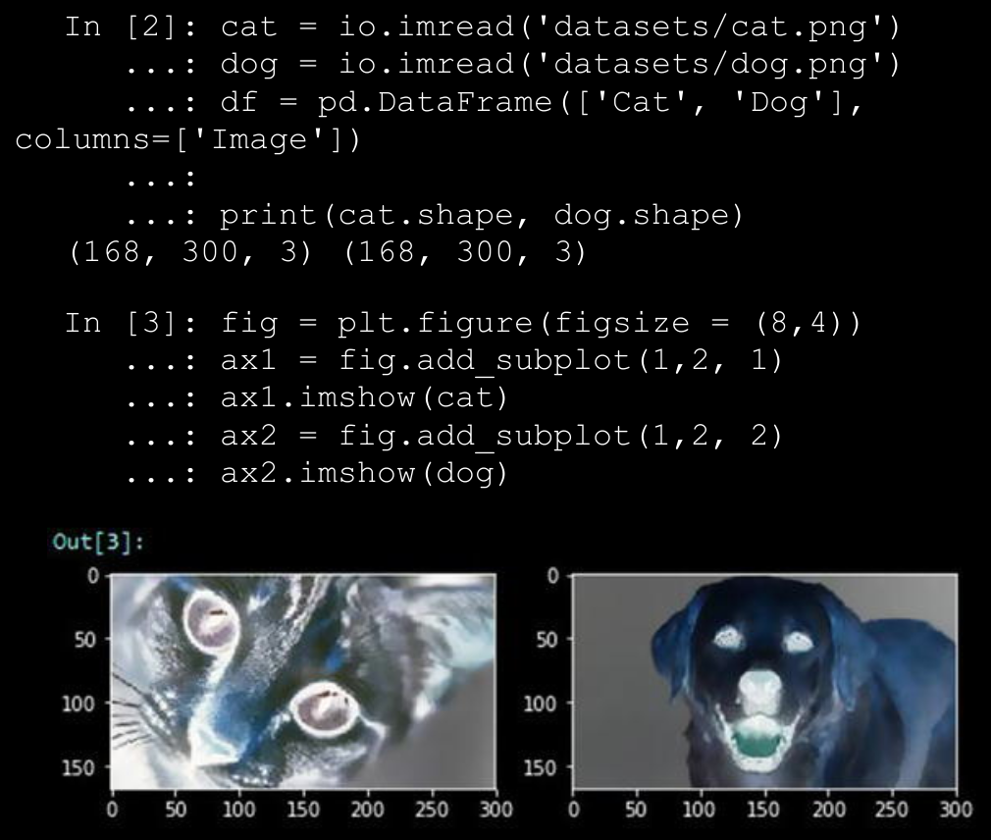

→We can clearly see from figure above that we have two images of a cat and a dog having dimensions 168x300 pixels where each row and column denotes a specific pixel of the image. The third dimension indicates these are color images having three color channels. Let’s now try to use numpyindexing to slice out and extract the three color channels separately for the dog image.

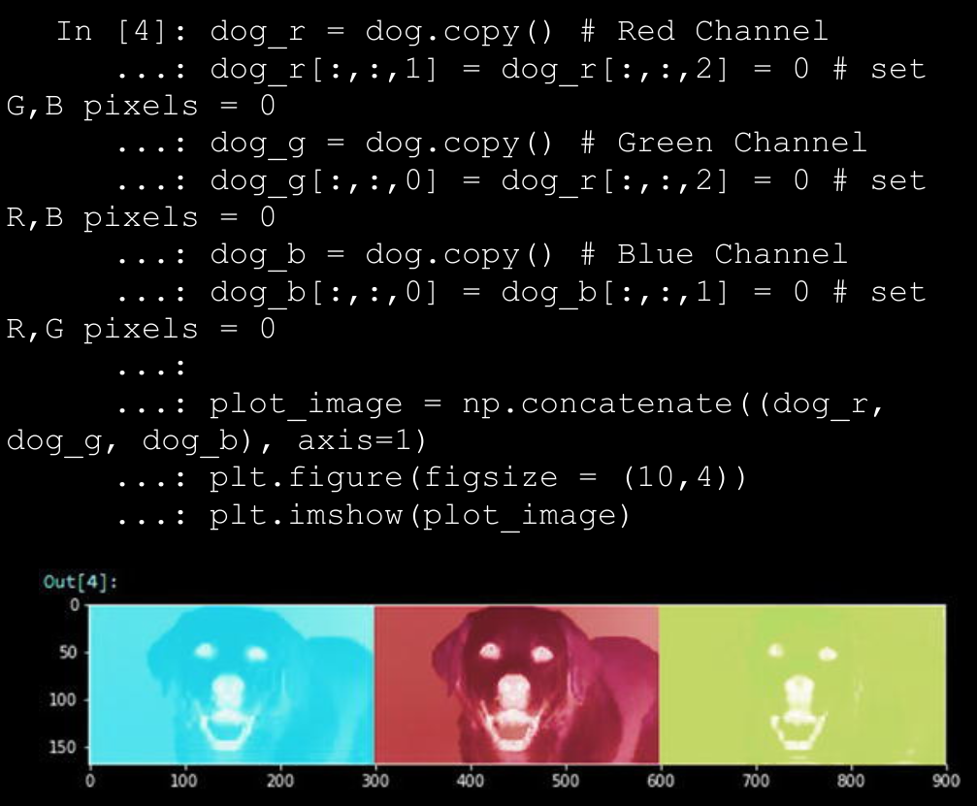

→ We can clearly see from figure above how we can easily use numpy indexing and extract out the three color channels from the sample image. You can now refer to any of these channel’s raw image pixel matrix and even flatten it if needed to form a feature vector.

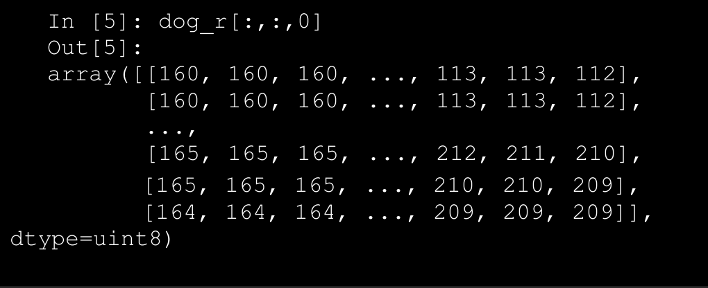

→ This image pixel matrix is a two-dimensional matrix so you can extract features from this further or even flatten it to a one-dimensional vector to use as inputs for any Machine Learning algorithm.

1. Grayscale Image Pixels

→ If you are dealing with color images, it might get difficult working with multiple channels and three-dimensional arrays. Hence converting images to grayscale is a nice way of keeping the necessary pixel intensity values but getting an easy to process two-dimensional image. Grayscale images usually capture the luminance or intensity of each pixel such that each pixel value can be computed using the equation



→ Where R, G & B are the pixel values of the three channels and Y captures the final pixel intensity information and is usually ranges from 0(complete intensity absence - black) to 1(complete intensity presence - white). The following snippet shows us how to convert RGB color images to grayscale and extract the raw pixel values, which can be used as features.

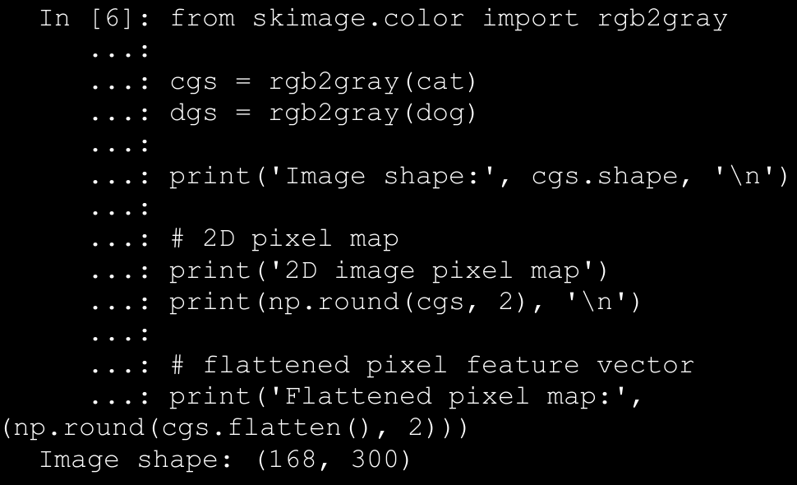

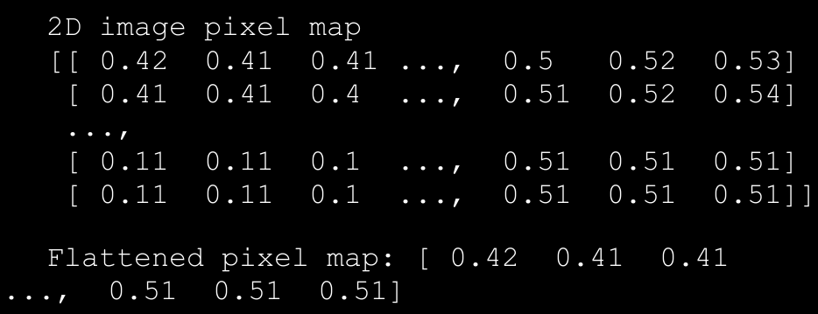

1. Edge Detection

→ One of the more interesting and sophisticated techniques involve detecting edges in an image. Edge detection algorithms can be used to detect sharp intensity and brightness changes in an image and find areas of interest. The canny edge detector algorithm developed by John Canny is one of the most widely used edge detector algorithms today.

→ This algorithm typically involves using a Gaussian distribution with a specific standard deviation σ (sigma) to smoothen and denoise the image. Then we apply a Sobel filter to extract image intensity gradients. Norm value of this gradient is used to determine the edge strength. Potential edges are thinned down to curves with width of 1 pixel and hysteresis based thresholding is used to label all points above a specific high threshold as edges and then recursively use the low threshold value to label points above the low threshold as edges connected to any of the previously labeled points. The following code applied the canny edge detector to our sample images.

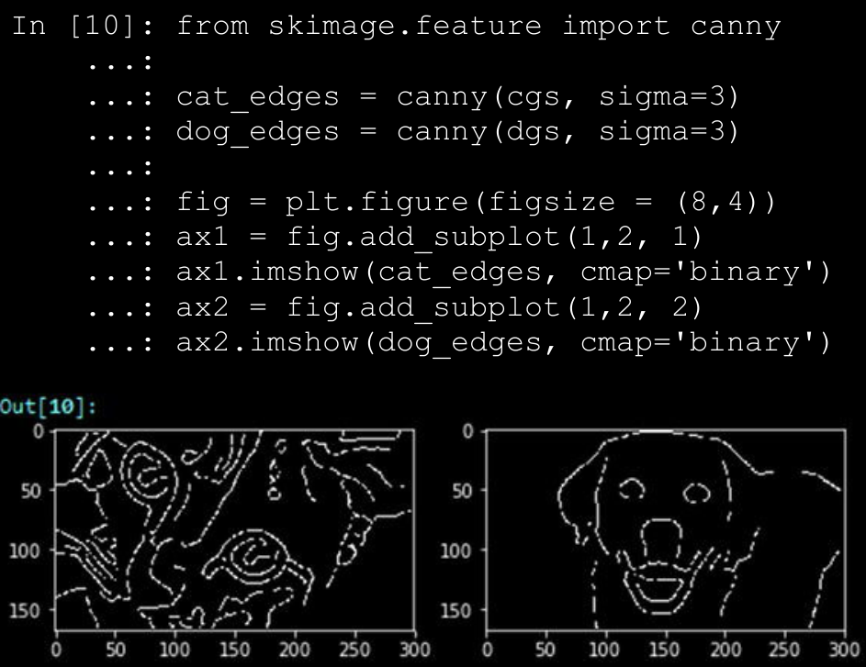

→ The image plots based on the edge feature arrays depicted in figure above clearly show the prominent edges of our cat and dog. You can use these edge feature arrays (cat_edges and dog_edges) by flattening them, extracting pixel values and positions pertaining to the edges (non-zero values), or even by aggregating them like finding out the total number of pixels making edges, mean value, and so on.

1. Object Detection

→ Another interesting technique in the world of computer vision is object detection where features useful in highlighting specific objects in the image are detected and extracted. The histogram of oriented gradients , also known as HOG, is one of the techniques that’s extensively used in object detection.

→ Going into the details of this technique would not be possible in the current scope but for the process of feature engineering, you need to remember that the HOG algorithm works by following a sequence of steps similar to edge detection. The image is normalized and denoised to remove excess illumination effects. First order image gradients are computed to capture image attributes like contour, texture, and so on. Gradient histograms are built on top of these gradients based on specific windows called cells.

→ Finally these cells are normalized and a flattened feature descriptor is obtained, which can be used as a feature vector for our models. The following code shows the HOG object detection technique on our sample images.

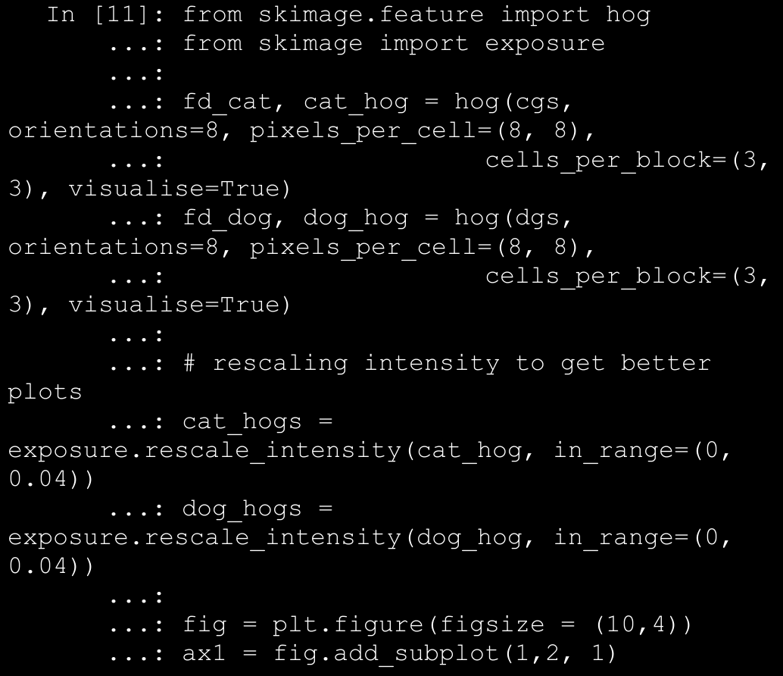

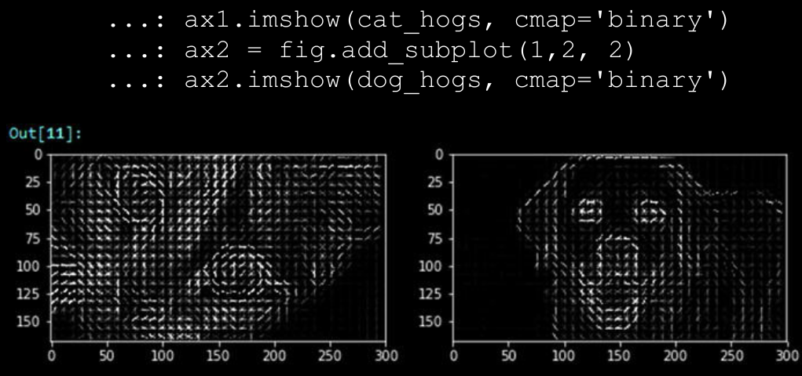

→ The image plots in figure above show us how the HOG detector has identified the objects in our sample images. You can also get the flattened feature descriptors as follows.

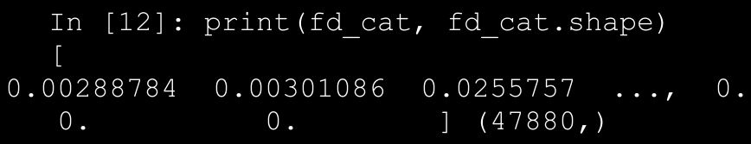

1. Localized Feature Extraction

→ We have talked about aggregating pixel values from two-dimensional image or feature matrices and also flattening them into feature vectors. Localized feature extraction based techniques are slightly better methods which try to detect and extract localized feature descriptors on various small localized regions of our input images.

→ This is hence rightly named localized feature extraction. We will be using the popular and patented SURF algorithm invented by Herbert Bay, et al. **SURF stands for Speeded Up Robust Features.**

→ The main idea is to get scale invariant local feature descriptors from images which can be used later as image features. This algorithm is similar to the popular **SIFT** algorithm.

→ There are mainly two major phases in this algorithm. The first phase is to detect points of interest using square shaped filters and hessian matrices. The second phase is to build feature descriptors by extracting localized features around these points of interest.

→ There are usually computed by taking a localized square image region around a point of interest and then aggregating Haar wavelet responses at specific interval based sample points. We use the mahotas Python framework for extracting SURF feature descriptors from our sample images.

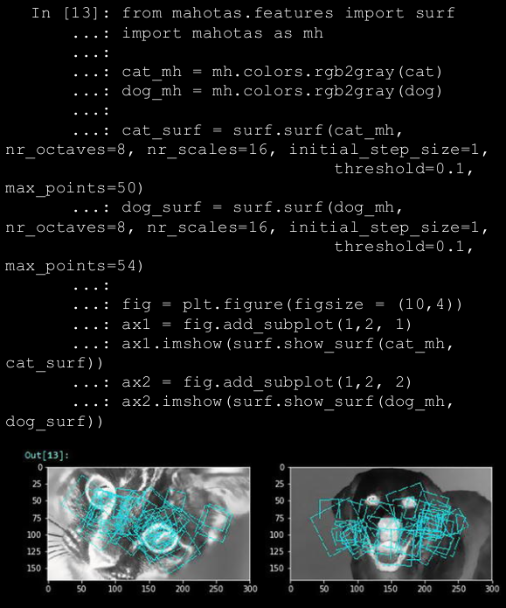

→ The square boxes in the image plots in figure above depict the square image regions around the points of interest which were used for localized feature extraction. You can also use the **surf.dense(...)** function to extract uniform dimensional feature descriptors at dense points with regular interval spacing in pixels. The following code depicts how to achieve this.

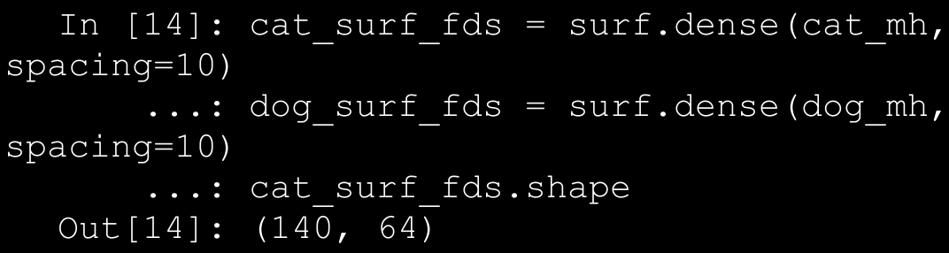

→ We see from the preceding output that we have obtained 140 feature descriptors of size 64 (elements) each. You can further apply other schemes on this like aggregation, flattening, and so on to derive further features. Another sophisticated technique that you can use to extract features on these SURF feature descriptors is to use the visual bag of words model, which we discuss in the next section.

1. Visual Bag of Words Model

→ We have seen the effectiveness of the popular Bag of Words model in extracting meaningful features from unstructured text documents. Bag of words refers to the document being broken down into its constituents, words and computing frequency of occurrences or other measures like tf-idf.

→ Similarly, in case of image raw pixel matrices or derived feature descriptors from other algorithms, we can apply a bag of words principle. We have seen the effectiveness of the popular Bag of Words model in extracting meaningful features from unstructured text documents. Bag of words refers to the document being broken down into its constituents, words and computing frequency of occurrences or other measures like tf-idf. Similarly, in case of image raw pixel matrices or derived feature descriptors from other algorithms, we can apply a bag of words principle.

→ However the constituents will not be words in this case but they will be subset of features/pixels extracted from images which are similar to each other.

→ Imagine you have multiple pictures of octopuses and you were able to extract the 140 dense surf features each having 64 values in each feature vector. You can now use an unsupervised learning algorithm like clustering to extract clusters of similar feature descriptors. Each cluster can be labeled as a visual word or a visual feature. Subsequently, each feature descriptor can be binned into one of these clusters or visual words.

→ Thus, you end up getting a one-dimensional visual bag of words vector with counts of number of feature descriptors assigned to each of the visual words for the 140x64 feature descriptor matrix. Each feature or visual word tends to capture some portion of the images that are similar to each other like octopus eyes, tentacles, suckers, and so on, as depicted in figure below.

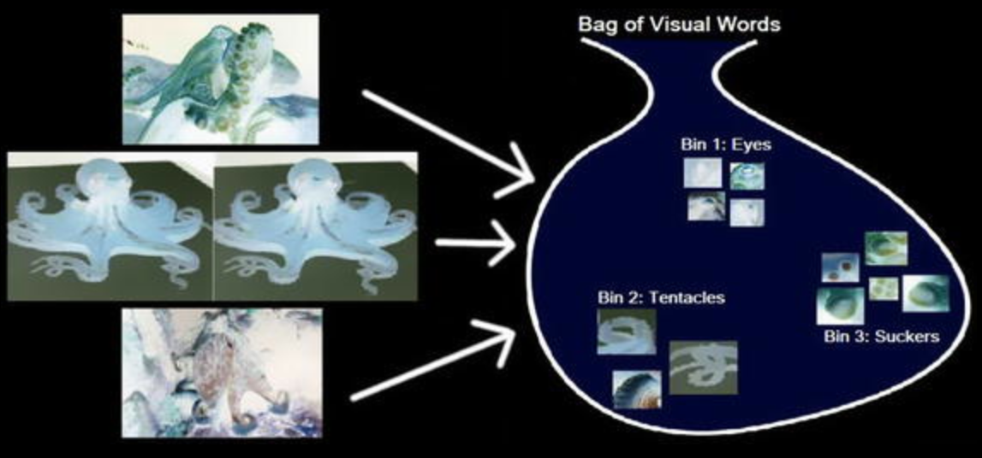

→ The basic idea is hence to get a feature descriptor matrix from using any algorithm like SURF, apply an unsupervised algorithm like K-means clustering, and extract out k bins or visual features/words and their counts (based on number of feature descriptors assigned to each bin). Then for each subsequent image, once you extract the feature descriptors, you can use the K-means model to assign each feature descriptor to one of the visual feature clusters and get a one-dimensional vector of counts. This is depicted in figure below for a sample octopus image, assuming our VBOW (Visual Bag of Words) model has three bins of eyes, tentacles, and suckers.

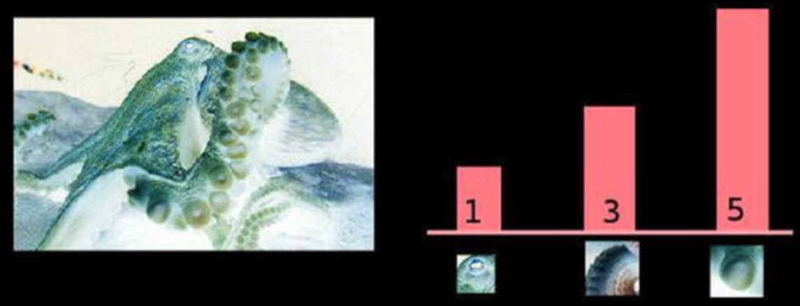

→ Thus you can see from Figure 4-33, how a two-dimensional image and its corresponding feature descriptors can be easily transformed into a one-dimensional VBOW vector [1, 3, 5].

→ We will now use our 140x64 SURF feature descriptors for our two sample images and use K-means clustering on them and compute VBOW vectors for each image by assigning each feature descriptor to one of the bins. We will take k=20 in this case. See figure below.

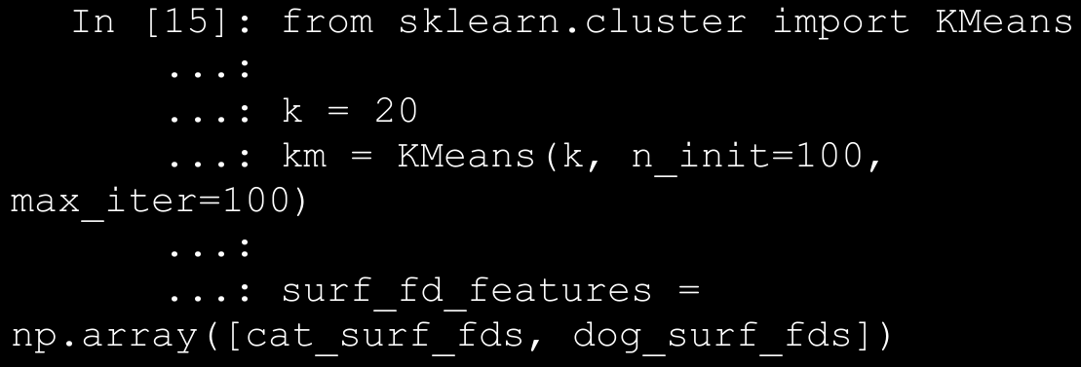

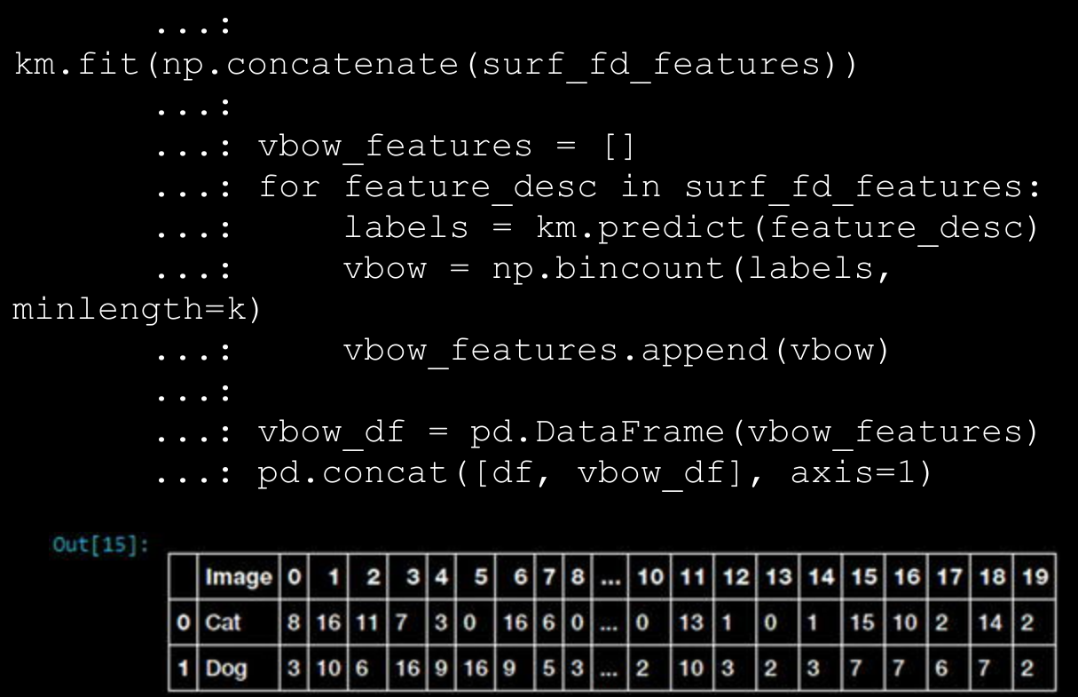

→You can see how easy it is to transform complex two-dimensional SURF feature descriptor matrices into easy to interpret VBOW vectors. Let’s now take a new image and think about how we could apply the VBOW pipeline. First we would need to extract the SURF feature descriptors from the image using the following snippet:

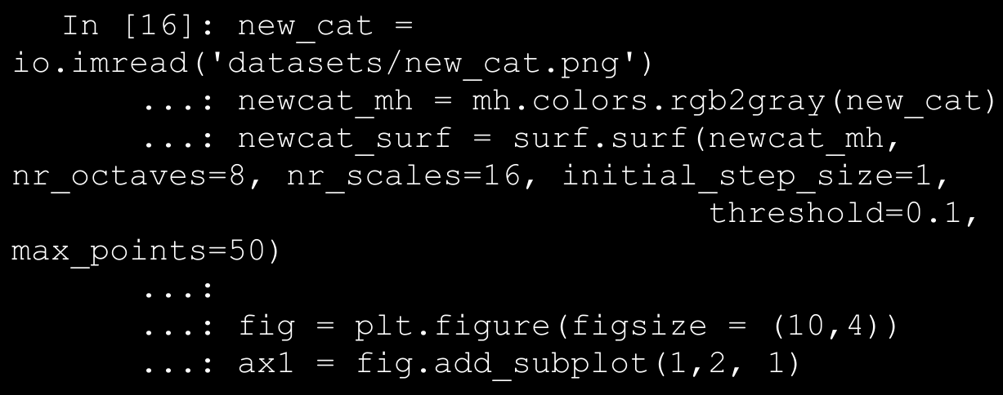

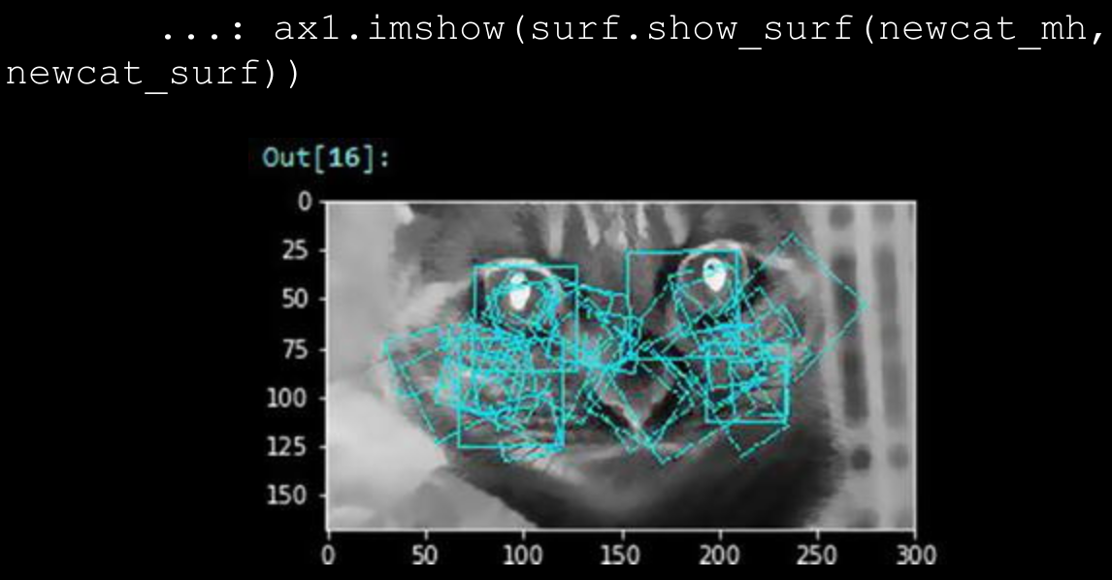

→ Let’s now extract the dense SURF features and transform them into a VBOW vector using our previously trained VBOW model. The following code helps us achieve this.

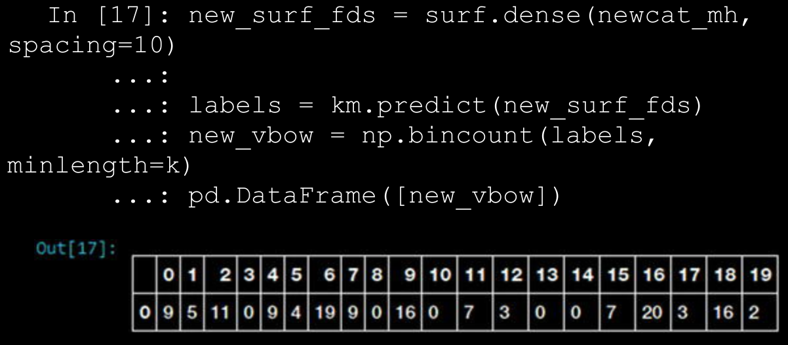

→ Thus you can see the final VBOW feature vector for the new image based on SURF feature descriptors. This is also an example of using an unsupervised Machine Learning model for feature engineering. You can now compare the similarity of this new image with the other two sample images using some similarity metrics.

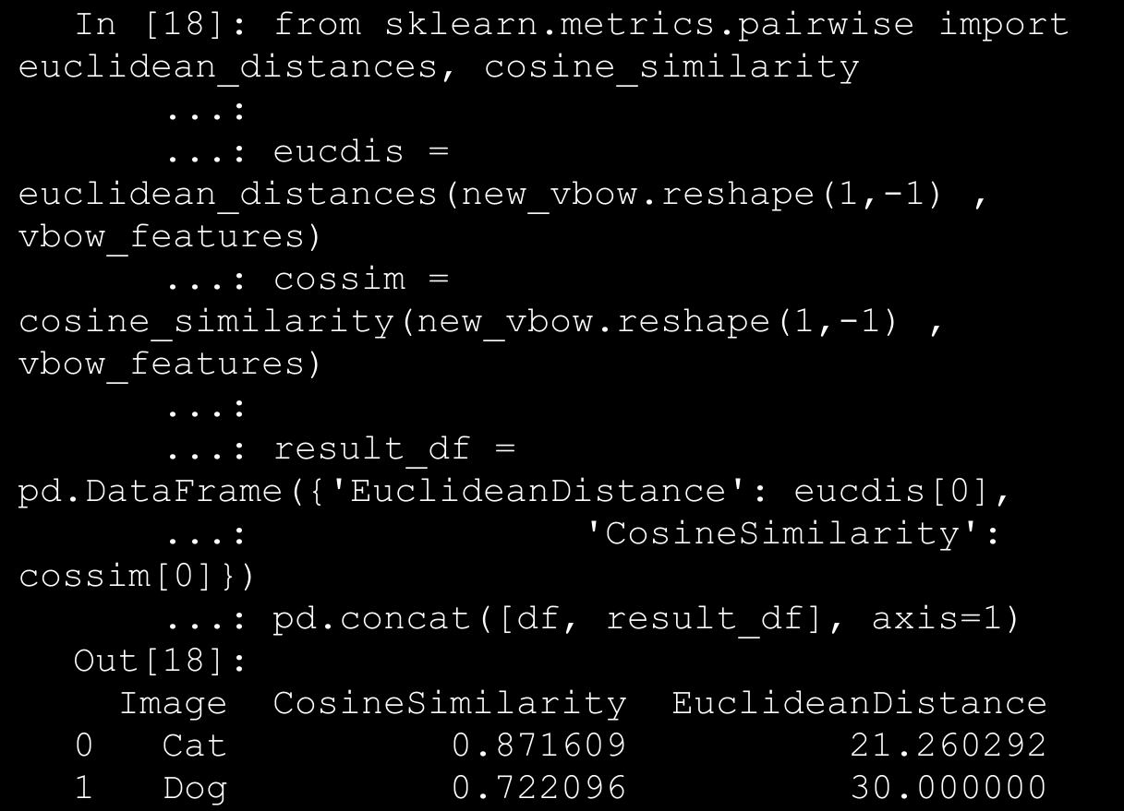

→ Based on the distance and similarity metrics, we can see that our new image (of a cat) is definitely closer to the cat image than the dog image. Try this out with a bigger dataset to get better results!

1. **Automated Feature Engineering with Deep Learning**

→ We have used a lot of simple and sophisticated feature engineering techniques so far in this section. Building complex feature engineering systems and pipelines is time consuming and building algorithms for the same is even more tasking. Deep Learning is a novel and new approach toward automating this complex task of feature engineering by making the machine extract features automatically by learning multiple layered and complex representations of the underlying raw data.

→ Convolutional neural networks or CNNs are extensively used for automated feature extraction in images. Just like we mentioned before, the idea of CNNs operate on the principles of convolution and pooling besides your regular activation function layers.

→ Convolutional layers typically slides or convolves learnable filters (also known as kernels or convolution matrix) across the entire width and height of the input image pixels. Dot products between the input pixels and the filter are computed at each position on sliding the filter. Two-dimensional activation maps for the filter get created and consequently the network is able to learn these filters when it activates on detecting specific features like edges, corners and so on. If we take n filters, we will get n separate two-dimensional activation maps, which can then be stacked along the depth dimension to get the output volume.

→ Pooling is a kind of aggregation or downsampling layer where typically a non-linear downsampling operation is inserted between convolutional layers. Filters are applied here too. They are slided along the convolution output matrix and, for each sliding operation, also known as a stride, elements in the slice of matrix covered by the pooling filter are either summed (Sum pooling) or averaged (Mean pooling) or the maximum value is selected (Max pooling). More than often max pooling works really well in several real-world scenarios. Pooling helps in reducing feature dimensionality and control model overfitting. Let’s now try to use Deep Learning for automated feature extraction on our sample images using CNNs. Load the following dependencies necessary for building deep networks.

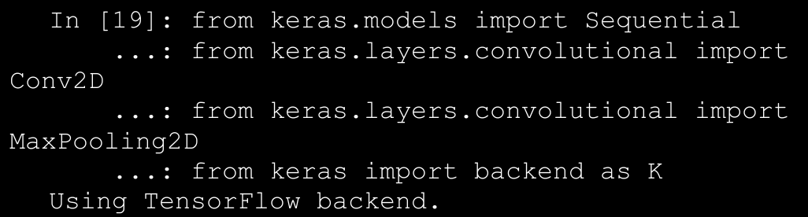

→ You can use Theano or Tensorflow as your backend Deep Learning framework for keras to work on. I am using tensorflow in this scenario. Let’s build a basic two-layer CNN now with a Max Pooling layer between them.

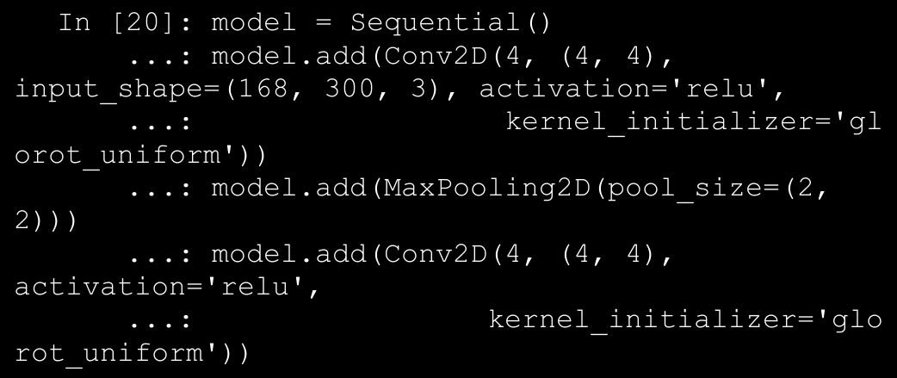

→ We can actually visualize this network architecture using the following code snippet to understand the layers that have been used in this network, in a better way.

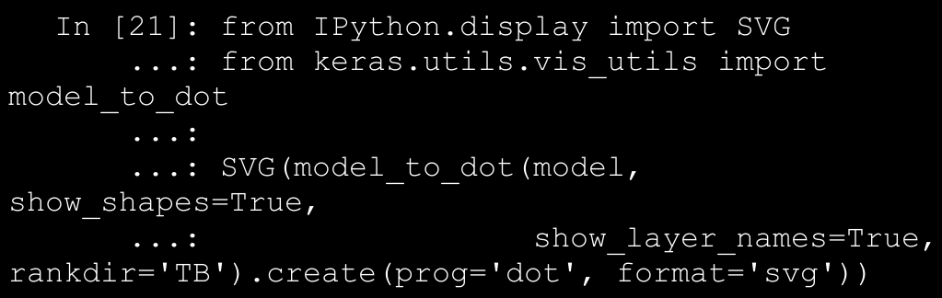

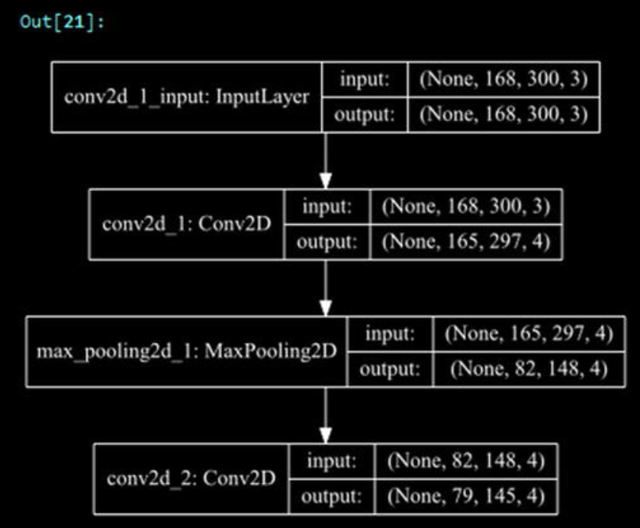

1. Evaluating Classification Models

→ Classification models are one of the most popular models among Machine Learning practitioners. Due to their popularity, it is essential to know how to build good quality, generalized models. They have a varied set of metrics that can be used to evaluate classification models. In this section, we target a small subset of those metrics that are essential. We use the models that we developed in the previous section to illustrate them in detail. For this, let’s first prepare train and test datasets to build our classification models. We will be leveraging the X and y variables from before, which holds the data and labels for the breast cancer dataset observations.

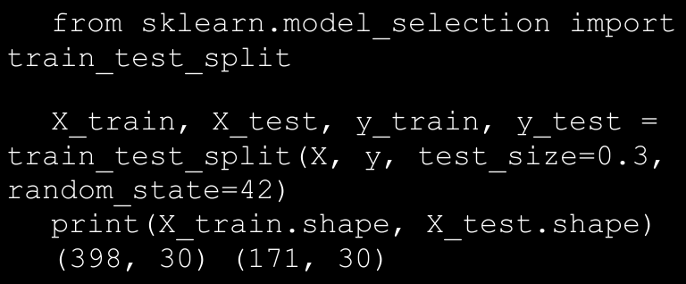

→ From the preceding output, it is clear that we have 398 observations in our train dataset and 171 observations in our test dataset.

1. PCA (Principal Component Analysis)

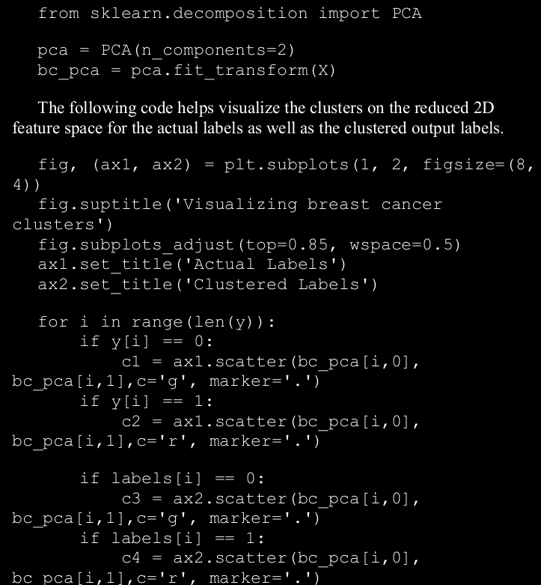

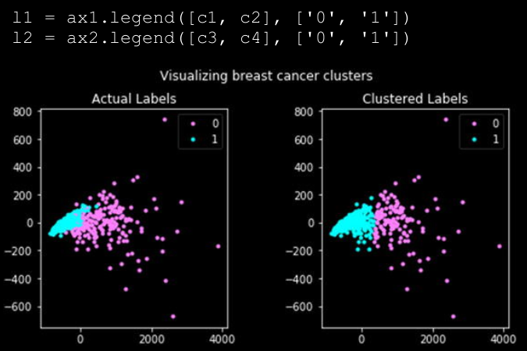

1. Confusion Matrix

→ Confusion matrix is one of the most popular ways to evaluate a classification model. Although the matrix by itself is not a metric, the matrix representation can be used to define a variety of metrics, all of which become important in some specific case or scenario. A confusion matrix can be created for a binary classification as well as a multi-class classification model.

→ A confusion matrix is created by comparing the predicted class label of a data point with its actual class label. This comparison is repeated for the whole dataset and the results of this comparison are compiled in a matrix or tabular format. This resultant matrix is our confusion matrix. Before we go any further, let’s build a logistic regression model on our breast cancer dataset and look at the confusion matrix for the model predictions on the test dataset.

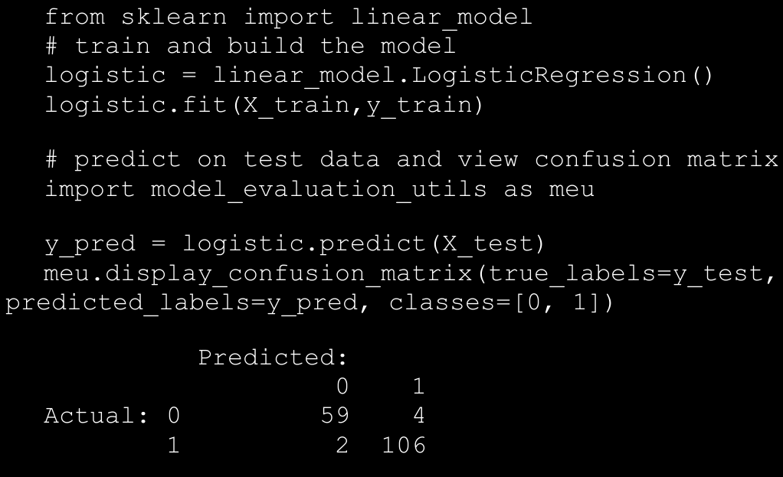

→ The preceding output depicts the confusion matrix with necessary annotations. We can see that out of 63 observations with label 0 (malignant), our model has correctly predicted 59 observations. Similarly out of 108 observations with label 1 (benign), our model has correctly predicted 106 observations. More detailed analysis is coming right up!

1. Understanding the Confusion Matrix

→ While the name itself sounds pretty overwhelming, understanding the confusion matrix is not that confusing once you have the basics right! To reiterate what you learned in the previous section, the confusion matrix is a tabular structure to keep a track of correct classifications as well as misclassifications. This is useful to evaluate the performance of a

classification model for which we know the true data labels and can compare with the predicted data labels.

→ Each column in the confusion matrix represents classified instance counts based on predictions from the model and each row of the matrix represents instance counts based on the actual\true class labels. This structure can also be reversed, i.e. predictions depicted by rows and true labels by columns. In a typical binary classification problem, we usually have a class label which defined as the positive class which is basically the class of our interest. For instance in our breast cancer dataset, let’s say we are interested in detecting or predicting when the patient does not have breast cancer (benign). Then label 1 is our positive class. However, suppose our class of interest was to detect cancer (malignant) then we could have chosen label 0 as our positive class. figure below shows a typical confusion matrix for a binary classification problem.

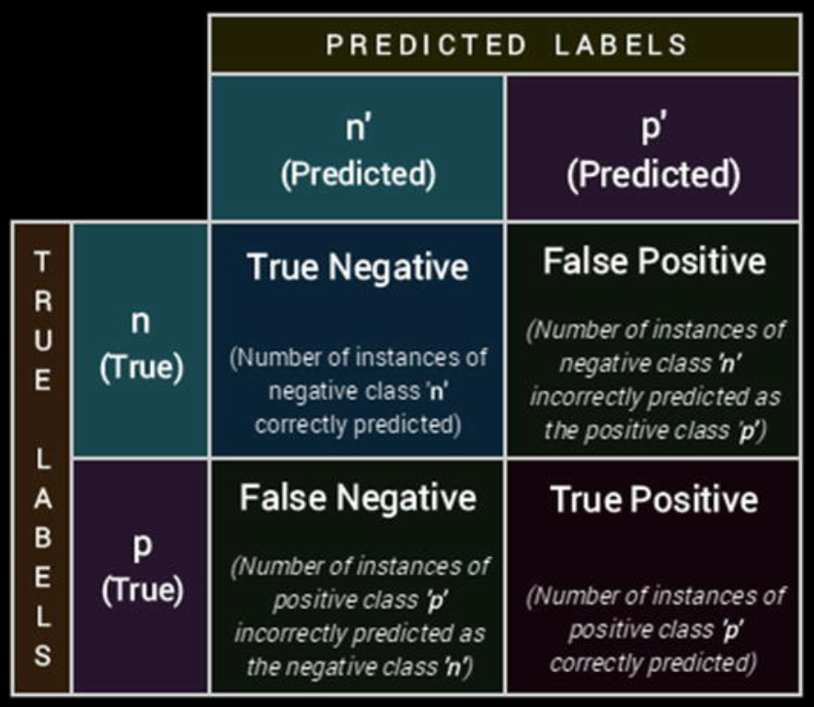

→ Thus based on this information, can you compute the previously mentioned metrics for our confusion matrix based on the model predictions on the breast cancer test data?

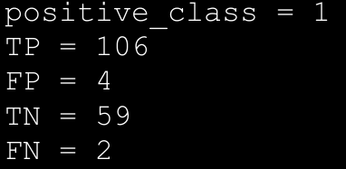

1. Performance Metrics

→ The confusion matrix by itself is not a performance measure for classification models. But it can be used to calculate several metrics that are useful measures for different scenarios. We will describe how the major metrics can be calculated from the confusion matrix, compute them manually using necessary formulae, and then compare the results with functions provided by scikit-learn on our predicted results and give an intuition of scenarios where each of those metric can be used.

* 1. **Accuracy**: This is one of the most popular measures of classifier performance. It is defined as the overall accuracy or proportion of correct predictions of the model. The formula for computing accuracy from the confusion matrix is:

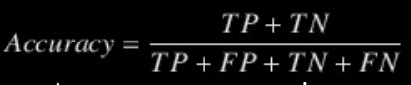

→ Accuracy measure is normally used when our classes are almost balanced and correct predictions of those classes are equally important. The following code computes accuracy on our model predictions.

* 1. **Precision**: Precision, also known as positive predictive value, is another metric that can be derived from the confusion matrix. It is defined as the number of predictions made that are actually correct or relevant out of all the predictions based on the positive class. The formula for precision is as follows:

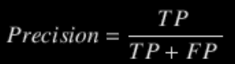

→ A model with high precision will identify a higher fraction of positive class as compared to a model with a lower precision. Precision becomes important in cases where we are more concerned about finding the maximum number of positive class even if the total accuracy reduces. The following code computes precision on our model predictions.

* 1. **Recall**: Recall, also known as sensitivity, is a measure of a model to identify the percentage of relevant data points. It is defined as the number of instances of the positive class that were correctly predicted. This is also known as hit rate, coverage, or sensitivity. The formula for recall is:

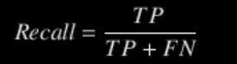

→ Recall becomes an important measure of classifier performance in scenarios where we want to catch the most number of instances of a particular class even when it increases our false positives. For example, consider the case of bank fraud, a model with high recall will give us higher number of potential fraud cases. But it will also help us raise alarm for most of the suspicious cases.

1. Bias-variance trade-off

→ An effective way to get a clearer idea at this somewhat confusing concept is through a visual representation of bias and variance, as depicted in figure below:

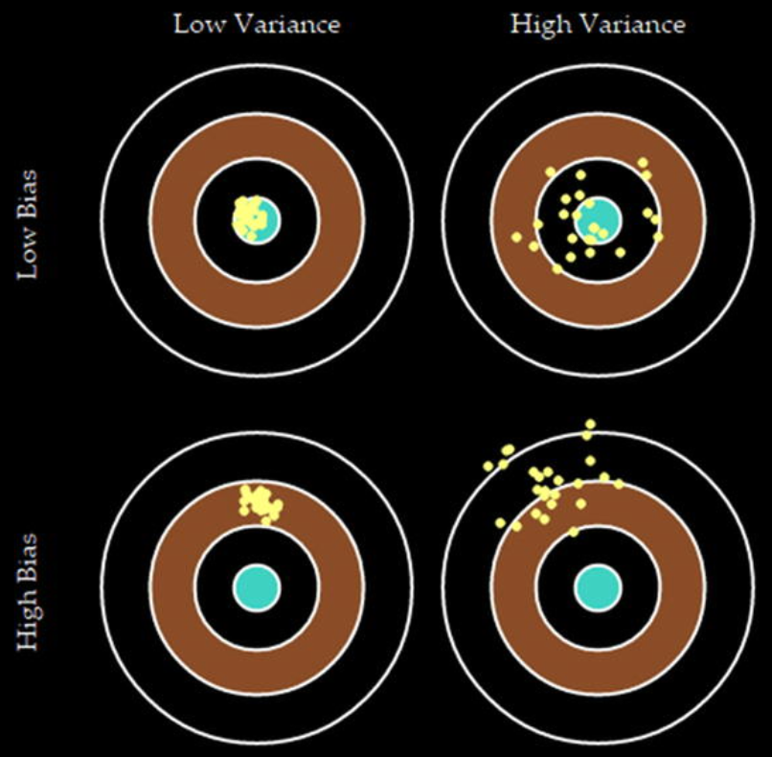

1. Cross Validation Set

→ A simple change in the data splitting process can help us avoid this leakage of unseen data. Suppose we initially made three different subsets of data instead of the original two. One is the usual training set, the second one is the test set and the last one is called a validation set. So we can train our models on the train data evaluate their performance on the validation data to tune model parameters (or even to select among different models).

→ Once we are done with the tuning process, we can evaluate the final model on the really unseen test set and report the performance on the test set as the approximate performance of the model on the real-world unseen data.

→In the very essence of things this is the basic principle behind the process of cross validation, as depicted in Figure below.

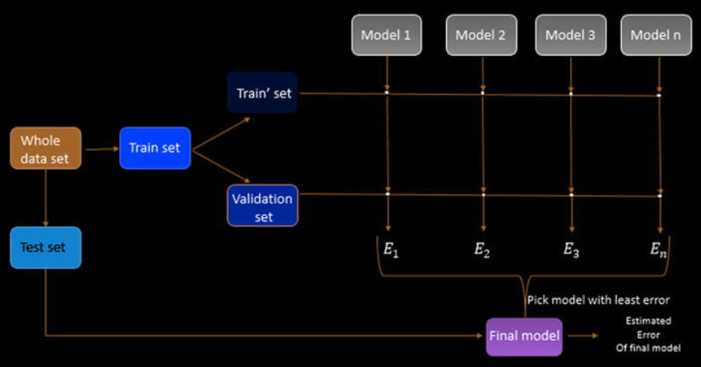

→ The train set so obtained is again split into an actual train set and a validation set.

→ The idea of cross validation is to get different splits of train and validation sets (different observations in each set, each time) using some strategy (which we will elaborate on later) and then build multiple iterations of each model on these different splits. The average error on these splits is then reported as the error of the model in question and the final decision is made on this averaged error metric.

→ This strategy has a brilliant effect on the estimated error of each model, as it ensures that the averaged error is a close approximation of the model’s error on really unseen data (here our test set) and we could also leverage the complete training dataset for building the model. This process is explained pictorially in Figure below.

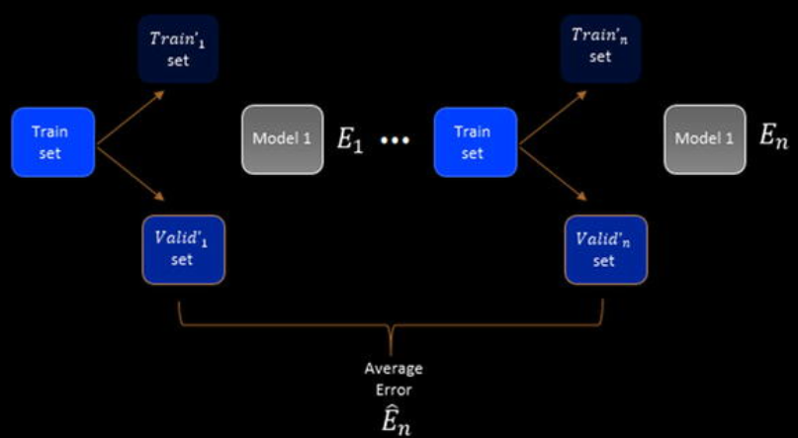

→ The various strategies in which these different train and

validation sets can be generated gives rise to different kind of cross-validation strategies. The common idea in each of these strategies remains the same. The only difference is in the way the original train set is split into a train and validation set for each iteration of model building.

1. Cross-Validation Strategies

→ We explained the basic principle of cross validation in the previous section. In this section, we see the different strategies in which we can split the training data into training and validation data. Apart from the way of this split, as mentioned before, the process for each of these strategies remains the same. The major types of cross-validation strategies are described as follows.

* 1. Leave one out CV

→In this strategy for cross validation, we select a random single data point from the initial training dataset and that becomes our validation set. So we have a single point only in our validation set and the rest n-1 observations become our training set. This means that if have 1000 data points in a training set than we will be developing 1000 iterations of each model with a different training set and validation set each time such that the validation set has one observation and the rest (999) go into the training set. This may become infeasible if the dataset size is large. But in practice the error can be estimated by performing some small number of iterations Due to the computational complexity of this measure, it is mostly suitable for small datasets and rarely used in practice.

* 1. K-Fold CV

→ The other strategy for cross-validation is to split the training dataset into k equal subsets. Out of these k subsets we train the model on k-1 subsets and keep one subset as a validation set. This process is repeated k times and the error is averaged over the k models that are obtained by developing different iterations of the model.

→ We keep changing the validation set in each of these iterations which ensures that in each iteration, the model is trained on a different subset of data. This practice of cross-validation is quite effective in practice, both for model selection and hyperparameter optimization.

→ A natural question for this strategy is to select the appropriate number of folds, as they will both control our error approximation and the computational runtime of our CV process. There are mathematical ways to select the most appropriate k but in practice a good choice of k ranges from 5-10. So, in most cases, we can do a 5-fold or 10-fold validation and be confident of the results that we obtained.

1. Hyperparameter Tuning Strategies:

→ Based on our discussions until now, we have all the prerequisites for tuning our model. We know what hyperparameters are, how the performance of a model can be evaluated, and how we can use cross-validation to search through the parameter space for optimal value of our algorithm’s

hyperparameters. In this section, we discuss two major strategies that tie all this together to determine the most optimal hyperparameters. Fortunately, the scikit-learn library has an excellent built-in support for performing hyperparameter search with cross-validation.

→ There are two major ways in which we can search our parameter space for an optimal model. These two methods differ in the way we will search for them: systemic versus random

* 1. Grid Search

→ This is the simplest of the hyperparameter optimization methods. In this method we will specify the grid of values (of hyperparameters) that we want to try out and optimize to get the best parameter combinations. Then we will build models on each of those values (combination of multiple parameter values), using cross-validation of course, and report the best parameters’ combination in the whole grid. The output will be the model using the best combination from the grid. Although it is quite simple, it suffers from one serious drawback that the user has to manually supply the actual parameters, which may or may not contain the most optimal parameters.

→ In scikit-learn, grid search can be done using the

GridSearchCV class. We go through an example by performing grid search on a support vector machine (SVM) model on the breast cancer dataset from earlier. The SVM model is another example of a supervised Machine Learning algorithm that can be used for classification. It is an example of a maximum margin classifier, where it tries to learn a representation of all the data points such that separate categories\labels are divided or separated by a clear gap, which is as large as possible.

* 1. Randomized Search

→ Grid search is a very popular method to optimizing hyperparameters in practice. It is due to its simplicity and the fact that it is embarrassingly parallelizable. This becomes important when the dataset we are dealing with is of a large size. But it suffers from some major shortcomings, the most important one being the limitation of manually specifying the grid. This brings a human element into a process that could benefit from a purely automatic mechanism.

→ Randomized parameter search is a modification to the traditional grid search. It takes input for grid elements as in normal grid search but it can also take distributions as input. For example consider the parameter gamma whose values we supplied explicitly in the last section instead we can supply a distribution from which to sample gamma. The efficacy of randomized parameter search is based on the proven (empirically and mathematically) result that the hyperparameter optimization functions normally have low dimensionality and the effect of certain parameters are more than others.

→ We control the number of times we want to do the

random parameter sampling by specifying the number of iterations we want to run (n_iter). Normally a higher number of iterations mean a more granular parameter search but higher computation time.

1. **Model Interpretation**

→ This brings us back to the main objective, “can we explain and interpret Machine Learning models in an easy to understand way”, such that anyone even without thorough knowledge of Machine Learning can understand them. The benefit of this would be two-fold—Machine Learning models will not just stop at being research projects or proof-of-concepts and it will pave the way for higher adoption of Machine Learning based solutions in enterprises.

→ Also, the prediction path for a single tree from the root of the tree to its leaves can be visualized capturing the contribution of the feature to the estimators decision policies. But, this intuitiveness may not be possible for complex non-linear models - Random Forest, Deep Neural Networks - Convolutional Neural Networks (CNNs), Recurrent Neural Networks (RNNS). The lack of understanding of the complex nature of Machine Learned decision policies makes predictive models to be still viewed as black boxes.

→ Model interpretations can help a data scientist and an end user in a variety of ways. It will help bridge the gap that often exists between the technology teams and the business.

→ To understand more about model interpretation and the **LIME framework**, which proposes to solve this. The **LIME framework** attempts to successfully explain any black box model locally.

→ The full form of the **LIME is Local Interpretable Model Agnostic Explanation**

→ We will be leveraging another library named Skater , an open sourced Python library designed to demystify the inner workings of of predictive models. Skater defines the scope of interpreting models 1.Globally(on the basis of a complete dataset) and 2. Locally (on the basis of an individual prediction). For global explanations, Skater makes use of model-agnostic variable importance and partial dependence plots to judge the bias of a model and understand its general behavior.

→ **Skater is now a mainstream project and an excellent framework for model interpretation and the models/methods like LIME are included in the skater only**.

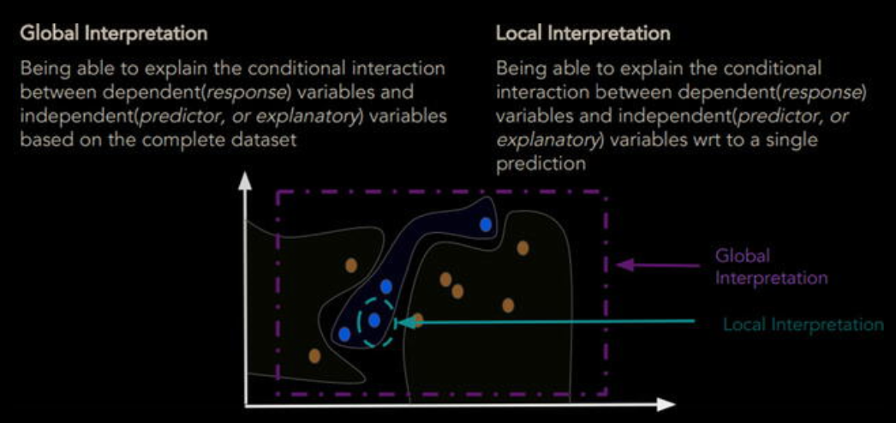

1. **Model Persistence**

→ **Model persistence is the simplest way of deploying a model.** In this scheme of things we will persist our final model on permanent media like our hard drive and use this persisted version for making predictions in the future. This simple scheme is a good way to deploy models with minimal effort.

→ Model development is generally done on a static data source but once deployed, typically the model is used on a constant stream of data either in Real time\near real time or in batches. For example, consider a bank fraud detection model; at the time of model development, we will have data collected over some historical time span.

→ In the simplest scheme of things, we can write a standalone Python script that is given the new data as soon as it arrives. It performs the necessary data transformations on the raw data and then reads our model from the permanent data store. Once we have the data and the model we can make a prediction and this prediction communication can be integrated with the required operations.

→ For persisting our model to disk, we can leverage libraries like pickle or **joblib**, which is also available with scikit-learn. This allows us to deploy and use the model in the future, without having to retrain it each time we want to use it.

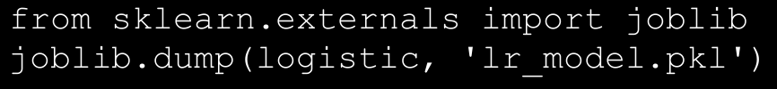

→ This code will persist our model on the disk as a file named

**lr_model.pkl**. So whenever we will load this object in memory again we will get the logistic regression model object.

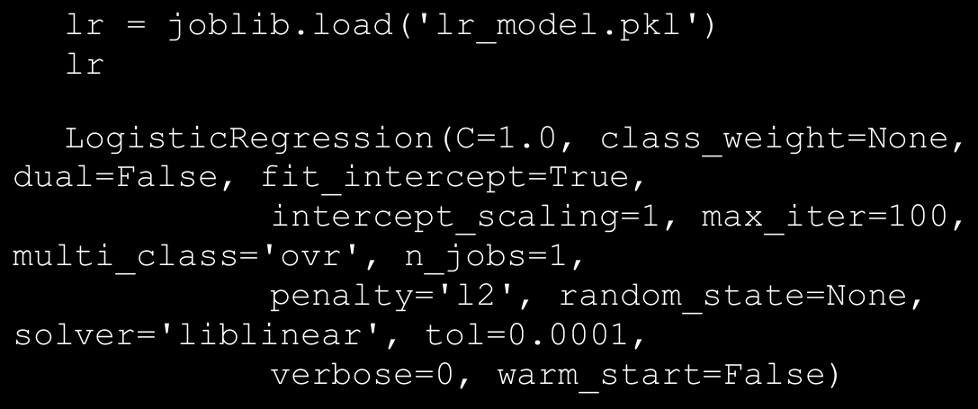

→ We can now use this lr object, which is our model loaded from the disk, and make predictions. A sample is depicted as follows.

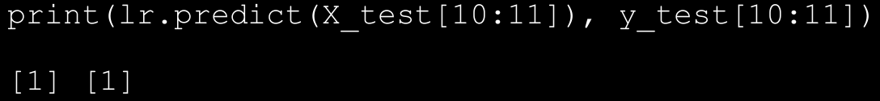

→ Remember that once you have a persisted model, you can easily integrate it with a Python based script or application that can be scheduled to predict in real time or batches of new data. However, proper engineering of the solution is necessary to ensure the right data reaches the model and the prediction output should also be broadcasted to the right channels.

1. Decision Tree Based Regression

→ Decision trees are supervised learning algorithms used for both regression and classification problems.

→ Since decision trees are supervised learning algorithms, we have certain number of data points with actual mileage values available. A decision tree starts off at the root and divides the dataset into two or more non-overlapping subsets, each represented as child node of the root. It divides the root into subsets based on a specific attribute. It goes on performing the split at every node until a leaf node is achieved where the target value is available.

1. Node Splitting

→ Decision trees work in a top-down manner and node splitting is an important concept for any decision tree algorithm. Most algorithms follow a greedy approach to divide the input space into subsets.

→ The basic process in simple terms is to try and split data points using different attributes/features and test against a cost function. The split resulting in least cost is selected at every step. Classification and regression problems use different set of cost functions. Some of the most common ones are as follows:

* 1. **Mean Squared Error(MSE)**: Used mainly for regression trees, it is calculated as the square of difference between observed and predicted values.
  2. **Mean Absolute Error**: Used for regression trees, it is similar to MSE though we only use the difference between the observed and predicted values.
  3. **Variance Reduction**: This was first introduced with CART algorithm, and it uses the standard formula of variance and we choose the split that results in least variance.
  4. **Gini Impurity/Index**: Mainly used by classification trees, it is a measure of a randomly chosen data point to have an incorrect label given it was labeled randomly.
  5. **Information Gain**: Again used mainly for classification problems, it is also termed as entropy. We choose the splits based on the amount of information gain. The higher information gain, the better it is.

1. Decision Tree Algorithms

→ Decision trees have been around for quite some time now. They have evolved with improvements in algorithms based on different techniques over the years. Some of the most commonly used algorithms are listed as follows:

* 1. **CART or Classification And Regression Tree**
  2. **ID3 or Iterative Dichotoizer 3**
  3. **C4.5**

1. Example implementation of Decision tree:

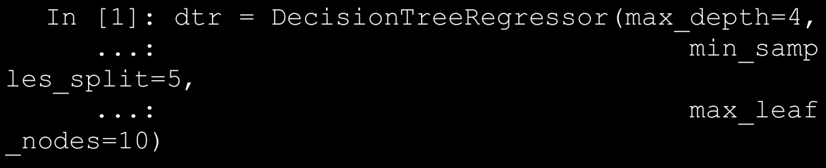

→ This code snippet prepares a DecisionTreeRegressor object that is set to have a maximum depth of 4, maximum leaf nodes as 10, and minimum number of samples required to split a node as 5. Though there can be many more, this example outlines how hyperparameters are utilized in algorithms.

→ As mentioned, decision trees have an added advantage of being interpretable. We can visualize the model object using Graphviz and pydot libraries, as shown in the following snippet.

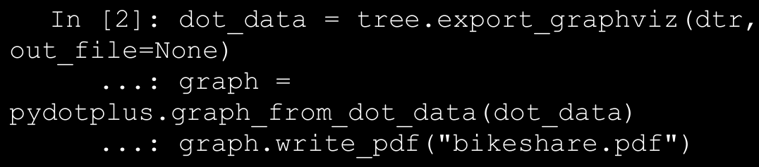

→ The output is a pdf file showcasing a decision tree with hyperparameters as set in the previous step.

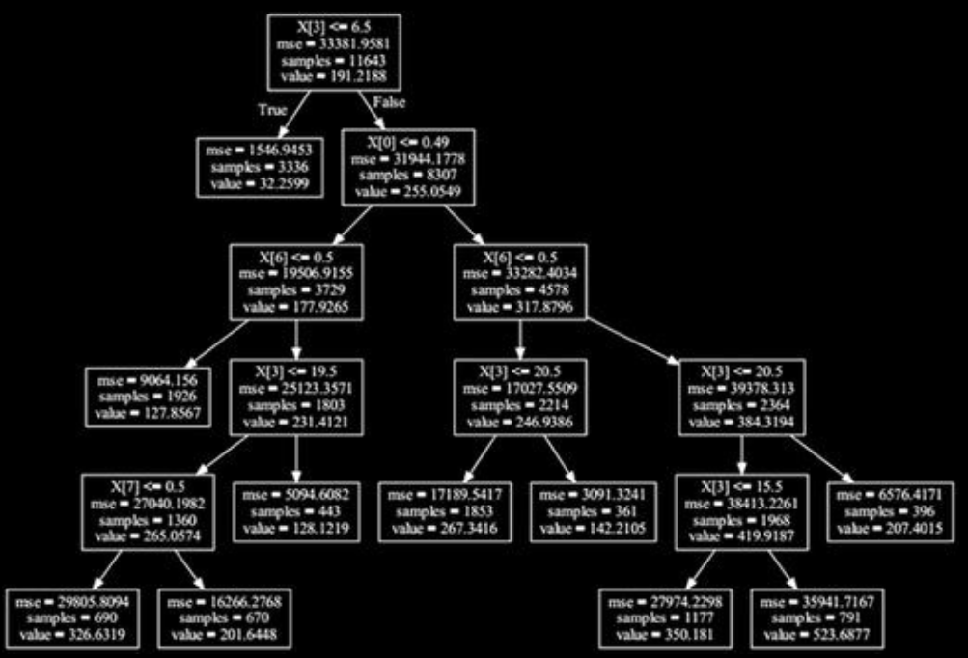

→ Now we start with the actual training process. As must be evident from our workflow so far, we would train our regressor using k-fold cross validation . Since we have hyperparameters as well in case of decision trees to worry, we need a method to fine-tune them as well.

→ There are many ways of fine-tuning the hyperparameters, the most common ones are **grid search** and **random search**, with grid search being the more popular one. As the name suggests, random search randomly searches the combinations of hyperparameters to find the best combination, grid search on the other hand is a more systematic approach where all combinations are tried before the best is identified. To make our lives easier, sklearn provides a utility to grid search the hyperparameters while cross validating the model using the **GridSearchCV()** method from **model_selection** module.

→ The **GridSearchCV()** method takes the Regression/Classifier object as input parameter along with a dictionary of hyperparameters, number of cross validations required, and a few more. We use the following dictionary to define our grid of hyperparameters.

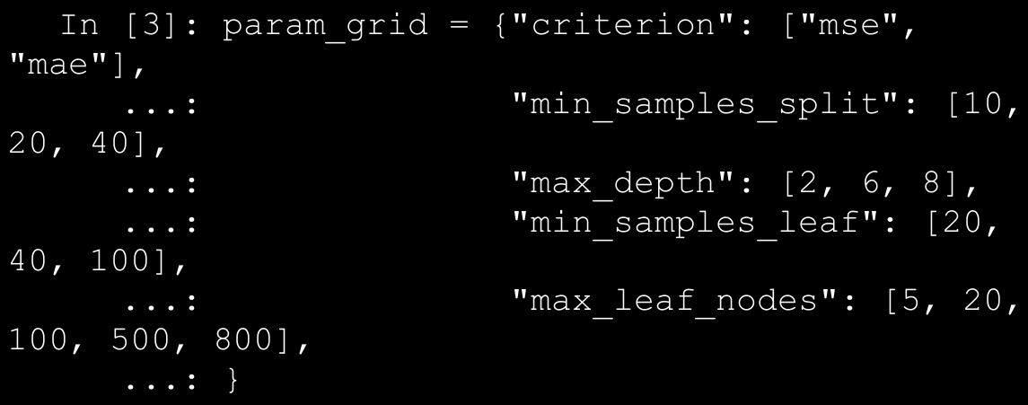

→ The dictionary basically provides a list of feasible values for each of the hyperparameters that we want to fine-tune. The hyper -parameters are the keys, while the values are presented as list of possible values of these hyperparameters. For instance, our dictionary provides max_depth with possible values of 2, 6, and 8 levels. The **GridSearchCV**() function will in turn search in this defined list of possible values to arrive at the best one value. The following snippet prepares a **GridSearchCV** object and fits our training dataset to it.

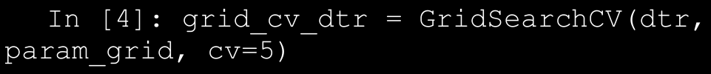

→ The grid search of hyperparameters with **k-fold cross validation** is an iterative process wrapped, optimized, and standardized **by GridSearchCV()** function . The training process takes time due to the same and results in quite a few useful attributes to analyze. The **best_score_ attribute** helps us get the best cross validation score our Decision Tree Regressor could achieve. We can view the hyperparameters for the model that generates the best score using **best_params_**. We can view the detailed information of each iteration of GridSearchCV()

using the **cv_results_ attribute**. The following snippet showcases some of these attributes.

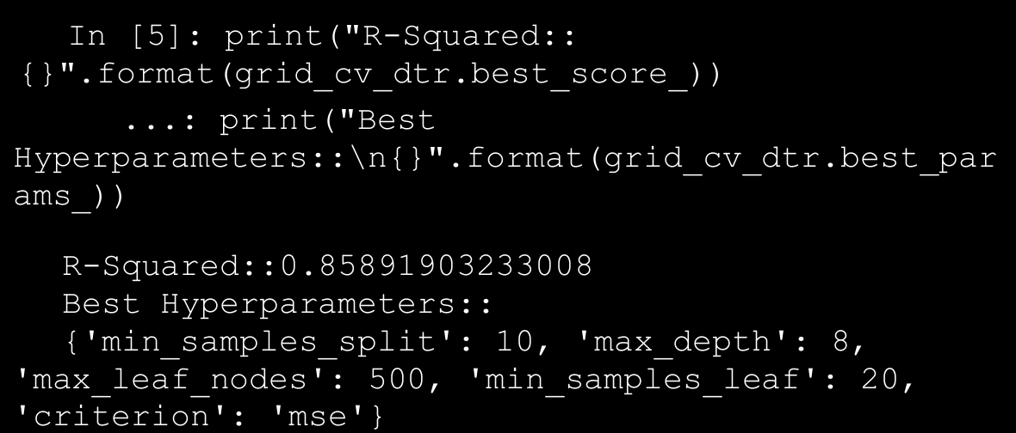

→ The results are decent and show a dramatic improvement over our linear regression model. Let’s first try to understand the learning/model fitting results across different settings of this model fitting. To get to different models prepared during our grid search, we use the cv_results_ attribute of our GridSearchCV object. The cv_results_ attribute is a numpy array that we can easily convert to a pandas dataframe. The data frame is shown in Figure below.

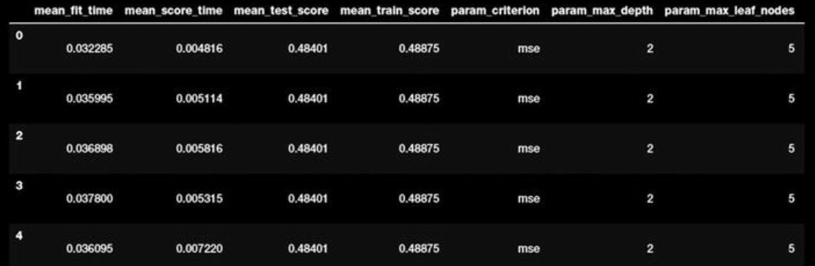

1. Text Pre-Processing and Normalization

→ One of the key steps before diving into the process of feature engineering and modeling involves cleaning, pre-processing, and normalizing text to bring text components like phrases and words to some standard format. The main component in our text normalization pipeline is as follow:

* 1. Cleaning Text
  2. Removing accented characters
  3. Expanding contractions
  4. Removing special characters
  5. Stemming and lemmatization
  6. Removing stopwords

→ We use all these components and tie them together in the following function called normalize_corpus(...) , which can be used to take a document corpus as input and return the same corpus with cleaned and normalized text documents.

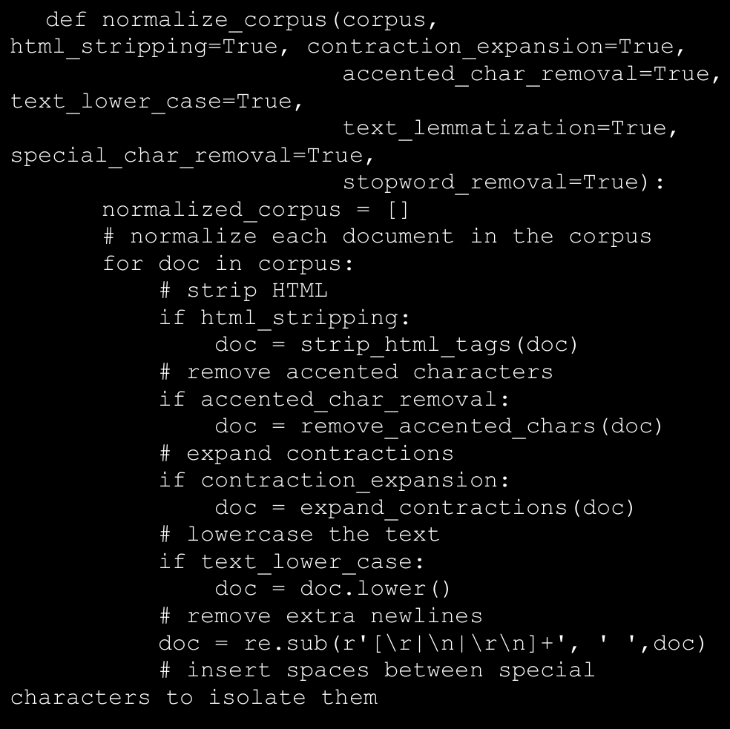

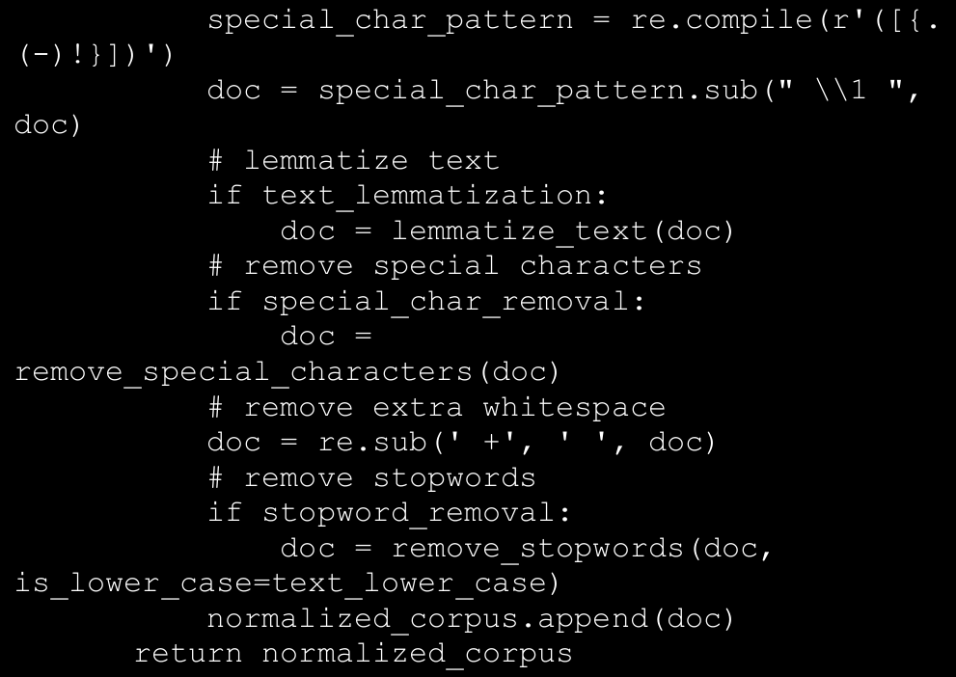

1. **Unsupervised Lexicon-Based Model (IMP)**

→ We have talked about unsupervised learning methods in the past, which refer to specific modeling methods that can be applied directly on data features without the presence of labeled data. One of the major challenges in any organization is getting labeled datasets due the lack of time as well as resources to do this tedious task. Unsupervised methods are very useful in this scenario and we will be looking at some of these methods in this section. **Even though we have labeled data, this section should give you a good idea of how lexicon based models work and you can apply the same in your own datasets when you do not have labeled data**.

→ Unsupervised sentiment analysis models use well curated

Knowledge bases, ontologies, lexicons, and databases that have detailed information pertaining to subjective words, phrases including sentiment, mood, polarity, objectivity, subjectivity, and so on. A lexicon model typically uses a lexicon, also known as a dictionary or vocabulary of words specifically aligned toward sentiment analysis.

→ Usually these lexicons

contain a list of words associated with positive and negative sentiment, polarity (magnitude of negative or positive score), parts of speech (POS) tags, subjectivity classifiers (strong, weak, neutral), mood, modality, and so on. You can use these lexicons and compute sentiment of a text document by matching the presence of specific words from the lexicon, look at other additional factors like presence of negation parameters, surrounding words, overall context and phrases and aggregate overall sentiment polarity scores to decide the final sentiment score. There are several popular lexicon models used for sentiment analysis. Some of them are mentioned as follows.

* + 1. Bing Liu’s Lexicon
    2. MPQA Subjective Lexicon
    3. Pattern Lexicon
    4. AFINN Lexicon
    5. SentiWordNet Lexicon
    6. VADER Lexicon

→ This is not an exhaustive list of lexicon models, but definitely lists among the most popular ones available today. We will be covering the last three lexicon models in more detail with hands-on code and examples using our movie review dataset. We will be using the last 15,000 reviews and predict their sentiment and see how well our model performs based on model evaluation metrics like accuracy, precision, recall, and F1-score.

→ Since we have labeled data, it will be easy for us to see how well our actual sentiment values for these movie reviews match our lexicon-model based predicted sentiment values.

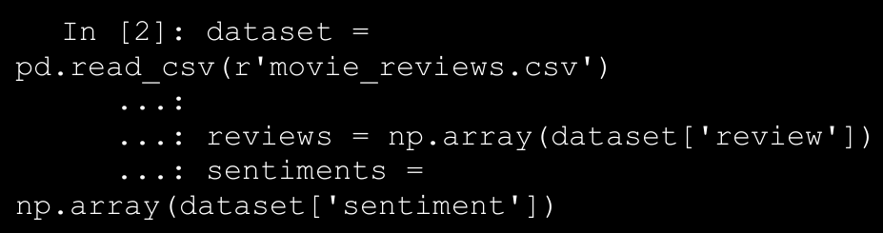

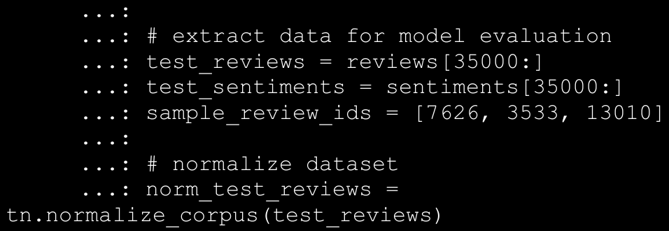

**A. Bing Liu’s Lexicon**

→ This lexicon contains over 6,800 words which have been divided into two files named positive-words.txt, containing around 2,000+ words/phrases and negative-words.txt, which contains 4,800+ words/phrases. The lexicon has been developed and curated by Bing Liu over several years and has also been explained in detail in his original paper by Nitin Jindal and Bing Liu, “Identifying Comparative Sentences in Text Documents” proceedings of the 29th Annual International ACM SIGIR, Seattle 2006. If you want to use this lexicon, you can get it from https:// www.cs.uic.edu/~liub/FBS/sentiment-

analysis.html#lexicon , which also includes a link to download it as an archive (RAR format).

**B. MPQA Subjectivity Lexicon**

→ The term MPQA stands for Multi-Perspective Question Answering and it contains a diverse set of resources pertaining to opinion corpora, subjectivity lexicon, subjectivity sense annotations, argument lexicon, debate corpora, opinion finder, and many more. This is developed and maintained by the University of Pittsburgh and their official web site http://mpqa.cs.pitt.edu/ contains all the necessary information. The subjectivity lexicon is a part of their opinion finder framework and contains subjectivity clues and contextual polarity.

→ The following snippet shows some sample lines from the lexicon.

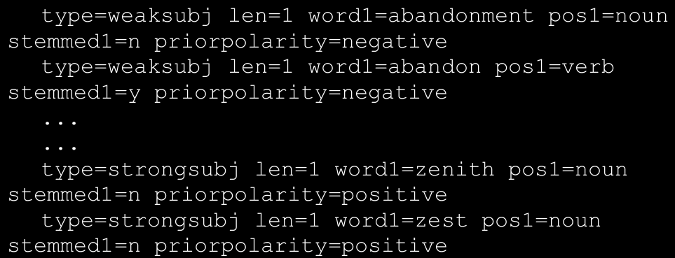

**C. Pattern Lexicon**

→ The pattern package is a complete natural language processing framework available in Python which can be used for text processing, sentiment analysis and more. This has been developed by CLiPS (Computational Linguistics & Psycholinguistics)

→ Thus you get important metadata information like WordNet corpus identifiers, polarity scores, word sense, POS tags, intensity, subjectivity scores, and so on.

D. AFINN Lexicon

→ The AFINN lexicon is perhaps one of the simplest and most popular lexicons that can be used extensively for sentiment analysis.

→ The current version of the lexicon is AFINN-en-165.txt

and it contains over 3,300+ words with a polarity score associated with each word.

→ The author has also created a nice wrapper library on top of this in Python called afinn which we will be using for our analysis needs. You can import the library and instantiate an object using the following code.

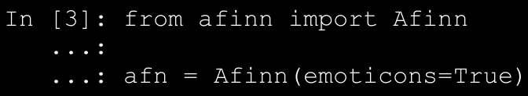

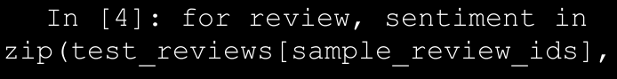

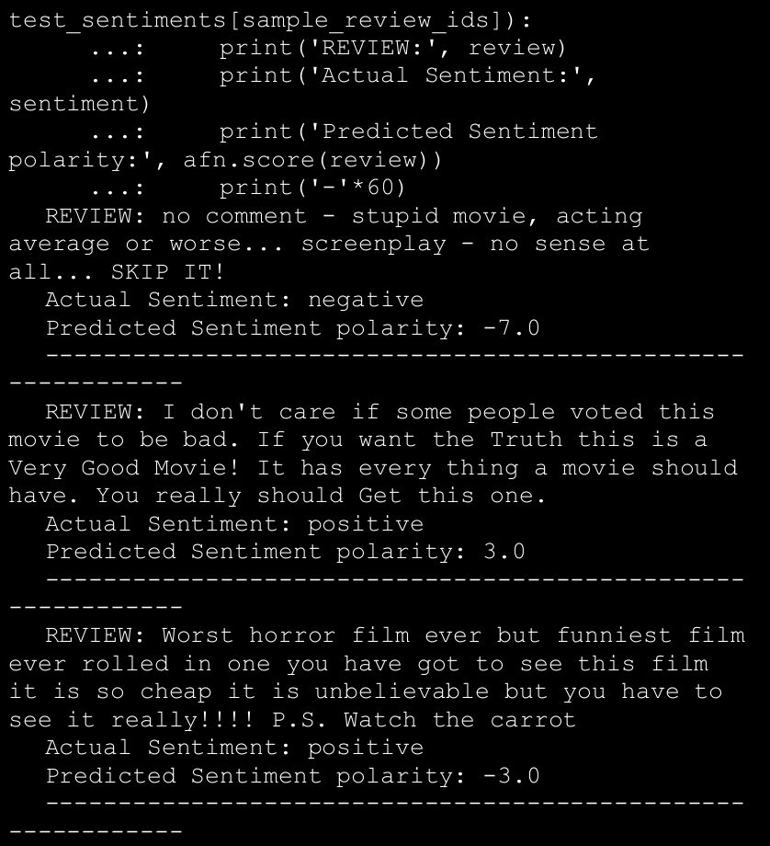

→ We can compare the actual sentiment label for each review and also check out the predicted sentiment polarity score. A negative polarity typically denotes negative sentiment. To predict sentiment on our complete test dataset of 15,000 reviews (I used the raw text documents because AFINN takes into account other aspects like emoticons and exclamations), we can now use the following snippet. I used a threshold of >= 1.0 to determine if the overall sentiment is positive else negative. You can choose your own threshold based on analyzing your own corpora in the future.

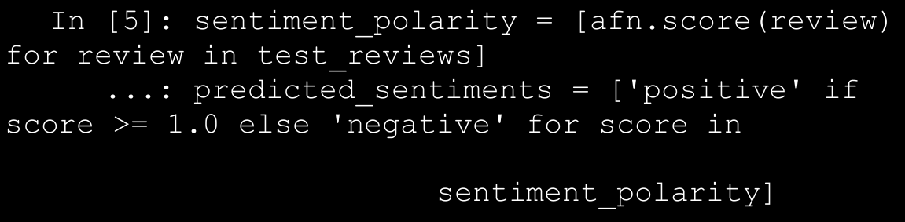

→ Now that we have our predicted sentiment labels, we can evaluate our model performance based on standard performance metrics using our utility function.

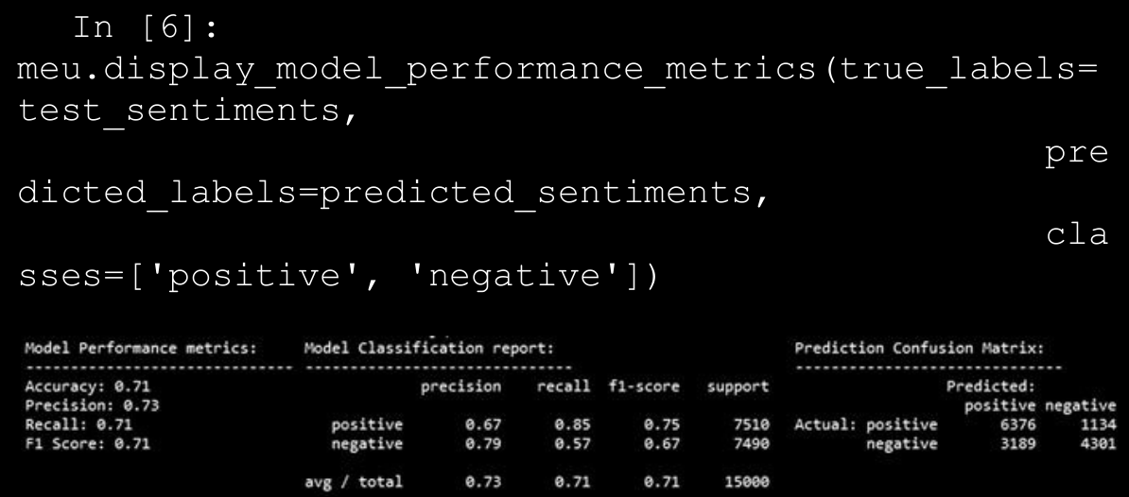

**D. SentiWordNet Lexicon**

→ The WordNet corpus is definitely one of the most popular corpora for the English language used extensively in natural language processing and semantic analysis. WordNet gave us the concept of synsets or synonym sets. The SentiWordNet lexicon is based on WordNet synsets and can be used for sentiment analysis and opinion mining. The SentiWordNet lexicon typically assigns three sentiment scores for each WordNet synset. These include a positive polarity score, a negative polarity score and an objectivity score.

→ We will be using the nltk library, which provides a Pythonic interface into SentiWordNet. Consider we have the adjective awesome. We can get the sentiment scores associated with the synset for this word using the following snippet.

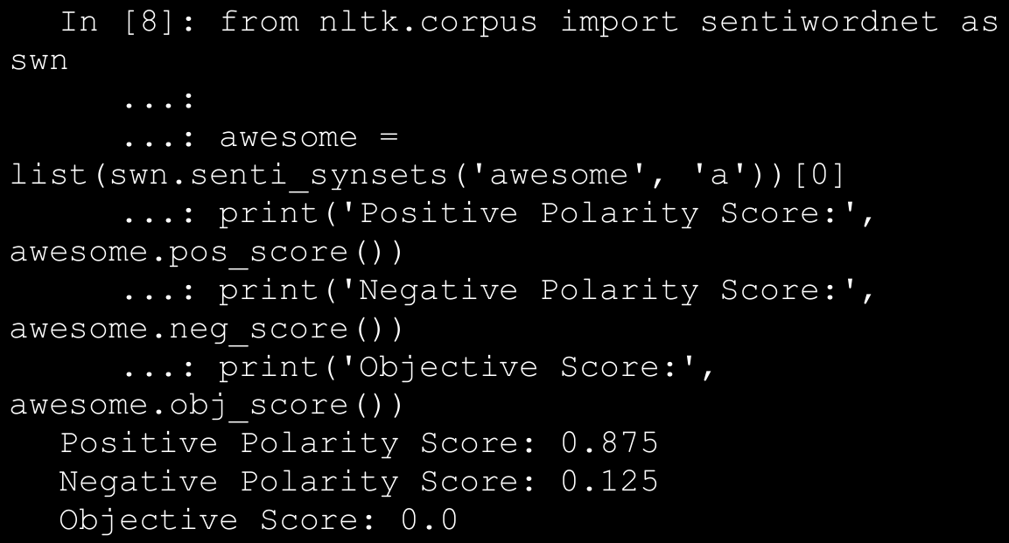

→ Let’s now build a generic function to extract and aggregate sentiment scores for a complete textual document based on matched synsets in that document.

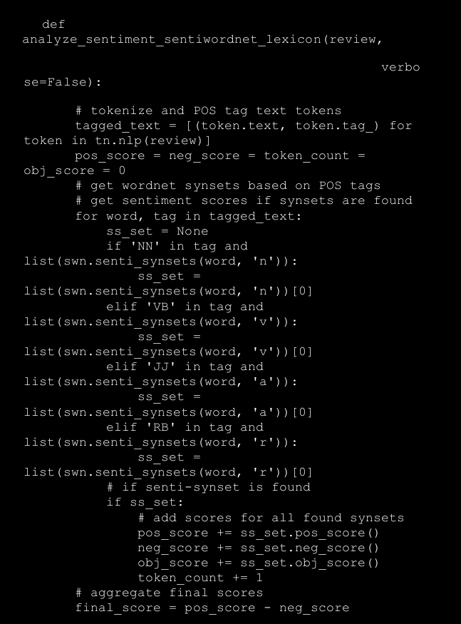

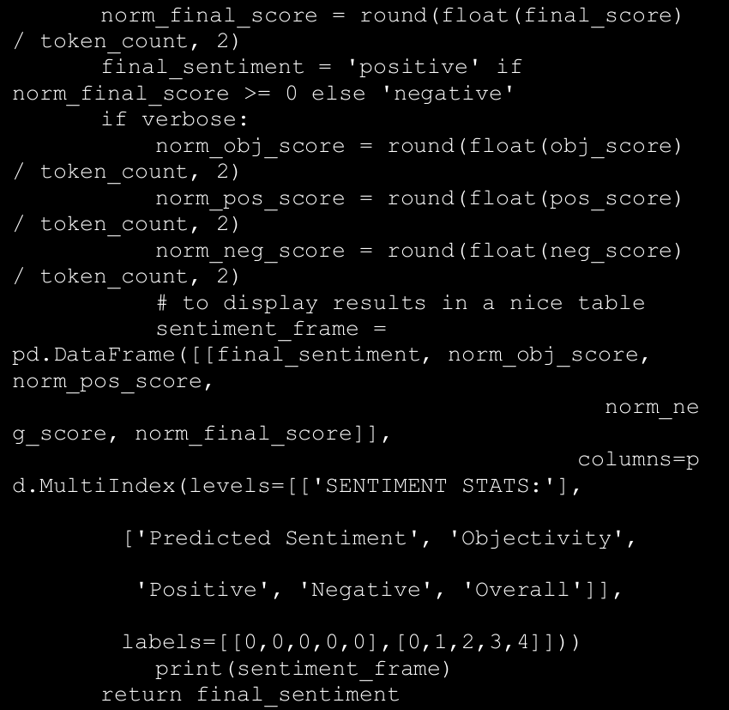

→ Our function basically takes in a movie review , tags each word with its corresponding POS tag, extracts out sentiment scores for any matched synset token based on its POS tag, and finally aggregates the scores. This will be clearer when we run it on our sample documents.

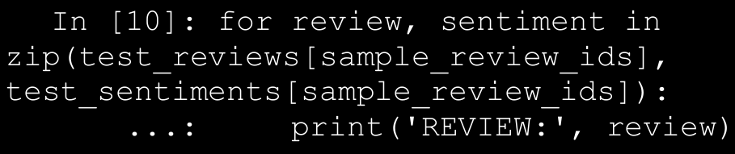

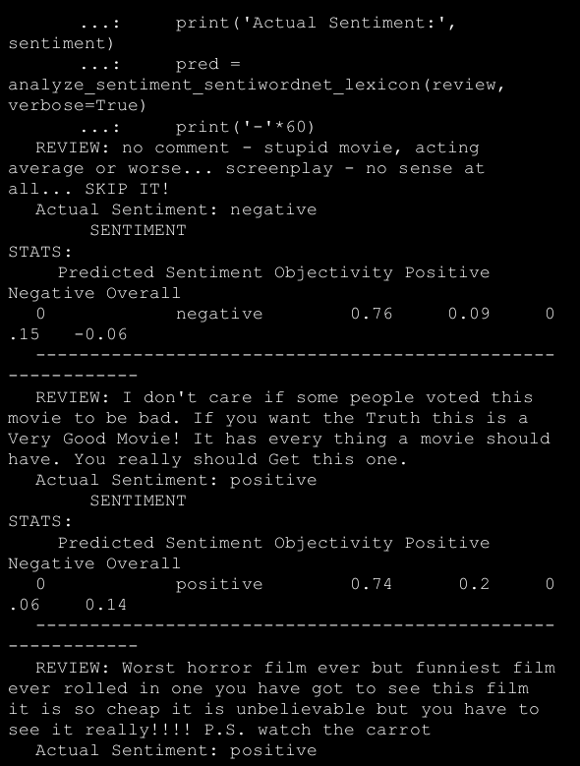

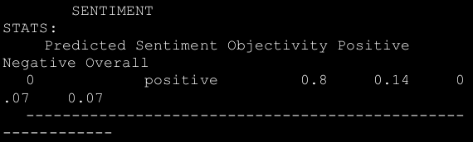

→ We can clearly see the predicted sentiment along with sentiment polarity scores and an objectivity score for each sample movie review depicted in formatted dataframes. Let’s use this model now to predict the sentiment of all our test reviews and evaluate its performance. A threshold of >=0 has been used for the overall sentiment polarity to be classified as positive and < 0 for negative sentiment.

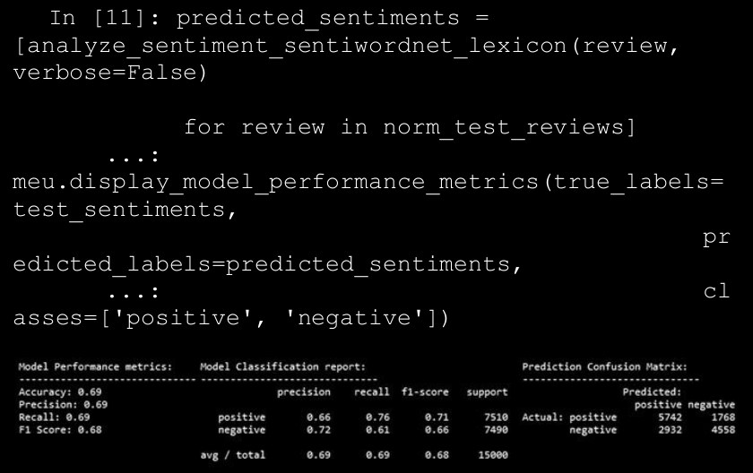

E. **VADER Lexicon**

→ The VADER lexicon , developed by C.J. Hutto, is a lexicon that is based on a rule-based sentiment analysis framework, specifically tuned to analyze sentiments in social media. VADER stands for Valence Aware Dictionary and Sentiment Reasoner.

→ You can use the library based on nltk's interface under the nltk.sentiment.vader module.

→ This lexicon, present in the file titled vader_lexicon.txt contains necessary sentiment scores associated with words, emoticons and slangs (like wtf, lol, nah, and so on). There were a total of over 9000 lexical features from which over 7500 curated lexical features were finally selected in the lexicon with proper validated valence scores. Each feature was rated on a scale from "[-4] Extremely Negative" to "[4] Extremely Positive", with allowance for "[0] Neutral (or Neither, N/A)". The process of selecting lexical features was done by keeping all features that had a non- zero mean rating and whose standard deviation was less than 2.5, which was determined by the aggregate of ten independent raters. We depict a sample from the VADER lexicon as follows.

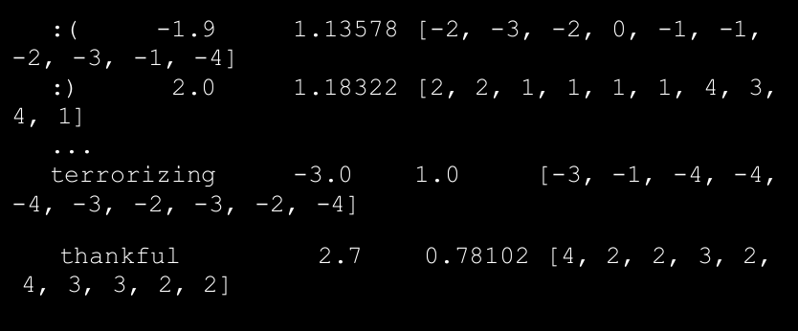

→ Each line in the preceding lexicon sample depicts a unique term, which can either be an emoticon or a word. The first token indicates the word/emoticon, the second token indicates the mean sentiment polarity score, the third token indicates the standard deviation, and the final token indicates a list of scores given by ten independent scorers. Now let’s use VADER to analyze our movie reviews! We build our own modeling function as follows.

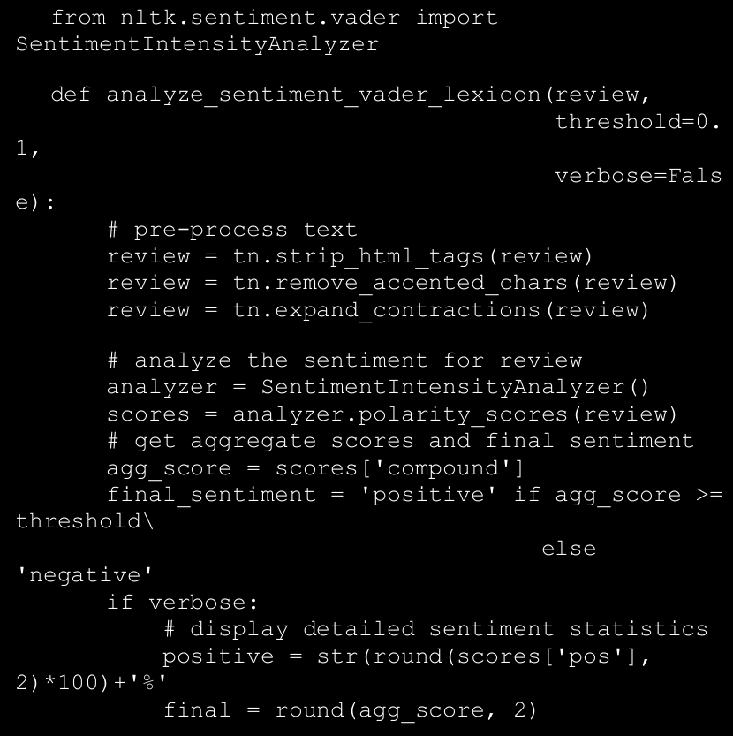

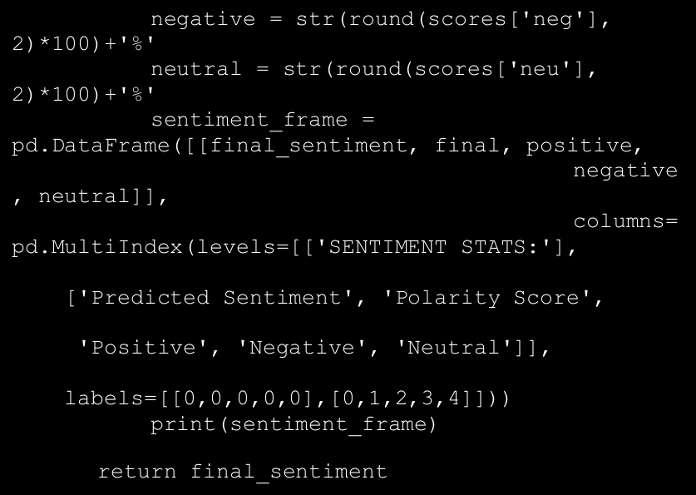

→ In our modeling function , we do some basic pre-processing but keep the punctuations and emoticons intact. Besides this, we use VADER to get the sentiment polarity and also proportion of the review text with regard to positive, neutral and negative sentiment. We also predict the final sentiment based on a user-input threshold for the aggregated sentiment polarity.

→ Typically, VADER recommends using positive sentiment for aggregated polarity >= 0.5, neutral between [-0.5, 0.5], and negative for polarity < -0.5. We use a threshold of >= 0.4 for positive and < 0.4 for negative in our corpus. The following is the analysis of our sample reviews.

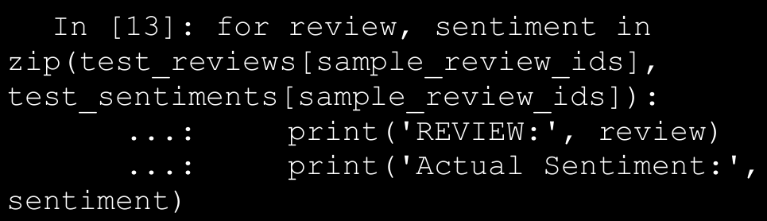

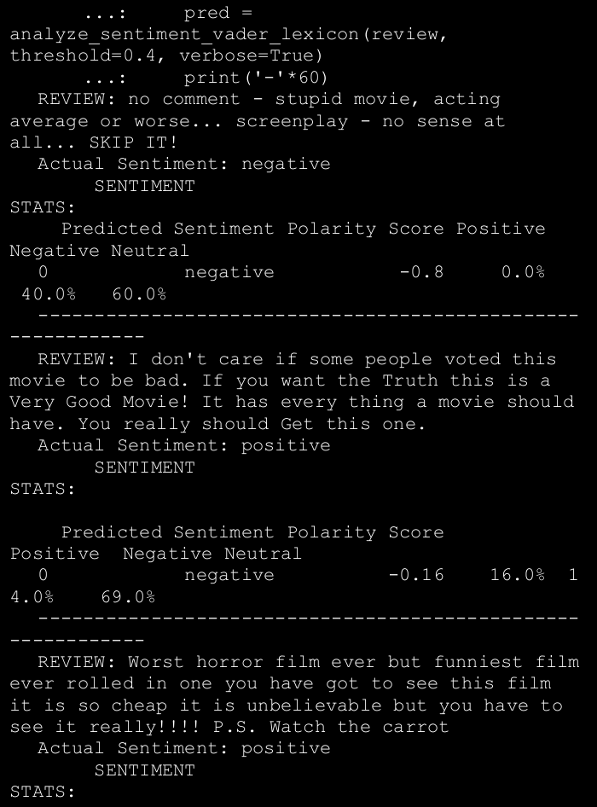

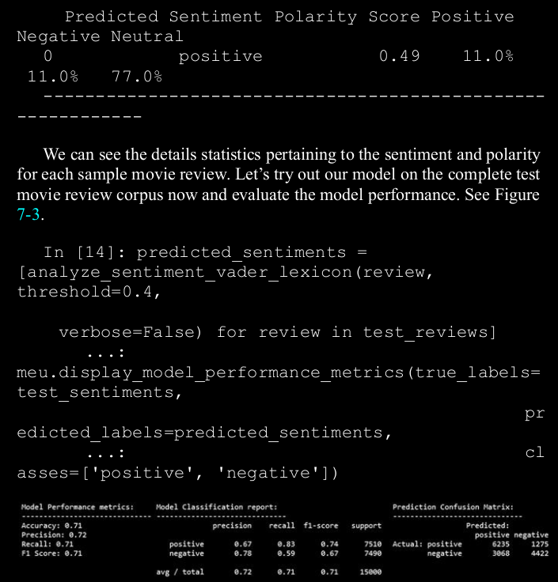

1. **What is Recurrent Neural Network (RNN) ?(I.M.P.)**

→ Recurrent Neural Network is a generalization of feedforward neural network that has an internal memory. RNN is recurrent in nature as it performs the same function for every input of data while the output of the current input depends on the past one computation. After producing the output, it is copied and sent back into the recurrent network. For making a decision, it considers the current input and the output that it has learned from the previous input.

→ Unlike feedforward neural networks, RNNs can use their internal state (memory) to process sequences of inputs. This makes them applicable to tasks such as unsegmented, connected handwriting recognition or speech recognition. In other neural networks, all the inputs are independent of each other. But in RNN, all the inputs are related to each other.

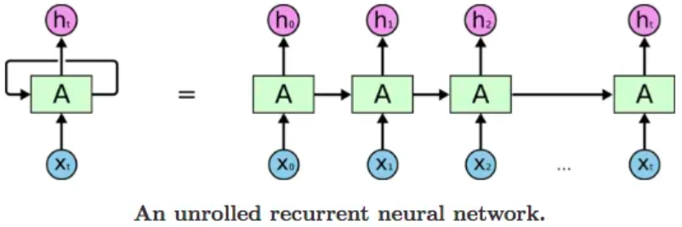

→ First, it takes the X(0) from the sequence of input and then it outputs h(0) which together with X(1) is the input for the next step. So, the h(0) and X(1) is the input for the next step. Similarly, h(1) from the next is the input with X(2) for the next step and so on. This way, it keeps remembering the context while training.

→ The formula for the current state is:

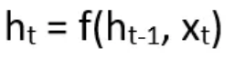

→ Applying Activation function:

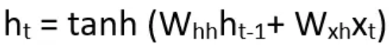

→Where W is weight, h is the single hidden vector, Whh is the weight at previous hidden state, Whx is the weight at current input state, tanh is the Activation function, that implements a Non-linearity that squashes the activations to the range[-1.1].

→ Output:

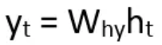

→ Where, Yt is the output state, Why is the weight at the output state.

**⇒ Advantages of Recurrent Neural Network**

A. RNN can model sequence of data so that each sample can be assumed to be dependent on previous ones

B. Recurrent neural network are even used with convolutional layers to extend the effective pixel neighbourhood.

**⇒ Disadvantages of Recurrent Neural Network**

A. Gradient vanishing and exploding problems.

B. Training an RNN is a very difficult task.

C. It cannot process very long sequences if using tanh or relu as an activation function.

1. **What is Long Short Term Memory (LSTM)?**

→ Long Short-Term Memory (LSTM) networks are a modified version of recurrent neural networks, which makes it easier to remember past data in memory. The vanishing gradient problem of RNN is resolved here. LSTM is well-suited to classify, process and predict time series given time lags of unknown duration. It trains the model by using back-propagation. In an LSTM network, three gates are present:

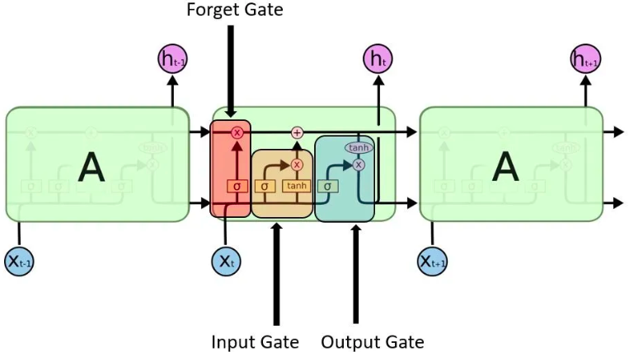

→ **Input Gate** - discover which value from input should be used to modify the memory. Sigmoid function decides which values to let through 0,1. and tanh function gives weightage to the values which are passed deciding their level of importance ranging from-1 to 1.

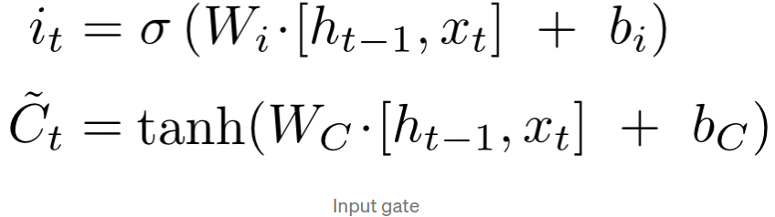

→ **Forget Gate** - discover what details to be discarded from the block. It is decided by the sigmoid function. it looks at the previous state(ht-1) and the content input(Xt) and outputs a number between 0(omit this)and 1(keep this)for each number in the cell state Ct−1.

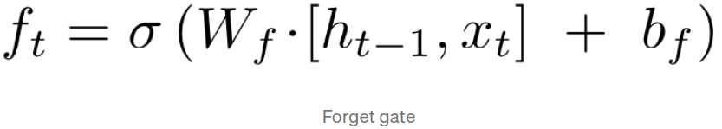

→ **Output Gate** - the input and the memory of the block is used to decide the output. Sigmoid function decides which values to let through 0,1. and tanh function gives weightage to the values which are passed deciding their level of importance ranging from-1 to 1 and multiplied with output of Sigmoid.

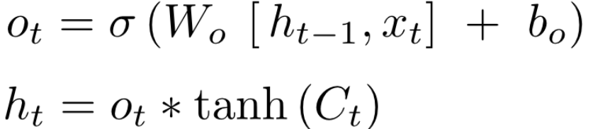

1. **Classifying Sentiment with Supervised Learning**

→ Another way to build a model to understand the text content and predict the sentiment of the text based reviews is to use supervised Machine Learning. To be more specific, we will be using classification models for solving this problem.

→ We will be building an automated sentiment text classification system in subsequent sections. The major steps to achieve this are mentioned as follows.

1. Prepare train and test datasets (optionally a validation dataset)

2. Pre-process and normalize text documents

3. Feature engineering

4. Model training

5. Model prediction and evaluation

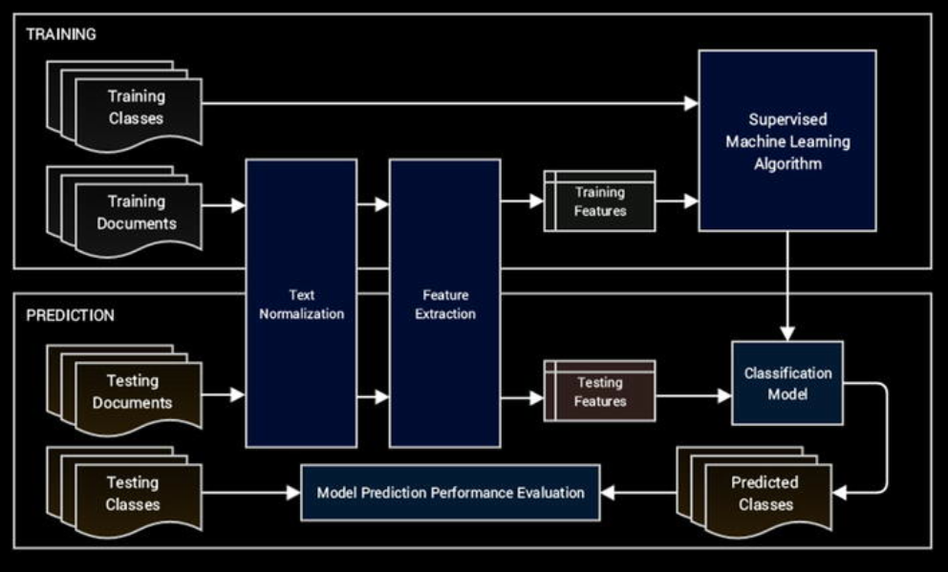

→ In our scenario, documents indicate the movie reviews and classes indicate the review sentiments that can either be positive or negative, making it a binary classification problem. We will build models using both traditional Machine Learning methods and newer Deep Learning in the subsequent sections.

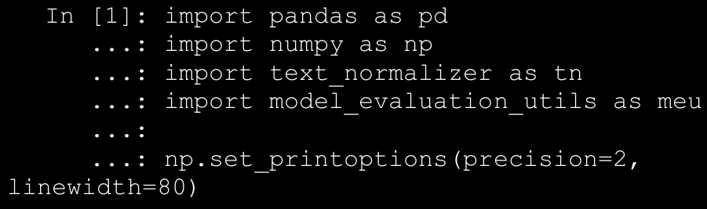

→ We can now load our IMDb movie reviews dataset, use the first 35,000 reviews for training models and the remaining 15,000 reviews as the test dataset to evaluate model performance. Besides this, we will also use our normalization module to normalize our review datasets (Steps 1 and 2 in our workflow).

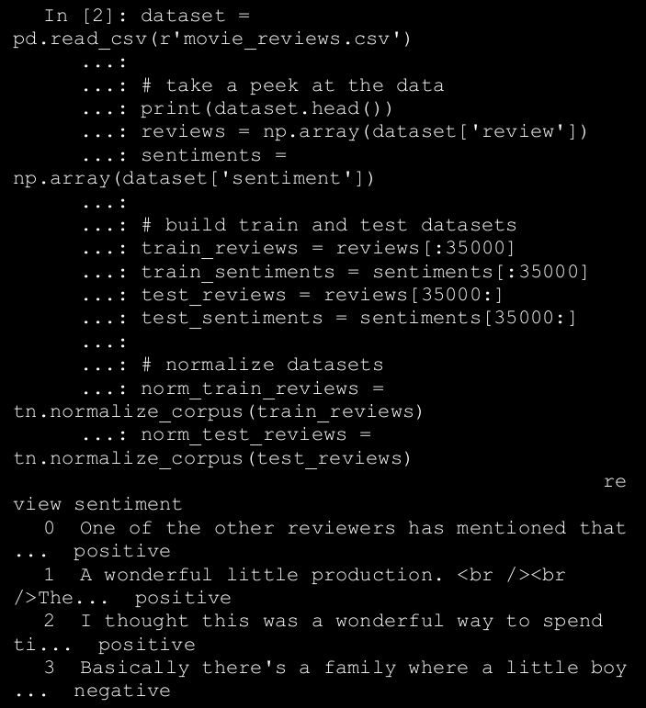

→Our datasets are now prepared and normalized so we can proceed from Step 3 in our text classification workflow described earlier to build our classification system.

* 1. Traditional Supervised Machine Learning Models

→ Our feature engineering techniques (Step 3) will be based on the Bag of Words model and the TF-IDF model.

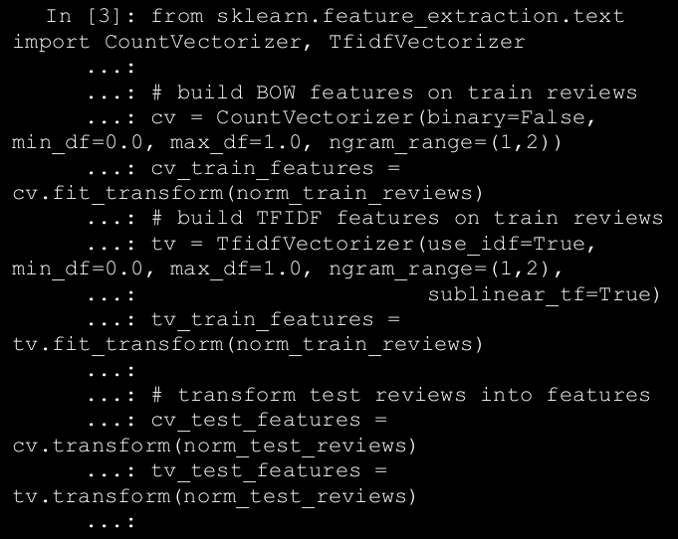

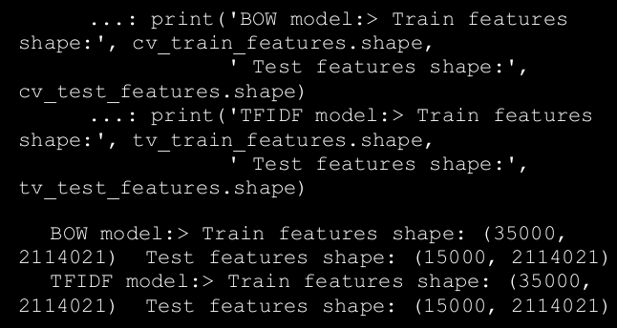

→ We take into account word as well as bi-grams for our feature-sets . We can now use some traditional supervised Machine Learning algorithms which work very well on text classification. We recommend using logistic regression, support vector machines, and multinomial Naïve Bayes models when you work on your own datasets in the future.

→ We will be going to built an model using Logistic Regression and SVM.

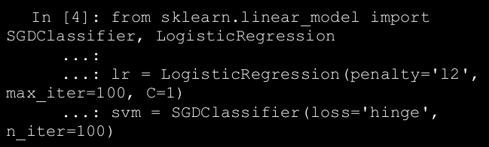

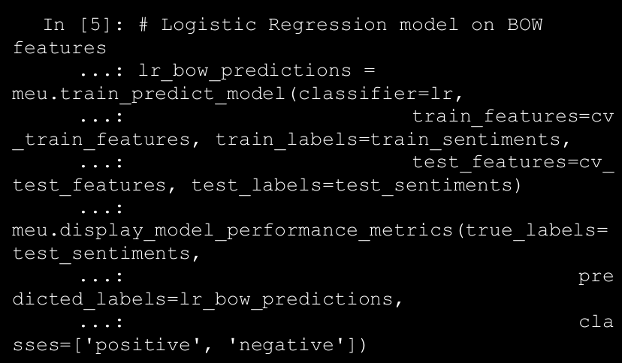

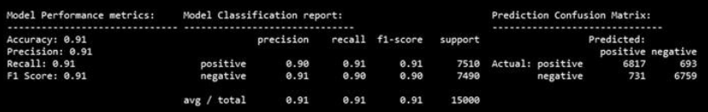

* 1. **Newer Supervised Deep Learning Models**

→ We have already mentioned multiple times in previous chapters about how Deep Learning has revolutionized the Machine Learning landscape over the last decade. In this section, we will be building some deep neural networks and train them on some advanced text features based on word embeddings to build a text sentiment classification system similar to what we did in the previous section. Let’s load the following necessary dependencies before we start our analysis.

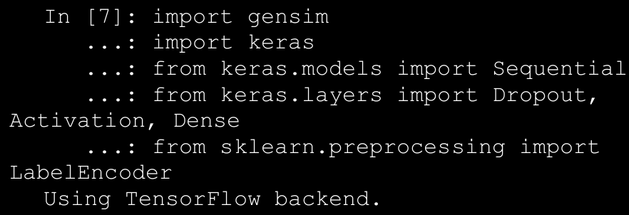

→ So far, our models in scikit-learn directly accepted the sentiment class labels as positive and negative and internally performed these operations. However for our Deep Learning models, we need to do this explicitly. The following snippet helps us tokenize our movie reviews and also converts the text-based sentiment class labels into one-hot encoded vectors.

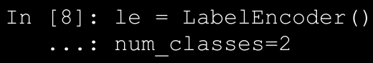

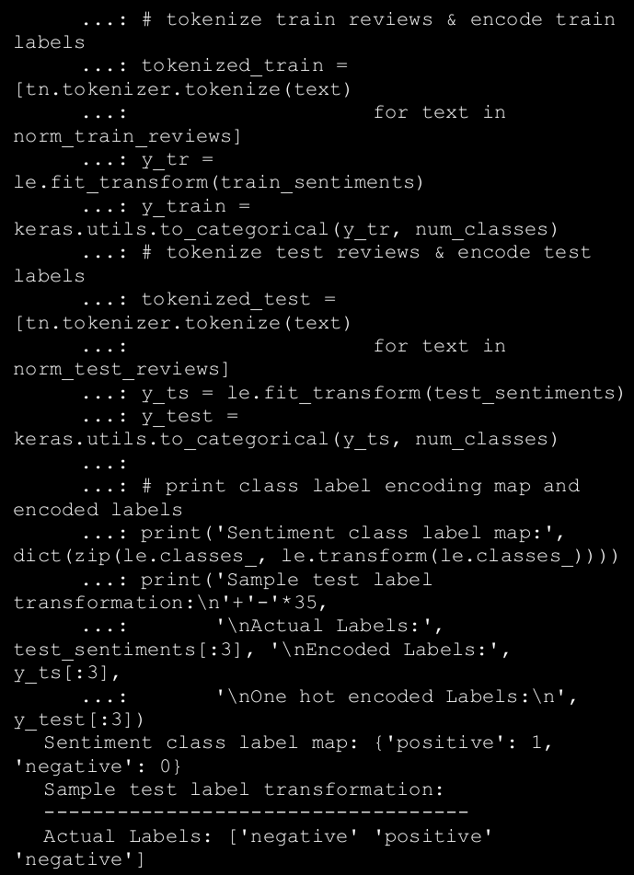

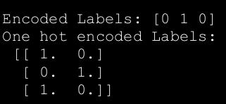

→ Thus, we can see from the preceding sample outputs how our sentiment class labels have been encoded into numeric representations, which in turn have been converted into one-hot encoded vectors. The feature engineering techniques we will be using in this section (Step 3) are slightly more advanced word vectorization techniques that are based on the concept of word embeddings. We will be using the word2vec and GloVe models to generate embeddings. We will be choosing the size parameter to be 500 in this scenario representing feature vector size to be 500 for each word.

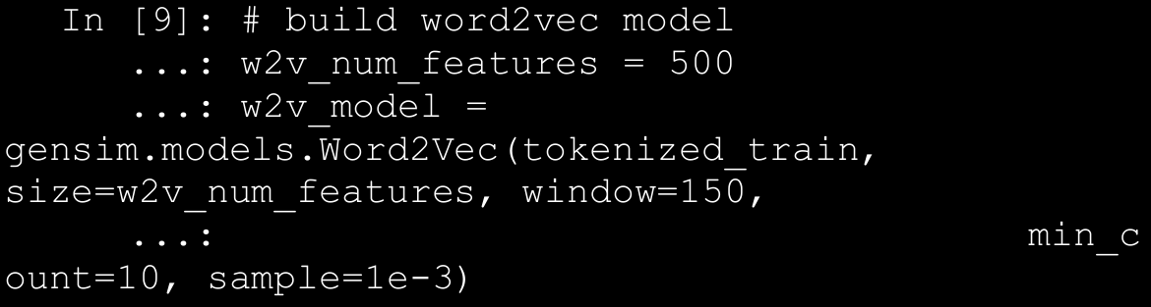

→ We will be using the document word vector averaging scheme on this model to represent each movie review as an averaged vector of all the word vector representations for the different words in the review. The following function helps us compute averaged word vector representations for any corpus of text documents.

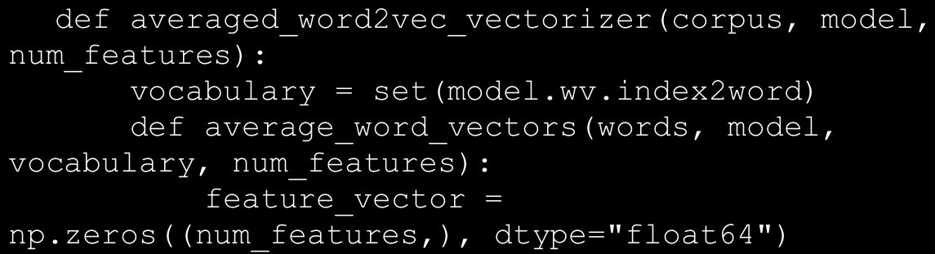

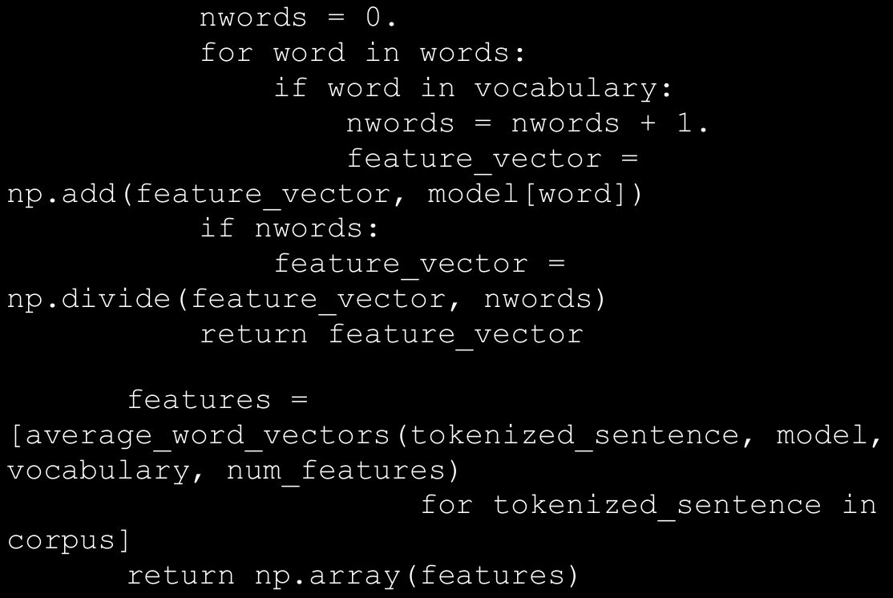

→ We can now use the previous function to generate averaged word vector representations on our two movie review datasets.

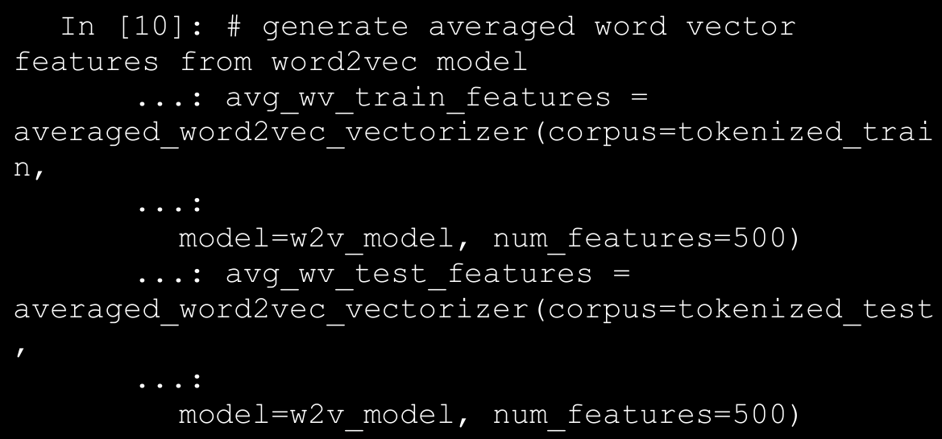

→ The GloVe model, which stands for Global Vectors, is an unsupervised model for obtaining word vector representations.

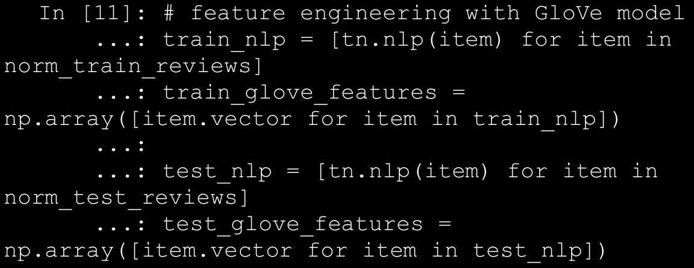

→ You can check the feature vector dimensions for our datasets based on each of the previous models using the following code.

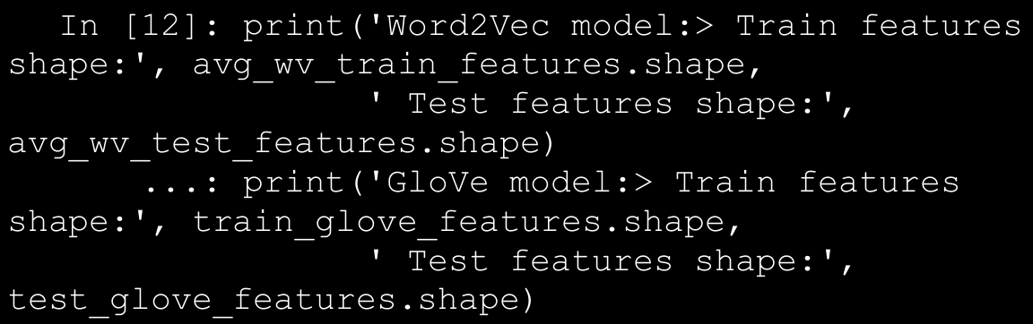

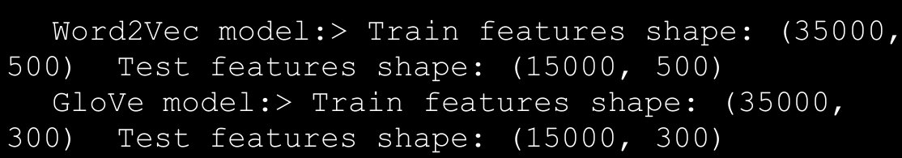

→ We can see from the preceding output that as expected the word2vec model features are of size 500 and the GloVe features are of size 300. We can now proceed to Step 4 of our classification system workflow where we will build and train a deep neural network on these features.e can see from the preceding output that as expected the word2vec

model features are of size 500 and the GloVe features are of size 300. We can now proceed to Step 4 of our classification system workflow where we will build and train a deep neural network on these features.

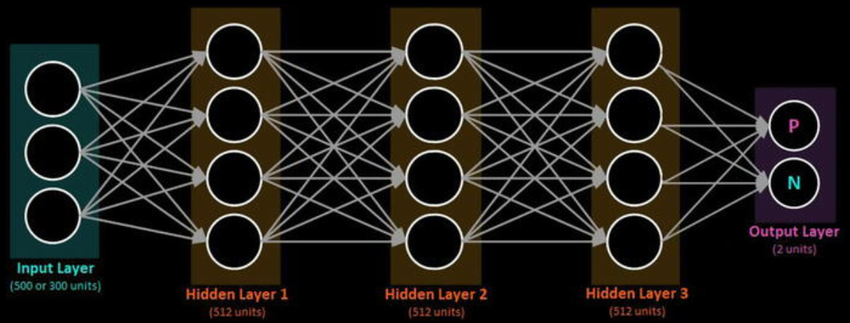

→ We call this a fully connected deep neural network (DNN) because neurons or units in each pair of adjacent layers are fully pairwise connected. These networks are also known as deep artificial neural networks (ANNs) or Multi-Layer Perceptrons (MLPs) since they have more than one hidden layer. The following function leverages keras on top of tensorflow to build the desired DNN model.

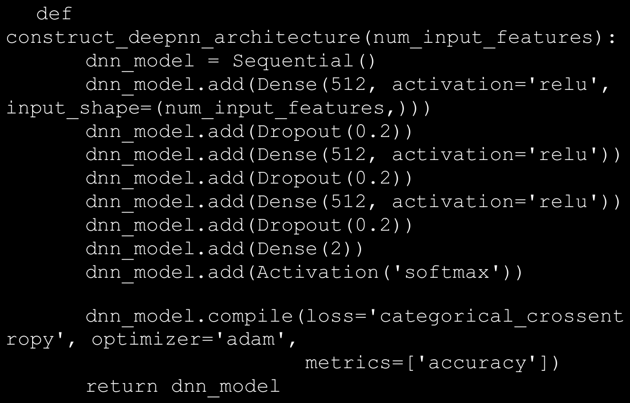

→ The final output layer consists of two units with a softmax activation

function . The softmax function is basically a generalization of the logistic function we saw earlier, which can be used to represent a probability distribution over n possible class outcomes. In our case where the class can either be positive or negative and the softmax probabilities will help us determine the same. The binary softmax classifier is also interchangeably known as the binary logistic regression function.

→ The compile(...) method is used to configure the learning or training process of the DNN model before we actually train it. This involves providing a cost or loss function in the loss parameter. This will be the goal or objective which the model will try to minimize. There are various loss functions based on the type of problem you want to solve, for example the mean squared error for regression and categorical cross-entropy for classification.

→ We will be using **categorical_crossentropy**, which helps us minimize the error or loss from the **softmax output**. We need an optimizer for helping us converge our model and minimize the loss or error function. Gradient descent or stochastic gradient descent is a popular optimizer. We will be using the adam optimizer which only required first order gradients and very little memory. Adam also uses momentum where basically each update is based on not only the gradient computation of the current point but also includes a fraction of the previous update. This helps with faster convergence.

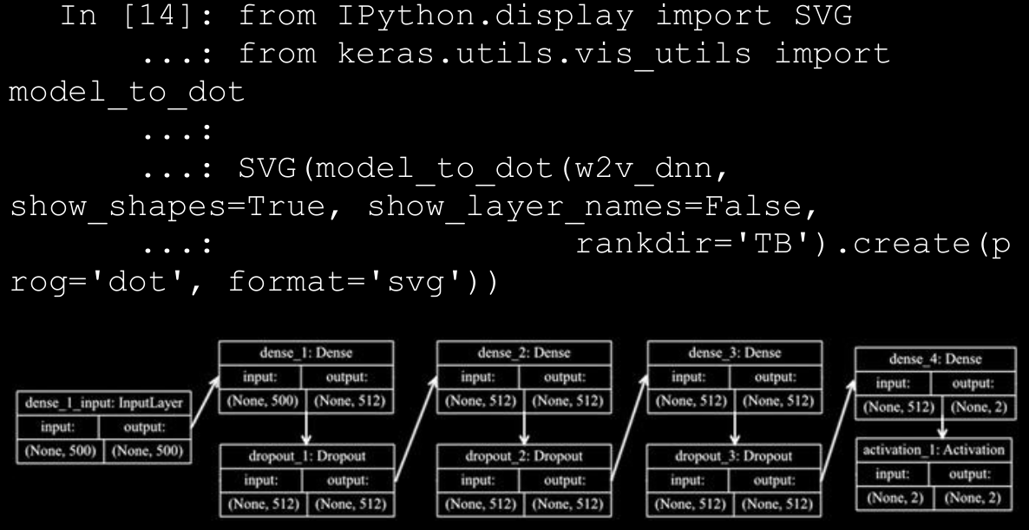

→ We will now be training our model on our training reviews dataset of word2vec features represented by avg_wv_train_features (Step 4). We will be using the fit(...) function from keras for the training process and there are some parameters which you should be aware of. The epoch parameter indicates one complete forward and backward pass of all the training examples through the network.

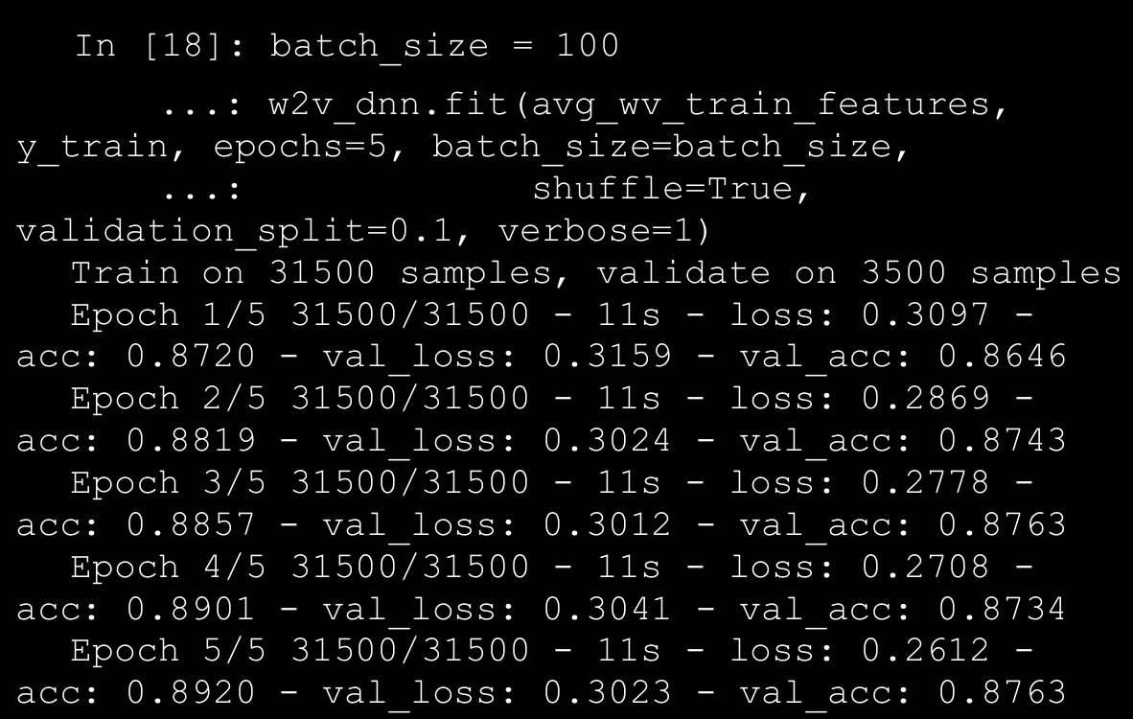

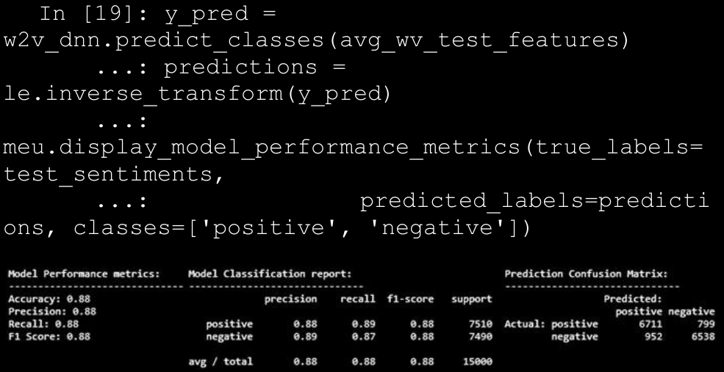

* 1. **Advanced Supervised Deep Learning Models**

→ We have used fully connected deep neural network and word embeddings in the previous section. Another new and interesting approach toward supervised Deep Learning is the use of recurrent neural networks (RNNs) and long short term memory networks (LSTMs) which also considers the sequence of data (words, events, and so on).

→ These are more advanced models than your regular fully connected deep networks and usually take more time to train. We will leverage keras on top of tensorflow and try to build a LSTM-based classification model here and use word embeddings as our features.

→ We will be working on our normalized and pre-processed train and test review datasets, norm_train_reviews and norm_test_reviews, which we created in our previous analyses. Assuming you have them loaded up, we will first tokenize these datasets such that each text review is decomposed into its corresponding tokens.

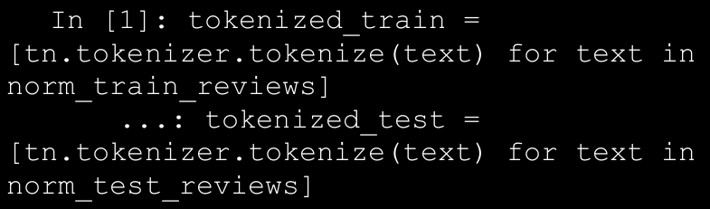

→ For feature engineering (Step 3), we will be creating word embeddings. However, we will create them ourselves using keras instead of using pre-built ones like word2vec or GloVe, which we used earlier. Word embeddings tend to vectorize text documents into fixed sized vectors such that these vectors try to capture contextual and semantic information.

→ For generating embeddings, we will use the Embedding layer from keras, which requires documents to be represented as tokenized and numeric vectors. We already have tokenized text vectors in our tokenized_train and tokenized_text variables. However we would need to convert them into numeric representations.

→ Besides this, we would also need the vectors to be of uniform size even though the tokenized text reviews will be of variable length due to the difference in number of tokens in each review. For this, one strategy could be to take the length of the longest review (with maximum number of tokens\words) and set it as the vector size, let’s call this **max_len**. Reviews of shorter length can be padded with a **PAD** term in the beginning to increase their length to max_len.

→ We would need to create a word to index vocabulary mapping for representing each tokenized text review in a numeric form. Do note you would also need to create a numeric mapping for the padding term which we shall call PAD_INDEX and assign it the numeric index of 0. For unknown terms, in case they are encountered later on in the test dataset or newer, previously unseen reviews, we would need to assign it to some index too.

→ This would be because we will vectorize, engineer features, and build models only on the training data. Hence, if some new term should come up in the future (which was originally not a part of the model training), we will consider it as an out of vocabulary (OOV) term and assign it to a constant index (we will name this term NOT_FOUND_INDEX and assign it the index of vocab_size+1). The following snippet helps us create this vocabulary from our tokenized_train corpus of training text reviews.

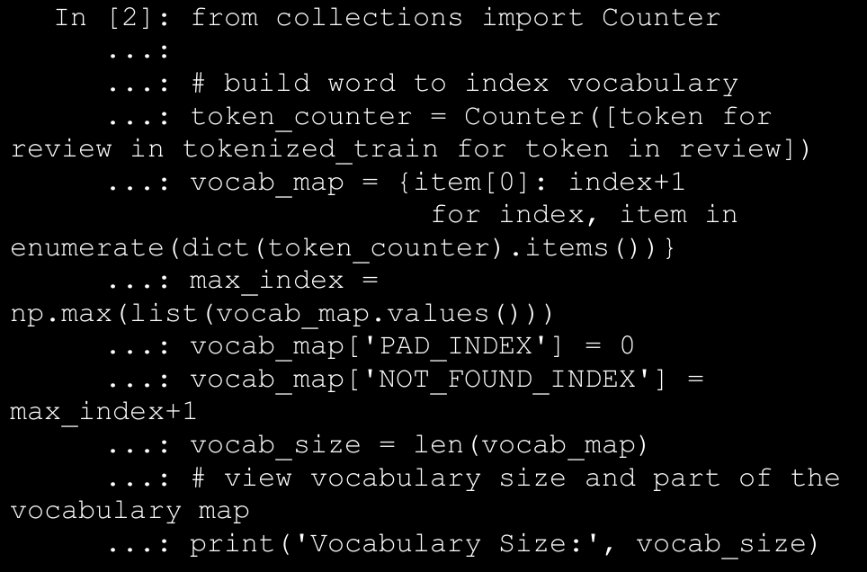

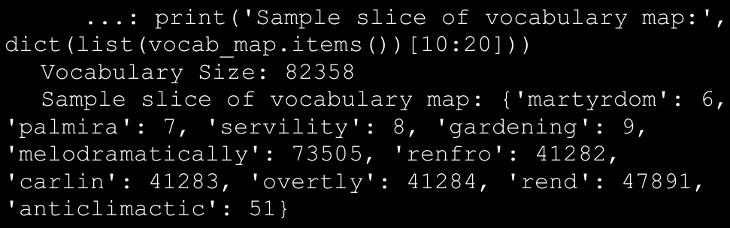

→ In this case we have used all the terms in our vocabulary, you can easily filter and use more relevant terms here (based on their frequency) by using the most_common(count) function from Counter and taking the first count terms from the list of unique terms in the training corpus. We will now encode the tokenized text reviews based on the previous vocab_map. Besides this, we will also encode the text sentiment class labels into numeric representations.

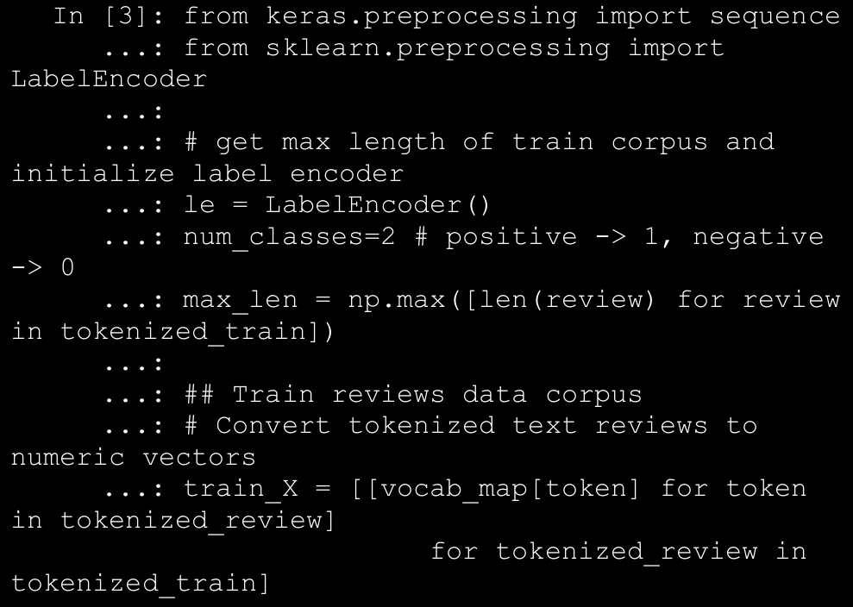

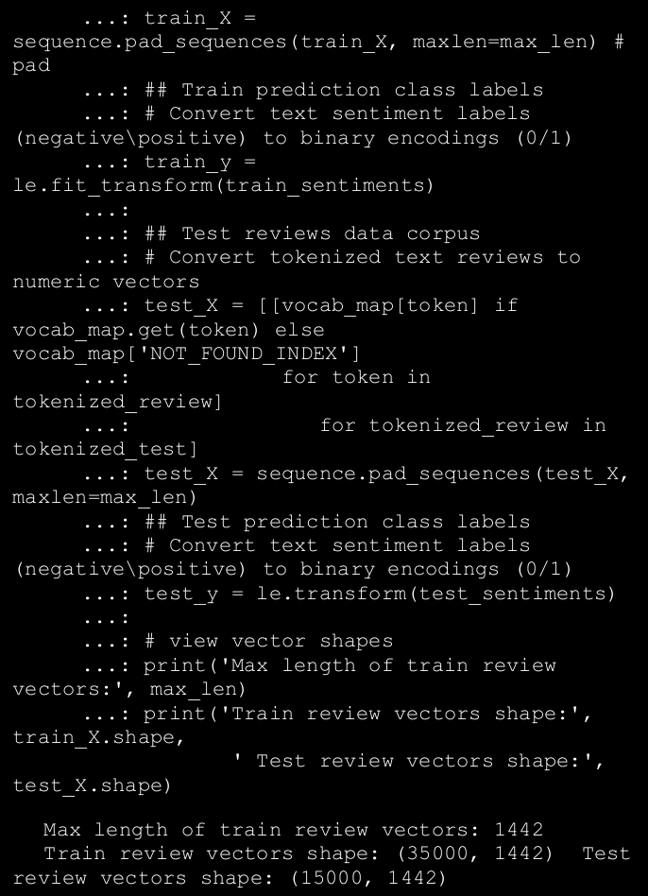

→ From the preceding code snippet and the output, it is clear that we encoded each text review into a numeric sequence vector so that the size of each review vector is 1442, which is basically the maximum length of reviews from the training dataset. We pad shorter reviews and truncate extra tokens from longer reviews such that the shape of each review is constant as depicted in the output. We can now proceed with Step 3 and a part of Step 4 of the classification workflow by introducing the Embedding layer and coupling it with the deep network architecture based on LSTMs.

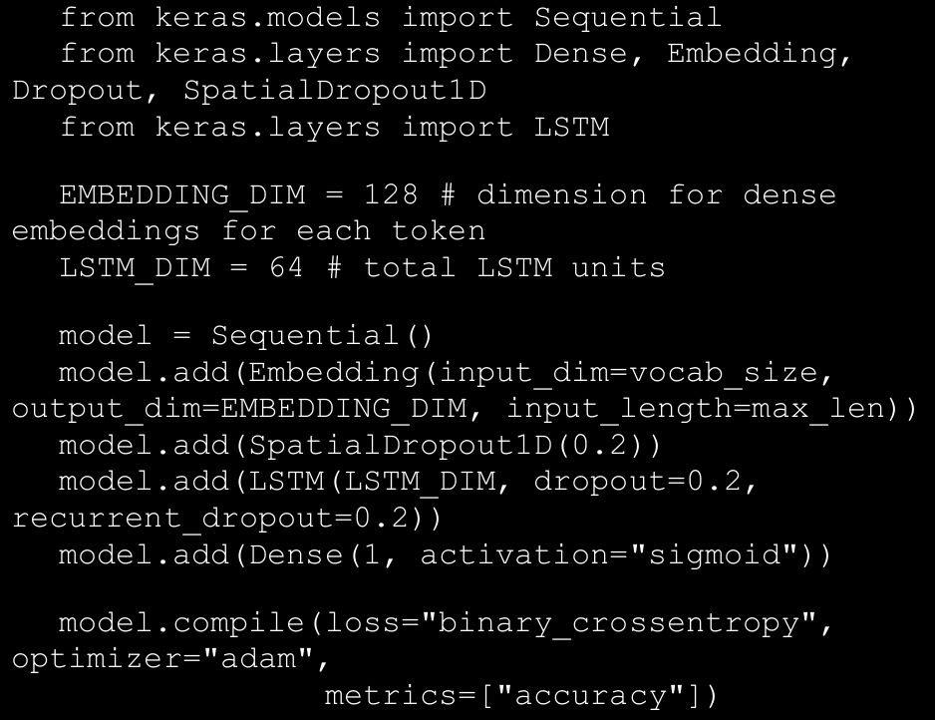

→ The Embedding layer helps us generate the word embeddings from scratch. This layer is also initialized with some weights initially and this gets updated based on our optimizer similar to weights on the neuron units in other layers when the network tries to minimize the loss in each epoch. Thus, the embedding layer tries to optimize its weights such that we get the best word embeddings which will generate minimum error in the model and also capture semantic similarity and relationships among words. How do we get the embeddings, let’s consider we have a review with 3 terms['movie', 'was', 'good'] and a vocab_map consisting of word to index mappings for 82358 words. The word embeddings would be generated somewhat similar to Figure below.

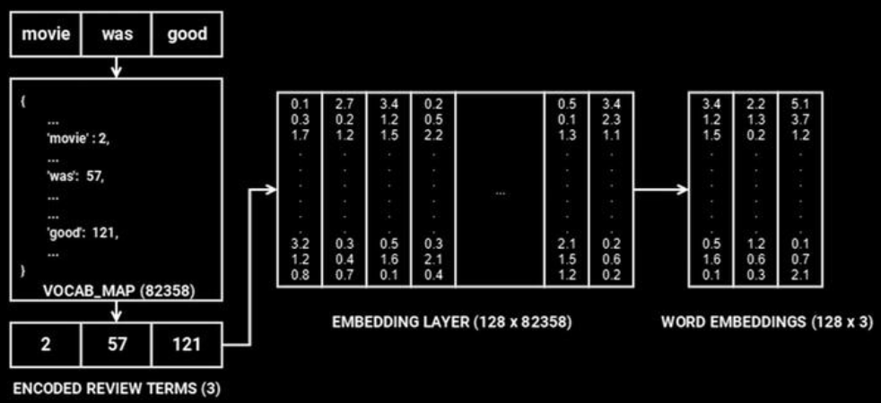

→Based on our model architecture, the Embedding layer takes in three parameters—input_dim, which is equal to the vocabulary size (vocab_size) of 82358, output_dim, which is 128, representing the dimension of dense embedding (depicted by rows in the EMBEDDING LAYER in Figure above), and input_len, which specifies the length of the input sequences (movie review sequence vectors), which is 1442.

→ In the example depicted in Figure above, since we have one review, the dimension is (1, 3). This review is converted into a numeric sequence [2, 57, 121] based on the VOCAB_MAP. Then the specific columns representing the indices in the review sequence are selected from the EMBEDDING LAYER (vectors at column indices 2, 57 and 121 respectively), to generate the final word embeddings.

**→ An embedding layer is a type of hidden layer in a neural network. In one sentence, this layer maps input information from a high-dimensional to a ower-dimensional space, allowing the network to learn more about the relationship between inputs and to process the data more efficiently.**

→The weights in the embedding layer get updated and optimized in each epoch based on the input data when propagated through the whole network like we mentioned earlier such that overall loss and error is minimized to get maximum model performance.

→ These dense word embeddings are then passed to the LSTM layer having 64 units. LSTMs basically try to overcome the shortcomings of RNN models especially with regard to handling long term dependencies and problems which occur when the weight matrix associated with the units (neurons) become too small (leading to vanishing gradient) or too large (leading to exploding gradient).

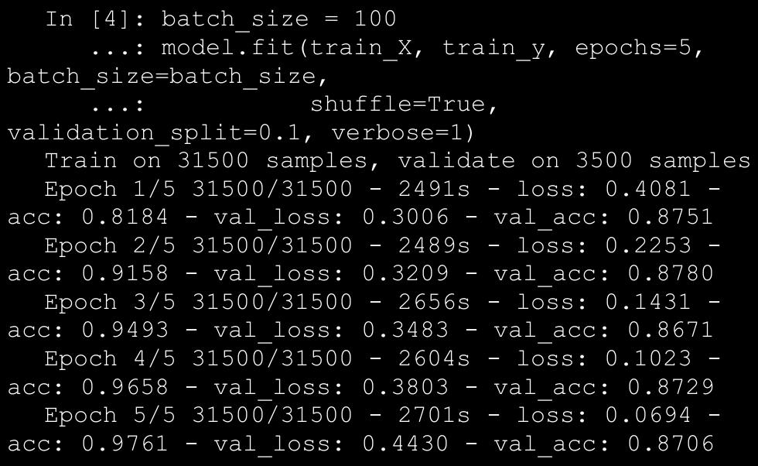

→ Training LSTMs on CPU is notoriously slow and as you can see my model took approximately 3.6 hours to train for just five epochs on an i5 3rd Gen Intel CPU with 8 GB of memory. Of course, a cloud-based environment like Google Cloud Platform or AWS on GPU took me approximately less than an hour to train the same model. So I would recommend you choose a GPU based Deep Learning environment, especially when working with RNNs or LSTM based network architectures. Based on the preceding output, we can see that just with five epochs we have decent validation accuracy but the training accuracy starts shooting up indicating some over-fitting might be happening. Ways to overcome this include adding more data or by increasing the dropout rate.

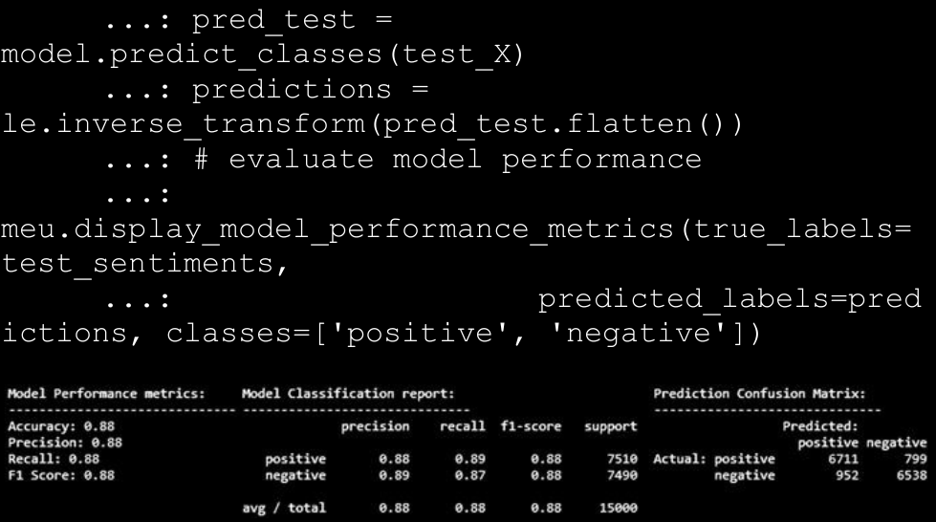

1. Analyzing Sentiment Causation

→ The first area of focus will be **model interpretation**, where we

will try to understand, interpret, and explain the mechanics behind predictions made by our classification models. The second area of focus is to **apply topic modeling** and extract key topics from positive and negative sentiment reviews.

⇒ Interpreting Predictive Models

→ We will be interpreting the model by help of the LIME framework.

→ There are various ways to interpret the predictions made by our predictive sentiment classification models. We want to understand more into why a positive review was correctly predicted as having positive sentiment or a negative review having negative sentiment. Besides this, no model is a 100% accurate always, so we would also want to understand the reason for mis-classifications or wrong predictions.

→ Let’s first build a basic text classification pipeline for the model that worked best for us so far. This is the Logistic Regression model based on the Bag of Words feature model. We will leverage the pipeline module from scikit-learn to build this Machine Learning pipeline using the following code.

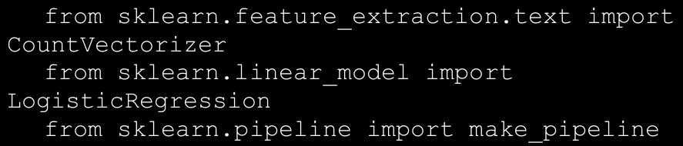

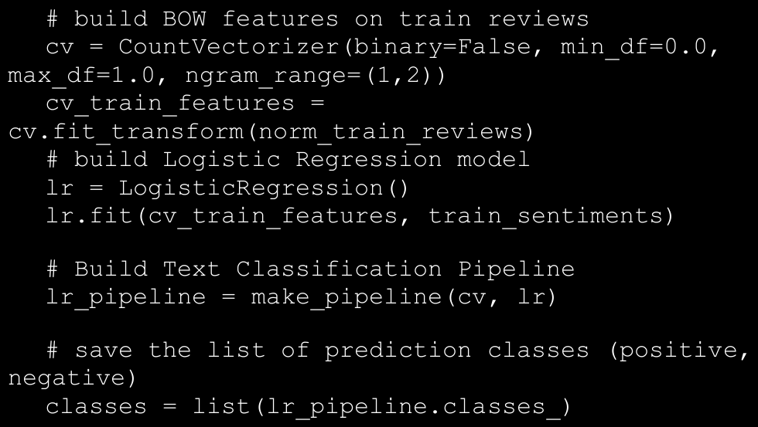

→ We build our model based on norm_train_reviews, which

contains the normalized training reviews that we have used in all our earlier analyses. Now that we have our classification pipeline ready, you can actually deploy the model by using pickle or joblib to save the classifier and feature objects. Assuming our pipeline is in production, how do we use it for new movie reviews? Let’s try to predict the sentiment for two new sample reviews (which were not used in training the model).

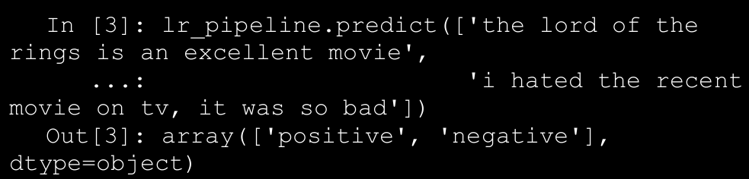

→ Our classification pipeline predicts the sentiment of both the reviews correctly! This is a good start, but how do we interpret the model predictions? One way is to typically use the model prediction class probabilities as a measure of confidence. You can use the following code to get the prediction probabilities for our sample reviews.

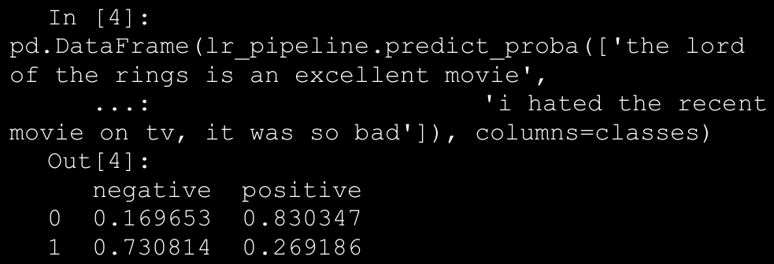

→ You need to load the following dependencies from the

skater package first. We also define a helper function which takes in a document index, a corpus, its response predictions, and an explainer object and helps us with the our model interpretation analysis.

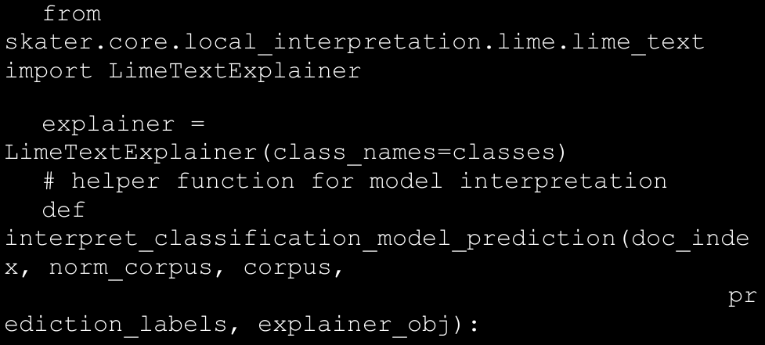

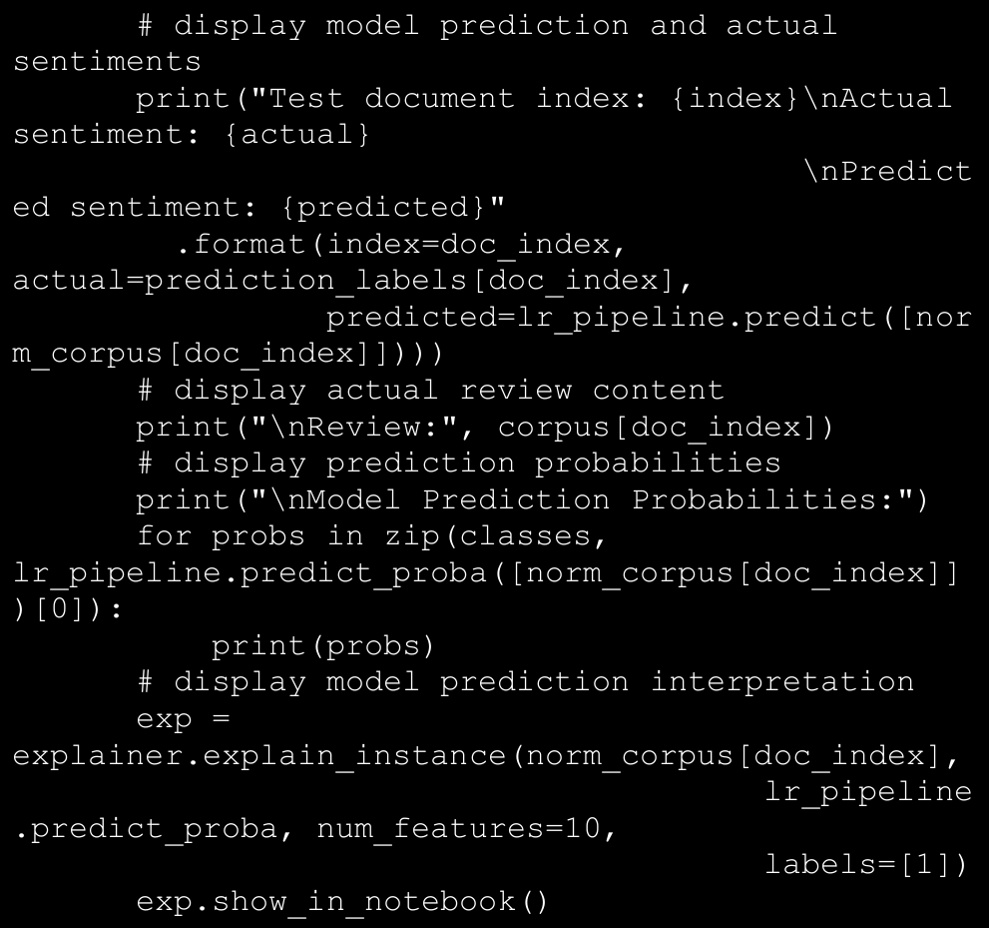

→The preceding snippet leverages skater to explain our text classifier to analyze its decision-making process in an easy to interpret form. Even though the model might be a complex one in a global perspective, it is easier to explain and approximate the model behavior on local instances. This is done by learning the model around the vicinity of the data point of interest X by sampling instances around X and assigning weightages based on their proximity toX. Thus, these locally learned linear models help in explaining complex models in a more easy to interpret way with class probabilities, contribution of top features to the class probabilities that aid in the decision making process.

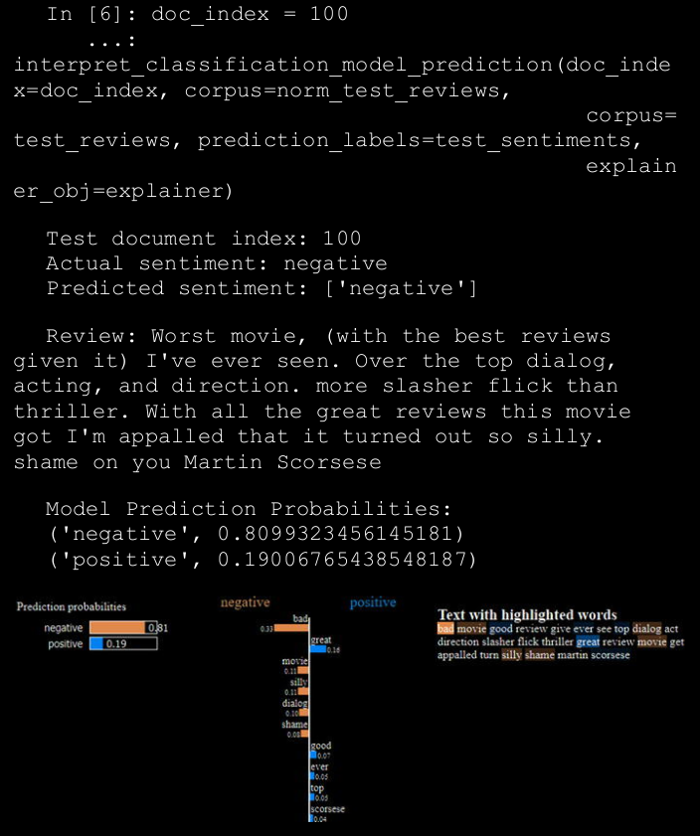

→ The preceding output tells us that our model predicted the movie review indicating a positive sentiment when in-fact the actual sentiment label is negative for the same review.

1. Customer Segmentation

→ Segmentation is the process of segregating any aggregated entity into separate parts or groups (segments). These parts may or may not share something common across them. Customer segmentation is similarly the process of dividing an organization’s customer bases into different sections or segments based on various customer attributes. It is driven by the belief that customers are inherently different and this difference is exemplified by their behavior. A deep understanding of an organization’s customer base and their behavior is often the focus of any customer segmentation project. The process of customer segmentation is based on the premise of finding differences among the customers’ behavior and patterns. These differences can be on the basis of their buying behavior, their demographic information, their geographic information, their psychographic attributes, and so on.

→ Some of the benefits of the customer segmentation is:

* 1. Customer Understanding
  2. Target Marketing
  3. Optimal Product Placement
  4. Finding latent customer segments
  5. Higher Revenue

→ Most of the time for the customer segmentation we use the clustering algorithm which is the best choice, We can also use the other algorithms also.

→ Now that we have some information about what customer segmentation is, various strategies and how it can be useful, we can start with the process of finding out customer segments in our online retail dataset. The dataset that we have consists of only the sales transactions of the customers and no other information about them, i.e., no other additional attributes. Usually in larger organizations we will usually have more attributes of information about the customers that can help in clustering. However, it will be interesting and definitely a challenge to work with this limited attribute dataset! So we will use a **RFM—Recency, Frequency and Monetary Value**—based model of customer value for finding our customer segments.

→ A combination of these three values can be used to assign a value to the customer. We can directly think of some desirable segments that we would want on such model. For example, a high value customer is one who buys frequently, just bought something recently, and spends a high amount whenever he buys or shops!

**A. Data Cleansing**

→ Another data cleaning operation is to separate transactions for a particular geographical region only, as we don’t want data from Germany’s customers to affect the analysis for another country’s customers. The following snippet of code achieves both these tasks. We focus on UK customers, which are notably the largest segment (based on country!).

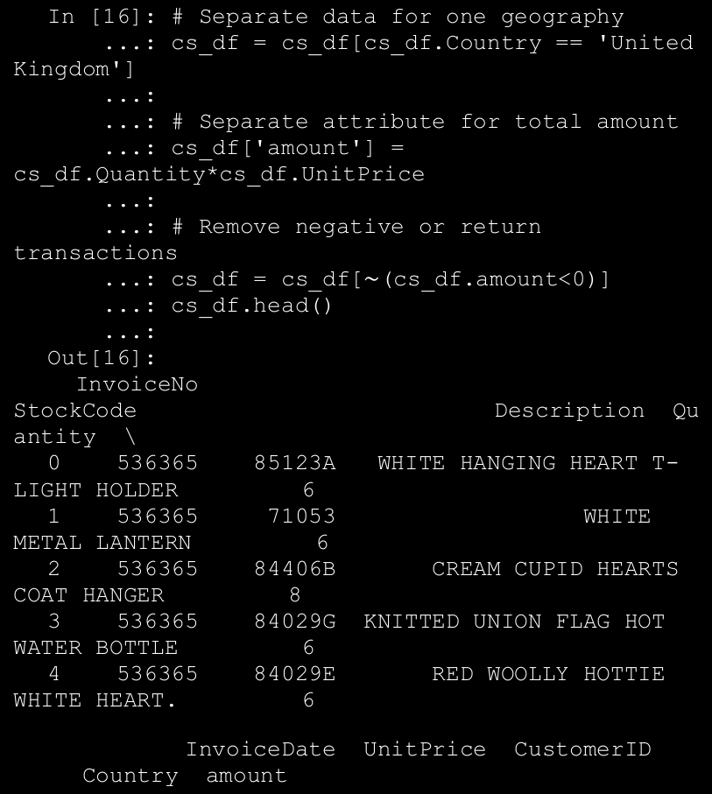

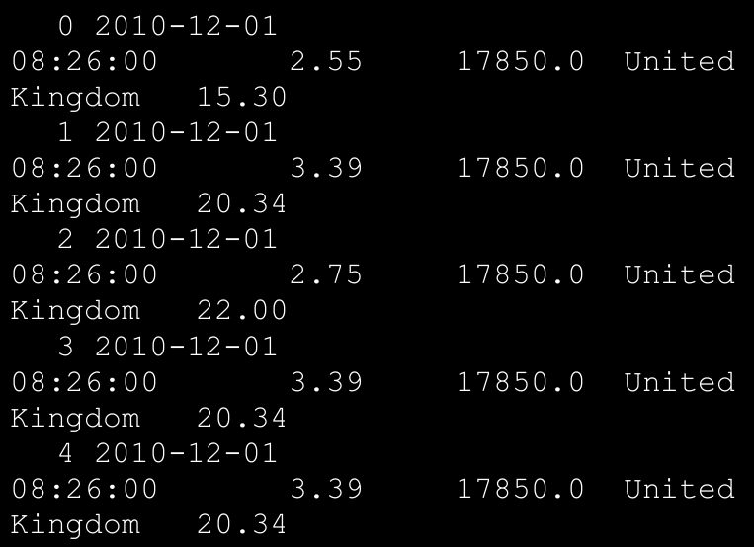

→ The data now has only buying transactions from United Kingdom. We will now remove all the transactions that have a missing value for the CustomerID field as all our subsequent transactions will be based on the customer entities.

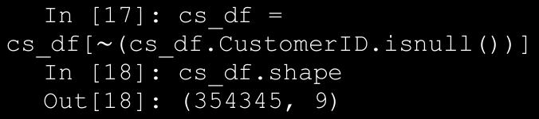

→ The next step is creating the recency, frequency, and monetary value features for each of the customers that exist in our dataset.

**B. Recency**

→ To create the recency feature variable, we need to decide the reference date for our analysis. For our use case, we will define the reference date as one day after the last transaction in our dataset.

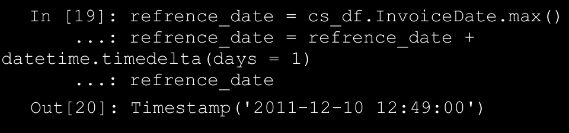

→ We will construct the recency variable as the number of days before the reference date when a customer last made a purchase. The following snippet of code will create this variable for us.

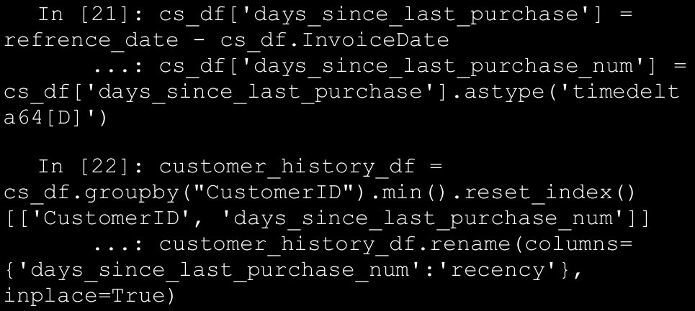

→ Before we proceed, let’s examine how the distribution of customer recency looks for our data.

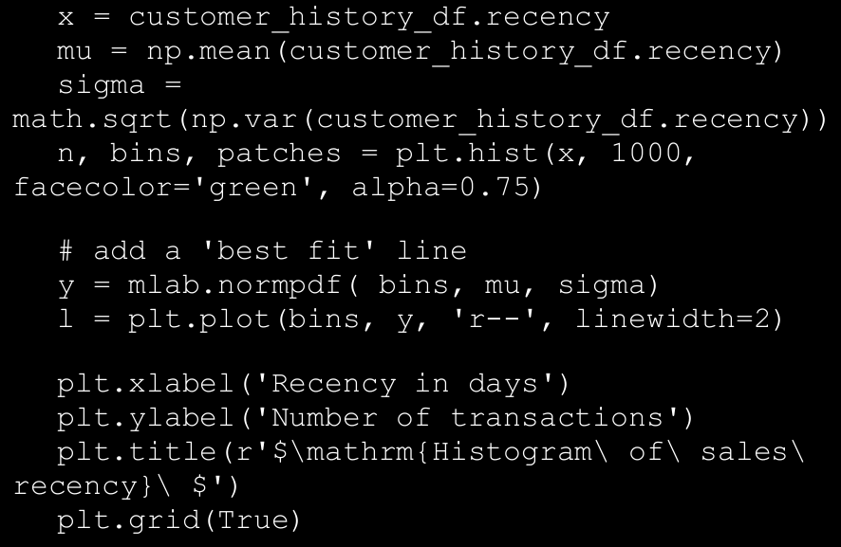

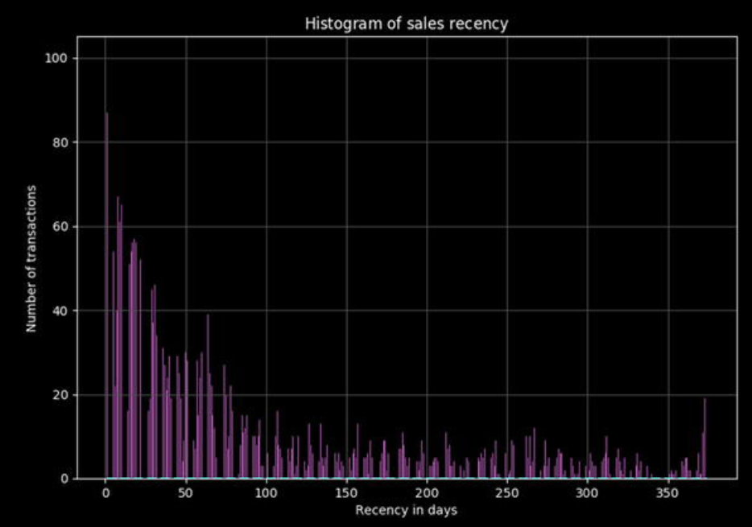

→ The histogram in Figure above tells us that we have skewed distribution of sales recency with a much higher number of frequent transactions and a fairly uniform number of less recent transactions.

**C. Frequency and Monetary Value**

→ Using similar methods, we can create a frequency and monetary value variable for our dataset. We will create these variables separately and then merge all the data frames to arrive at the customer value dataset. We will perform our clustering -based customer segmentation on this dataframe. The following snippet will create both these variables and the final merged dataframe.

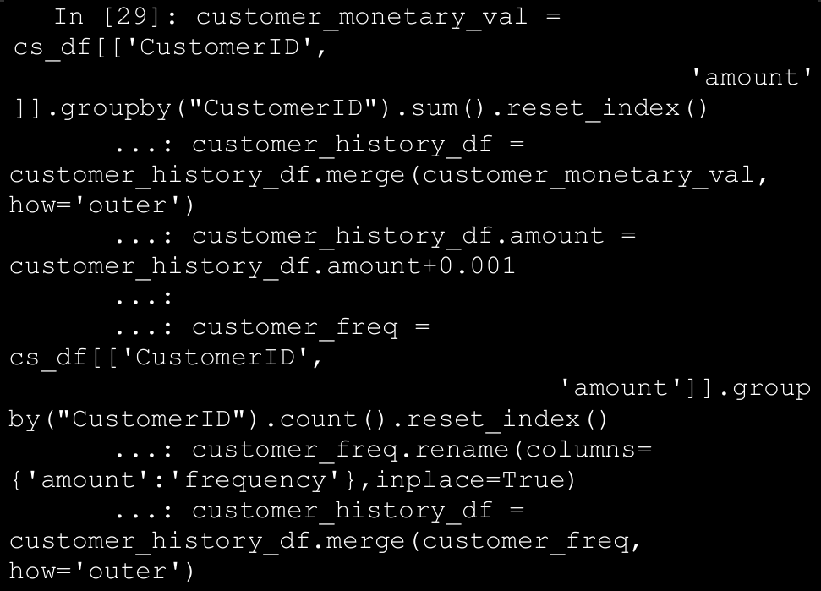

→ The input data frame for clustering will look like the dataframe depicted in Figure below. Notice that we have added a small figure 0.001 to the customer monetary value, as we will be transforming our values to the log scale and presence of zeroes in our data may lead to an error.

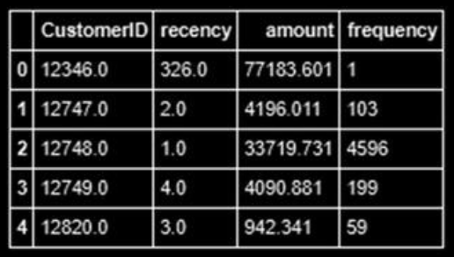

**D. Data Preprocessing**

→ Once we have created our customer value dataframe, we will perform some preprocessing on the data. For our clustering, we will be using the K-means clustering algorithm.

→ One of the requirements for proper functioning of the algorithm is the mean centering of the variable values. Mean centering of a variable value means that we will replace the actual value of the variable with a standardized value, so that the variable has a mean of 1 and variance of 0. This ensures that all the variables are in the same range and the difference in ranges of values doesn’t cause the algorithm to not perform well. This is akin to feature scaling.

→ Another problem that you can investigate about is the huge range of values each variable can take. This problem is particularly noticeable for the monetary amount variable. To take care of this problem, we will transform all the variables on the log scale. This transformation, along with the standardization, will ensure that the input to our algorithm is a homogenous set of scaled and transformed values.

→ An important point about the data preprocessing step is that sometimes we need it to be reversible. In our case, we will have the clustering results in terms of the log transformed and scaled variable. But to make inferences in terms of the original data, we will need to reverse transform all the variable so that we get back the actual RFM figures. This can be done by using the preprocessing capabilities of Python.

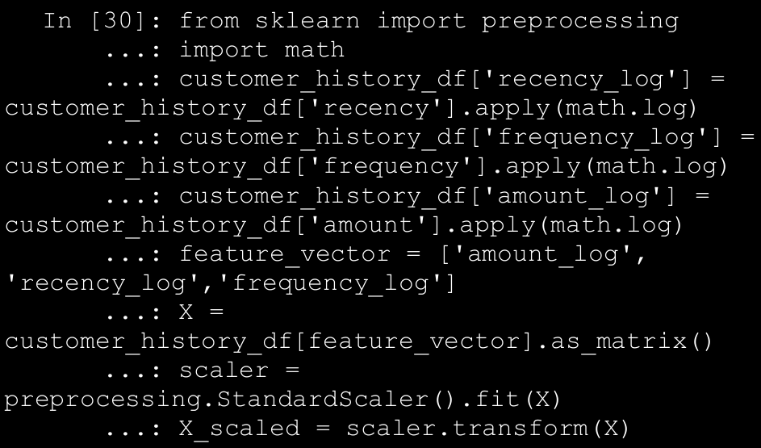

→ The previous code snippet will create a log valued and mean centered version of our dataset. We can visualize the results of our preprocessing by inspecting the variable with the widest range of values. The following code snippet will help us visualize this.

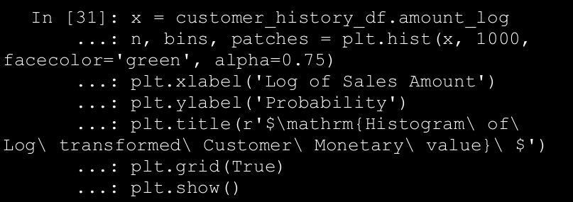

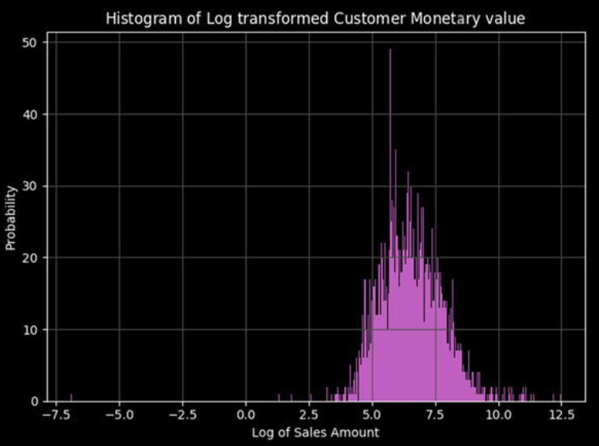

→ Let’s try to visualize our three main features (R, F, and M) on a three-dimensional plot to see if we can understand any interesting patterns that the data distribution is showing.

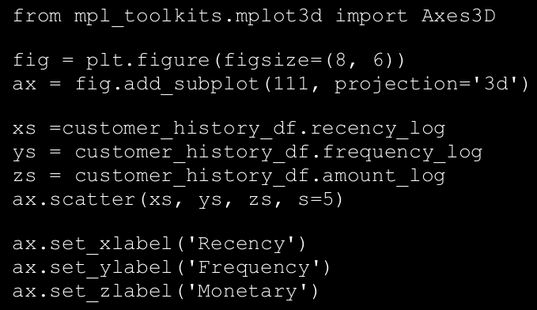

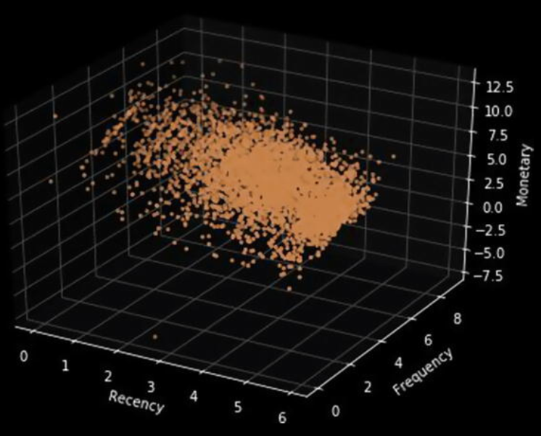

→ The obvious patterns we can see from the plot in Figure above is **that people who buy with a higher frequency and more recency tend to spend more based on the increasing trend in Monetary value with a corresponding increasing** and decreasing trend for Frequency and Recency, respectively. Do you notice any other interesting patterns?

**\*NOTE: For finding the optimal number of clusters in the k-means we can use the silhouette score**

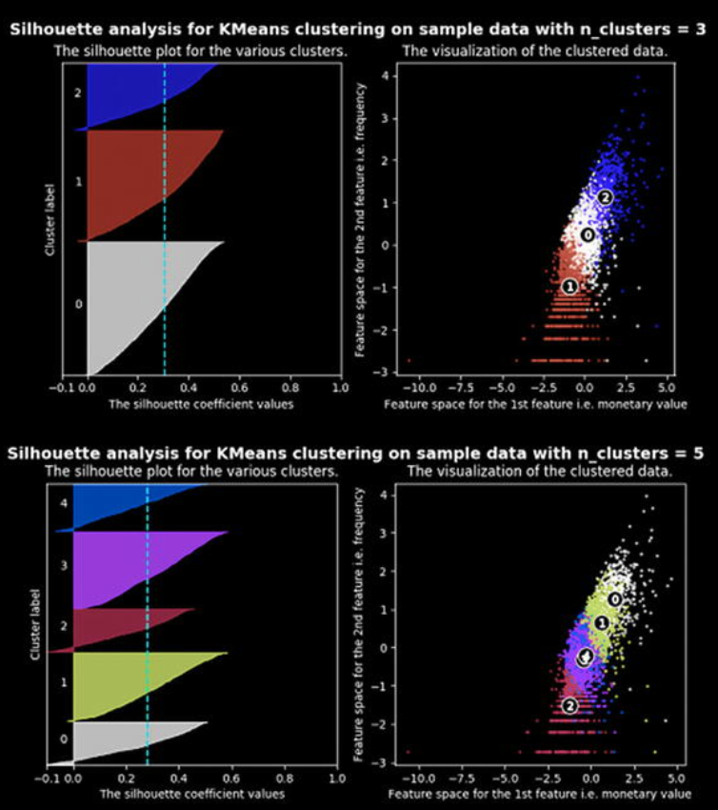

**→**In the visualization depicted in Figure above, we plotted the silhouette score of each cluster along with the center of each of the cluster discovered. We will use this information in the next section on cluster analysis. Although we have to keep in mind that in several cases and scenarios, sometimes we may have to drop the mathematical explanation given by the algorithm and look at the business relevance of the results obtained.

**E. Clustering for segments**

→ Before we proceed to the analysis of clusters such obtained, let’s look at the cluster center values after retransforming them to normal values from the log and scaled version. The following code helps us convert the center values to the reversed transformed values.

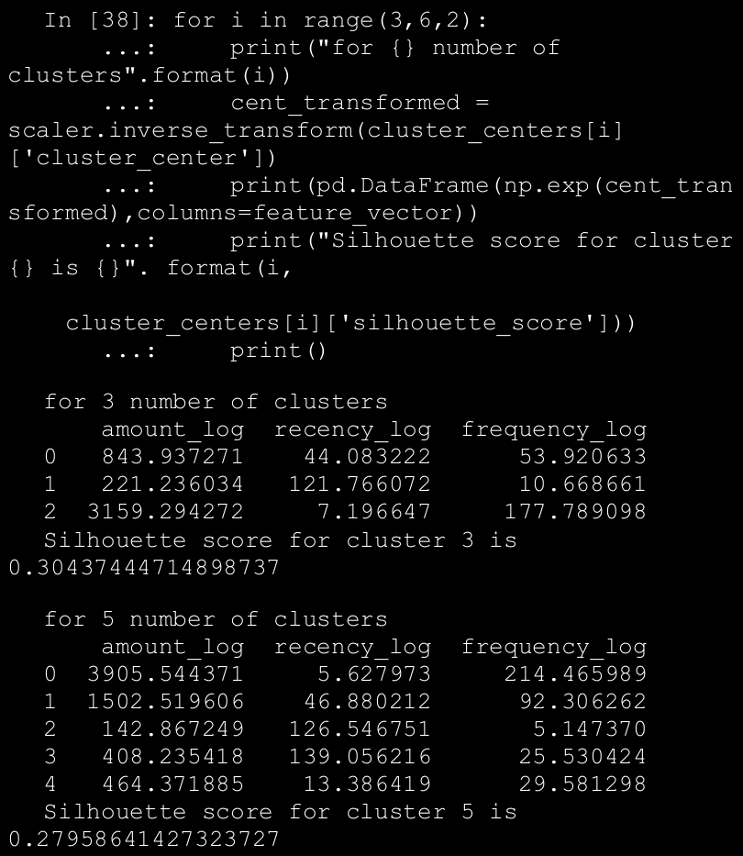

→ When we look at the results of the clustering process, we can infer some interesting insights. Consider the three-cluster configuration and try to understand the following insights.

* We get three clusters with stark differences in the Monetary value of the customer.
* Cluster 2 is the cluster of high value customer who shops frequently and is certainly an important segment for each business.
* In the similar way we obtain customer groups with low and medium spends in clusters with labels 1 and 0, respectively.
* Frequency and Recency correlate perfectly to the Monetary value based on the trend we talked about in above topic (High Monetary-Low Recency-High Frequency).

→ The five-cluster configuration results are more surprising! When we go looking for more segments, we find out that our high valued customer base is comprised of two subgroups.

* Those who shop often and with high amount (represented by cluster 0).
* Those who have a decent spend but are not as frequent (represented by cluster 1).

→This is in direct conflict with the result we obtain from the silhouette score matrix which says the five-cluster segments are less optimal then the three cluster segments. Of course, remember you must not strictly go after mathematical metrics all the time and think about the business aspects too. Besides this, there could be more insights that are uncovered as you visualize the data based on these segments which might prove that in-fact the three-cluster segmentation was far better.

**F. Cluster Description**

→ On the basis of eyeballing the cluster centers, we can figure out that we have a good difference in the customer value in the segments as defined in terms of recency, amount and frequency.

→ The following code leverages plotly and will take the cluster labels we got for the configuration of five clusters and create boxplots that will show how the median, minimum, maximum, highest, and lowest values are varying in the five groups. Note that we want to avoid the extremely high outlier values of each group, as they will interfere in making a good observation (due to noise) around the central tendencies of each cluster. So we will restrict the data such that only data points which are less than 0.8th percentile of the cluster is used. This will give us good information about the majority of the users in that cluster segment. The following code will help us create this plot for the total sales value.

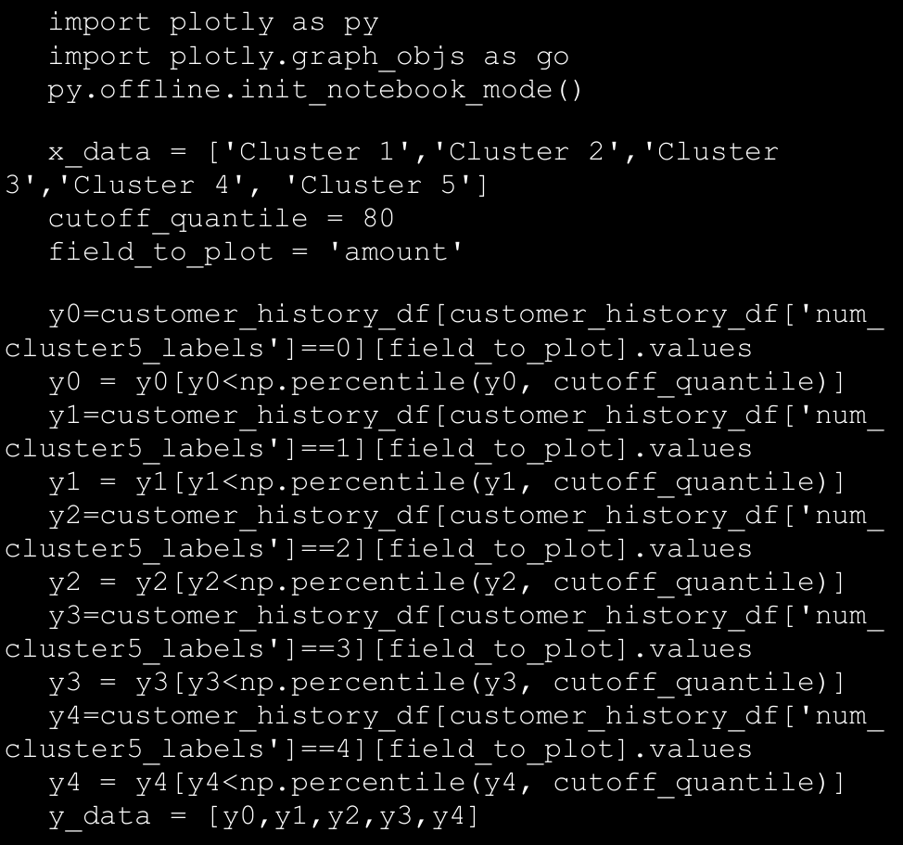

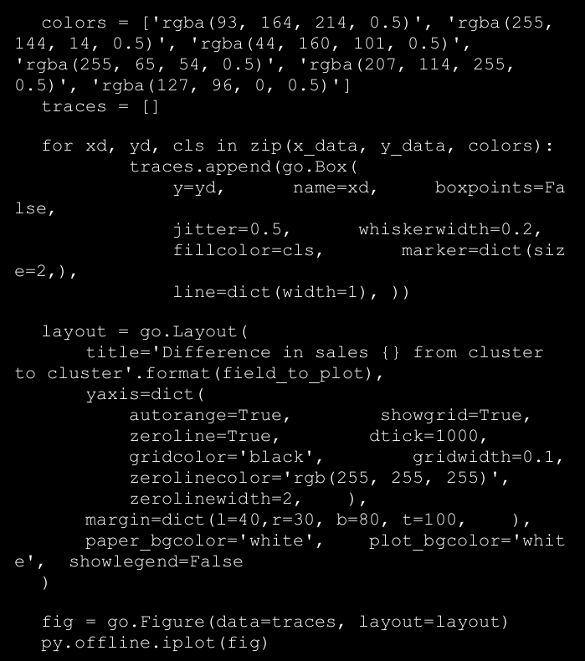

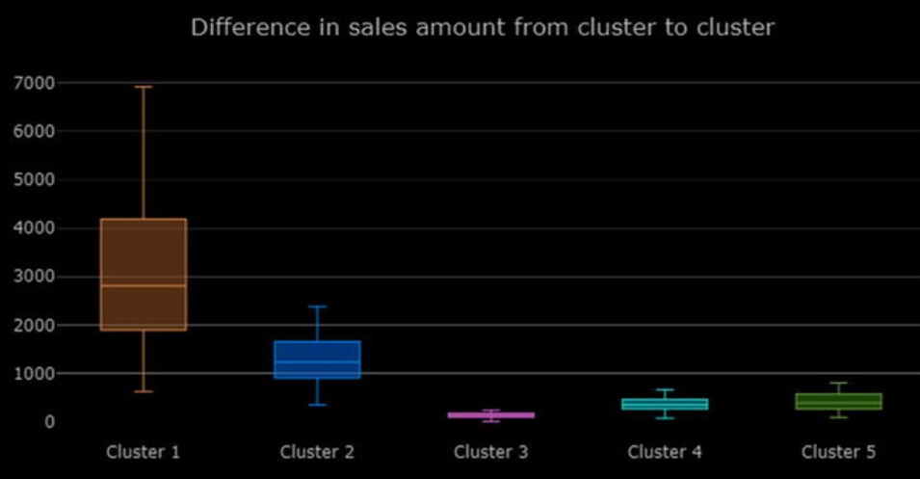

→ In Figure above we can see that the Clusters 1 and 2 have a higher average sales amount, thus being the highest spenders. Although we don’t see much difference in the sales values of Clusters 4 and 5, we do see a markedly smaller sales amount in Cluster 3. This gives us an indication that we can merge the candidates of Clusters 4 and 5 together, at least on the basis of sales amount.

→ While the graphs having three cluster looks like as shown below:

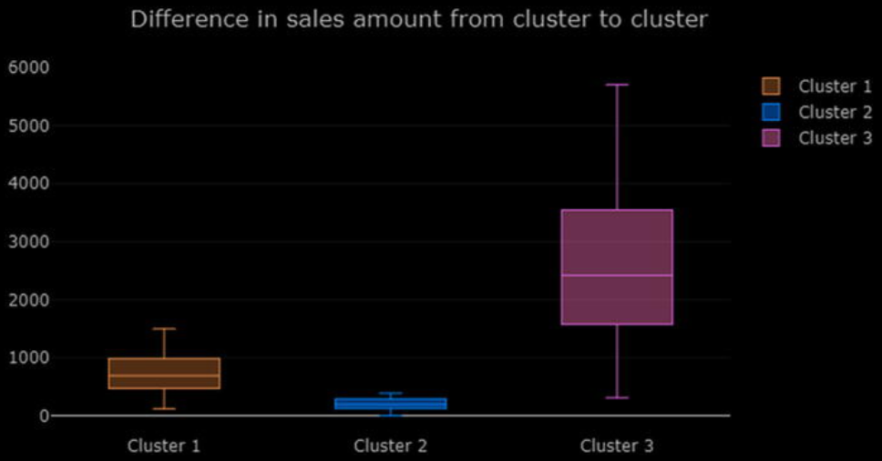

→ We can further improve the quality of clustering by adding relevant features to the dataset that we have created. Often firms will buy data regarding their customers from external data vendors and use it to enhance the segmentation process. We had a limitation of only having around a year worth of transaction data but even a mid-size organization may have multiple years of transaction data which can improve the results. Another dimension to explore can be trying out different algorithms for performing the segmentation for instance hierarchical clustering, which we explored in some of the earlier chapters. A good segmentation process will encompass all these avenues to arrive at optimal segments that provide valuable insight.

→ The important caveat from this analysis is that when it comes to

correlating the actual value of results with the mathematical metrics we

cannot always rely on the metrics. We need to include this habit of

including business metrics and domain insights in our modeling process as

often times this becomes the difference between an implemented high value

project and a forgotten data-focused solution. Once we obtain these results,

we can further discuss them with the marketing team of the organization to come up with appropriate practices for each of the segment identified.

1. **Cross Selling**

→ What is cross selling? In the simplest terms, cross selling is the ability to sell more products to a customer by analyzing the customer’s shopping trends as well as general shopping trends and patterns which are in common with the customer’s shopping patterns. This simple definition captures the essential idea of cross selling, but it is not as descriptive as we would like it to be.

→ We will illustrate the idea with an example. Say we are concerned about our health (which everyone should be) and decide to buy a protein supplement on our favorite e-commerce site. In most scenarios, the moment you get to your product page, you will have a section that will tell you other products that you can buy along with the product(s) of your choice.

→ More often than not, these recommended products would be very appealing. For example, if I am in the market for a protein supplement it will definitely be a good idea for me to buy a vitamin supplement too. The retailer will often offer you a bundle of products with some attractive offer and it is highly likely that we will end up buying the bundled products instead of just the original item. This is the simple but powerful concept of cross selling. We research the customer transactions and find out potential additions to the customer’s original needs and offer it to the customer as a suggestion in the hope and intent that they buy them benefiting both the customer as well as the retail establishment.

→ In this section, we explore **association rule-mining**, a powerful technique that can be used for cross selling.

1. **Market Basket Analysis with Association Rule-Mining**

→ Before we go on to understand how to generate the association rules from our transactional data, let’s try to understand how we will use those rules. A famous story in data analytics circles is the story of “Beer and Diapers”. The basic crux of the story is the concept that a major retailer upon analyzing their customer transaction behavior discovered a strong association between sales of beer and diapers. The retailer was able to exploit this association by moving the beer section close to the diapers section leading to higher sales volume.

→ **Suppose we can mathematically capture the significance of these associations, then it would be a good idea to try and exploit the rules which are likely to be correct. The whole concept of association rule-mining is based on the concept that customer purchase behavior has a pattern which can be exploited for selling more items to the customer in the future. An association rule usually has the structure as depicted in this equation below:**

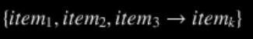

→ This rule can be read in the obvious manner that when the customer bought items on the (left hand side) LHS of the rule he is likely to buy the item k . In the later sections, we define mathematical metrics that will capture the strength of such rules.

→ We can use these rules in a variety of ways . The most obvious way to use these rules is to develop bundles of products which make it convenient for the customer to buy these items together. Another way to use these rules is to bundle products along with some discounts for other relevant products in the bundle, hence ensuring that the customer becomes more likely to buy more items. Some unlikely ways to use association rules is for designing a better web site navigational structure, intrusion detection, bioinformatics, and so on.

**⇒ Association Rule-Minning Basics**

→Before proceeding to explore the association rules in our dataset, we will go through some essential concepts for association rule-mining. These terms and concepts will help you in the later analysis and also in understanding the rules that the algorithm will generate. Consider Table below with some toy transaction data.

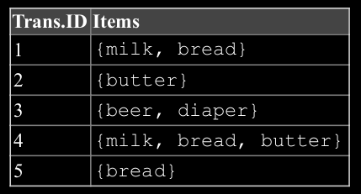

→ Each row in the table consists of a transaction. For example, the customer bought milk and bread in the first transaction. Following are some vital concepts pertaining to association rule-mining.

* 1. **Itemset**: Itemset is just a collection of one or more items that occur together in a transaction. For example, here {milk, bread} is example of an itemset.
  2. **Support**: Support is defined as number of times an itemset appears in the dataset. Mathematically it is defined as:

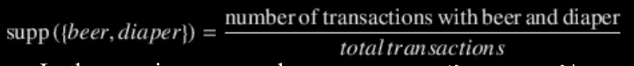

→ In the previous example, support (beer, diaper) = 1/5

= 0.2.

* 1. **Confidence**: Confidence is a measure of the times the number of times a rule is found to exist in the dataset. For a rule which states 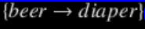 the confidence is mathematically defined as:
  2. **Lift**: Lift of the rule is defined as the ratio of observed support to the support expected in the case the elements of the rule were independent. For the previous set of transactions if the rule is defined as 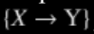, then the lift of the rule is defined as:

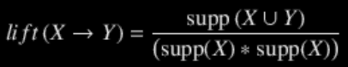

* 1. **Frequent itemset**: Frequent itemsets are itemsets whose support is greater than a user defined support threshold.

1. **FP Growth**

→ The most famous algorithm for association rule-mining is the **Apriori algorithm**, for which you will find a lot of code and resources on the web and in standard data mining literature. However, here we will use a **different and more efficient algorithm, the FP growth algorithm** for finding our association rules.

→ The major bottleneck in any association rule-mining

algorithm is the generation of frequent itemsets. If the transaction dataset is having **k unique products**, then potentially we have **2^k** possible **itemsets**. The Apriori algorithm will first generate these itemsets and then proceed to finding the frequent itemsets.

→ This limitation is a huge performance bottleneck as even for around 100 unique products the possible number of itemsets is huge. This limitation makes the Apriori algorithm prohibitively computationally expensive. The FP growth algorithm is superior to Apriori algorithm as it doesn’t need to generate all the candidate itemsets. The algorithm uses a special data structure that helps it retains itemset association information. An example of the data structure is depicted in figure below:

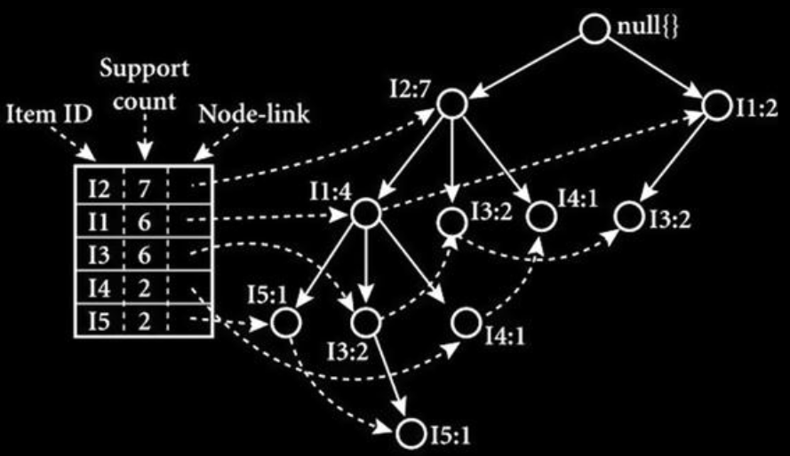

→ We will be learning in brief so you can understand the core concepts in this method. The FP growth algorithm uses a divide-and-conquer strategy and leverages a special data structure called the FP-tree, as depicted in Figure 8-10, to find frequent itemsets without generating all itemsets. The core steps of the algorithm are as follows:

* + 1. Take in the transaction database and create an FP-tree structure to represent frequent itemsets.
    2. Divide this compressed representation into the multiple conditional datasets such that each one is associated with the frequent pattern.
    3. Mine for patterns in each dataset so that shorter patterns can be recursively concatenated to longer patterns, hence making it more efficient.

1. **Association Rule-Minning in Action**

→ We will illustrate association rule-mining using the famous grocery dataset. This dataset consists of a collection of transactions that are sourced from a grocery retailer. We will use this data as the basis of our analysis and build our rule-mining work flow using this data.

→ Once we have grasped the basics of association rule-mining on the grocery dataset, we will leave it as an exercise for you to apply the same concepts on our transaction dataset that we used in the customer segmentation section. Remember to load the following dependencies before getting started.

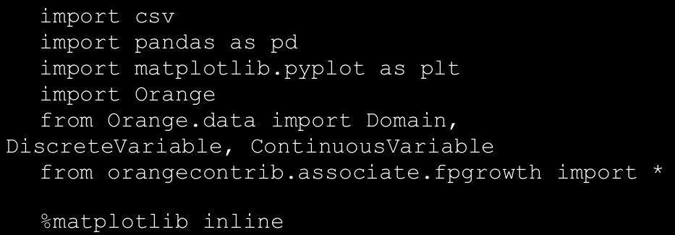

→ The first observation that we make from this dataset is that it is not available in a completely structured, easy-to-analyze format. This limitation will mean that the first thing we will have to do is to write custom code that will convert the raw file into a data structure we can use. Since we have done most of our analysis until now using the pandas dataframe, we will convert this data into a similar data structure. The following code snippet will perform the conversion for us.

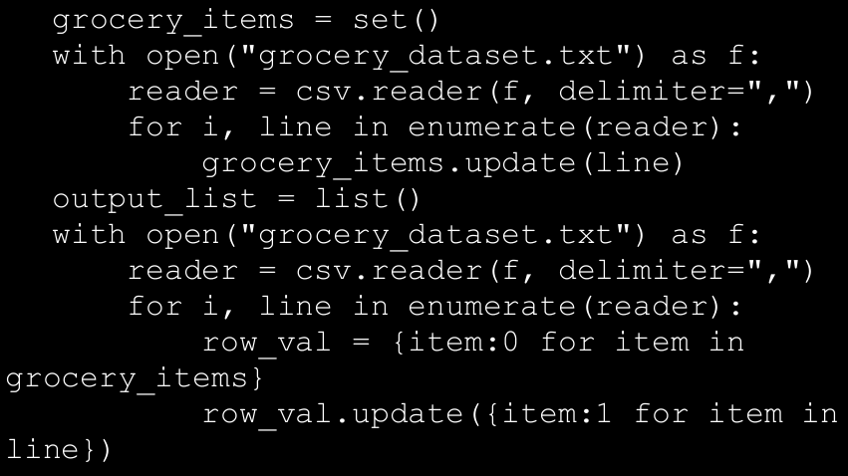

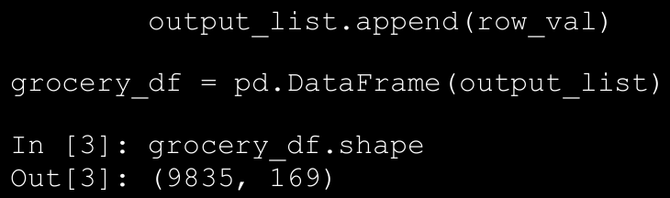

→ The conversion gives us a dataframe of dimension (num_transaction, total_items), where each transaction row has

columns corresponding to its constituent items as 1. For example, for row 3 in the data table above, we will have the column for whole milk as 1 and the rest of columns will be all 0. Although this data structure is sparse, meaning it has a lot of zeros, our framework that extracts association rules will take care of this sparseness.

→ Before we proceed to building association rules on our dataset ,we will explore some salient features of our dataset. We already know that we have 9,835 total transactions and a total of 169 items in the dataset. But what are the top 10 items that occur in the dataset and how much of the total sales they account for. We can plot a simple histogram that will help us extract this information.

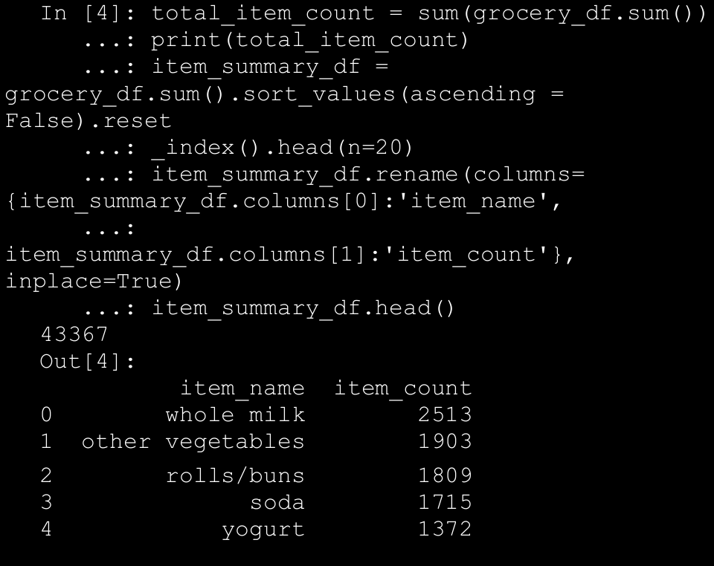

→ For creating the histogram, we will create a summary data frame using the previous code. This tells us that we have a total of 43,000+ items occurring in total in all those transactions and we also see the top five most sold items. Let’s use this dataframe to plot the top 20 most sold items. The following snippet of code will help us create the required bar graph.

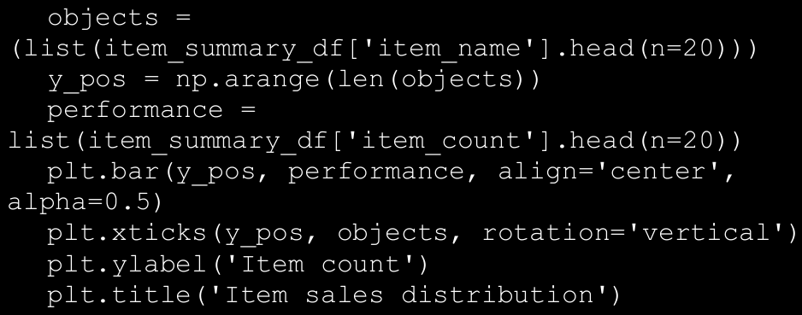

→ The bar graph depicting the item sales is depicted in Figure below. It indicates that a surprisingly large share of total items is claimed by only these 20 items.

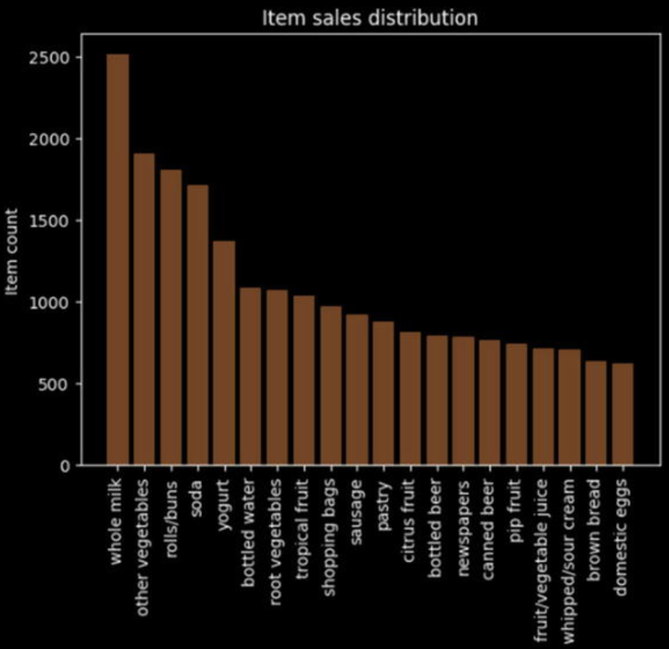

→ Let’s also find out how much percentage of total sales is explained by

these 20 items alone. We will use the cumulative sum function offered by pandas (cumsum) to find this out. We will create two columns in our dataframe. One will tell how much percentage of total sales can be attributed to a particular item and the other will keep a cumulative sum of this sales percentage.

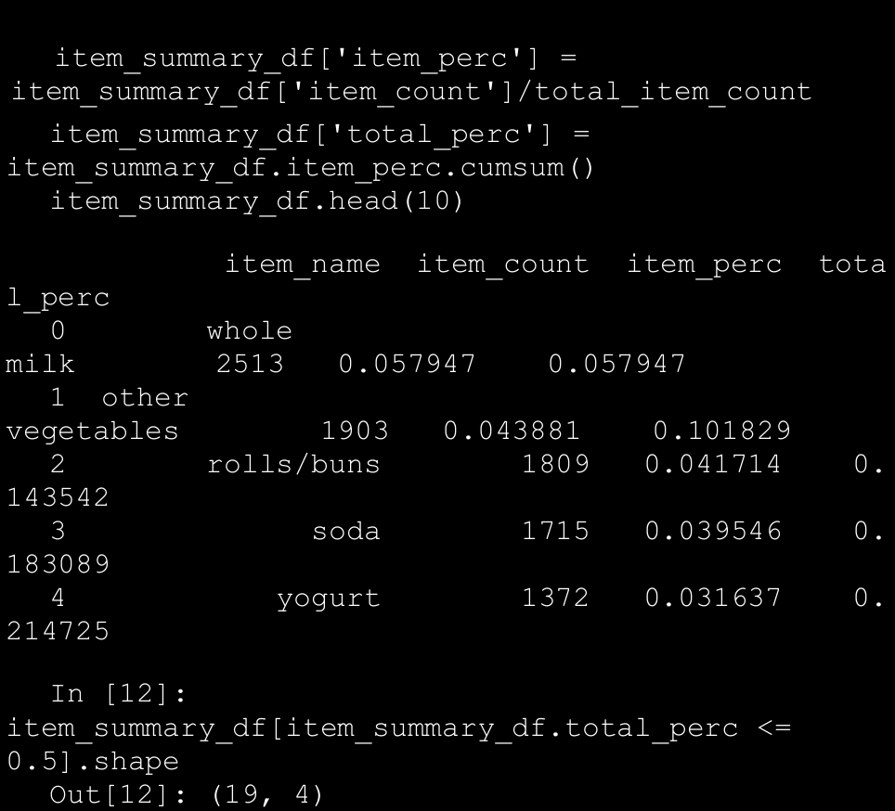

→ **This shows us that the top five items are responsible for 21.4% of the entire sales and only the top 20 items are responsible for over 50% of the sales! This is important for us, as we don’t want to find association rules for items which are bought very infrequently. With this information we can limit the items we want to explore for creating our association rules. This also helps us in keeping our possible itemset number to a manageable figure.**

1. **Mining Rule**

→ We will be using the **Orange** and the **Orange3-Associate**, The orange3-associate package contains the implementation of **FP growth**.

→ Before we go on using the package for finding association rules, we will discuss about the way data is represented in Orange library. The data representation is a little tricky but we will help you modify the existing data into the format required by Orange. Primarily we will focus on how to convert our pandas dataframes to the Orange Table data structure.

**⇒ Orange Table Data Structure**

→ The Table data structure is the primary way to represent any tabular data in Orange. Although it is similar in some way to a numpy array or a pandas dataframe, it differs from them in the way it stores metadata about the actual data. In our case we can easily convert our pandas dataframe to the Table data structure by providing the metadata about our columns. We need to define the domain for each of our variables. The domain means the possible set of values that each of our variables can use. This information will be stored as metadata and will be used in later transformation of the data. As our columns are only having binary values—i.e. either 0 or 1—we can easily create the domain by using this information. The following code snippet helps us convert our dataframe to an Orange table.

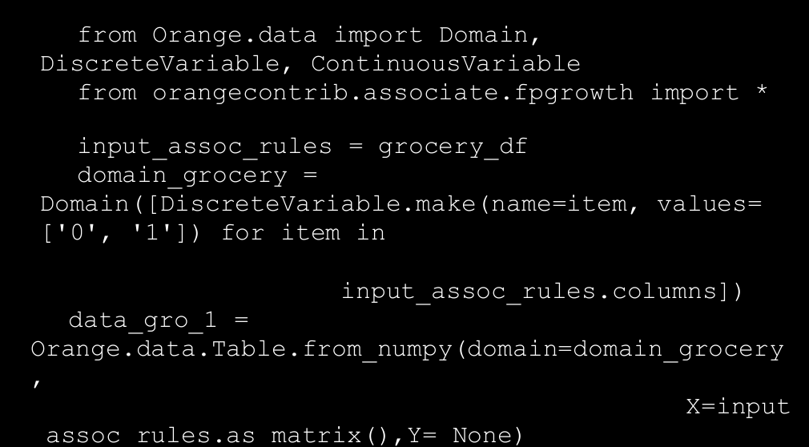

→ Here we defined the domain of our data by specifying each variable as a DiscreteVariable having values as (0, 1). Then using this domain, we created our Table structure for our data.

**⇒ Using the FP Growth Algorithm**

→ Now we have all the pieces required to perform our rule-mining. But before proceeding, we want to take care of one more important aspect of the analysis. We saw in the earlier section how only a handful of items are responsible for bulk of our sales so we want to prune our dataset to reflect this information. For this we have created a function prune_dataset, which will help us reduce the size of our dataset based on our requirements. The function can be used for performing two types of pruning:

* 1. **Pruning based on percentage of total sales**: The parameter total_sales_perc will help us select the number of items that will explain the required percentage of sales. The default value is 50% or 0.5.
  2. **Pruning based on ranks of items**: Another way to perform the pruning is to specify the starting and the ending rank of the items for which we want to prune our dataset.

→ By default, we will only look for transactions which have at least two items, as transactions with only one item are counter to the whole concept of association rule-mining. The following code snippet will help us select only that subset of data which explain 40% of the total sales by leveraging our pruning function.

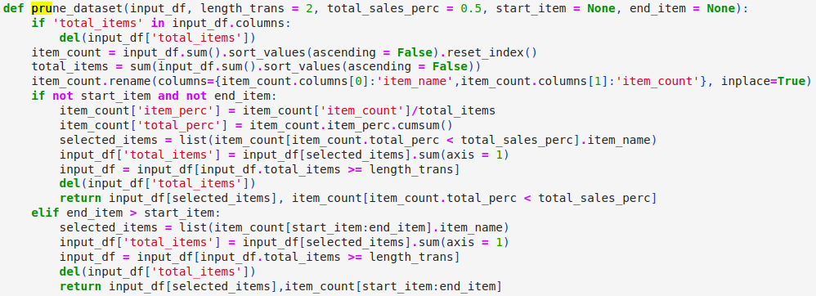

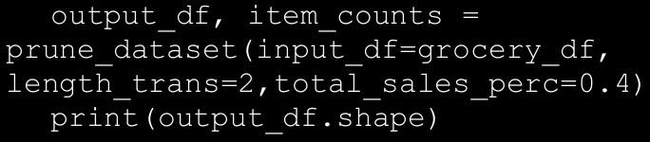

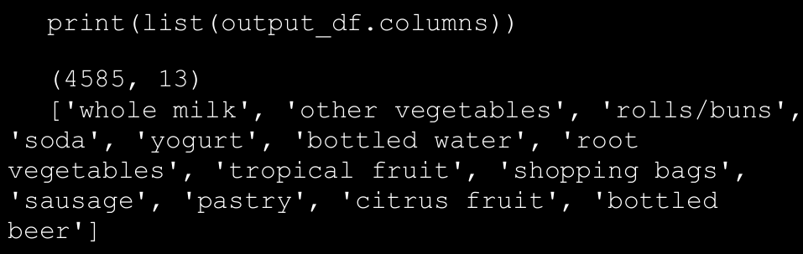

→ So we find out that we have only 13 items responsible for 40% of sales and 4585 transactions that have those items along with other items and we can also see what those items are. The next step is to convert this selected data into the required Table data structure.

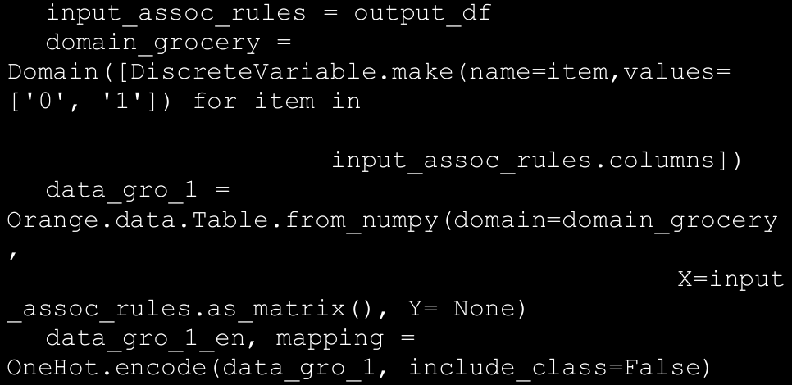

→The new addition to the previous code is the last line. This is required for coding our input so that the entire domain is represented as binary variables. This will complete all the parsing and data manipulation required for our rule-mining. Phew!

→ The final step is creating our rules. **We need to specify two pieces of information for generating our rules: support and confidence.** We have already defined both of them conceptually earlier, so we will not be defining them again. An important piece of information is to start with a higher support, as lower support will mean a higher number of frequent itemsets and hence a longer execution time. We will specify a min-support of 0.01—45 transactions at least—and see the number of frequent itemsets that we get before we specify confidence and generate our rules.

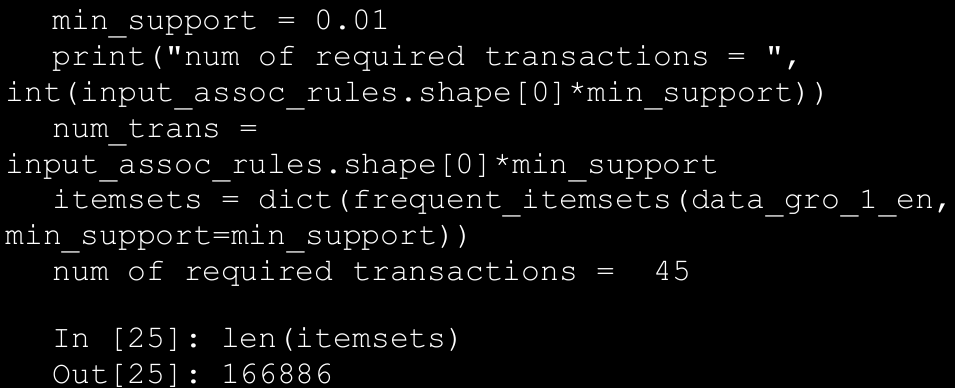

→ So we get a whopping 166,886 itemsets for a support of only 1%! This will increase exponentially if we decrease the support or if we increase the number of items in our dataset. The next step is specifying a confidence value and generating our rules. We have written a code snippet that will take a confidence value and generate the rules that fulfill our specified support and confidence criteria. The rules generated are then decoded using the mapping and variable names. Orange3- Associate also provides a helper function that will help us extract metrics about each of these rules. The following code snippet will perform rule generation and decoding of rules, and then compile it all in a neat dataframe that we can use for further analysis.

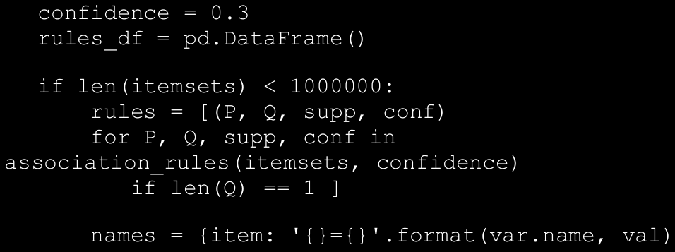

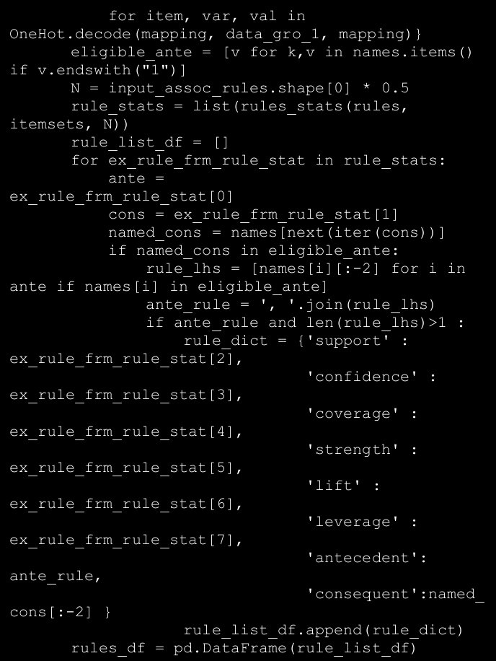

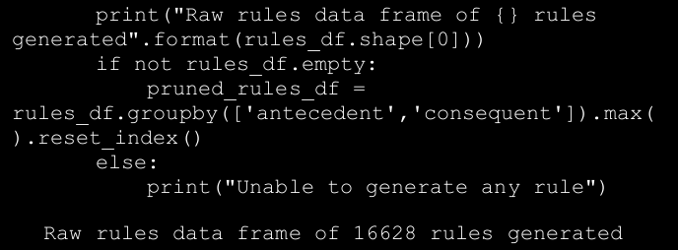

→ The output of this code snippet consists of the association rules dataframe that we can use for our analysis. You can play around with the item number, consequent, antecedent, support, and confidence values to generate different rules. Let’s take some sample rules generated using transactions that explain 40% of total sales, min-support of 1% (required number of transactions >=45) and confidence greater than 30%. Here, we have collected rules having maximum lift for each of the items that can be a consequent (that appear on the right side) by using the following code.

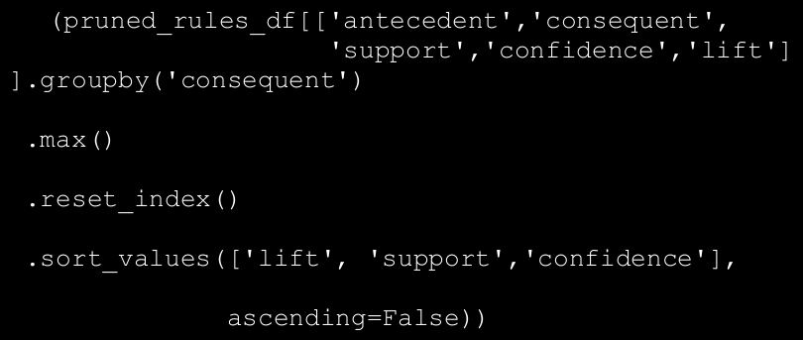

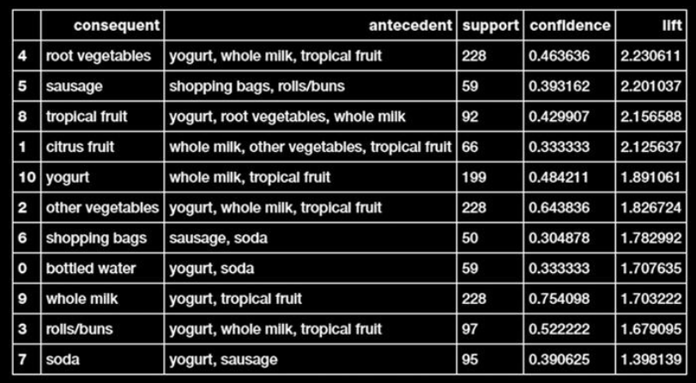

→ The pattern that the rule states in the equation is easy to understand—people who bought yogurt, whole milk, and tropical fruit also tend to buy root vegetables. Let’s try to understand the metrics. Support of the rule is 228, which means, all the items together appear in 228 transactions in the dataset. Confidence of the rule is 46%, which means that 46% of the time the antecedent items occurred we also had the consequent in the transaction (i.e. 46% of times, customers who bought the left side items also bought root vegetables).

→ Another important metric in Figure above is Lift. Lift means that the probability of finding root vegetables in the transactions which have yogurt, whole milk, and tropical fruit is greater than the normal probability of finding root vegetables in the previous transactions (2.23). Typically, a lift value of 1 indicates that the probability of occurrence of the antecedent and consequent together are independent of each other. Hence, the idea is to look for rules having a lift much greater than 1. In our case, all the previously mentioned rules are good quality rules.

→ This is a significant piece of information, as this can prompt a retailer to bundle specific products like these together or run a marketing scheme that offers discount on buying root vegetables along with these other three products.

1. **Inferential Statistics**

→ The general notion of inferential statistics is to draw inferences and propositions of a population using a data sample. The idea is to use statistical methods and models to draw statistical inferences from a given hypotheses. **Each hypothesis consists of a null hypothesis and an alternative hypothesis**.

→ Based on statistical test results, if the result is statistically significant based on pre-set significance levels (e.g., **if obtained p-value is less than 5% significance level), we reject the null hypothesis in favor of the alternative hypothesis. Otherwise, if the results is not statistically significant, we conclude that our null hypothesis was correct.**

→ Coming back to our problem from the previous section, given multiple data groups or subsets of wine samples based on wine quality rating, is there any way to prove that mean alcohol levels or pH levels vary significantly among the data groups?

→ A great statistical model to prove or disprove the difference in mean among subsets of data is to use the one-way ANOVA test. **ANOVA stands for “analysis of variance”**, which is a nifty statistical model and can be used to analyze statistically significant differences among means or averages of various groups.

→ This is basically achieved using a statistical test that helps

us determine whether or not the means of several groups are equal. Usually the null hypothesis is represented as

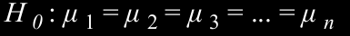

→ The following snippet helps us perform the one-way ANOVA test.

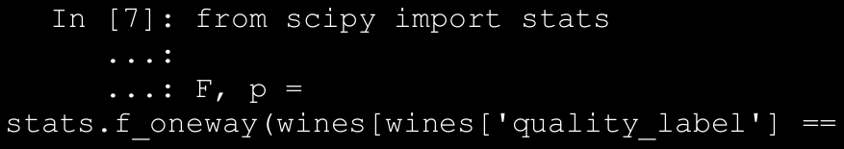

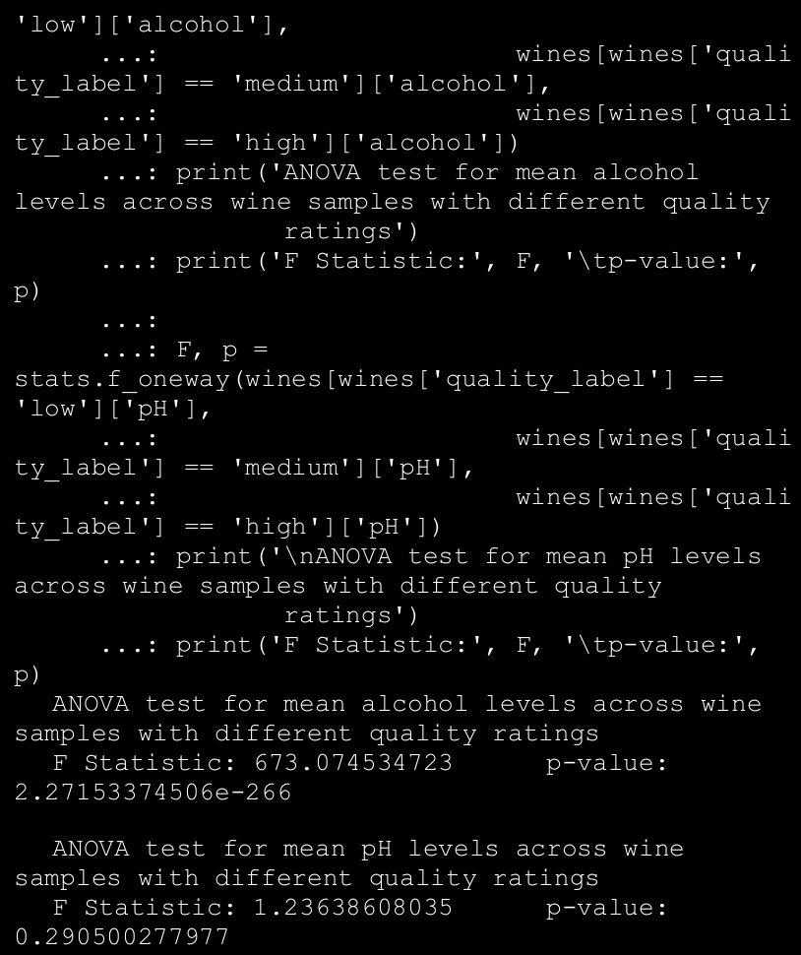

→ From the preceding results we can clearly see we have a p-value much less than 0.05 in the first test and greater than 0.05 in the second test. This tells us that there is a statistically significant difference in alcohol level means for at least two groups out of the three (rejecting the null hypothesis in favor of the alternative). However, in case of pH level means, we do not reject the null hypothesis and **thus we conclude that the pH level means across the three groups are not statistically significantly different. We can even visualize these two features and observe the means using the following snippet**.

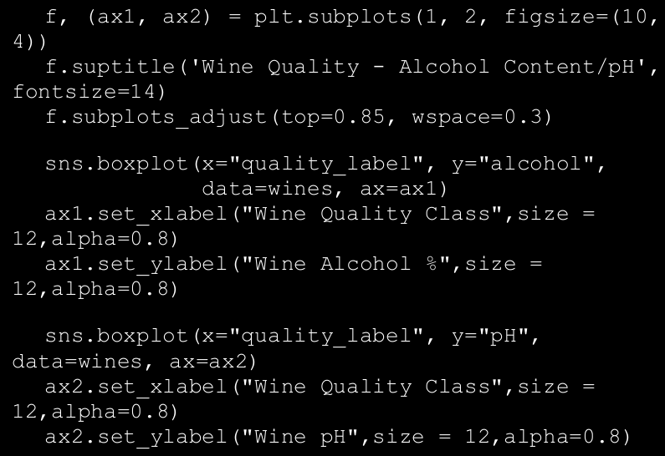

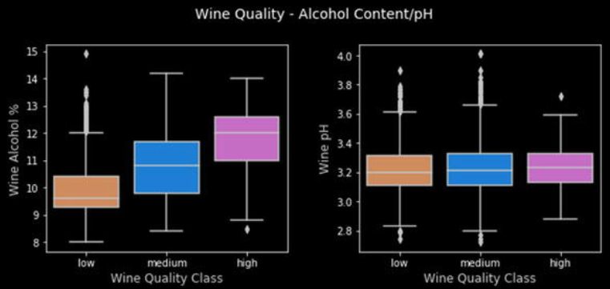

1. **Univariate Analysis**

→ This is perhaps one of the easiest yet a core foundational step in exploratory data analysis. Univariate analysis involves analyzing data such that at any instance of analysis we are only dealing with one variable or feature. No relationships or correlations are analyzed among multiple variables. The simplest way to easily visualize all the variables in your data is to build some histograms. The following snippet helps visualize distributions of data values for all features. While histogram may not be an appropriate visualization in many cases, it is a good one to start with for numeric data.

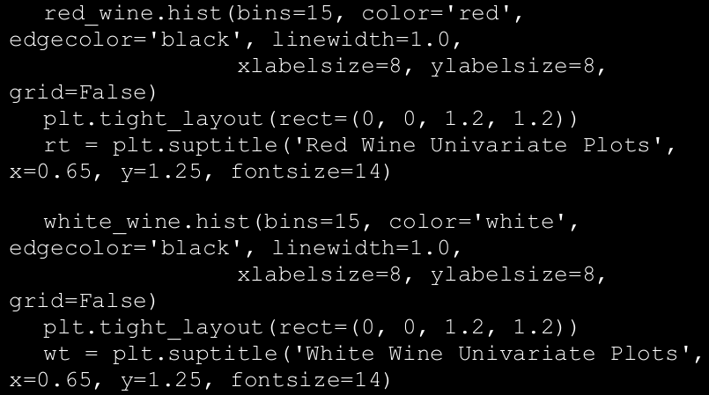

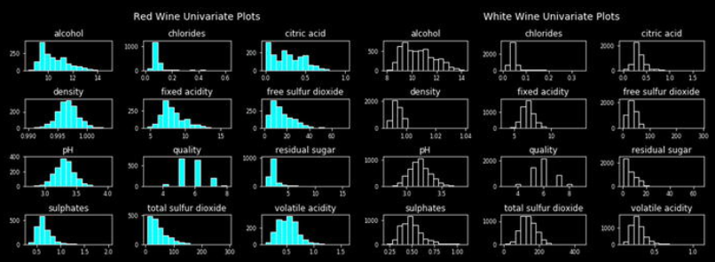

→ Do you notice any interesting patterns across the two wine types? Let’s take the feature named residual sugar and plot the distributions across data pertaining to red and white wine samples.

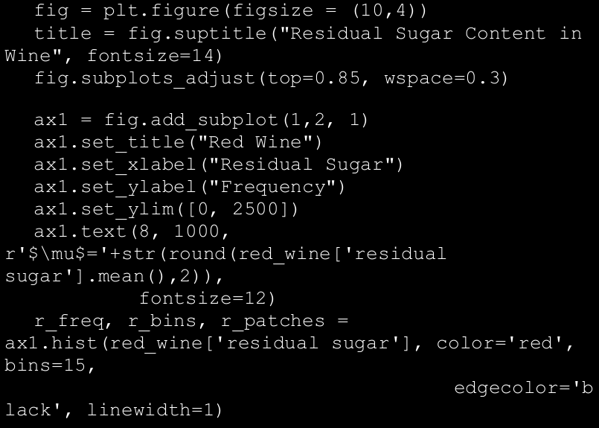

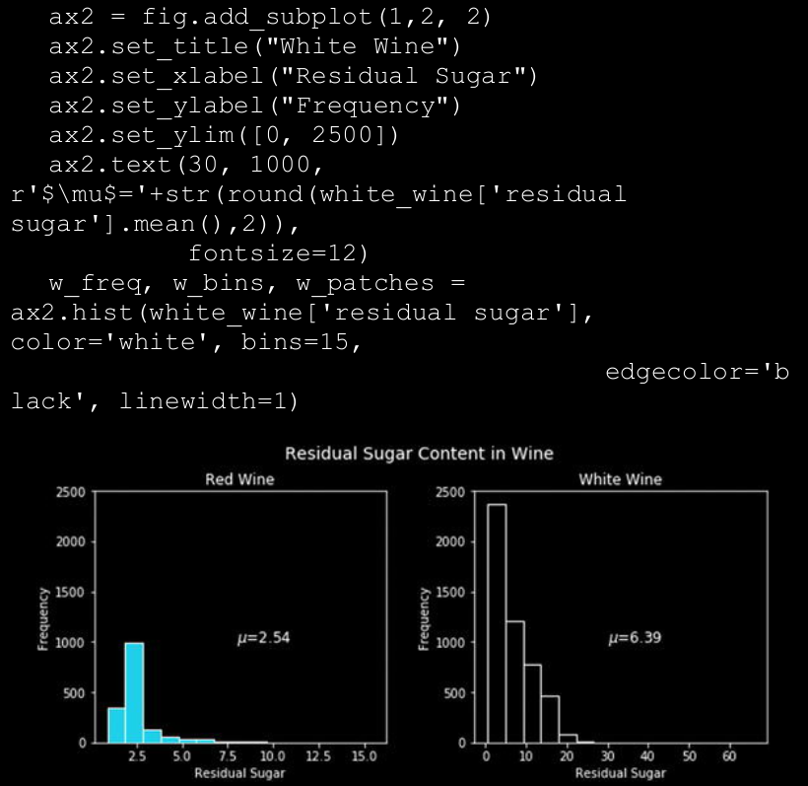

→ We can notice easily from the visualization in Figure above that residual sugar content in white wine samples seems to be more as compared to red wine samples. You can reuse the plotting template in the preceding code snippet and visualize more features.

1. **Multivariate Analysis**

→ Analyzing multiple feature variables and their relationships is what multivariate analysis is all about. We would want to see if there are any interesting patterns and relationships among the physicochemical attributes of our wine samples, which might be helpful in our modeling process in the future. One of the best ways to analyze features is to build a pairwise correlation plot depicting the correlation coefficient between each pair of features in the dataset. The following snippet helps us build a correlation matrix and plot the same in the form of an easy-to-interpret heatmap.

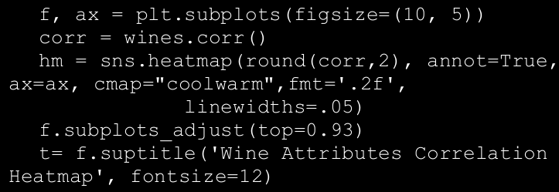

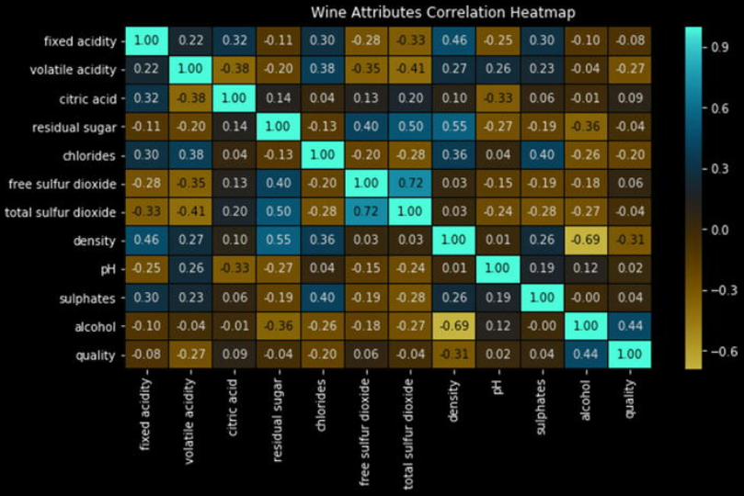

→ While most of the correlations are weak, as observed in Figure above, we can see a strong negative correlation between density and alcohol and a strong positive correlation between total and free sulfur dioxide, which is expected. You can also visualize patterns and relationships among multiple variables using pairwise plots and use different hues for the wine types essentially plotting three variables at a time. The following snippet depicts a sample pairwise plot for some features in our dataset.

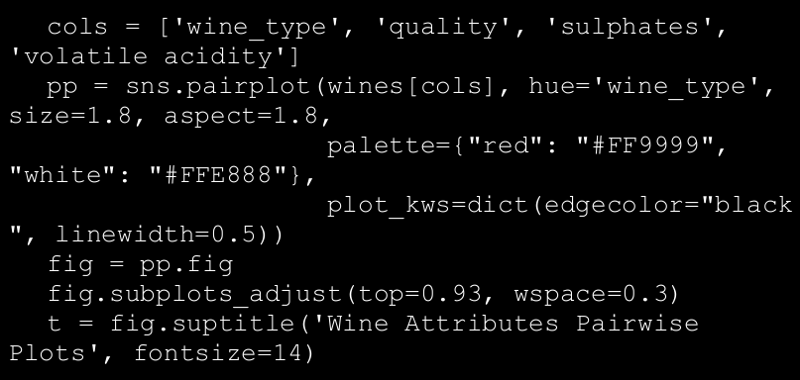

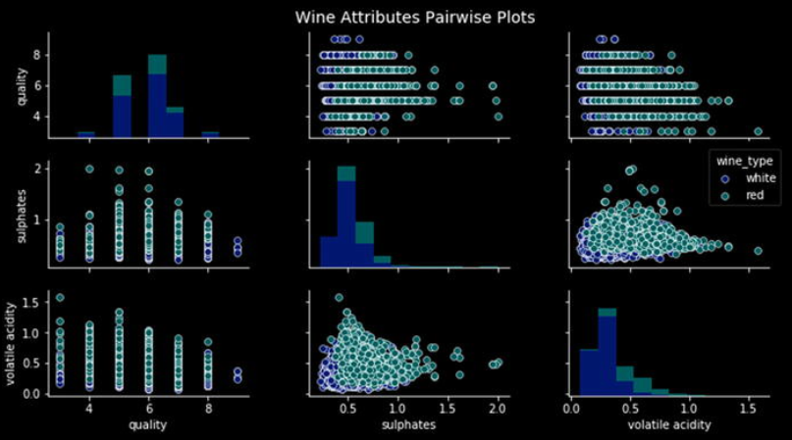

→ From the plots in Figure above, we can notice several interesting patterns, which are in alignment with some insights we obtained earlier. These observations include the following:

* 1. Presence of higher sulphate levels in red wines as compared to white wines.
  2. Lower sulphate levels in wines with high quality ratings
  3. Lower levels of volatile acids in wines with high quality ratings
  4. Presence of higher volatile acid levels in red wines as compared to white wines.

1. **The ROC Curve**

→ Another way of understanding how well the model is performing is the roc curve.

→ This curve can be plotted using the true positive rate (TPR) and the false positive rate (FPR) of a classifier. TPR is known as sensitivity or recall, which is the total number of correct positive results predicted among all the positive samples the dataset. FPR is known as false alarms or (1 - specificity), determining the total number of incorrect positive predictions among all negative samples in the dataset.

→ The ROC curve is also known as a sensitivity versus (1 − specificity) plot sometimes. The following code uses our model evaluation utilities module to plot the ROC curve for our logistic regression model in the ROC space.

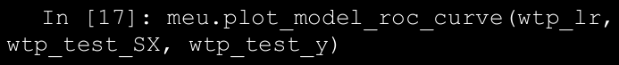

→ Typically in any ROC curve, the ROC space is between points (0,0) and (1, 1). Each prediction result from the confusion matrix occupies one point in this ROC space. Ideally, the best prediction model would give a point on the top-left corner (0,1) indicating perfect classification (100% sensitivity and specificity). A diagonal line depicts a classifier that does a random guess. Ideally if your ROC curve occurs in the top half of the graph, you have a decent classifier, which is better than average. Figure below makes this clearer.

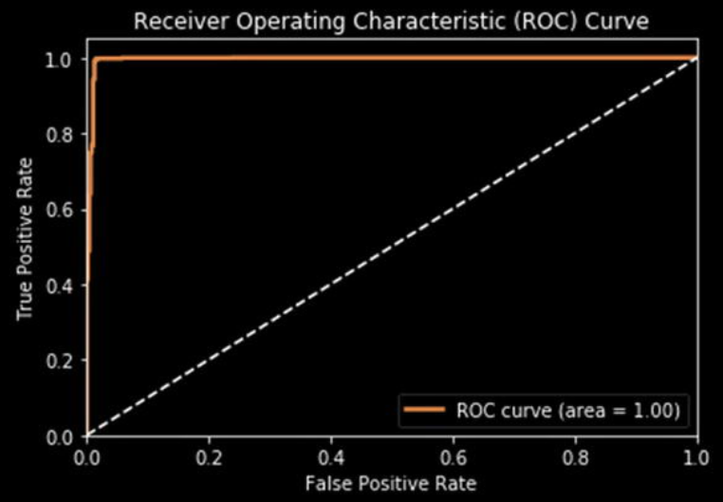

1. **Analyzing Music Trends and Recommendation**

→ This chapter studies how we can use transactional data to develop different types of recommendation engines. We will learn about an auxiliary dataset of a very interesting dataset, “The million song dataset”. We will go through user listening history and then use it to develop multiple recommendation engines with varying levels of sophistication.

→ The first thing we may want to do in the dataset of this size is determine how many unique users (or songs) we should consider. In the original dataset, we have around a million users, but we want to determine the number of users we should consider.

→ For example, if 20% of all the users account for around 80% of total play counts, then it would be a good idea to focus our analysis on those 20% users. Usually this can be done by summarizing the dataset by users (or by songs) and getting a cumulative sum of the play counts. Then we can find out how many users account for 80% of the play counts, etc.

→ But due to the size of the data, the cumulative summation function provided by pandas will run into trouble. So we will write code to read the file line by line and extract the play count information on a user (or song). **This will also serve as a possible method that readers can use in case the dataset size exceeds the memory available on their systems**. The code snippet that follows will read the file line by line, extract total play count of all the users, and persist that information for

later use.

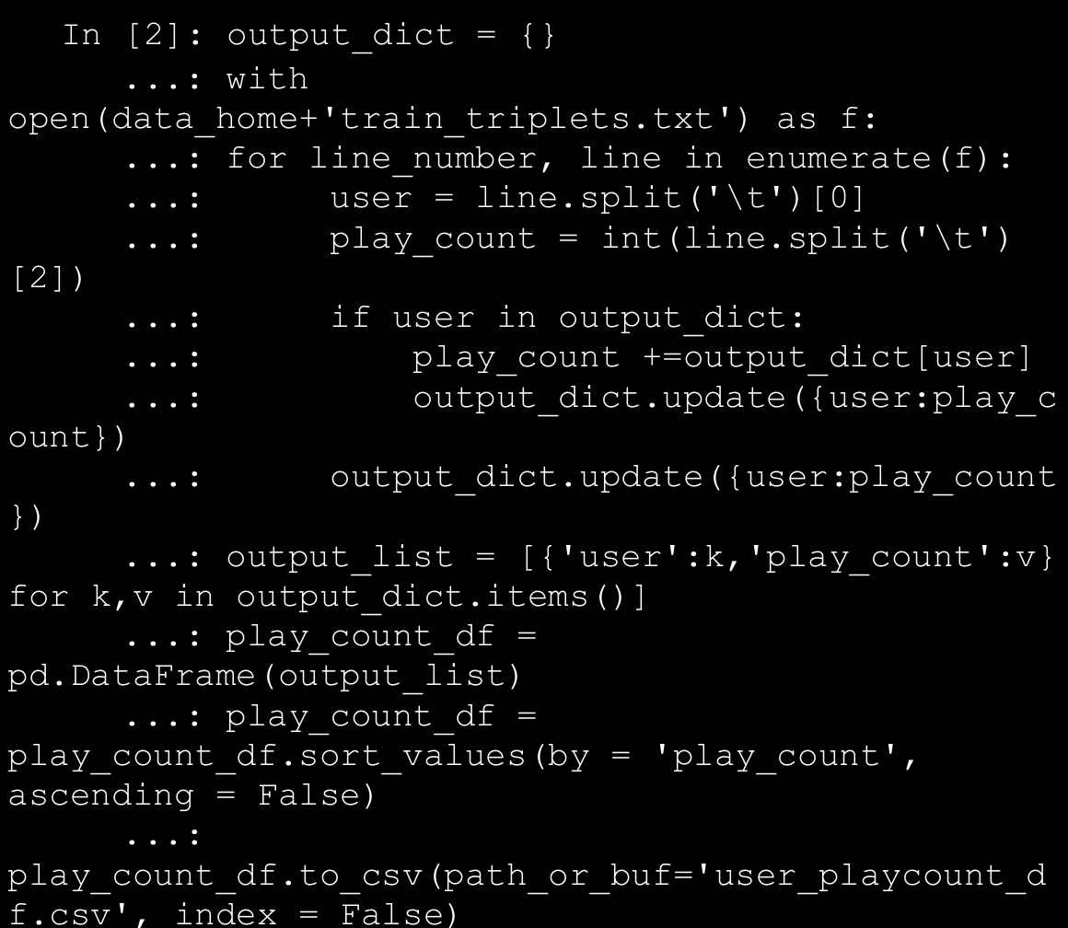

→ The persisted dataframe can be then loaded and used based on our requirements. We can use a similar strategy to extract play counts for each of the songs. A few lines from the dataset are shown in Figure below:

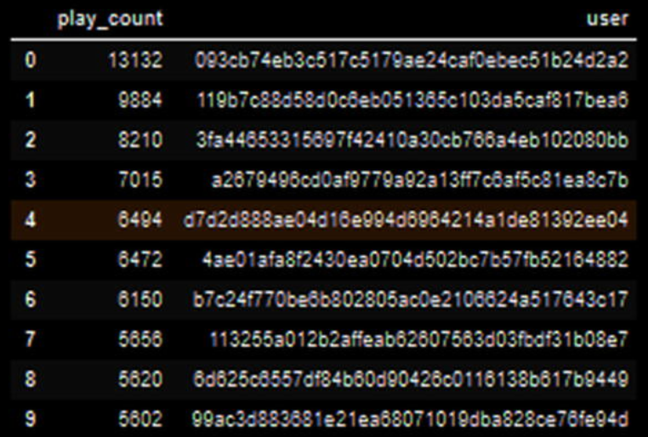

→ The first thing we want to find out about our dataset is the number of users that we will need to account for around 40% of the play counts. We have arbitrarily chosen a value of 40% to keep the dataset size manageable; you can experiment with these figures to get different sized datasets and even leverage big data processing and analysis frameworks like Spark on top of Hadoop to analyze the complete dataset! The following code snippet will determine the subset of users that account for this percentage of data. In our case around 10,0000 users account for 40% of play counts, hence we will subset those users.

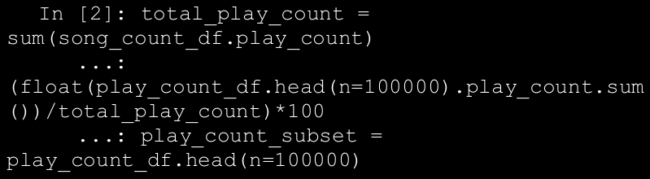

→ In similar way, we can determine the number of unique songs required to explain 80% of the total play count. In our case, we will find that 30,000 songs account for around 80% of the play count. This information is already a great find, as around 10% of the songs are contributing to 80% of the play count. Using a code snippet similar to one given previously, we can determine the subset of such songs. With these songs and user subsets, we can subset our original dataset to reduce the dataset to contain only filtered users and songs. The code snippet that follows uses these dataframes to filter the original dataset and then persists the resultant dataset for future uses.

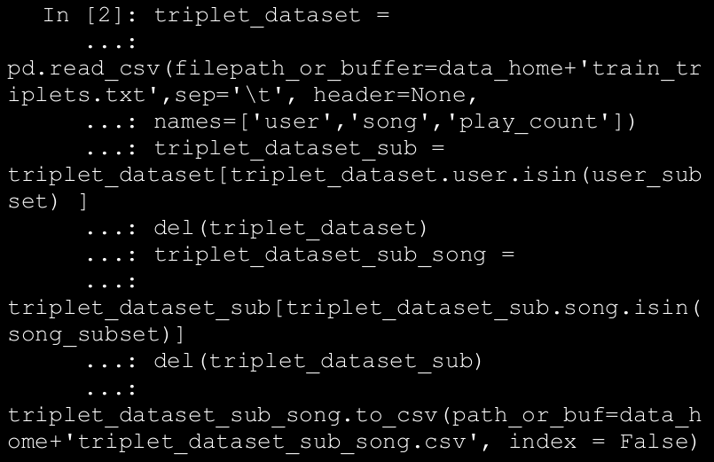

→ This subsetting will give us a dataframe with around 10 million rows of tuples. We will use this as the starting dataset for our all future analyses. You can play around with these numbers to arrive at different datasets and possibly different results.

**⇒ Visual Analysis**

→Before we start developing various recommendation engines, let’s do some visual analysis of our dataset. We will try to see what the different trends are regarding the songs, albums, and releases.

* 1. Most Popular Songs

→ The first information that we can plot for our data concerns the popularity of the different songs in the dataset. We will try to determine the top 20 songs in our dataset. A slight modification of this popularity will also serve as our most basic recommendation engine. The following code snippet gives us the most popular songs from our dataset.

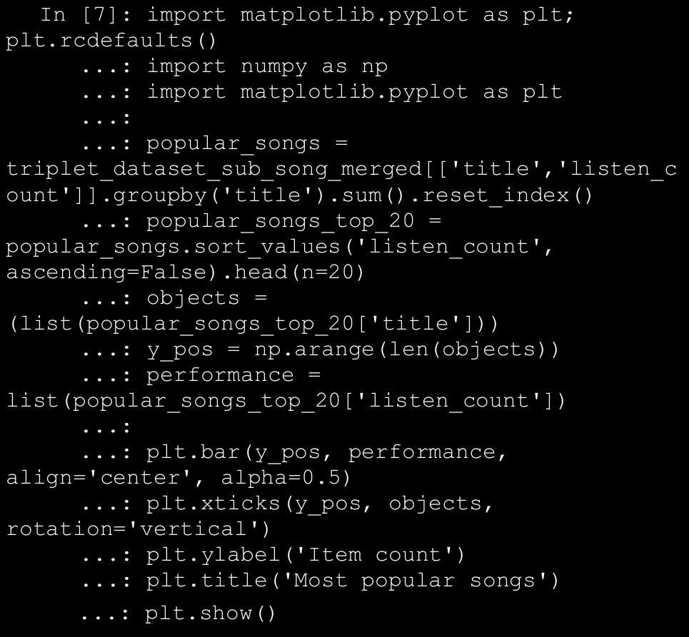

→ The plot that’s generated by the code snippet is shown in Figure below The plot shows that the most popular song of our dataset is “You’re the One”. We can also search through our track dataframe to see that the band responsible for that particular track is The Black Keys.

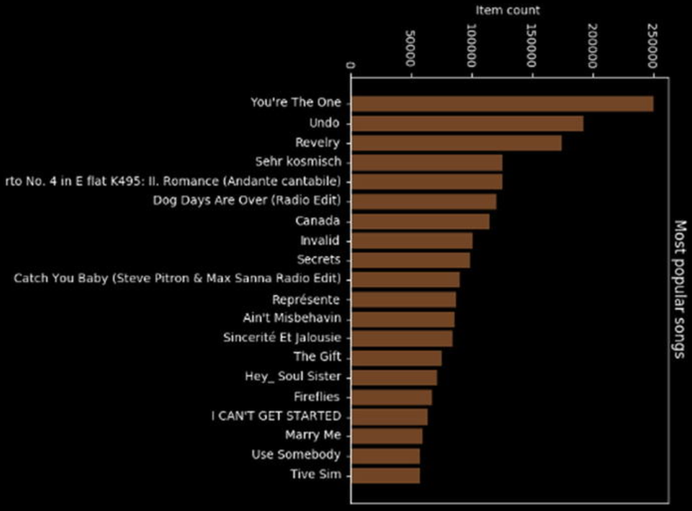

* 1. User vs Song Distribution

→ The last information that we can seek from our dataset is regarding the distribution of song count for users. This information will tell us how the number of songs that users listen to on average are distributed. We can use this information to create different categories of users and modify the recommendation engine on that basis. The users who are listening to a very select number of songs can be used for developing simple recommendation engines and the users who provide us lots of insight into their behavior can be candidates for developing complex recommendation engines.

→ Before we go on to plot that distribution, let’s try to find some statistical information about that distribution. The following code calculates that distribution and then shows summary statistics about it.

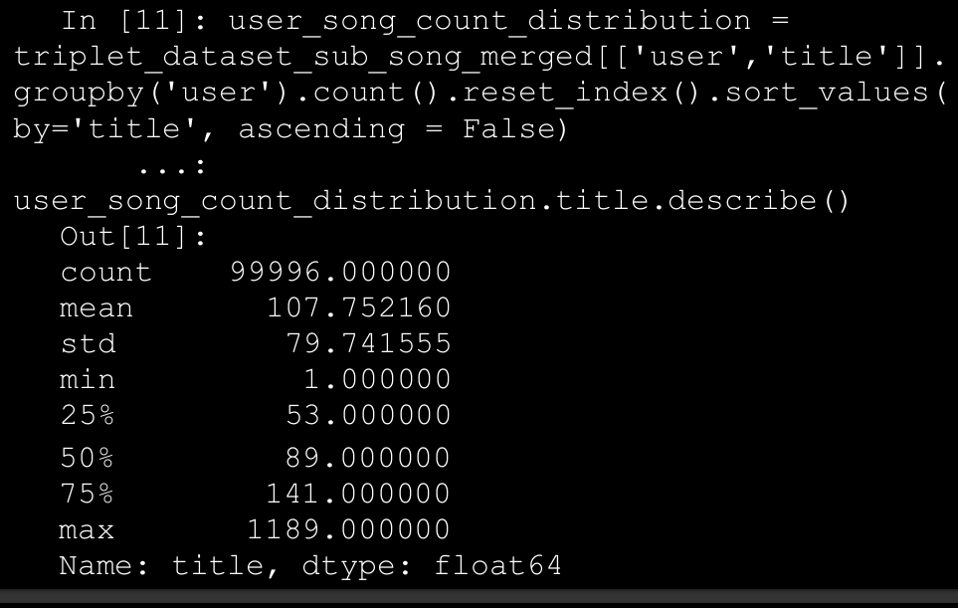

→ This gives us some important information about how the song counts are distributed across the users. We see that on an average, a user will listen to 100+ songs, but some users have a more voracious appetite for son diversification. Let’s try to visualize this particular distribution. The code that follows will help us plot the distribution of play counts across our dataset. We have intentionally kept the number of bins to a small amount, as that can give approximate information about the number of classes of users we have.

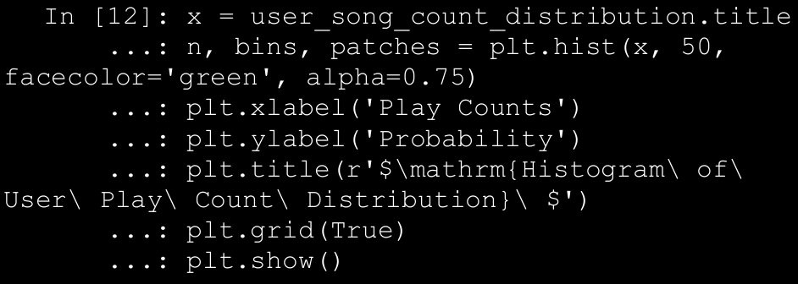

→ The distribution plot generated by the code is shown in Figure below. The image clearly shows that, although we have a huge variance in the minimum and maximum play count, the bulk of the mass of the distribution is centered on 100+ song counts.

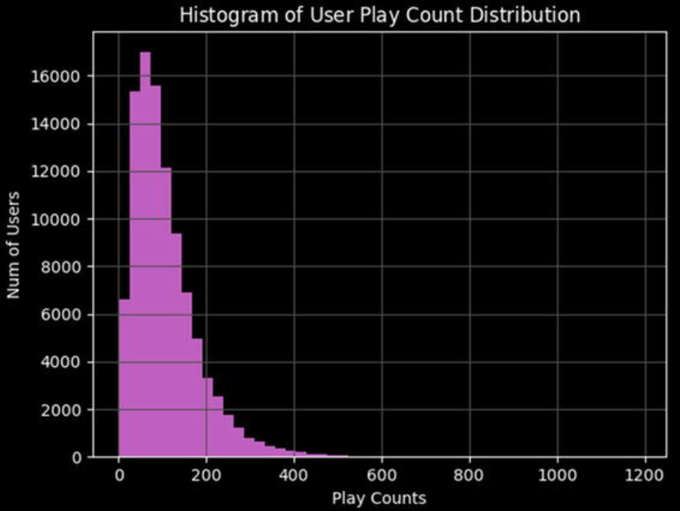

1. Types of Recommendation Engines

→ The major area of distinction in different recommendation engines comes from the entity that they assume is the most important in the process of generating recommendations. There are different options for choosing the central entity and that choice will determine the type of recommendation engine we will develop.

* 1. **User-based recommendation engines:** In these types of recommendation engines, the user is the central entity. The algorithm will look for similarities among users and on the basis of those similarities will come up with the recommendation.
  2. **Content-based recommendation engines:** On the other end of the recommendation engine spectrum, we have the content-based recommendation engine. In these, the central entity is the content that we are trying to recommend; for example, in our case the entity will be songs we are trying to recommend. These algorithm will attempt to find features about the content and find similar content. Then these similarities will be used to make recommendations to the end users.
  3. **Hybrid-recommendation engines:** These types of recommendation engines will take into account both the features of the users and the content to develop recommendations. These are also sometimes termed as collaborative filtering recommendation engines as they “collaborate” by using the similarities of content as well as users.These are one of the most effective classes of recommendation engines, as they take the best features of both classes of recommendation engines.

1. Popularity-Based Recommendation Engine

→ The simplest recommendation engine is naturally the easiest to develop. As we can easily develop recommendation engines, this type of recommendation engine is a very straightforward one to develop. The driving logic of this recommendation engine is that if some item is liked (or listened to) by a vast majority of our user base, then it is a good idea to recommend that item to users who have not interacted with that item.

→ The code to develop this kind of recommendation is extremely easy and is effectively just a summarization procedure. To develop these recommendations, we will determine which songs in our dataset have the most users listening to them and then that will become our standard recommendation set for each user. The code that follows defines a function that will do this summarization and return the resultant dataframe.

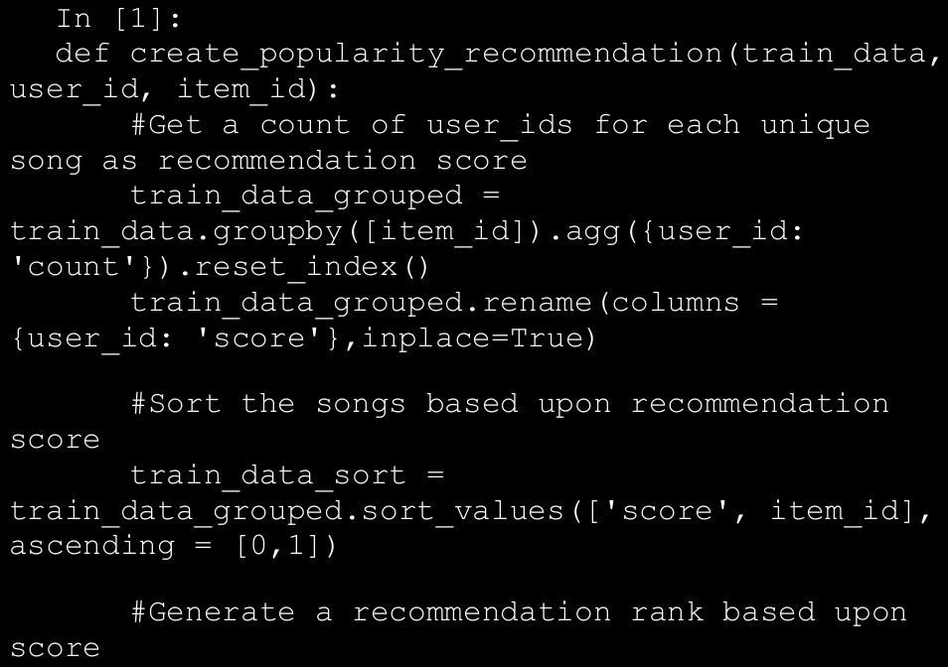

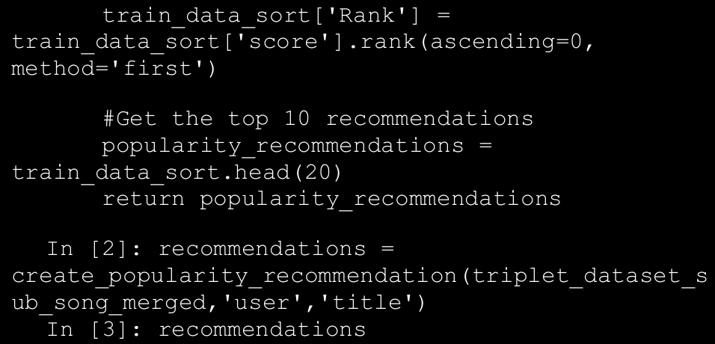

→ We can use this function on our dataset to generate the top 10 recommendations to each of our users. The output of our plain vanilla recommendation system is shown in Figure below. Here you can see that the recommendations are very similar to the list of the most popular songs that you saw in the last section, which is expected as the logic behind both is the same—only the output is different.

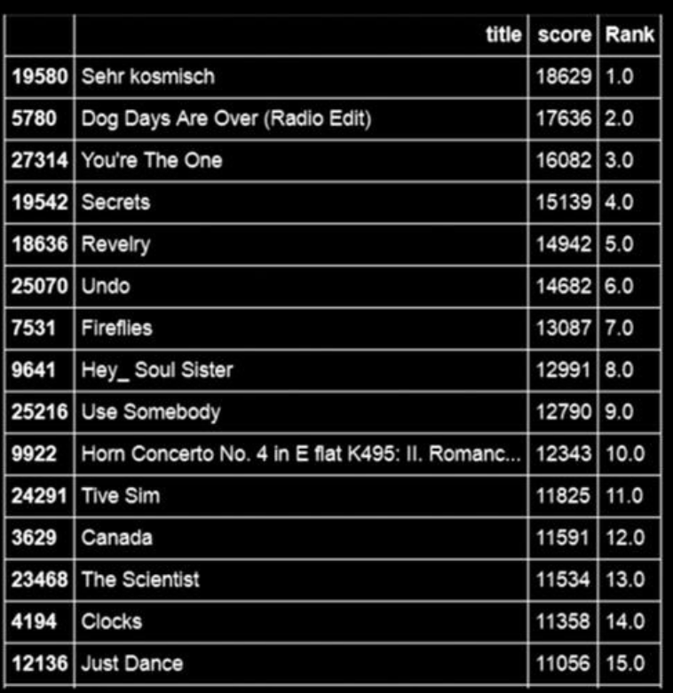

1. Item Similarity Based Recommendation Engine

→ In this section we deal with a slightly more complex solution. This recommendation engine is based on calculating similarities between a user’s items and the other items in our dataset.

→Before we proceed further with our development effort, let’s describe how we plan to calculate “item-item” similarity, which is central to our recommendation engine. Usually to define similarity among a set of items, we need a feature set on the basis of which both items can be described. In our case it will mean features of the songs on the basis of which one song can be differentiated from another. Although as we don’t have ready access to these features (or do we?), we will define the similarity in terms of the users who listen to these songs. Confused? Consider this mathematical formula, which should give you a little more insight into the metric. **similarity ij = intersection(users i , users j ) / union(users i , users j)**

→ This similarity metric is known as the Jaccard index and in our case we can use it to define the similarities between two songs. The basic idea remains that if two songs are being listened to by a large fraction of common users out of the total listeners, the two songs can be said to be similar to each other. On the basis of this similarity metric, we can define the steps that the algorithm will take to recommend a song to a user k.

1. Determine the songs listened to by the user k.
2. Calculate the similarity of each song in the user’s list to those in our dataset, using the similarity metric defined previously.
3. Determine the songs that are most similar to the songs already listened to by the user.
4. Select a subset of these songs as recommendation based on the similarity score.

→ As the Step B can become a computation-intensive step when we have a large number of songs, we will subset our data to 5,000 songs to make the computation more feasible. We will select the most popular 5,000 songs so it is quite unlikely that we would miss out on any important recommendations.

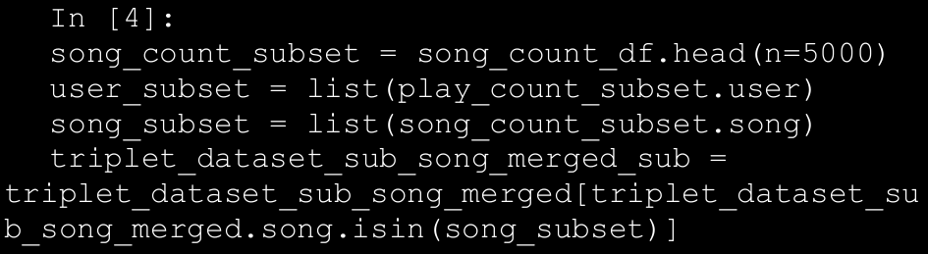

→ This code will subset our dataset to contain only most popular 5,000 songs. We will then create our similarity based recommendation engine and generate a recommendation for a random user. We leverage Siraj’s Recommenders module here for the item similarity based recommendation system.

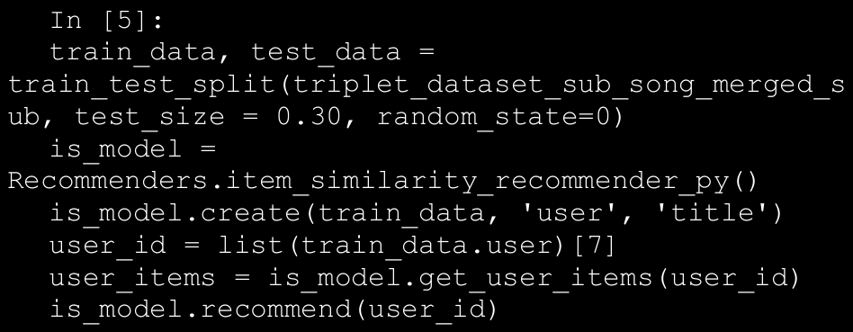

→ The recommendations for random users are shown in Figure below. Notice the stark difference from the popularity based recommendation engine. So this particular person is almost guaranteed to not like the most popular songs in our dataset.

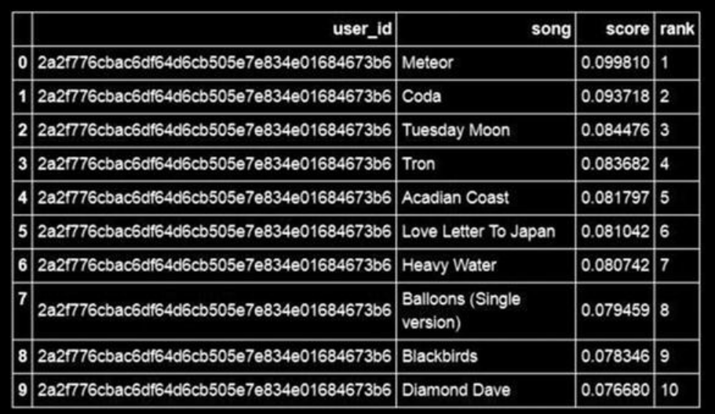

1. **Matrix Factorization Based Recommendation Engine**

→ Matrix factorization based recommendation engines are probably the most used recommendation engines when it comes to implementing recommendation engines in production. In this section, we give an intuition-based introduction to matrix factorization based recommendation engines. We avoid going into a heavily mathematical discussion, as from a practitioner’s perspective the intent is to see how we can leverage this to get valuable recommendations from real data.

→ Matrix factorization refers to identification of two or more matrices from an initial matrix, such that when these matrices are multiplied we get the original matrix. Matrix factorization can be used to discover latent features between two different kinds of entities. What are these latent features? Let’s discuss that for a moment before we go for a mathematical explanation.

→ Consider for a moment why you like a certain song—the answer may range from the soulful lyrics, to catchy music, to it being melodious, and many more. We can try to explain a song in mathematical terms by measuring its beats, tempo, and other such features and then define similar features in terms of the user. For example, we can define that from a user’s listening history we know that he likes songs with beats that are bit on the higher side, etc. Once we have consciously defined such “features,” we can use them to find matches for a user based on some similarity criteria. But more often than not, the tough part in this process is defining these features, as we have no handbook for what will make a good feature. It is mostly based on domain experts and a bit of experimentation. But as you will see in this section, you can use matrix factorization to discover these latent features and they seem to work great.

→ The starting point of any matrix factorization-based method is the utility matrix, as shown in Table below. **The utility matrix is a matrix of user X item dimension in which each row represents a user and each column stands for an item**.

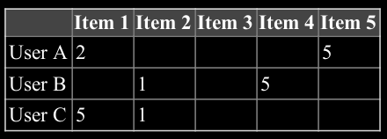

→ Notice that we have a lot of missing values in the matrix; these are the items that the user hasn’t rated, either because he hasn’t watched it or because he doesn’t want to watch it. We can right away guess, say Item 4 is a recommendation for User C because User B and User C don’t like Item 2, so it is likely they may end up liking the same items, in this case Item 4.

→The process of matrix factorization means finding out a low rank approximation of the utility matrix. So we want to break down the utility matrix U into two low rank matrices so that we can recreate the matrix U by multiplying those two matrices. Mathematically,

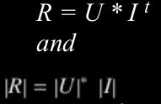

→ Here R is our original rating matrix, U is our user matrix, and I is our item matrix. Assuming the process helps us identify K latent features, our aim is to find two matrices X and Y such that their product (matrix multiplication) approximates R.

**X = |U| x K matrix (A matrix with dimensions of num_users * factors)**

**Y = |P| x K matrix (A matrix with dimensions of factors * num_movies)**

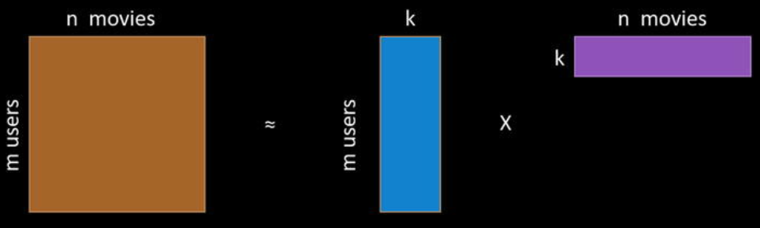

→ We can also try to explain the concept of matrix factorization as an image. Based on Figure above, we can regenerate the original matrix by multiplying the two matrices together. To make a recommendation to the user, we can multiply the corresponding user’s row from the first matrix by the item matrix and determine the items from the row with maximum ratings. That will become our recommendations for the user. The first matrix represents the association between the users and the latent features, while the second matrix takes care of the associations between items (songs in our case) and the latent features. Figure above depicts a typical matrix factorization operation for a movie recommender system but the intent is to understand the methodology and extend it to build a music recommendation system in this scenario.

* 1. **Matrix Factorization and Singular value**

→There are multiple algorithms available for determining factorization of any matrix. We use one of the simplest algorithms, which is the singular value decomposition or SVD. Here, we explain how the decomposition provided by SVD can be used as matrix factorization. Singular value decomposition of a matrix returns three different matrices: U, S, and V. You can follow these steps to determine the factorization of a matrix using the output of SVD function.

* Factorize the matrix to obtain U, S, and V matrices.
* Reduce the matrix S to first k components. (The function we are using will only provide k dimensions, so we can skip this step.)
* Compute the square root of reduced matrix S k to obtain the matrix S k^1/2 .
* Compute the two resultant matrix U*S k 1/2 and S k 1/2 *V as these will serve as our two factorized matrices, as depicted in Figure above.

→We can then generate the prediction of user i for product j by taking the dot product of the i th row of the first matrix with the j th column of the second matrix. This information gives us all the knowledge required to build a matrix factorization based recommendation engine for our data.

* 1. **Building a Matrix Factorization Based Recommendation Engine**

→ After the discussion of the mechanics of matrix factorization based recommendation engines, let’s try to create such a recommendation engine on our data. The first thing that we notice is that we have no concept of “rating” in our data; all we have are the play counts of various songs. This is a well known problem in the case of recommendation engines and is called the “implicit feedback” problem. There are many ways to solve this problem but we will look at a very simple and intuitive solution. We will replace the play count with a fractional play count. The logic being that this will measure the strength of “likeness” for a song in the range of [0,1]. We can argue about better methods to address this problem, but this is an acceptable solution to our problem. The following code will complete the task.

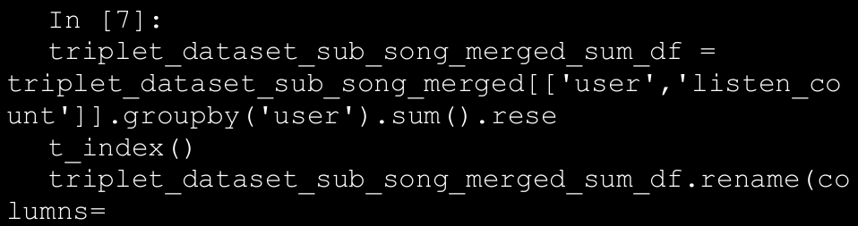

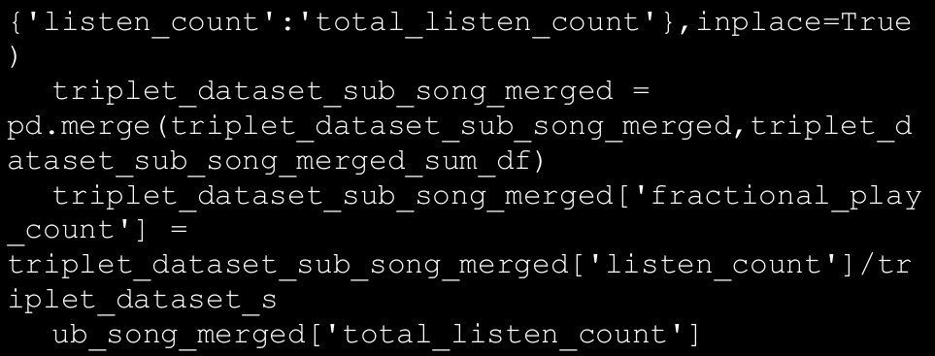

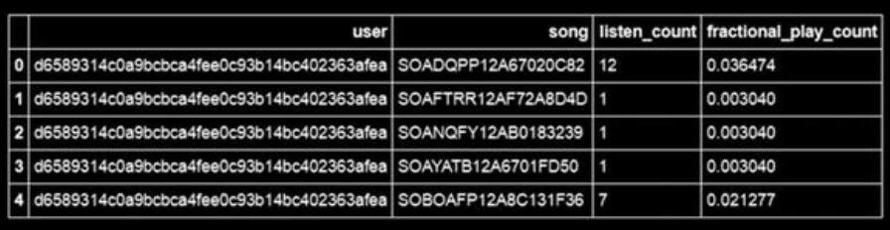

→ The next transformation of data that is required is to convert our dataframe into a numpy matrix in the format of utility matrix. We will convert our dataframe into a sparse matrix, as we will have a lot of missing values and sparse matrices are suitable for representation of such a matrix. Since we won’t be able to transform our song IDs and user IDs into a numpy matrix, we will convert these indices into numerical indices. Then we will use these transformed indices to create our sparse numpy matrix. The following code will create such a matrix.

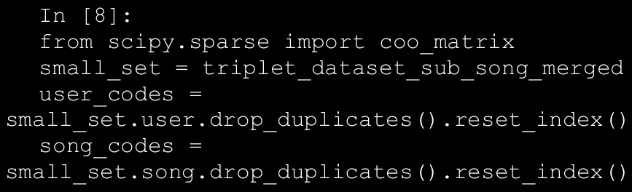

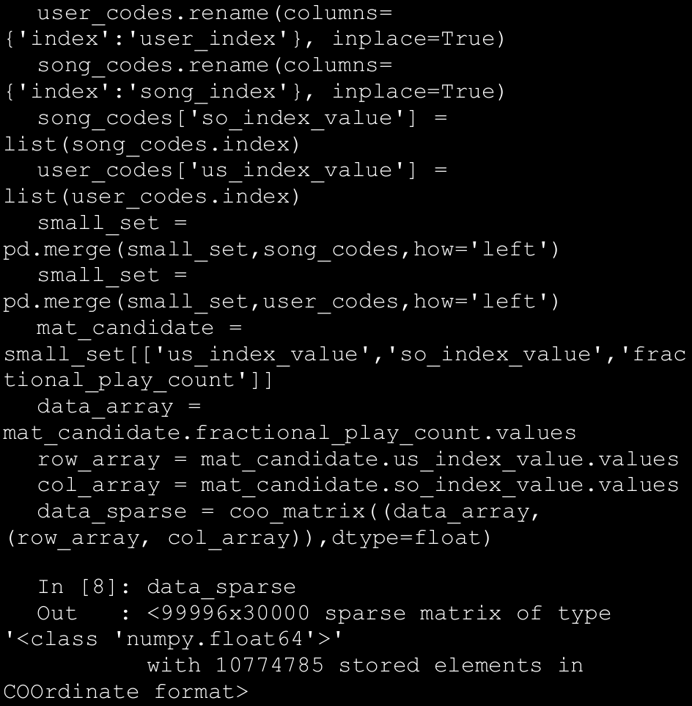

→ Once we have converted our matrix into a sparse matrix, we will use the svds function provided by the scipy library to break down our utility matrix into three different matrices. We can specify the number of latent factors we want to factorize our data. In the example we will use 50 latent factors but users are encouraged to experiment with different values of latent factors and observe how the recommendation change as a result. The following code creates the decomposition of our matrix and predicts the recommendation for the same user as in the item similarity recommendation use case. We leverage our compute_svd(...) function to perform theSVD operation and then use the compute_estimated_matrix(...) for the low rank matrix approximation after factorization.

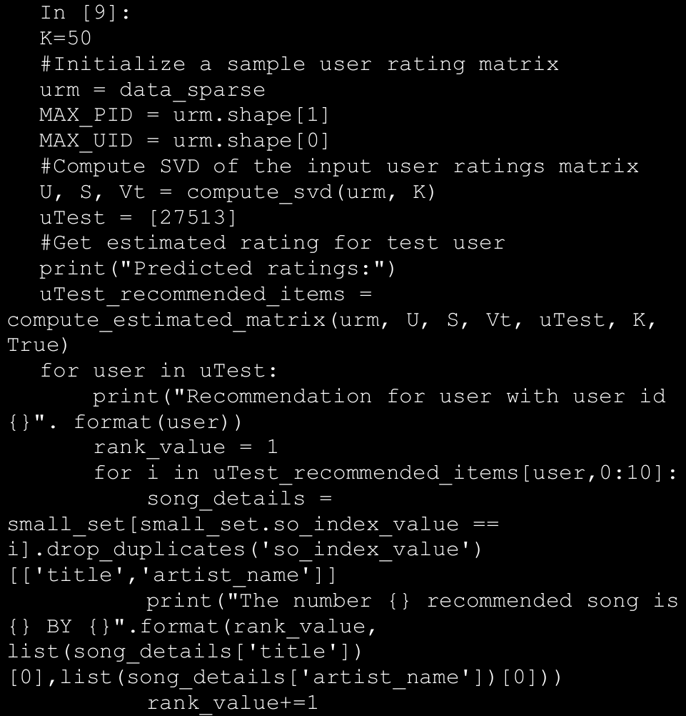

→ The recommendations made by the matrix factorization based system are also shown in Figure below.

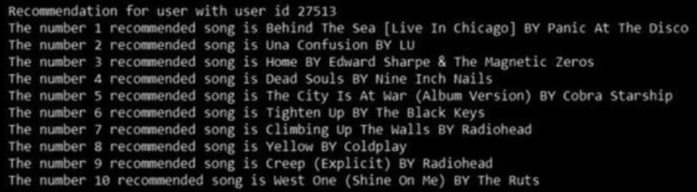

→ We used one of the simplest matrix factorization algorithms for our use case; you can try to find out other more sophisticated implementation of the matrix factorization routine, which will lead to a different recommendation system. Another topic which we have ignored a bit is the conversion of song play count into a measure of “implicit feedback”. The system that we chose is acceptable but is far from perfect. There is a lot of literature that discusses the handling of this issue.

1. **Forecasting Stock and Commodity Prices**

→ **Predictive analytics or modeling involves concepts from data mining, advanced statistics, Machine Learning, and so on to model historical data to forecast future events**. Predictive modeling has use cases across domains such as financial services, healthcare, telecommunications, etc.

→There are a number of techniques developed over the years to understand temporal data and model patterns to score future events and behaviors. Time series analysis forms the descriptive aspect of such data and the understanding helps in modeling and forecasting the same.

→ Traditional approaches like **regression analysis and Box-Jenkins methodologies** have been deeply studied and applied over the years. More recently, improvements in computation and Machine Learning algorithms have seen Machine Learning techniques like neural networks or to be more specific, Deep Learning, making a headway in forecasting use cases with some amazing results.

* 1. **Time Series Data and Analysis**

→ A time series is a sequence of observed values in a time-ordered manner. The observations are recorded at equally spaced time intervals. Time series data is available and utilized in the fields of statistics, economics, finance,

weather modeling, pattern recognition, and many more.

→ Time series analysis is the study of underlying structure and forces that produced observations. It provides descriptive frameworks to analyze characteristics of data and other meaningful statistics. It also provides techniques to then utilize this to fit a model to forecast, monitor, and control.

→ There is another school of thought that separates the descriptive and modeling components of time series. Here, time series analysis typically is concerned with only the descriptive analysis of time series data to understand various components and underlying structure. The modeling aspect that utilizes time series for prediction / forecasting use cases is termed as time series forecasting . Though in general, both schools of thought utilize the same set of tools and techniques. It is more about how the concepts are grouped for a structured learning and application.

→ **Time series can be analyzed both in frequency and time domains**. The frequency domain analysis includes spectral and wavelet analysis techniques, while time domain includes auto- and cross-correlation analysis. **In this topic, we primarily focus on time series forecasting in the time domain with a brief discussion around descriptive characteristics of time series data**. Moreover, we concentrate on univariate time series analysis (time is an implicit variable).

→ To better understand concepts related to time series, we utilize a sample dataset. The following snippet loads a web site visit data with a daily frequency using pandas.

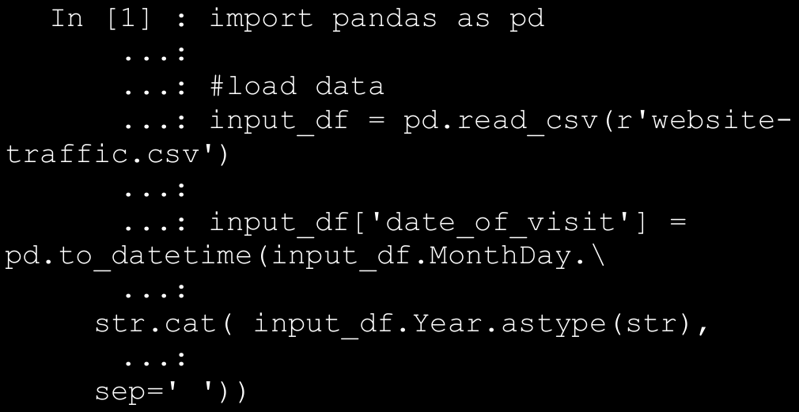

→ The snippet first creates a new attribute called the date_of_visit using a combination of Day, Month, and Year values available in the base dataframe. Since the dataset is about web site visits per day, the variable of interest is the visit count for the day with the time dimension, i.e. **date_of_visit** being the implicit one. The output plot of visits per day is shown in Figure below.

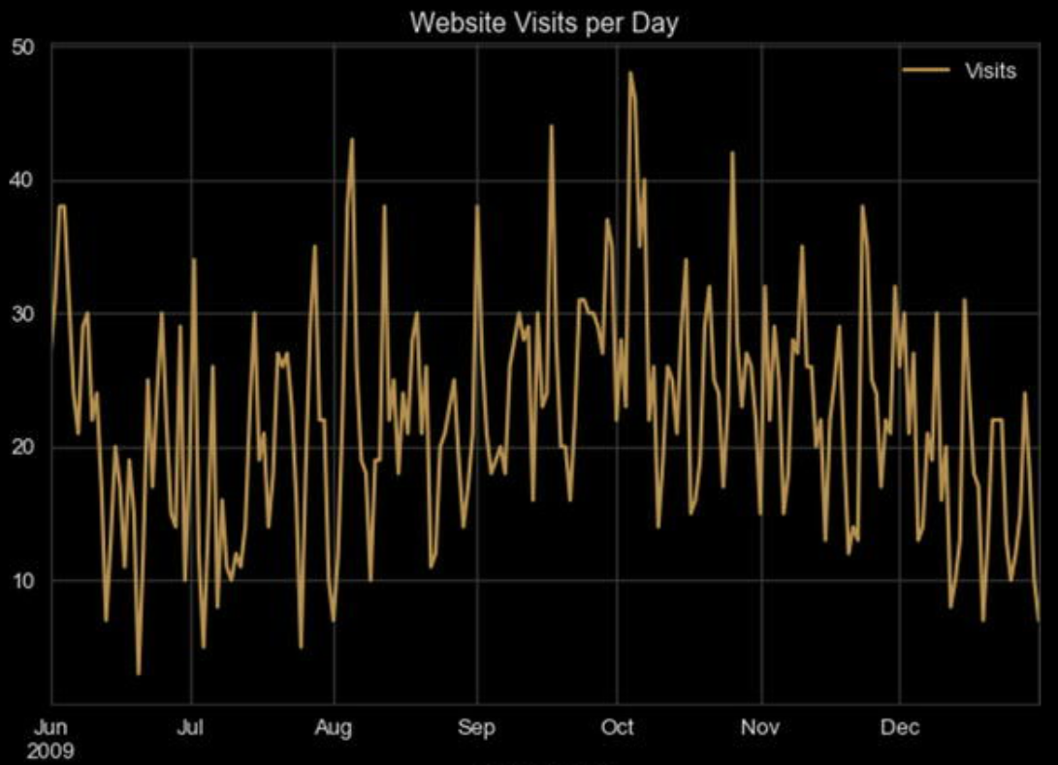

* 1. **Time Series Components**

→ The time series at hand is data related to web site visits per day for a given web site. As mentioned earlier, time series analysis deals with understanding the underlying structure and forces that result in the series as we see it. Let’s now try to deconstruct various components that make up the time series at hand. **A time series is said to be comprised of the following three major components**:

* + 1. Seasonality: These are the periodic fluctuations in the observed data. For example, weather patterns or sale patterns.
    2. Trend: This is the increasing or decreasing behavior of the series with time. For example, population growth patterns.
    3. Residual: This is the remaining signal after removing the seasonality and trend signals. It can be further decomposed to remove the noise component as well.

→ It is interesting to note that most real-world time series data have a combination or all of these components available. Yet, it is mostly the noise that’s always apparently present, with trend and seasonality being optional in certain cases. In the following snippet, we utilize statsmodels to decompose our web site visit time series into its three constituents and then plot the same.

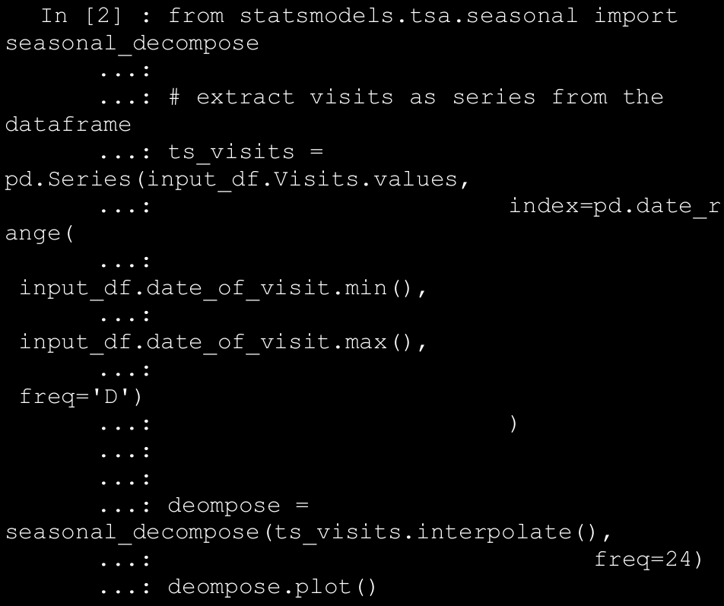

→ We first create a pandas Series object with additional care taken to set the frequency of the time series index. It is important to note that statsmodels has a number of time series modeling modules available and they rely on underlying data structures (such as pandas, numpy, etc.) to specify the frequency of the time series. In this case, since the data is at a daily level, we set the frequency of ts_visits object to ‘D’ denoting a daily frequency. We then simply use the seasonal_decompose() function from statsmodels to get the required constituents. The decomposed series is shown in the plot in Figure below.

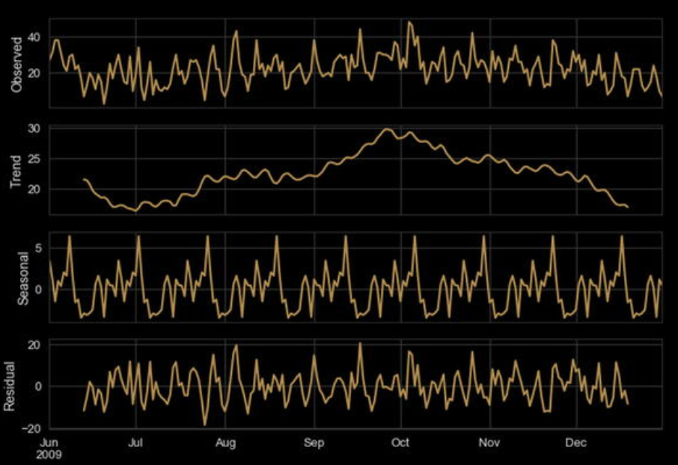

→ It is apparent from Figure above, the time series at hand has both upward and downward trends in it. It shows a gradual increasing trend until October, post which it starts a downward behavior. The series certainly has a monthly periodicity or seasonality to it. The remaining signal is what is marked as residual in Figure above.

1. **Smoothing Techniques in time series**

→ As discussed in the previous chapters, preprocessing the raw data depends upon the data as well as the use case requirements. Yet there are certain standard preprocessing techniques for each type of data. Unlike the datasets we have seen so far, where we consider each observation to be independent of other (past or future) observations, time series have inherent dependency on historical observations. As seen from the decomposition of web sitevisits series, there are multiple factors impacting each observation. It is an inherent property of time series data to have random variation to it apart

from its other constituents. To better understand, model, and utilize time series for prediction related tasks, we usually perform a preprocessing step better termed as smoothing. Smoothing helps reduce the effect of random variation and helps clearly reveal the seasonality, trend, and residual components of the series. There are various methods to smooth out a time

series. They are broadly categorized as follows.

* 1. **Moving Average**

→ Instead of taking an average of complete time series (which we do in cases of non-temporal data) to summarize, moving average makes use of a rolling windowed approach. In this case, we compute the mean of each successive smaller windows of past data to smoothen out the impact of random variation. The following is a general formula for moving average calculation.

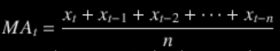

→ Where, MA t is the moving average for time period t, x t, x t-1 and so on denote observed values at particular time periods, and n is the window size. For example, the following snippet calculates the moving average for visits with a window size of 3.

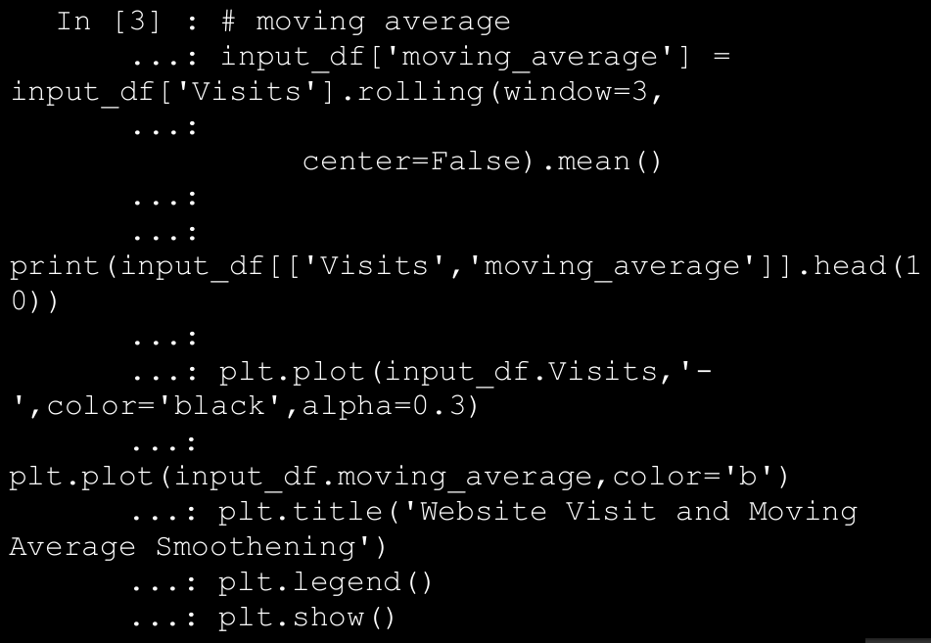

→ The moving average calculated using a window size 3 has the following results. It should be pretty clear that for a window size of 3, the first two observations would not have any moving averages available, hence the NaN.

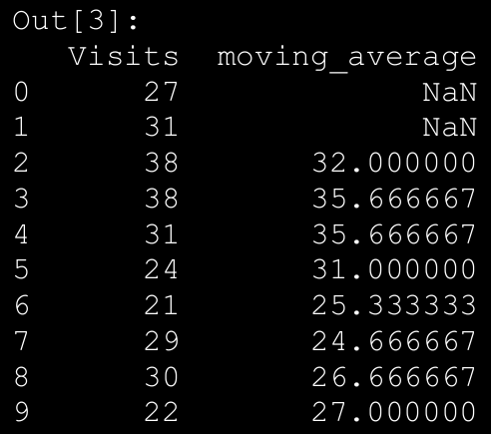

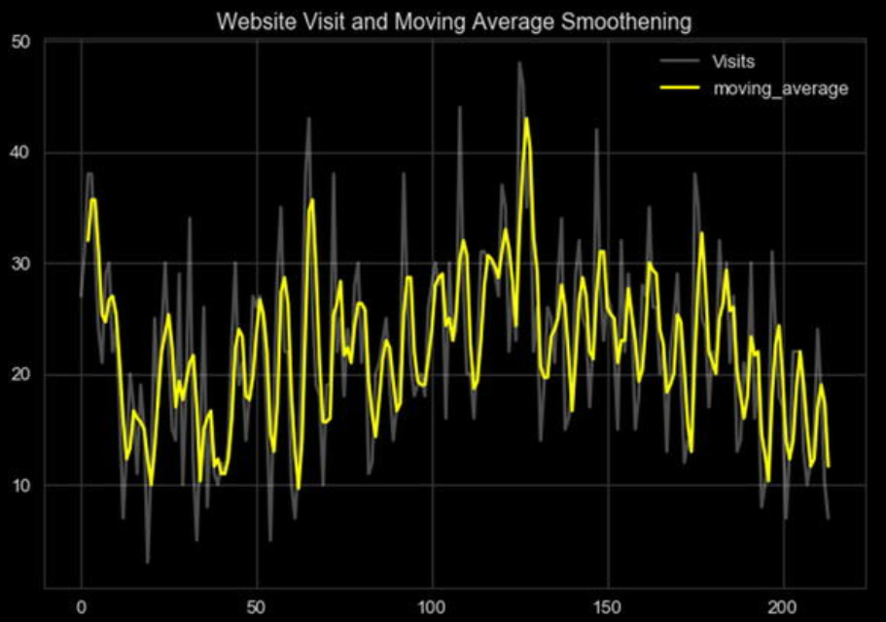

→ The plot in Figure above shows the smoothened visits time series. The smoothened series captures the overall structure of the original series all the while reducing the random variation in it. You are encouraged to explore and experiment with different window sizes and compare the results.

→ Depending on the use case and data at hand, we also try different variations of moving average like centered moving average, double moving average, and so on apart from different window sizes.

* 1. **Exponential Smoothing**

→ Moving average based smoothening is effective yet it is a pretty simple preprocessing technique. In case of moving average, all past observations in the window are given equal weight. Unlike the previous method, exponential smoothening techniques apply exponentially decreasing weights to older observations. In simple words, exponential smoothening methods give more weight to recent past observations as compared to older observations. Depending on the level of smoothening required, there may be one or more smoothening parameters to set in case of exponential smoothening.

→ Exponential smoothening is also called exponentially weighted moving average or EWMA for short. Single exponential smoothening is one of the simplest to get started with. The general formula is given as.

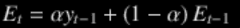

→ Where, E t is the t th smoothened observation, y is the actual observed value at t-1 instance, and α is smoothing constant between 0 and 1. There are different methods to bootstrap the value of E 2 (the time period from which smoothing begins). It can be done by setting it to y 1 or an average of first n time periods and so on. Also, the value of α determines how much of the past is accounted for. A value closer to 1 dampens out the past observations quickly while values closer to 0 dampen out slowly. The following snippet uses the pandas ewm() function to calculate the smoothened series for visits. The parameter halflife is used to calculate α in this case.

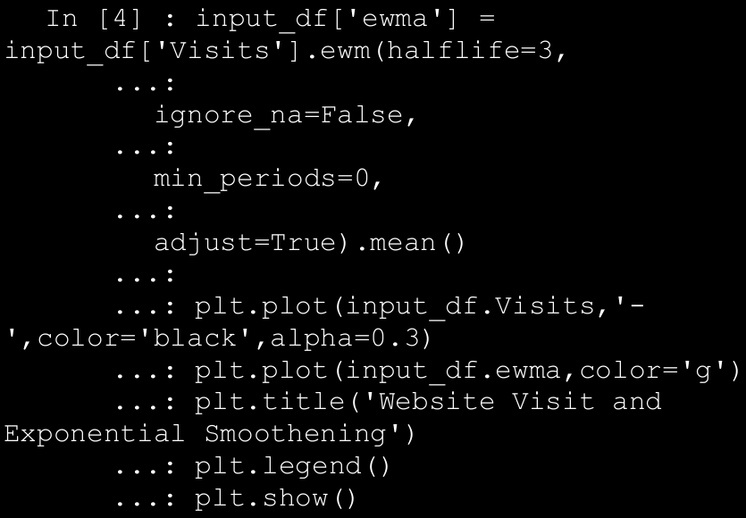

→ The plot depicted in Figure below showcases the EWMA smoothened series along with the original one.

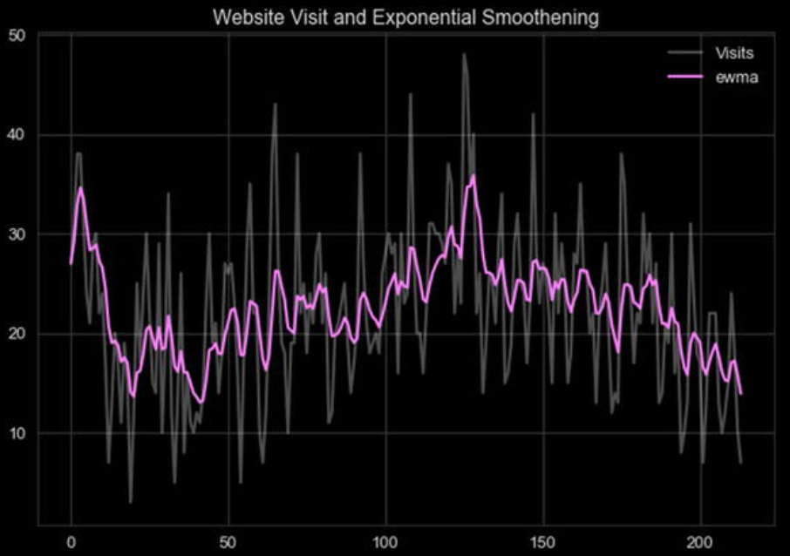

1. Forecasting Gold Price

→ To access publicly shared datasets on Quandl, we can use the pandas-datareader library as well as quandl (library from Quandl itself). For this use case, we will depend upon quandl. Kindly install the same using pip or conda. The following snippet shows a quick one-liner to get your hands on gold pricing information since 1970s.

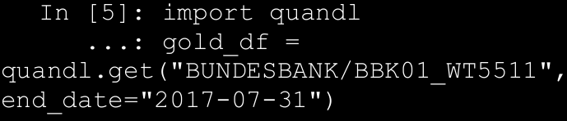

→ The get() function takes the stock/commodity identifier as first

parameter followed by the date until which we need the data. Note that not all datasets are public, for some of them, API access must be obtained.

* 1. Traditional Approaches

→ Time series analysis and forecasting have been long studied in detail. There are matured and extensive set of modeling techniques available for the same. Out of the many, the following are a few most commonly used and explored techniques:

* Simple moving average and exponential smoothing based forecasting
* Holt’s, Holt-Winter’s Exponential Smoothing based forecasting
* Box-Jenkins methodology (AR, MA, ARIMA, S-ARIMA, etc.)
  1. Key concepts:
     1. Stationarity: One the key assumptions behind the ARIMA models we will be discussing next. Stationarity refers to the property where for a time series its mean, variance, and autocorrelation are time invariant. In other words, mean, variance, and autocorrelation do not change with time. For instance, a time series having an upward (or downward) trend is a clear indicator of a non-stationarity because its mean would change with time.
     2. Differencing: One of the methods of stationarizing series. Though there can be other transformations, differencing is widely used to stabilize the mean of a time series. We simply compute difference between consecutive observations to obtain a differenced series. We can then apply different tests to confirm if the resulting series is stationary or not. We can also perform second order differencing, seasonal differencing, and so on, depending on the time series at hand.
     3. Unit Root Tests: Statistical tests that help us understand if a given series is stationary or not. The Augmented Dickey Fuller test begins with a null hypothesis of series being non-stationary, whileKwiatkowski-Phillips-Schmidt-Shin test or KPSS has a null hypothesis that the series is stationary. We then perform a regression fit to reject or fail to reject the null hypothesis.
  2. ARIMA:

→ The Box-Jenkin’s methodology consists of a wide range of statistical models which are widely used to model time series for forecasting. For this section, we will be concentrating on one such model called as ARIMA.

→ ARIMA stands for Auto Regressive Integrated Moving Average model. Sounds pretty complex, right? Let’s look at the basics and constituents of this model and then build on our understanding to forecast gold prices.

* Auto Regressive or AR Modeling: A simple linear regression model where current observation is regressed upon one or more prior observations. The model is denoted as.



→ where, X t is the observation at time t, εt is the noise and

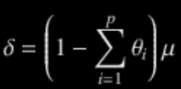

→ the dependency on prior values is denoted by p or the order of AR model.

* Moving Average or MA Modeling: Is again essentially a linear regression model that models the impact of noise/error from prior observations to current one. The model is denoted as



→ where, μ is the series mean, ε i are the noise terms, and q is the order of the model.

→The AR and MA models were known long before Box-Jenkin’s methodology was presented. Yet this methodology presented a systematic approach to identify and apply these models for forecasting.

→ The ARIMA model is a logical progression and combination of the two models. Yet if we combine AR and MA with a differenced series, what we get is called as ARIMA(p,d,q) model.

→ Where,

* p is the order of Autoregression
* q is the order of moving average
* d is the order of differencing

→ Thus, for a stationary time series ARIMA models combine autoregressive and moving average concepts to model the behavior of a long running time series and helps in forecasting. Let’s now apply these concepts to model gold price forecasting.

* 1. Modeling

→ While describing the dataset, we extracted the gold price information using quandl. Let’s first plot and see how this time series looks. The following snippet uses the pandas to plot the same.

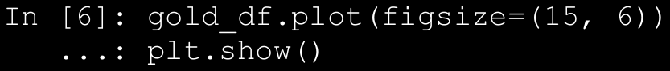

→ The plot in Figure below shows a general upward trend with sudden rise in the 1980s and then near 2010.

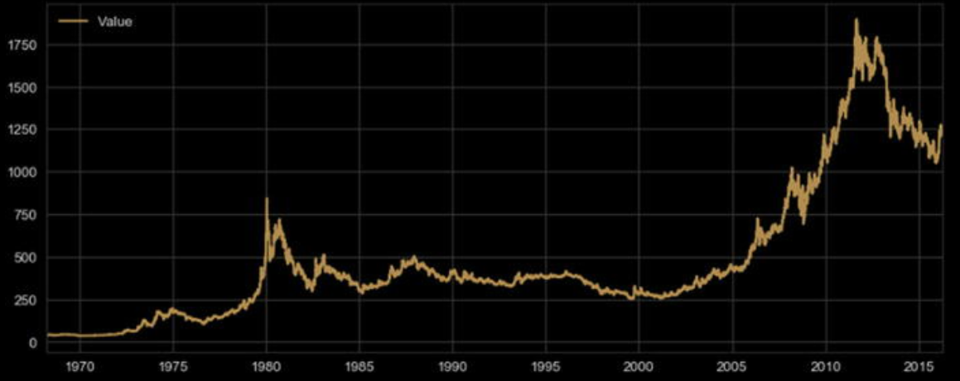

→ Since stationarity is one of the primary assumptions of ARIMA models, we will utilize Augmented Dickey Fuller test to check our series for stationarity . The following snippet helps us calculate the AD Fuller test statistics and plot rolling characteristics of the series.

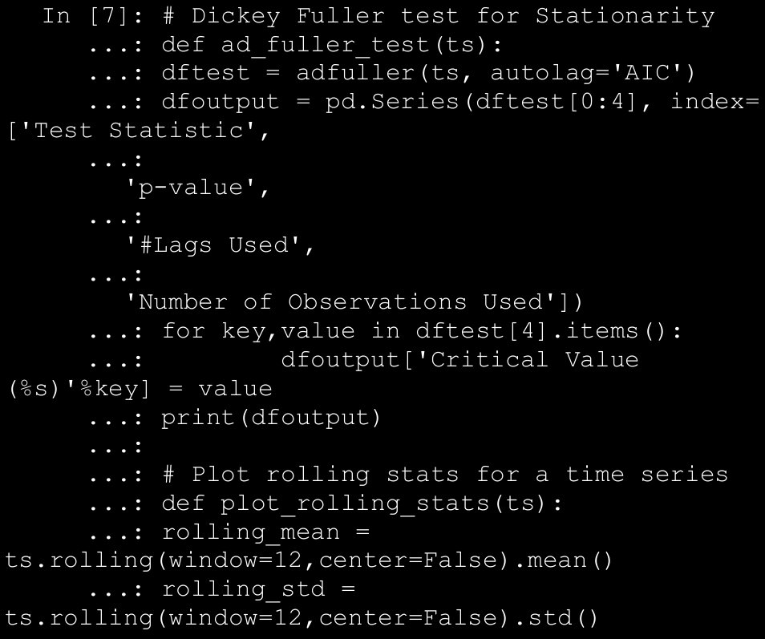

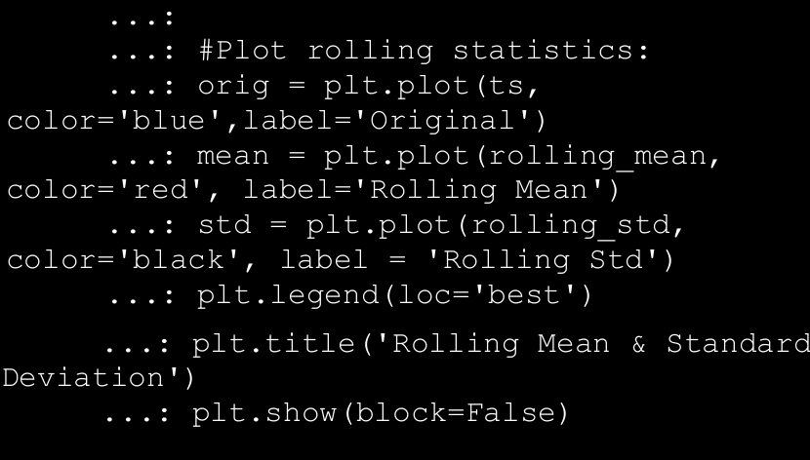

→ If the test statistic of AD Fuller test is less than the critical value(s), we reject the null hypothesis of non-stationarity. The AD Fuller test is available

as part of the statsmodel library . Since it is quite evident that our original series of gold prices is non-stationary, we will perform a log transformation and see if we are able to obtain stationarity. The following snippet uses the rolling stats plots and AD Fuller tests to check the same.

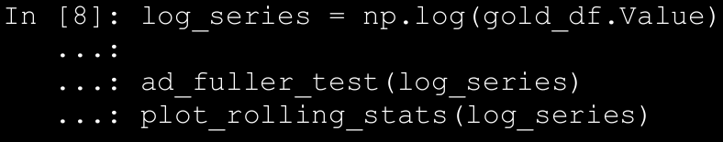

→ The test statistic of -1.8 is greater than either of critical values, hence we fail to reject the null hypothesis, i.e., the series is non-stationary even after log transformation. The output and plot depicted in Figure below confirm the same.

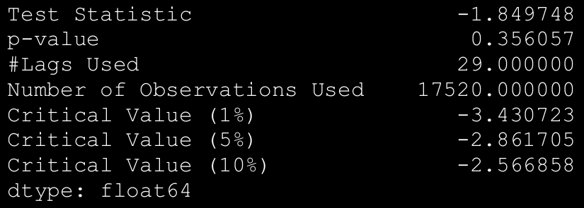

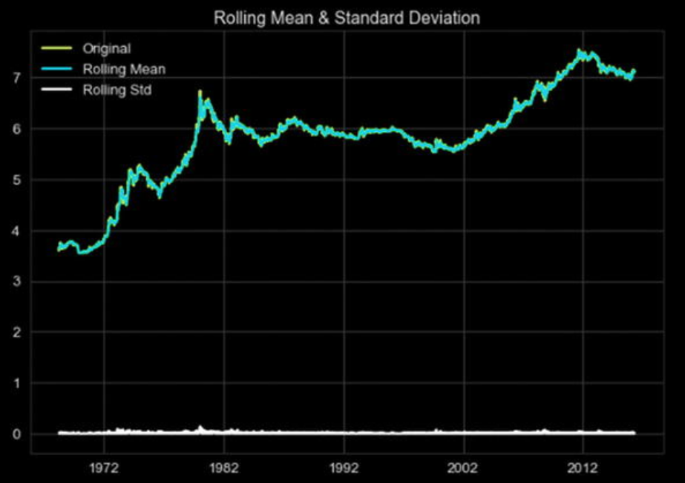

→ The plot points out a time varying mean of the series and hence the non-stationarity. As discussed in the key concepts, differencing a series helps in achieving stationarity. In the following snippet, we prepare a first order differenced log series and perform the same tests.

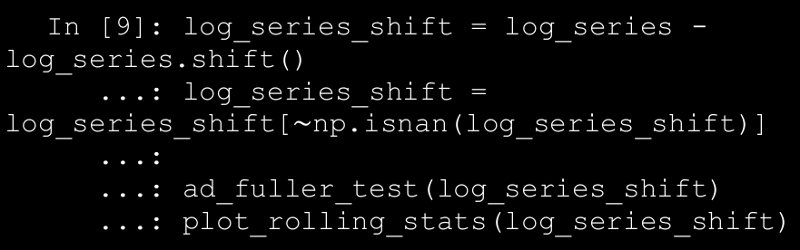

→ The test statistic at -23.91 is lower than even 1% critical value, thus we reject the null hypothesis for AD Fuller test. The following are the test results.

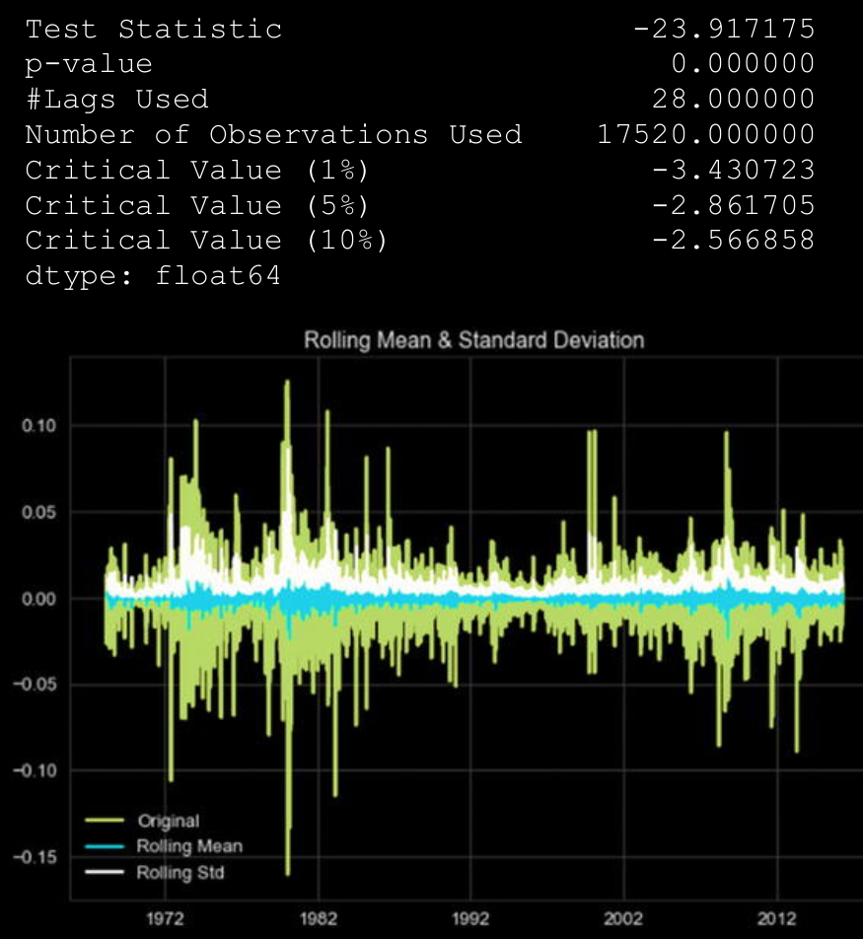

→This exercise points us to the fact that we need to use a log differenced series for ARIMA to model the dataset at hand. See Figure above. Yet we still need to figure out the order of autoregression and moving average components, i.e., p and q.

→Building an ARIMA model requires some experience and intuition as compared other models. Identifying p, d, and q parameters of the model can be done using different methods, though arriving at the right set of numbers is dependent both upon requirements and experience.

→ One of the commonly used methods is the plotting of ACF and PACF plots to determine p and q values. ACF or Auto Correlation Function plot and PACF or the Partial Auto Correlation Function plot helps us narrow down the search space of determining the p and q values with a few caveats. There are certain rules or heuristics developed over the years to best utilize these plots and thus these do not guarantee the best possible values.

→ The ACF plot helps us understand the correlation of an observation with its lag (or previous value). The ACF plot is used to determine the MA order, i.e. q. The value at which ACF drops is the order of the MA model. On the same lines, PACF points toward correlation between an observation and a specific lagged value, excluding effect of other lags. The value at which PACF drops points toward the order of AR model or the p in ARIMA(p,d,q).

→ Let’s again utilize statsmodels to generate ACF and PACF plots for our series and try to determine p and q values. The following snippet uses the log differenced series to generate the required plots.

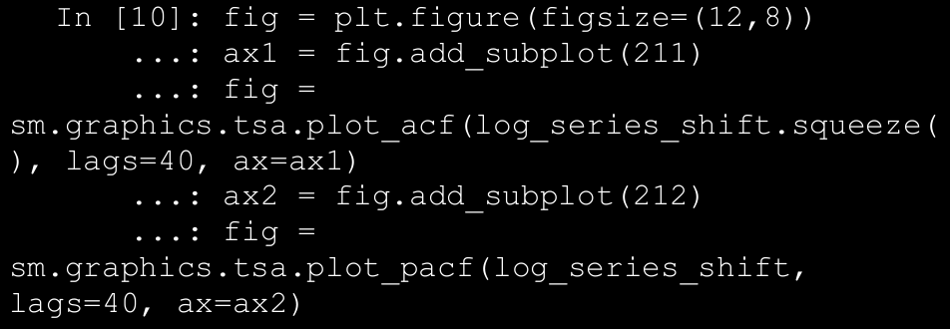

→ The output plots (Figure below) show a sudden drop at lag 1 for both ACF and PACF, thus pointing toward possible values of q and p to be 1 each, respectively.

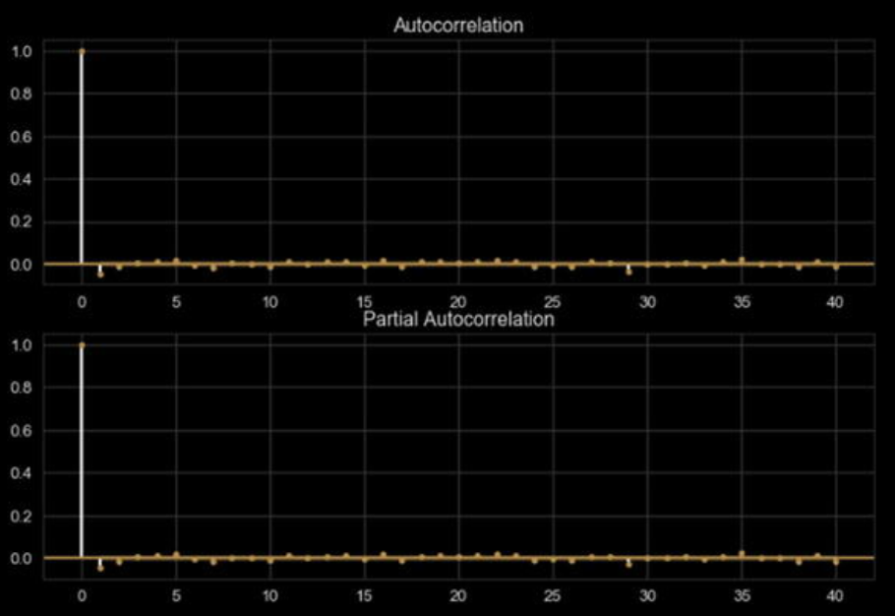

→ The ACF and PACF plot also help us understand if a series is stationary or not. If a series has gradually decreasing values for ACF and PACF, it points toward non-stationarity property in the series.

→ Another method to derive the p, d, q parameters is to perform a grid search of the parameter space. This is more in tune with the Machine Learning way of hyperparameter tuning. Though statsmodels does not provide such a utility (for obvious reasons though), we can write our own utility to identify the best fitting model. Also, pretty much like any other Machine Learning/Data Science use case, we need to split our dataset into train and test sets. We utilize scikit-learn’s TimeSeriesSplit utility to help us get proper training and testing sets.

→ We write a utility function arima_grid_search_cv() to grid

search and cross validate the results using the gold prices at hand. The function is available in arima_utils.py module for reference. The following snippet performs a five-fold cross validation with auto-ARIMA to find the best fitting model.

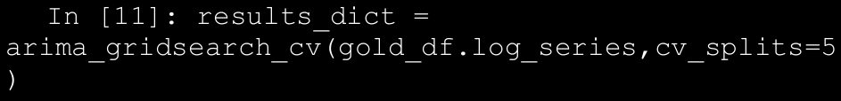

→Note that we are passing the log transformed series as input to the arima_gridsearch_cv() function. As we saw earlier, the log differenced series was what helped us achieve stationarity, hence we use the log transformation as our starting point and fit an ARIMA model with d set to 1. The function call generates a detailed output for each train-test split (we have five of them lined up), each iteration performing a grid search over p, d, and q. Figure below shows the output of the first iteration, where the training set included only 2924 observations.

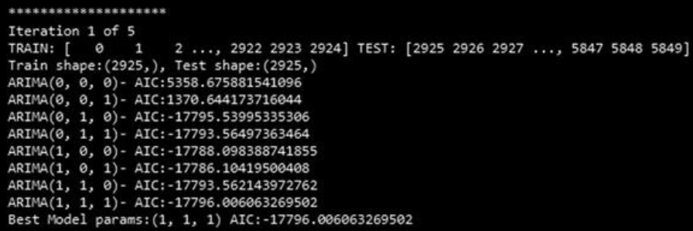

→ Similar to our findings using ACF-PACF, auto ARIMA suggests that the best fitting model is ARIMA(1,1,1) based upon the AIC criteria. Note that AIC or Akaike Information Criterion measures the goodness of fit and parsimony. It is a relative metric and does not point toward quality of models in an absolute sense, i.e., if all models being compared are poor, AIC will not be able to point that out. Thus, AIC should be used as a heuristic. A low value points toward a better fitting model. The following is the summary generated by the ARIMA(1,1,1) fit, see Figure below.

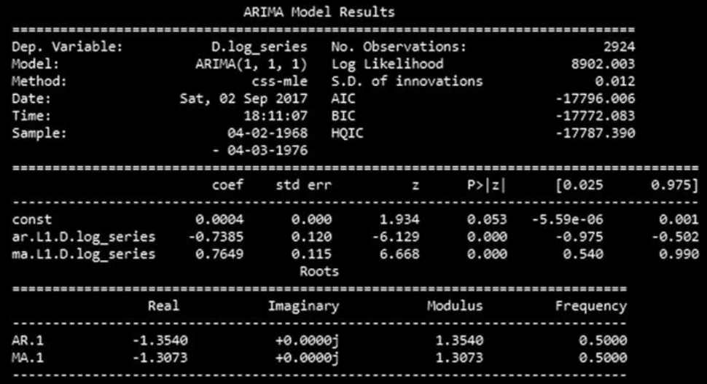

→ The summary is quite self-explanatory. The top section shows details about the training sample, AIC, and other metrics. The middle section talks about the coefficients of the fitted mode. In case of ARIMA(1,1,1) for iteration 1, both AR and MA coefficients are statistically significant. The Forecast Plot for iteration 1 with ARIMA(1,1,1) fitted is shown in Figure below.

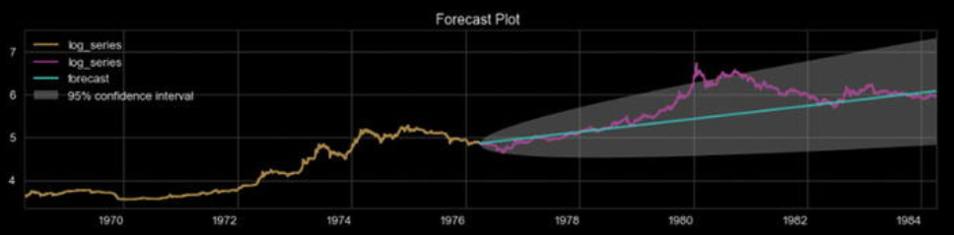

→ As evident from the plot in Figure 11-11, the model captures the overall upward trend though it misses out on the sudden jump in values around 1980. Yet it seems to give a pretty nice idea of what can be achieved using this methodology. The arima_gridsearch_cv() function produces similar statistics and plots for five different train-test splits. We observe that ARIMA(1,1,1) provides us decent enough fit, although we can define additional performance and error criteria to select a particular model.

1. **Stock Price Prediction using Recurrent Neural Networks: LSTM**

→ Artificial neural networks are being employed to solve a number of use cases in a variety of domains. Recurrent neural networks are a class of neural networks with capabilities of modeling sequential data. LSTMs or Long Short Term Memory is an RNN architecture that’s useful for modeling arbitrary intervals of information.

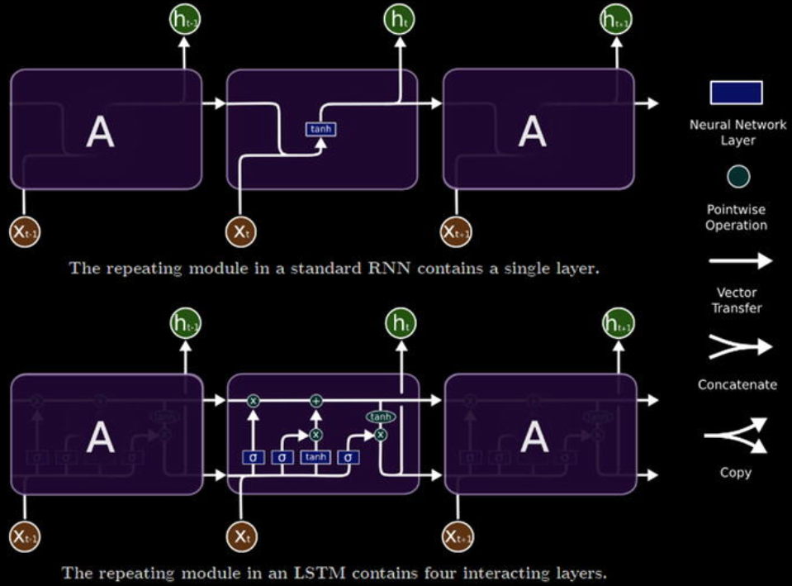

→ As a quick refresher, Figure above points toward the general

architecture of an RNN along with the internals of a typical LSTM unit. LSTM comprises of three major gates—the input, output, and forget gates. These gates work in tandem to learn and store long and short term sequence related information.

→ For stock price prediction, we will utilize LSTM units to implement an RNN model. RNNs are typically useful in sequence modeling applications; some of them are as follows:

* **Sequence classification** tasks like sentiment analysis of a given corpus
* **Sequence tagging** tasks like POS tagging a given sentence
* **Sequence mapping** tasks like speech recognition

→ **Unlike traditional forecasting approaches (like ARIMA), which require preprocessing of time series information to conform to stationarity and other assumptions along with parameter identification (p, d, q, for instance), neural networks (particularly RNNs) impose far fewer restrictions.**

→ Since stock price information is also a time series data, we will explore the application of LSTMs to this use case and generate forecasts. There are a number of ways this problem can be modeled to forecast values.

* 1. **Regression Modeling**

→ To model our current use case as a regression problem, we state that the stock price at timestamp t+1 (dependent variable) is a function of stock price at timestamps t, t -1, t -2, …, t -n. Where n is the past window of stock prices. Now that we have a framework defined on how we would model our time series, we need to transform our time series data into windowed form. See Figure below.

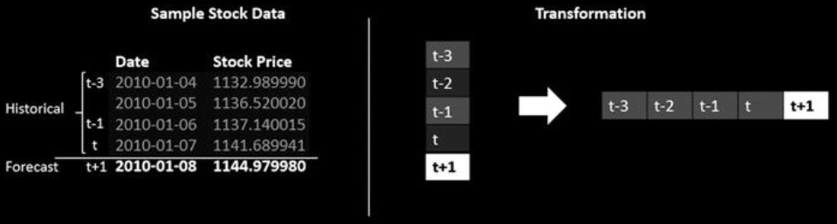

→ The windowed transformation is outlined in Figure below where a window size of 4 is used. The value at time t+1 is forecasted using past four values. We have data for the S&P 500 index since 2010, hence we would apply this windowed transformation in a rolling fashion and create multiple such sequences. Thus, if we have a time series of length M and a window size of n, there would be M-n-1 total windows generated.

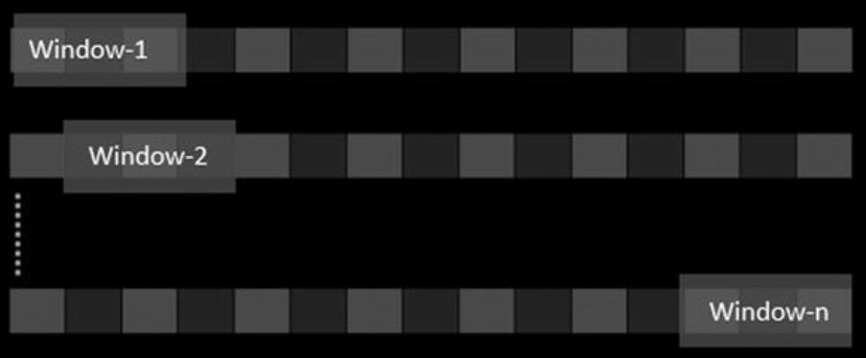

→ For using LSTMs to model our time series, we need to apply one more level of transformation to be able to input our data. LSTMs accept 3D tensors as input, we transform each of the windows (or sequences) in (N, W, F) format. Here, N is the number of samples or windows from the original time series, W is the size of each window or the number of historical time steps and F is the number of features per time step. In our case, as we are only using the closing price, F is equal to 1, N and W are configurable. The following function performs the windowing and 3D tensor transformations using pandas and numpy.

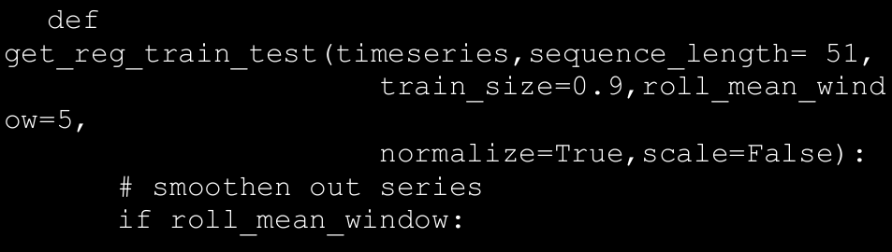

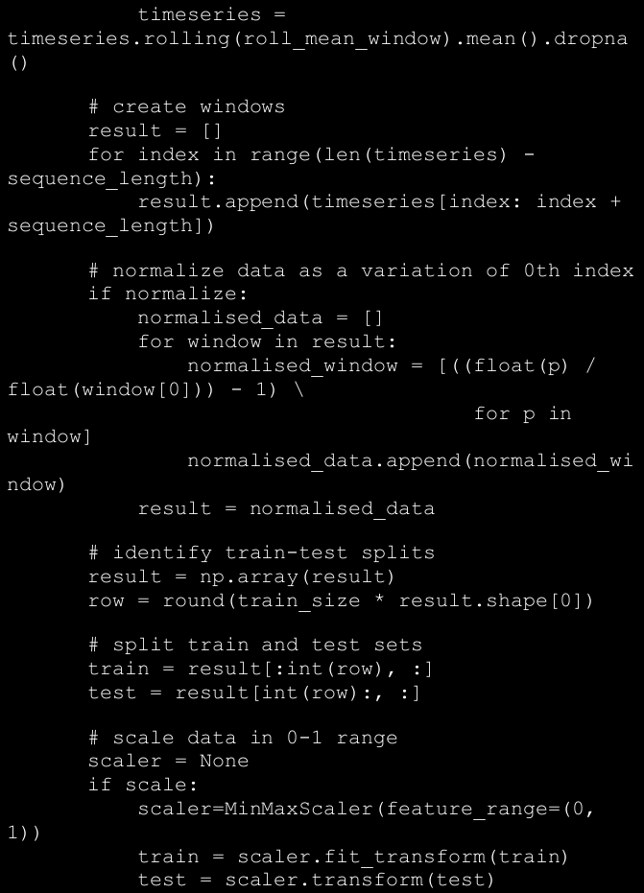

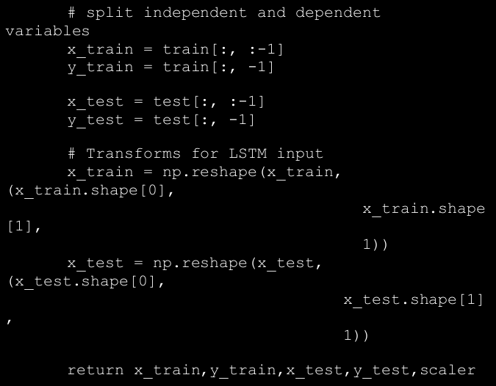

→ The function get_reg_train_test() also performs a number of

other optional preprocessing steps. It allows us to smoothen the time series using rolling mean before the windowing is applied. We can also normalize the data as well as scale based on requirements. Neural networks are sensitive to input values and it is generally advised to scale inputs before training the network. For this use case, we will utilize the normalization of the time series wherein, for each window, every time step is the percentage change from the first value in that window (we could also use scaling or both and repeat the process).

→ For our case, we begin with a window size of six days (you can

experiment with smaller or larger windows and observe the difference). The following snippet uses the get_reg_train_test() function with

normalization set to true.

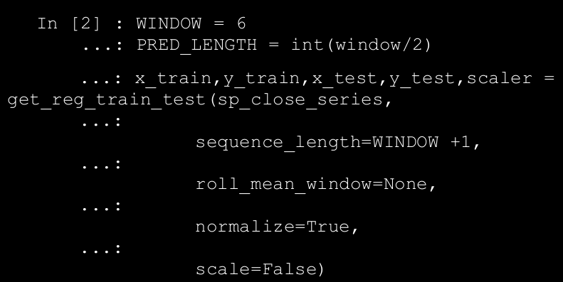

→ This snippet creates a seven-day window that is comprised of six days of historical data (x_train) and one-day forecast y_train. The shapes of the train and test variables are as follows.

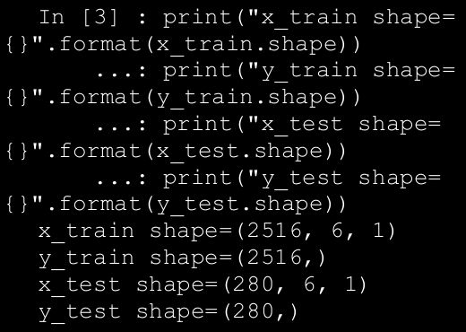

→ The x_train and x_test tensors conform to the (N, W, F) format

we discussed earlier and is required for input to our RNN. We have 2516

sequences in our training set, each with six time steps and one value to

forecast. Similarly, we have 280 sequences in our test set.

→ Now that we have our datasets preprocessed and ready, we build up an RNN network using keras. The keras framework provides us high level

abstractions to work with neural networks over theano and

tensorflow backends. The following snippet showcases the model

prepared using the get_reg_model() function.

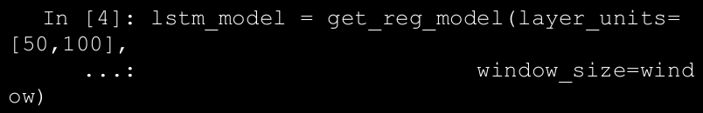

→ The generated LSTM model architecture has two hidden LSTM layers

stacked over each other with first one having 50 LSTM units and the second one having 100. The output layer is a Dense layer with linear activation function. We use mean squared error as our loss function to optimize upon. Since we are stacking LSTM layers, we need to set return_sequences to true in order for the subsequent layer to get the required values. As is evident, keras abstracts most of the heavy lifting and makes it pretty intuitive to build even complex architectures with just a few lines of code. The next step is to train our LSTM network. We use batch size of 16 with 20 epochs and a validation set of 5%. The following snippet uses the fit() function to train the model.

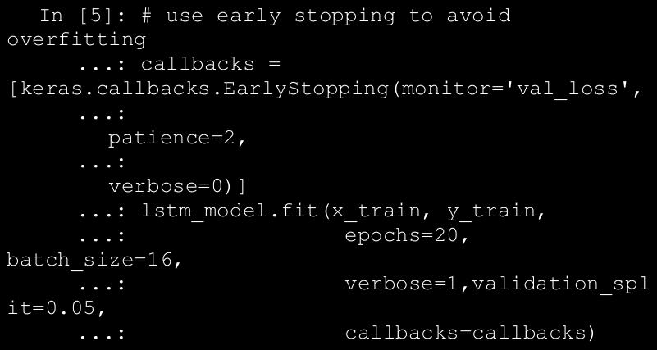

→ The model generates information regarding training and validation loss

for every epoch it runs. The callback for stopping enables us to stop the

training if there is no further improvement observed for two consecutive

epochs. We start with a batch size of 16; you may experiment with larger batch sizes and observe the difference.

→ Once the model is fit, the next step is to forecast using the predict()

function. Since we have modeled this as a regression problem with a fixed window size, we would generate forecasts for every sequence. To do so, we write another utility function called predict_reg_multiple(). This function takes the lstm model, windowed dataset, window and prediction lengths as input parameters to return a list of predictions for every input window. The predict_reg_multiple() function works as follows.

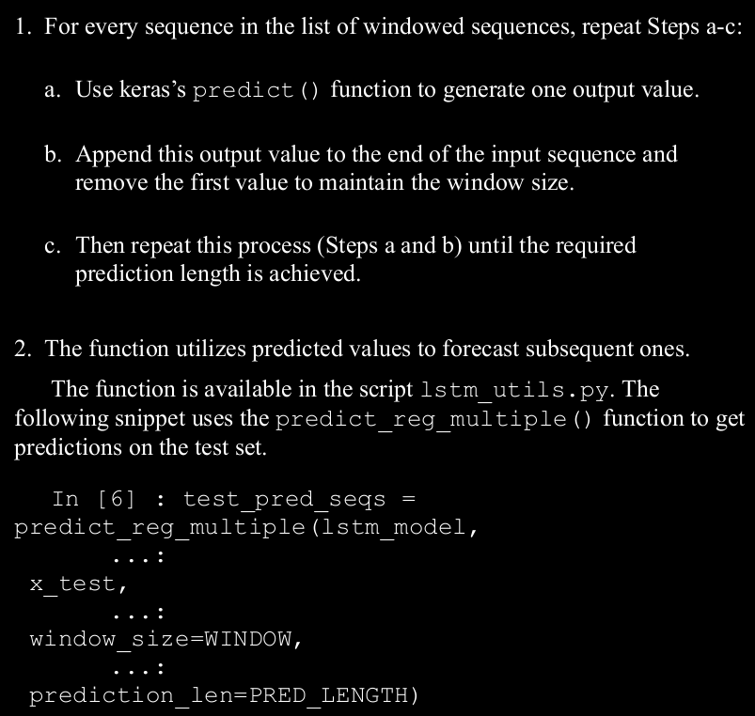

→ To analyze the performance, we will calculate the RMSE for the fitted

sequence. We use sklearn’s metrics module for the same. The following snippet calculates the RMSE score.

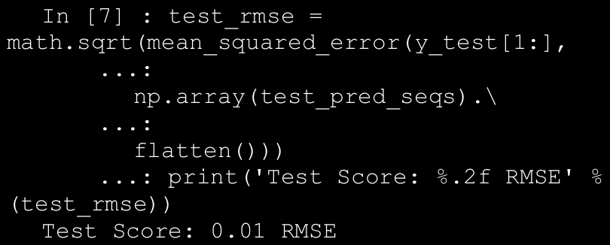

→ To visualize our predictions, we plot the predictions against the

normalized testing data. We use the function plot_reg_results(),

which is also available for reference in lstm_utils.py. The following

snippet generates the required plot using the same function.

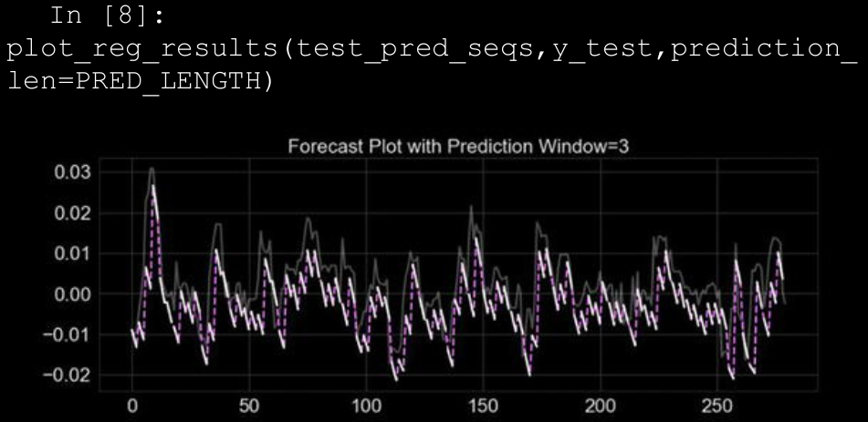

* 1. **Sequence Modeling**

→ Recurrent neural networks are naturally suited for sequence modeling

tasks like machine translation, speech recognition and so on. RNNs utilize

memory (unlike normal feed forward neural networks) to keep track of

context and utilize the same to generate outputs. In general feed forward

neural networks assume inputs are independent of each other. This

independence may not hold in many scenarios (such as time series data).

RNNs apply same transformations to each element of the sequence, with

outcomes being dependent upon previous values.

→ In case of our stock price time series, we would like to model it now as

sequence where value at each time step is a function of previous values.

Unlike the regression-like modeling, here we do not divide the time series

into windows of fixed sizes, rather we would utilize the LSTMs to learn

from the data and determine which past values to utilize for forecasting.

→ To do so, we need to perform certain tweaks to the way we processed

our data in the previous case and also how we built our RNN. In the previous section, we utilized the (N,W,F) format as input. In the current setting, the format remain the same with the following changes.

* N(number of sequences): This will be set to 1 since we are dealing with only one stock’s price information.
* W(length of sequence): This will be set to total number of days worth of price information we have with us. Here we use the whole series as one big sequence.
* F(features per timestamp): This is again 1, as we are only dealing with closing stock value per timestamp.

→ Talking about the output, in the previous section we had one output for

every window/sequence in consideration. While modeling our data as a

sequence/time series we expect our output to be a sequence as well. Thus, the output is also a 3D tensor following the same format as the input tensor.

→ We write a small utility function get_seq_train_test() to help

us scale and generate train and test datasets out of our time series. We use a 70-30 split in this case. We then use numpy to reshape our time series into 3D tensors. The following snippet utilizes the get_seq_train_test() function to do the same.

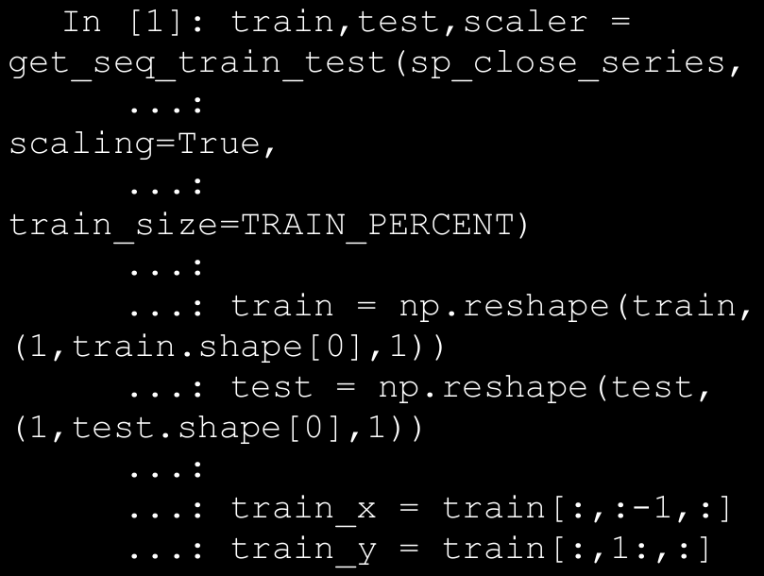

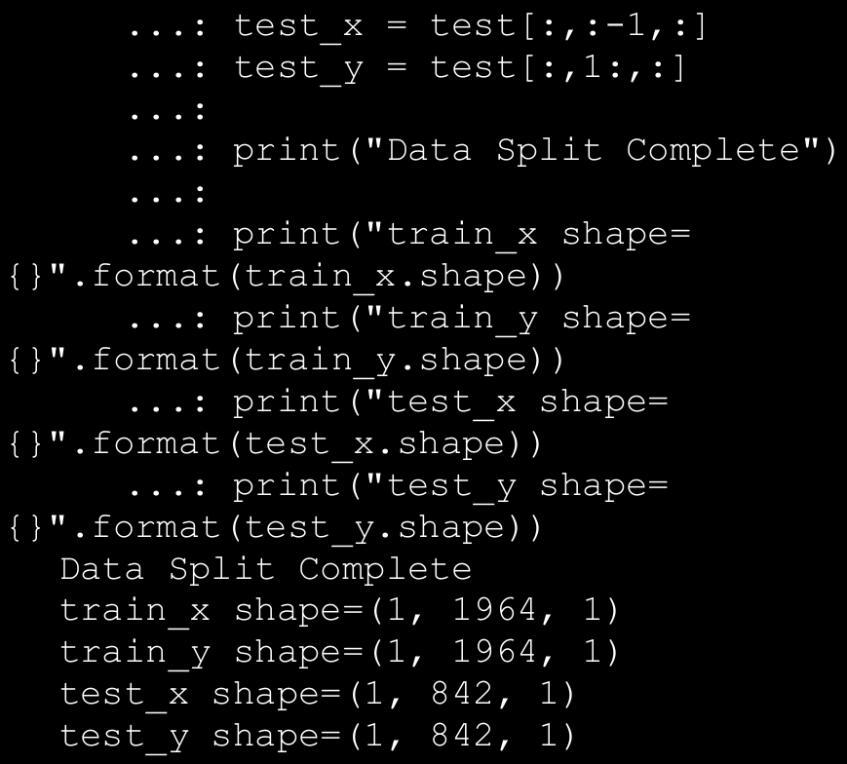

→ The requirement in this case is to apply similar transformations/processing for every time step and be able to get output for every input timestamp rather than waiting for the whole sequence to be

processed. To enable such scenarios, keras provides a wrapper over dense layers called **TimeDistributed**. This wrapper applies the same task to every time step and provides hooks to get output after each such time step. We use TimeDistributed wrapper over Dense layer to get output from each of the time steps being processed. The following snippet showcases get_seq_model() function to generate the required model.

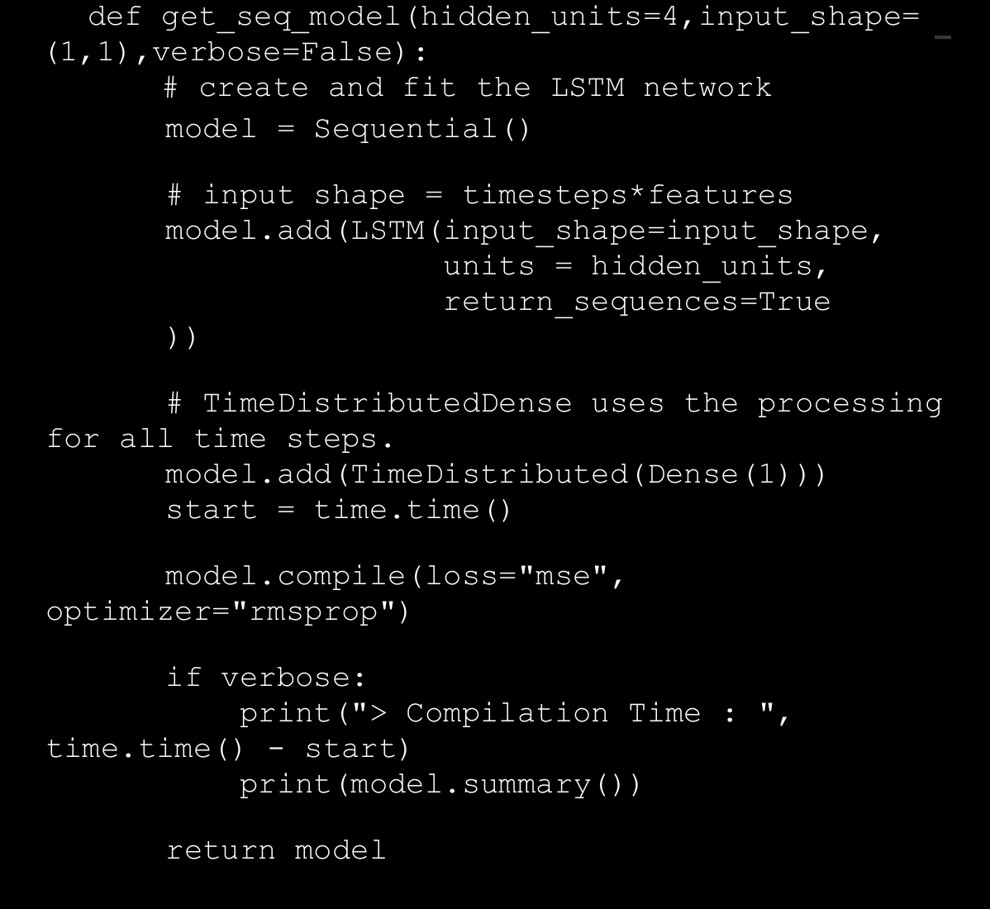

→ This function returns a single hidden layer RNN network with four

LSTM units and a TimeDistributed Dense output layer. We again use mean squared error as our loss function.

→ We have our dataset preprocessed and split into train and test along with a model object using the function get_seq_model(). The next step is to simply train the model using the fit() function. While modeling stock price information as a sequence, we are assuming the whole time series as one big sequence. Hence, while training the model, we set the batch size as 1 as there is only one stock to train in this case. The following snippet gets the model object and then trains the same using the fit() function.

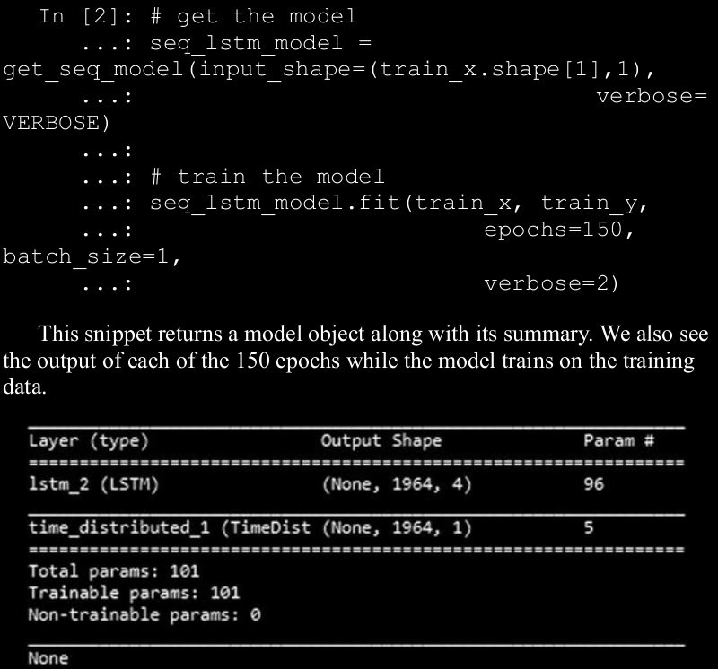

→ We also calculate and print the RMSE score of the forecast.

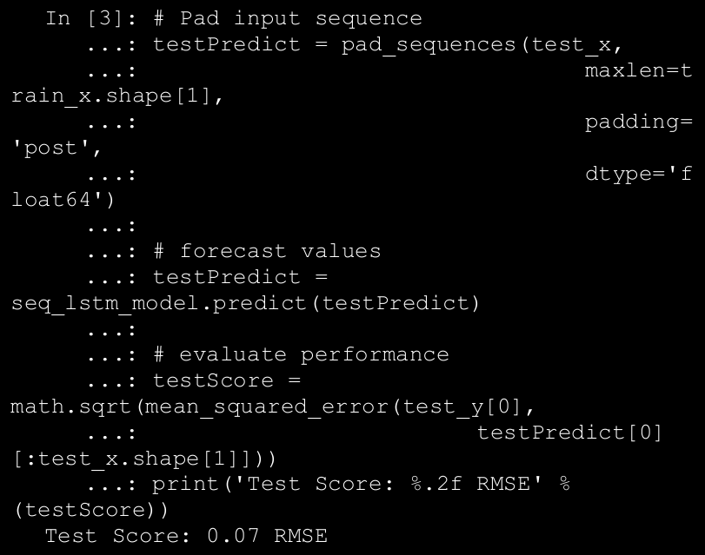

→ We can perform the same steps on the training set as well and check the performance. While generating the train and test datasets, the function

get_seq_train_test() also returned the scaler object. We next use this scaler object to perform an inverse transformation to get the prediction

values in the original scale. The following snippet performs inverse

transformation and then plots the series.

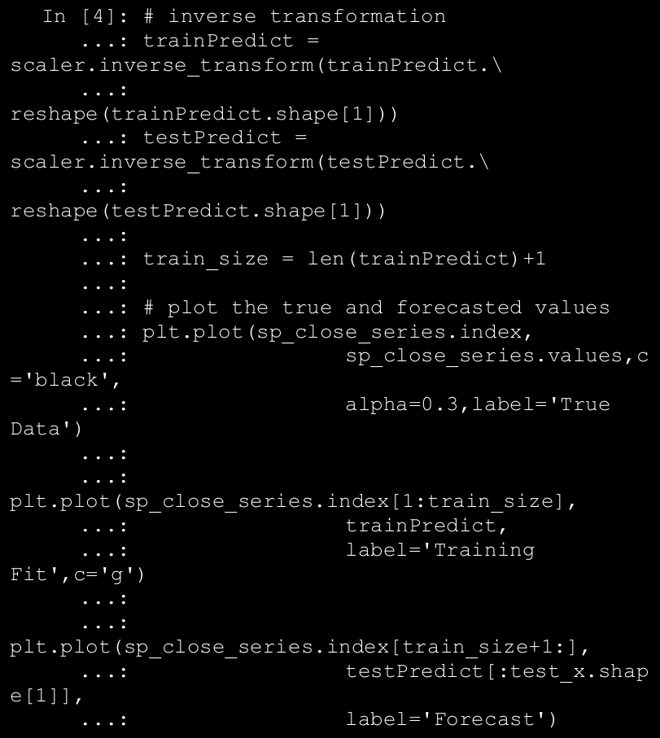

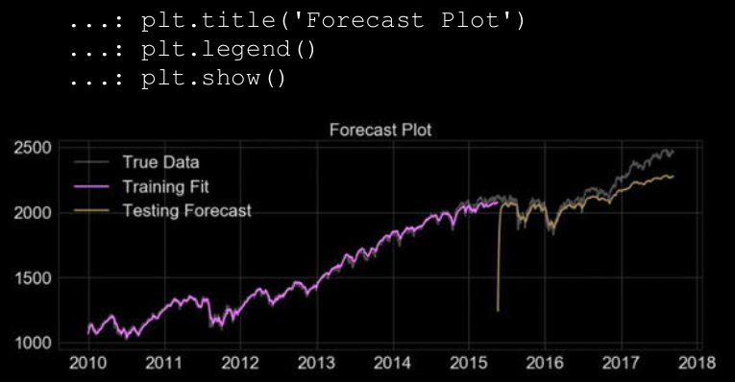

1. **Upcoming Techniques: Prophet**

→ The Data Science landscape is ever evolving and new algorithms, tweaks

and tools are coming up at a rapid pace. One such tool is called Prophet.

This is a framework, open sourced by Facebook’s Data Science team for

analyzing and forecasting time series.

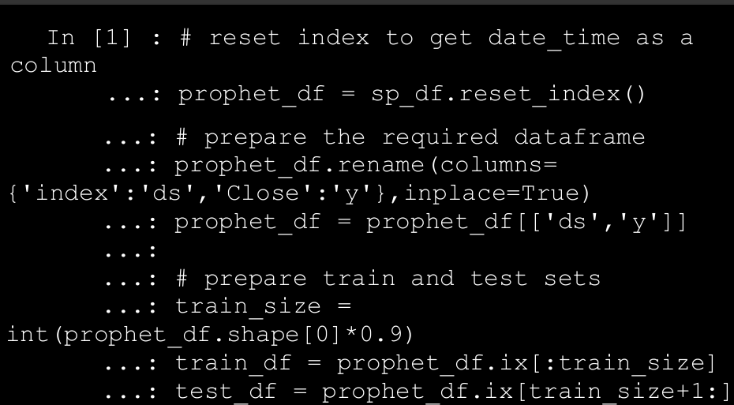

→ Once we have the datasets prepared, we create an object of the Prophet class and simply fit the model using fit() function.

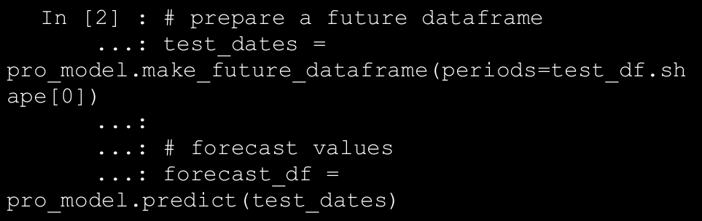

→ The following snippet plots the forecasted values against the original time series along with its confidence intervals.

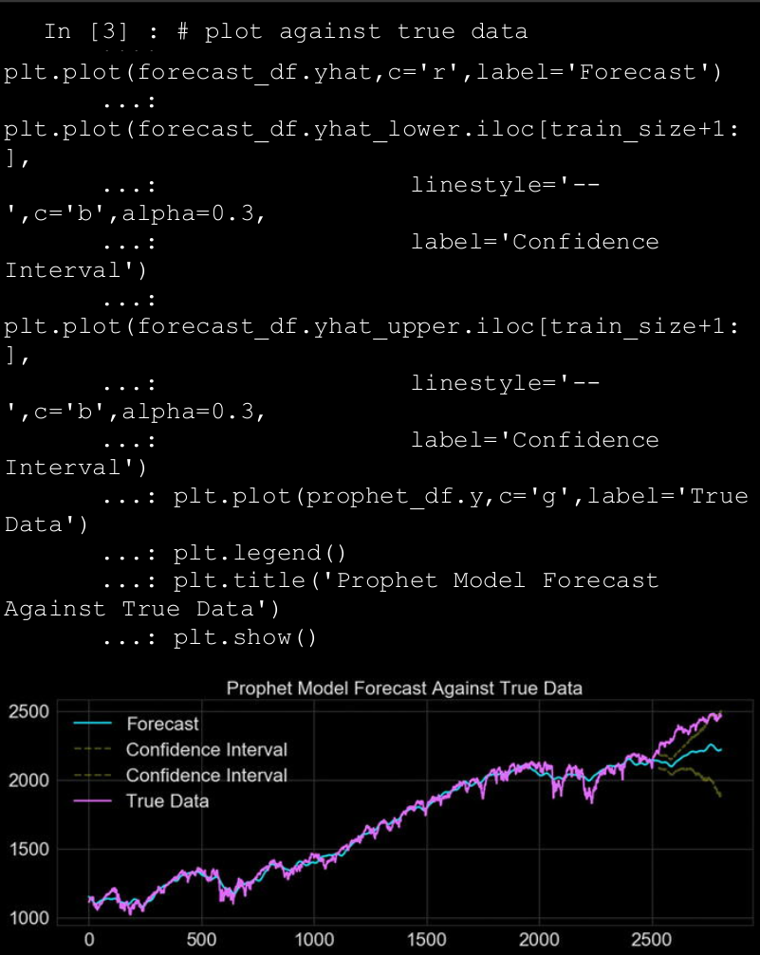

1. **Deep Learning for computer vision**

→ This topic discusses convolutional neural networks through the task

of image classification using publicly available datasets like CIFAR,ImageNet, and MNIST. We will utilize our understanding of CNNs to then take on the task of style transfer and understand how neural networks can be used to understand high-level features. Through this chapter, we cover the following topics in detail:

* Brief overview of convolutional neural networks
* Image classification using CNNs from scratch
* Transfer learning: image classification using pretrained models
* Neural style transfer using CNNs

**⇒ Convolutional Neural Networks**

→ Convolutional Neural Networks (CNNs) are similar to the general neural

networks we have discussed over the course of this book. The additional

explicit assumption of input being an image (tensor) is what makes CNNs

optimized and different than the usual neural networks. This explicit

assumption is what allows us to design deep CNNs while keeping the

number of trainable parameters in check (in comparison to general neural

networks).

* **Convolutional Layer**: This is the key differentiating component of a CNN as compared to other neural networks. Convolutional layer or conv layer is a set of learnable filters. These filters help capture spatial features. These are usually small (along the width and height) but cover the full depth (color range) of the image. During the forward pass, we slide the filter across the width and the height of the image while computing the dot product between the filter attributes and the input at any position. The output is a two- dimensional activation map from each filter, which are then stacked to get the final output.
* **Pooling Layer**: These are basically down-sampling layers used to reduce spatial size and number of parameters. These layers also help in controlling overfitting. Pooling layers are inserted in between conv layers. Pooling layers can perform down sampling using functions such as max, average, L2-norm, and so on.
* **Fully Connected Layer**: Also known as FC layer. These are similar to fully connected layers in general neural networks. These have full connections to all neurons in the previous layer. This layer helps perform the tasks of classification.
* **Parameter Sharing**: The unique thing about CNNs apart from the conv layer is parameter sharing. Conv layers use same set of weights across the filters thus reducing the overall number of parameters required.

→ A typical CNN architecture with all the components is depicted in Figure below:

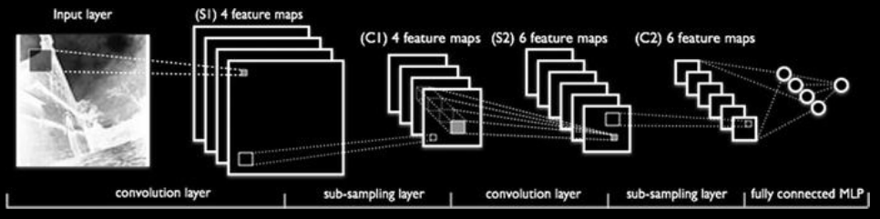

* 1. **Image classification with CNNS**

→ Convolutional Neural Networks are prime examples of the potential and power of neural networks to learn detailed feature representations and patterns from images and perform complex tasks, ranging from object recognition to image classification and many more.

→ CNNs have gone through tremendous research and advancements have led to more complex and power architectures, like VGG-16, VGG-19, Inception V3, and many more interesting models.

* 1. **Dataset**

→ The CIFAR10 dataset is a collection of tiny labeled images spanning

across 10 different classes.

→ This dataset contains tiny images of size 32 x 32 with 50,000 training

and 10,000 test samples. Each image can fall into one and only one of the

following classes Automobile, Airplane, Bird, Cat, Deer, Dog, Frog, Horse, Ship, Truck.

* 1. **CNN Based Deep Learning Classifier from Scratch**

→ Similar to any Machine Learning algorithm, neural networks also require the input data to be certain shape, size, and type. So, before we reach the modeling step, the first thing is to preprocess the data itself. The following snippet gets the dataset and then performs one hot encoding of the labels. Remember there are 10 classes to work with and hence we are dealing with a multi-class classification problem.

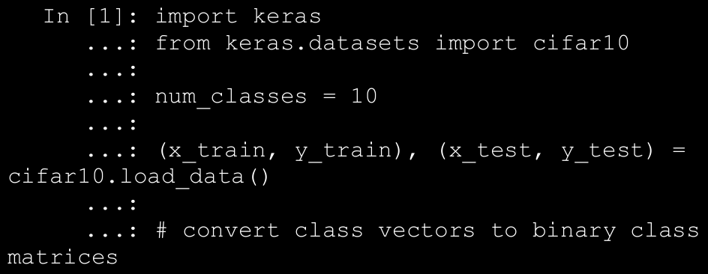

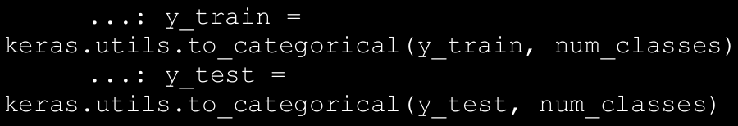

→ The dataset, if not already present locally, would be downloaded

automatically. The following are the shapes of the objects obtained.

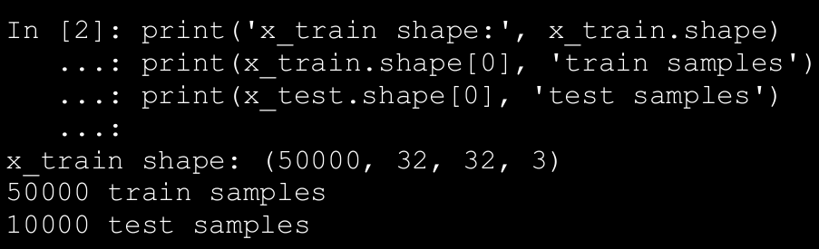

→ Now that we have training and test datasets. The next step is to build the CNN model. Since we have two dimensional images (the third dimension is the channel information), we will be using Conv2D layers. As discussed in the previous section, CNNs uses a combination of convolutional layers and pooling layers followed by a fully connected end to identify/classify the data. The model architecture is built as follows.

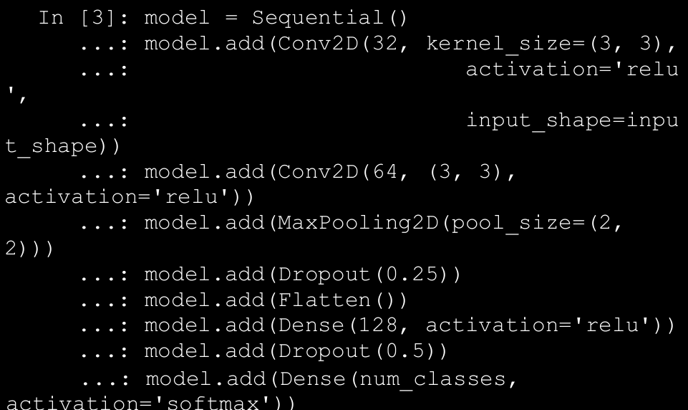

→ It starts off with a convolutional layer with a total of 32 3 x 3 filters and

activation function as the rectified linear unit (relu). The input shape

resembles each image size, i.e. 32 x 32 x 3 (color image has three channels—RGB). This is followed by another convolutional layer and a max-pooling layer. Finally, we have the fully connected dense layer. Since we have 10 classes to choose from, the final output layer has a softmax activation.

→The next step involves compiling . We use categorical_crossentropy as our loss function since we are dealing with multiple classes. Besides this, we use the Adadelta optimizer and then train the classifier on the training data. The following snippet showcases the same.

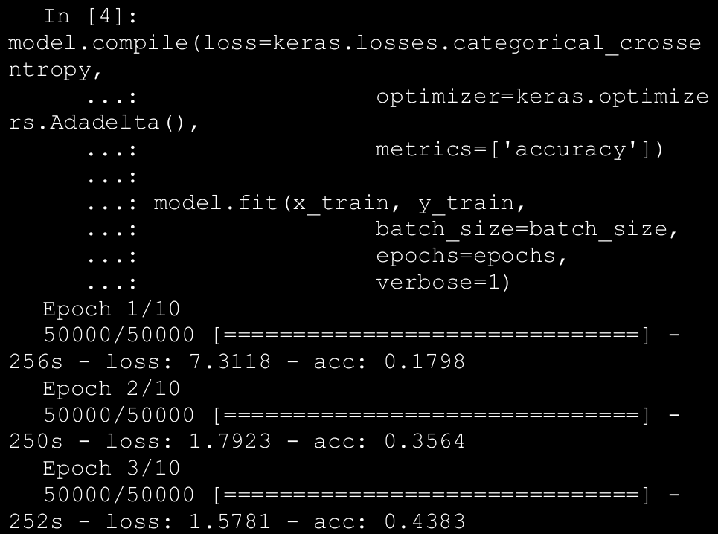

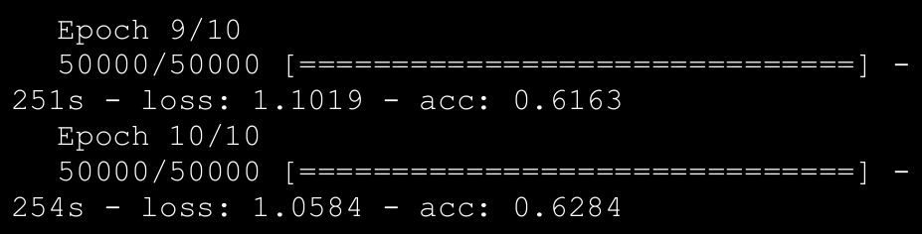

→ From the preceding output, it is clear that we trained the model for 10

Epochs.

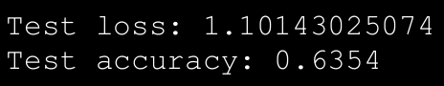

→ Thus, we can see that our very simple CNN based Deep Learning model achieved an accuracy of 63.5%, given the fact that we have built a very simple model and that we haven't done much preprocessing or model

Tuning.

→ The initial few conv layers of the model kind of work toward feature

extraction while the last couple of layers (fully connected) help in

classifying the data.

→ **Thus, it would be interesting to see how the image data is manipulated by the conv-net we just created**. Luckily, keras provides hooks to extract information at intermediate steps in the model. They depict how various regions of the image activate the conv layers and how the corresponding feature representations and patterns are extracted.

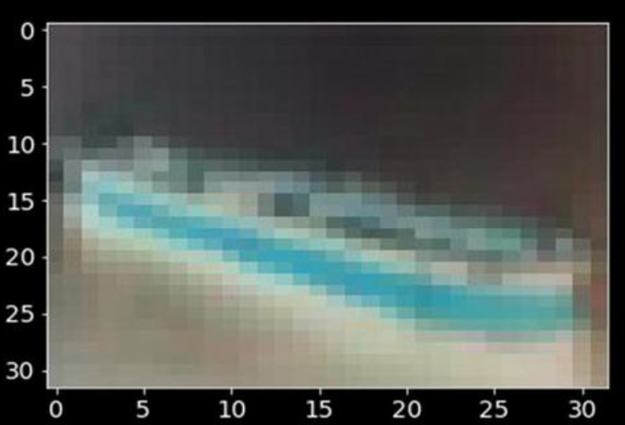

→ It looks like a ship and the model correctly identifies the same as well as depicted in this snippet.

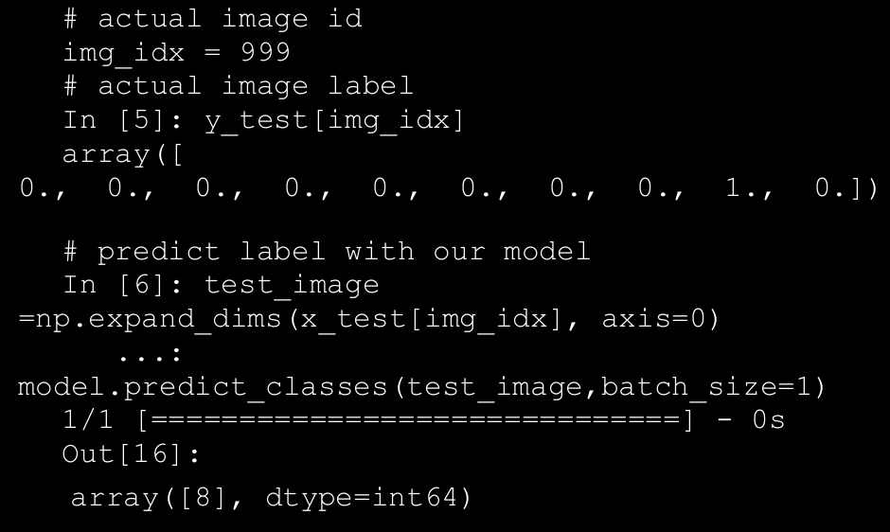

→ You can extract and view the activation maps of the image based on

what representations are learned and extracted by the conv layers using the get_activations(...) and display_activations(...) functions in the notebook. Figure below shows the activations of initial conv layers of the CNN model we just built.



* 1. **CNN Based Deep Learning Classifier with Pretrained Models**

→ Building a classifier from scratch has its own set of pros and cons. Yet, a more refined approach is to leverage pre-trained models over large complex datasets. There are many famous CNN architectures like LeNet, ResNet, VGG-16, VGG-19, and so on. These models have deep and complex architectures that have been fine-tuned and trained over diverse, large datasets. Hence, these models have been proven to have amazing

performance on complex object recognition tasks.

* **Pre-trained model as feature extractor** : The pre-trained model is used to extract features for our dataset. We build a fully connected classifier on top of these features. In this case we only need to train the fully connected classifier, which does not take much time.
* **Fine - tuning pre-trained models** : It is possible to fine-tune an existing pre-trained model by fixing some of the layers and allowing others to learn/update weights apart from the fully connected layers. Usually it is observed that initial layers capture generic features while the deeper ones become more specific in terms of feature extraction. Thus, depending upon the requirements, we fix certain layers and fine-tune the rest.

→ In this section, we see an example where we will utilize a pre-trained

conv-network as a feature extractor and build fully connected layer based classifier on top of it and train the model. We will not train the feature extraction layers and hence leverage principles of transfer learning by using the pre-trained conv layers for feature extraction.

→ The following snippet loads theVGG-19 model architecture consisting of the conv layers and leaves out the fully connected layers.

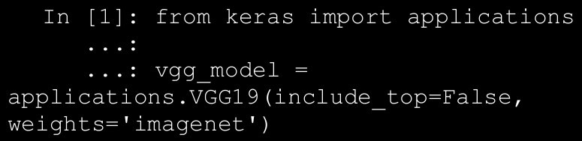

→ Before moving on to feature extraction using the VGG-19 model, it

would be a good idea to check out the model's architecture.

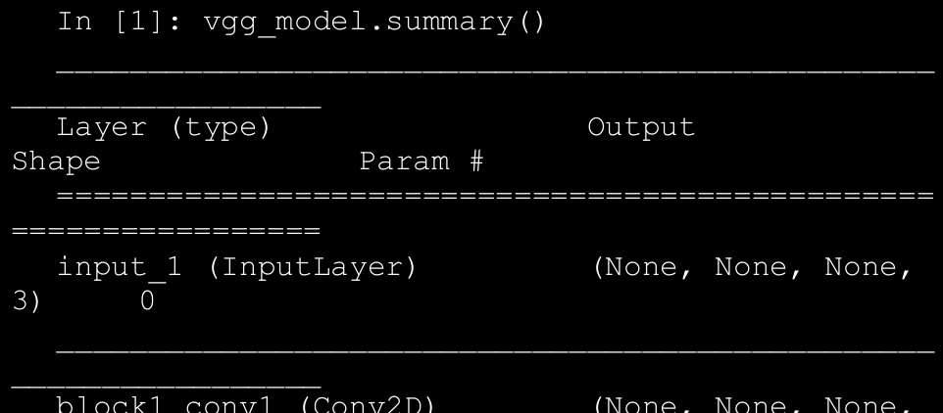

→ From the preceding output , you can see that the architecture is huge

with a lot of layers. Figure below depicts the same in an easier- to- understand visual depicting all the layers.

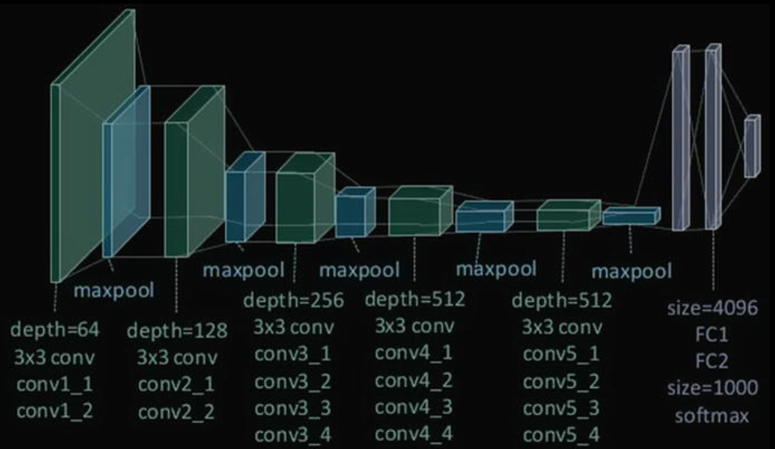

→ Since the VGG19 model has been loaded without the final fully connected layers, the predict(...) function of the model helps us get the extracted features on our dataset. The following snippet extracts the features for both training and test datasets.

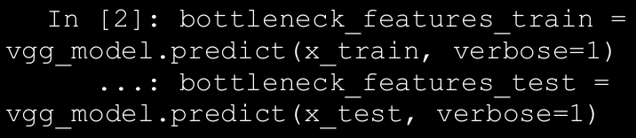

→ These features are widely known as bottleneck features due to the fact that there is an overall decrease in the volume of the input data points. It would be worth exploring the model summary to understand how the VGG

model transforms the data. The output of this stage (the bottleneck features) is used as input to the classifier we are going to build next. The following snippet builds a simple fully connected two-layer classifier.

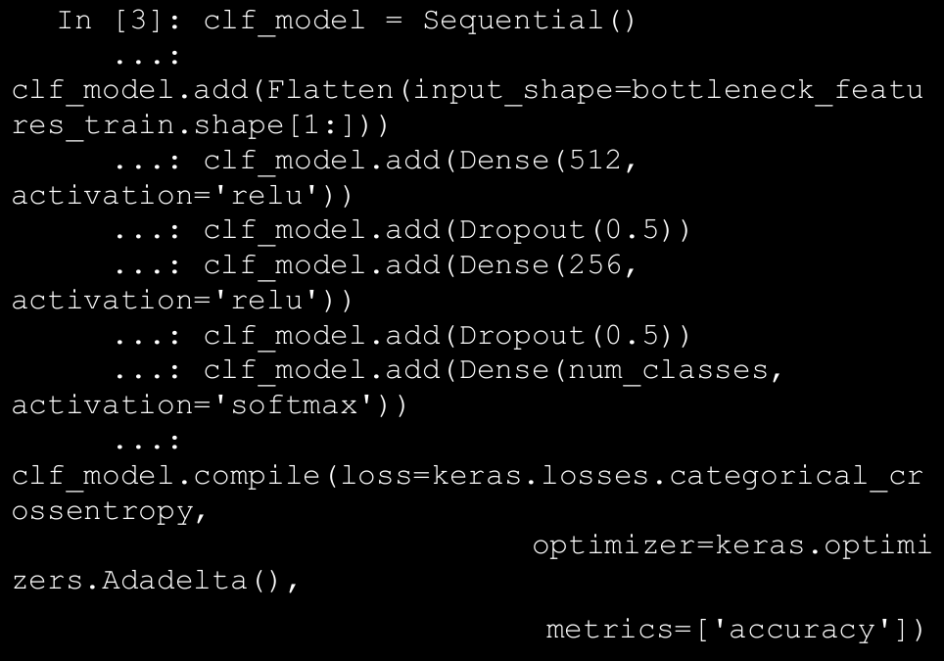

→ The model's input layer matches the dimensions of the bottleneck features (for obvious reasons). As with the CNN model we built from scratch, this model also has a dense output layer with softmax activation

function. Training this model as opposed to a complete VGG19 is fairly

simple and fast, as depicted in the following snippet.

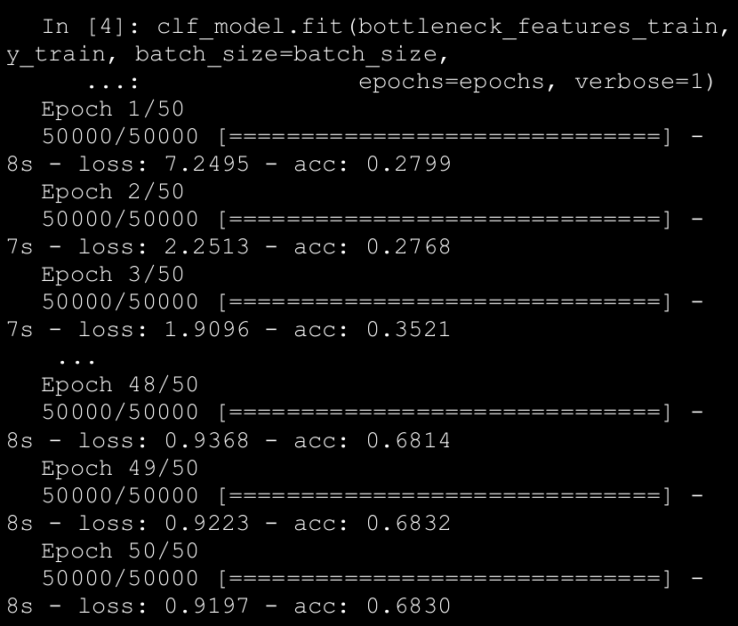

→ Overall, we achieve an accuracy of 68% on the training dataset and around 64% on the test dataset.

→ Now you’ll see the performance of this classifier built on top a pre-trained model on the test dataset. The following snippet showcases a utility function that takes the index number of an image in the test dataset as input and compares the actual labels and the predicted labels.

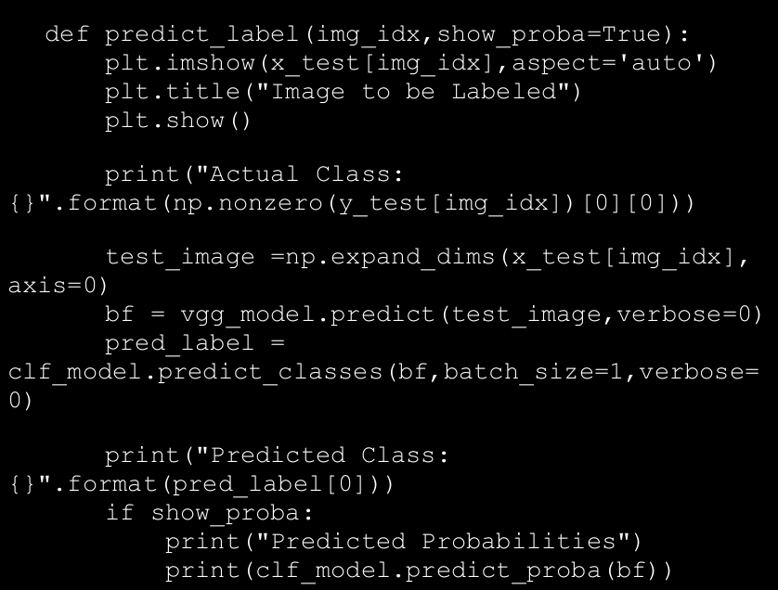

→ The following is the output of the predict_label(...) function

when tested against a couple of images from the test dataset. As depicted in Figure below, we correctly predicted the images belong to class label 5 (dog) and 9 (truck)!

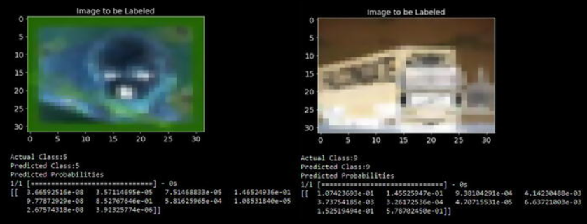

1. Ed
2. Ed
3. De
4. W
5. E
6. Dsfew
7. Few
8. Few
9. Efw
10. Ewf
11. Ewf
12. Ew
13. fwe
14. Ed
15. Ew
16. Ew
17. E
18. Ew
19. We
20. Ew
21. Ew
22. We
23. De
24. Ew
25. Dw
26. dew

